View original page on Canvas

Video

Example File
- PowerPoint Example (.pptx)

Guide

Slide Master
With the Slide Master tool you can make changes to all slides within a presentation (e.g., changing the text size of all slide Titles). You can also make changes to a specific slide layout, or even create new custom layouts.

Objective
- State the process for making a change to a Layout with the Slide Master.

Opening Slide Master
I’ll open a new presentation on Windows. On the Ribbon I’ll select the Design tab, and choose the “Gallery” layout.


To open the Slide Master:
- Select the VIEW tab from the Ribbon.
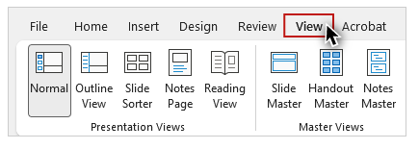
- Click on "Slide Master."
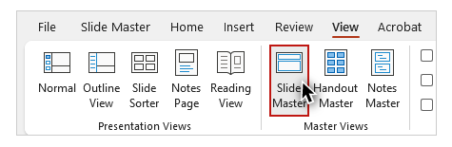

Slide Master Layouts
The different built-in layouts that are available for use in a presentation will be displayed in the left-hand sidebar.
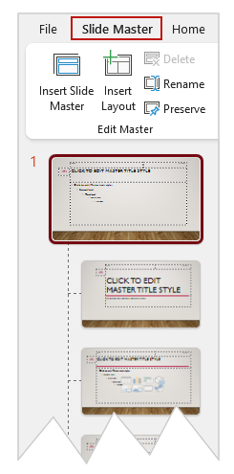
The first layout in the sidebar is the Master Layout. Below the Master Layout are the different individual layouts. Changes made to an element in the Master Layout will be applied to every layout that has that same element.
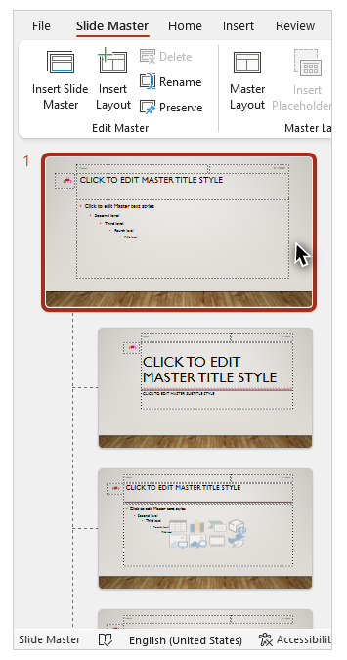
Changes made to an individual layout will impact every slide in the presentation that uses that layout. All changes will be applied when the user closes the Slide Master tool.

Creating a New Layout
I'll create a new custom layout for slides that will be presenting famous works of art as they might appear on a gallery wall. This example shows Pablo Picasso’s Mediterranean Landscape.
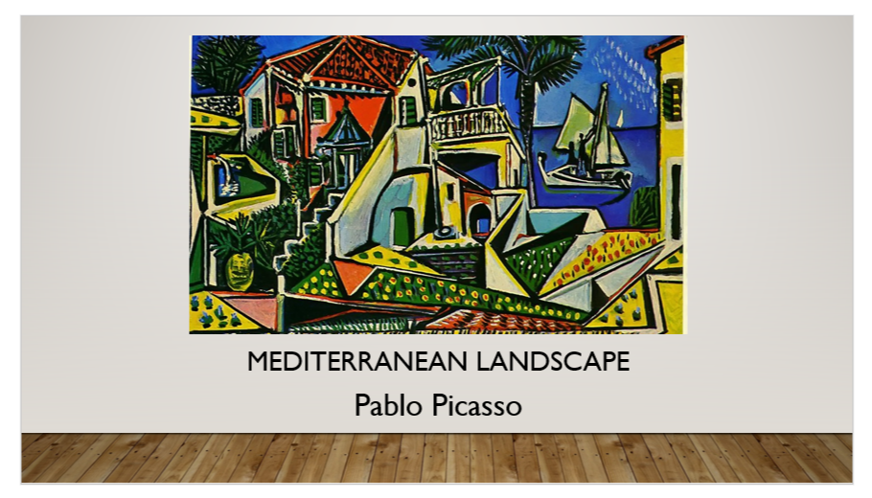
On the Slide Master Ribbon, I'll click Insert Layout.
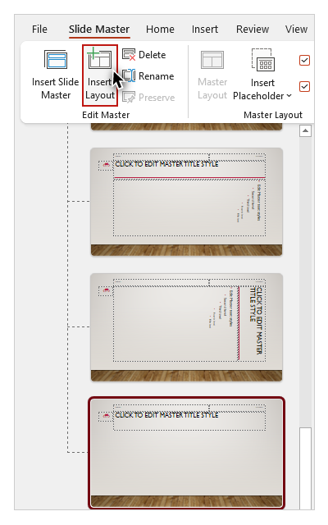
Then I will give the Layout a descriptive name by selecting the Rename tool, typing in a name (I’ll use "Artwork"), and clicking the “Rename” button.
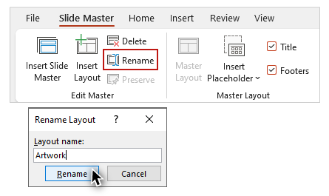
Because I do not wish to have a footer in my custom layout, I will uncheck the Footers checkbox on the Ribbon.
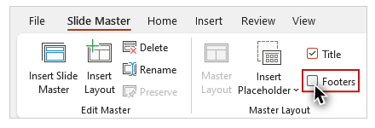

Placeholders
Now I have a Layout with just a Title placeholder at the top. I’ll verify that this is a title placeholder by unchecking the Title checkbox on the Ribbon and seeing that the placeholder is hidden, then I’ll recheck the checkbox to show it again
As shown in the example, I want my presentation to look like a museum display where the image is the main feature of the slide, with the title and artist’s name below it. I’ll move the title placeholder to the bottom of the slide, under the area where the artwork will be positioned.
Remember, a Placeholder is a container in a Layout for content that you will add later when you use the Layout to create a slide (e.g., text or an image).

Adding Placeholders

Text Placeholder
I'll use the Insert Placeholder tool to add a Text Placeholder for the artist’s name.


To insert a placeholder into a slide:
- Select the Insert Placeholder tool.
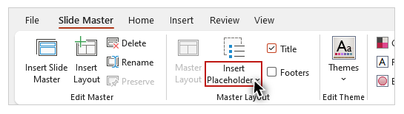
- Choose a placeholder type from the dropdown menu.
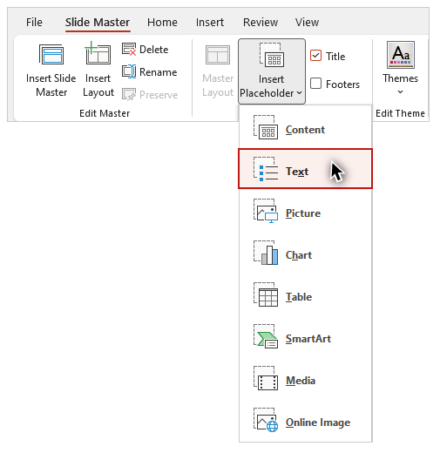
- Use the mouse to click and drag a shape for your placeholder.


Picture Placeholder
I'll repeat the process to add a Picture Placeholder for the artwork. I've added the placeholders in this specific order because this is the order that I want them to be read by screen reading software—Title (which is read first by default), then the artist's name, and finally the image.
After I adjust the size and position of the slide's placeholder areas, I'll click “Close Master View.”
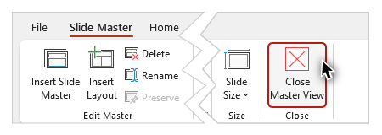
On Mac, this button is labeled “Close Master.”
Using layouts is the most reliable way to ensure that your presentation has the structure needed to support all users. Following the principles and processes covered in this video, the Slide Master will help you to create your own layouts, and to customize existing ones. In the next video, you will learn about reading order and some additional principles of accessibility for presentations.

