View original page on Canvas

Video

Example Files
- Columns Example (.docx)
- Columns Example (.pptx)

Guide

Columns
Columns are most commonly used to present a large block of text on a single page. In this video you will learn how to create columns correctly to optimize their accessibility.

Objectives
- Describe the impact on a screen reading software user that encounters columns that have been created incorrectly.
- Identify the process for creating Columns.

The Impact of Inaccessible "Columns"
The first time you saw something that had columns of text, you had to figure out how to read them: start at the top, read down to the bottom, and move on to the top of the next column.

Can you imagine how confused you would have been if you had tried to read the text by following the visual lines across the columns?
Unfortunately, this is exactly what happens when a screen reading software user encounters "columns" of text that have been incorrectly created using the Tab key or Spacebar to create white space between lines of text. I'll open the Word example file on Windows, and use NVDA to read the content under the heading "Incorrect Formatting".
[NVDA reads]
"Don't use the Tab key and/or Spacebar to content's reading order is all wrong. Plus, create 'columns' in Word or PowerPoint. While column layouts created with the built-in tool this manual formatting may look OK, they are easier to make—and edit."
[narrator resumes]

Creating Columns
The process for creating columns is the same for Word and PowerPoint, on both the Windows and Mac operating systems. The location of the Columns tool is slightly different between Word—
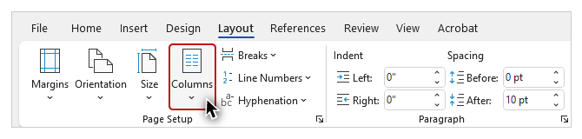
and PowerPoint:
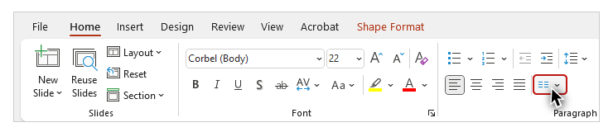
I will demonstrate the process in both applications.

Word
I'll go to the next page of the example file to work with the text under the "Correct Formatting" heading.


To apply the Columns structure in Word on Windows (or Mac):
- Select any existing text;
- Open the LAYOUT tab on the Ribbon.
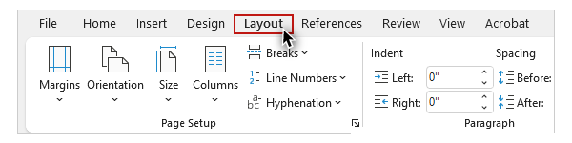
- Click Columns and select the number of columns you would like.
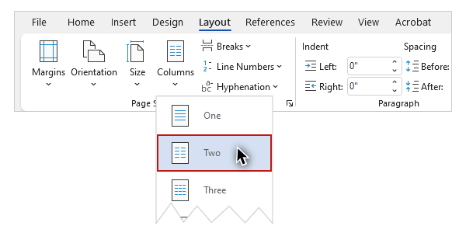
If desired, you can customize your columns by clicking the "More Columns" option.
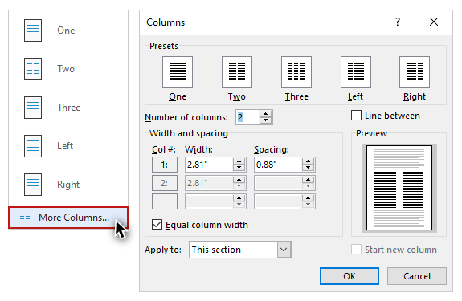
Now I'll read these proper columns with NVDA:
[NVDA reads]
"[Column 1 of 2] Don't use the Tab key and/or Spacebar to create "columns" in Word or PowerPoint. While this manual formatting may look OK, the content's reading order is all wrong. [Column 2 of 2] Plus, column layouts created with the built-in tool are easier to make—and edit."
[narrator resumes]

PowerPoint
To show where this tool is located in PowerPoint, I'll open the example file on Mac, and navigate to slide #3.


To apply the Columns structure in PowerPoint on Mac (or Windows):
- Select any existing text.
- Open the HOME tab on the Ribbon and go to Columns.
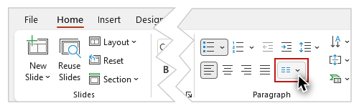
- Click Columns and select the number of columns you would like.
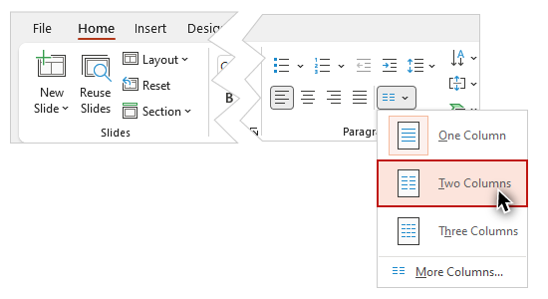
PowerPoint also offers the ability to customize your columns by clicking the "More Columns" option:
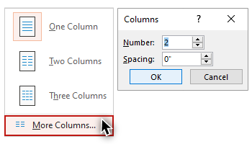

Text Flow
Switching back to the Word example, I'll move to the "Text Flow" section on the next page and put my cursor at the top of the first column. I’ll type in new content, and as I do, the text flows from one column to the next. The document structure applied to this text will also allow it to revert to a single column when using the “Read” mode in Word, and “Reflow” in Acrobat Reader.
Lists and columns are important tools for optimizing the visual presentation of information in your documents. These tools also provide the document structure needed to support assistive technologies. Implementing the principles and processes you have learned in this section are an important part of making your documents accessible to the largest number of users.

