View original page on Canvas

Video

Guide

Filename & Document Title
Giving your document a descriptive filename and title will help everyone quickly recognize your document.

Objectives
- Describe one way a document's filename may be used by assistive technology.
- Identify the process for adding a Title to a document in Word and PowerPoint.

Filename
The filename you provide when you save a document has an impact on usability and accessibility for everyone. Both Word and PowerPoint display the filename at the top of the application window.

When navigating into a Word or PowerPoint document from another document or application, screen reading software will read the filename. To demonstrate this, I’ll open up two example Word documents on Windows. Next I’ll open NVDA. Listen as I navigate from one document to the other, and back again.
[NVDA reads]
“Lists example | Word ; columns example | Word; lists example | Word.”
[narrator resumes]
A filename should succinctly describe the document. Although using spaces and special characters (e.g., %) in filenames is less of an issue now than it was in the past, there are some contexts where their use could cause an issue, such as when a filename with special characters is converted to a URL.
You may want to consider how your filename might be read by screen reading software. Special characters may or may not be read, so it’s generally best to avoid them. Words that are separated by hyphens (“-”) will be read as individual words. So will words separated by capital letters instead of spaces, often referred to as "camelCase."

Document Title
The document's title should mirror, or be similar to, its heading 1. Because the process for adding a title is different on Windows and Mac, I’ll demonstrate the steps on each operating system.

Windows
First I’ll open a blank Word document on Windows. I’ll type in the text “My Heading 1” and apply the proper style.


To add a Title to Word (or PowerPoint) on Windows:
- Click the FILE tab.
- Enter your text in the "Title" field, in the Properties section.
- 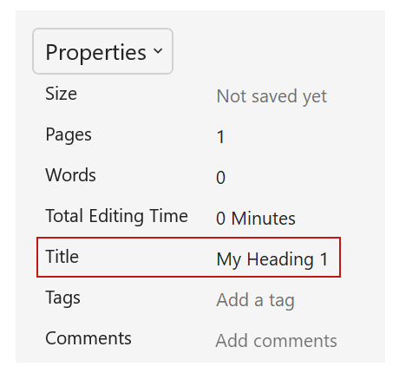
- Save your file.
I’ve added the text “My Heading 1.”

Mac
Now I’ll open up a blank Word document on Mac and add the same Heading 1.


To add a Title on Word (or PowerPoint) on Mac:

  - Open the FILE dropdown on the application menu and select "Properties."
  - Click the Summary tab on the dialog and enter your text in the "Title" field.
  - Click "OK."
- 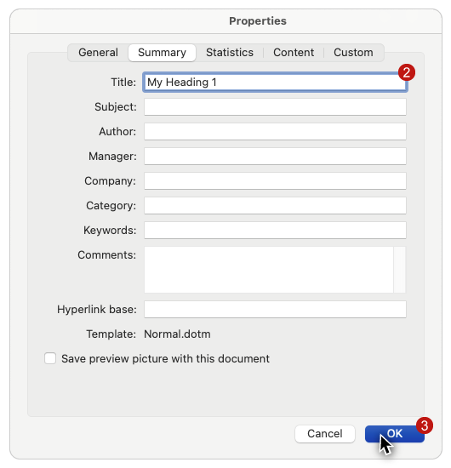
As before, I’ve entered the text “My Heading 1.”

Acrobat
While Word and PowerPoint use the filename to identify a document, users will be presented with a document's title when viewing a PDF in Acrobat, or even in a web browser.

The document title will also be read by screen reading software.
Now that you know how to provide your users with a descriptive filename and title, you are ready to practice evaluating and repairing source documents.

