View original page on Canvas

Video

Example
Word Example (.docx)

Guide

Creating PDFs: Part 2
In Part 1 you learned about two processes for creating PDFs from Word and PowerPoint files:
- Using the ACROBAT tab.
- Creating a PDF in Acrobat itself.
In this video I will demonstrate both processes on Windows.

Please note: if you are a Mac user, watch the Mac Users: Adobe's Cloud Service video before proceeding.
All references to "Acrobat" in this video (and the videos following it) refer to Adobe Acrobat Pro DC. If you haven't installed this version of Acrobat Pro [gong sound], please stop this video and install it.

Objectives
- Identify the process for creating a PDF using the Acrobat tab.
- State the process for creating a PDF in Acrobat.

Creating a PDF with the Acrobat tab
When you install Acrobat Pro DC on your computer, Adobe will also install an add-in that allows you to create a PDF without leaving Word or PowerPoint. You will know it is installed when you see the ACROBAT tab on the application’s ribbon.
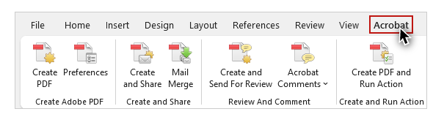
If you do not see the ACROBAT tab, you do not have a compatible version of Acrobat Pro DC, or the installation process failed. Please see the Resource Links [cork pop sound] in this section for information from Microsoft and Adobe on resolving either of these issues.
I’ll open the Word example on Windows.


To create a PDF file using the Acrobat tab on Word (or PowerPoint):
- If there are unsaved changes––save the file.
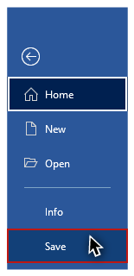
- On the ACROBAT tab click "Create PDF" (the "Save Adobe PDF File As" dialog opens).
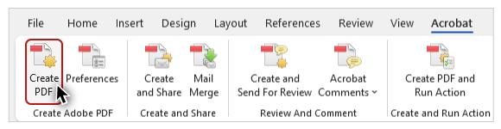
- Name the PDF.
- Click "Save."
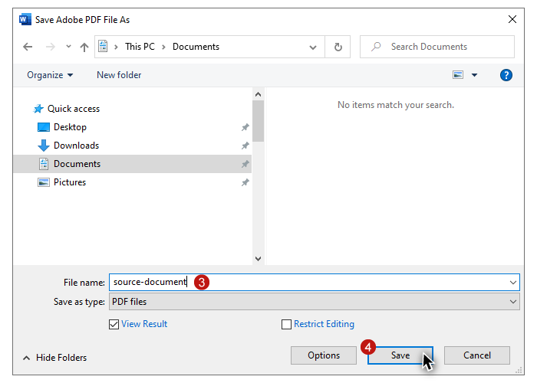
When the process is complete the PDF will automatically open in Acrobat.

Creating a PDF in Acrobat
You can also create a PDF within Acrobat itself. The result is the same as if you had created it from the ACROBAT tab in Word or PowerPoint. In Acrobat, I'll navigate to the application menus and select:
- File
- Create
- PDF from File
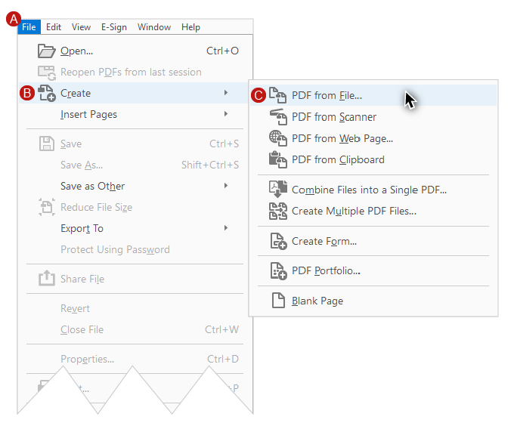
The "Open" dialog is displayed. I'll select:
- The source document file.
- Click “Open.”
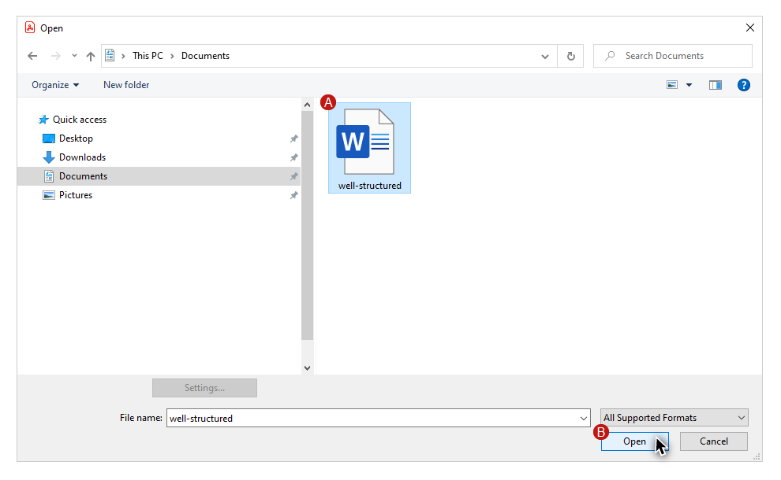
In this demonstration I have opened the Word example file.
By following the processes outlined here, the PDFs that you create will maintain the accessibility information in your well-structured Word and PowerPoint source documents. In Module 4 you will learn how to use Acrobat to optimize the PDFs you create.

