View original page on Canvas

Video

Checklist
- Evaluation Checklist: Word and PowerPoint (.pdf)

Example File
- Word Example (.docx)

Guide

Evaluating Accessibility
When you have an important email that you will be sending to a large group, you probably take some time to ensure that the information it contains will be clear to all recipients. You will certainly review spelling and grammar, but you might also review your choice of words and tone, how your sentences are grouped into paragraphs, and other more subjective characteristics. Now that you have learned principles and processes for creating well-structured electronic documents, you’re ready to learn about evaluating the accessibility of those documents using Office’s built-in tool and a WebAIM checklist.

Objectives
- Identify the process for running the Check Accessibility tool.
- Describe the three types of issues listed in the Inspection Results.
- State the process for addressing an issue listed in the Inspection Results.

Starting the Checker
Both Word and PowerPoint contain an accessibility checker that will identify many––but not all––potential issues in a document. Although there are some slight differences in the Inspection Results interface on Windows and Mac, the process for generating and addressing these results is the same on Windows and Mac in Word and PowerPoint.
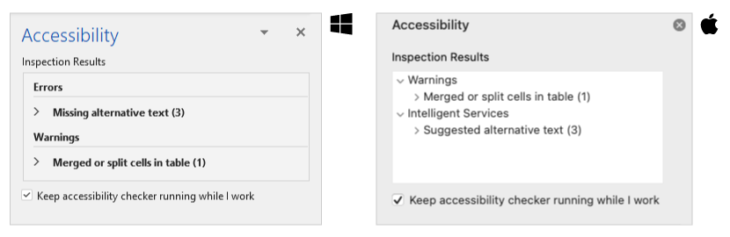
I’ll open the example Word document on Windows.


To check the accessibility of a document on Word (or PowerPoint) on Windows (and Mac):
- Select the REVIEW tab on the Ribbon.
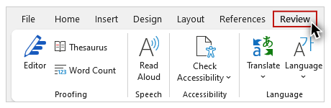
- Click the "Check Accessibility" tool.
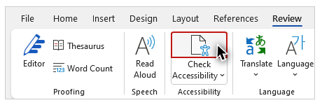
After the checker has finished running, on the right-hand side of Word’s interface, the Accessibility panel will open, and the Inspection Results will be displayed in the top section.
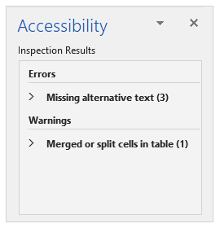
Information on why an issue is important—and how to fix it—is presented in the bottom part of this panel. When a user clicks on an item listed in the results, the page on which the element is located will be displayed, and the element will receive focus. For example, if page 1 is displayed in the application’s working area, and an element with an issue is located on page 3, the application will automatically scroll to page 3 when that issue is selected.

Accessibility Checker Rules
The checker has a set of built-in rules to identify potential issues. Depending upon the severity of an issue, it is classified as: an Error, a Warning, or a Tip.

Errors
Microsoft defines an Error as “Content that makes a document difficult or impossible to read and understand for people with disabilities.” Some rules for Errors are: all non-text content has alternative text; tables specify column header information; and, all slides have titles.

Warnings
A Warning is defined as “Content that in most (but not all) cases makes the document difficult for people with disabilities.” Some rules for Warnings are: sufficient contrast between text and background; tables have a simple structure; and, the reading order of the objects on a slide presentation is logical.

Tips
A Tip is defined as “Content that people with disabilities can understand but that could be presented in a different way to improve the user's experience.” Rules for Tips include: slide titles in a deck are unique; and sections in a deck are unique.

Addressing Inspection Results
I’ll return to the Inspection Results in our example document and address two issues. In the Errors section, after the issue “Missing alternative text”, the number 3 is listed in parentheses, informing me that there are three elements to evaluate. I’ll click on this issue to expand the list:
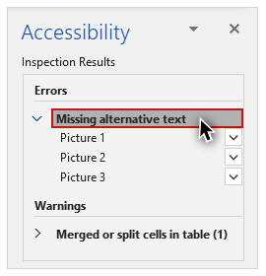
When I select “Picture 1”, the document scrolls from page 1 to page 2 to bring the image into the application’s working area, and the picture is selected. I’ll right-click this image, and add Alt Text. Now that I have addressed this Error, the element is removed from the Inspection Results.
Next, in the Warnings section, I’ll click “Merged or split cells in table”, and then select Table 1:
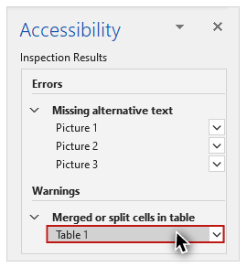
This table has four columns labeled Column 1 - 4, and four rows labeled Row 1 - 4. Row 2 has one merged cell that spans both Column 3 and Column 4. Although this might have been done because the data value was the same, merged cells may present difficulties for screen reading software users, and should be avoided when possible. To correct this, I’ll right-click the merged cell, and select “Split cells” from the menu to open a dialog window:
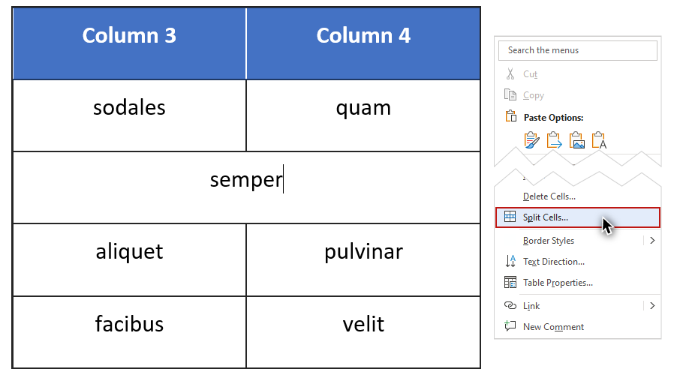
On the Split Cells dialog I will leave the default values––Number of columns: 2; and Number of rows: 1––and click OK. As a final step I will copy the text from the first cell and paste it into the second.

Evaluation Process
The Check Accessibility tool is good at identifying many potential issues, but there are also many issues that it cannot detect. For example, it will flag an image with missing alternative text, but not an image with incorrect alternative text. Evaluating accessibility requires some manual checks as well.
WebAIM’s Word and PowerPoint evaluation checklist provides manual evaluation steps to be used in combination with the Check Accessibility tool. The checklist contains a series of tables that are organized by topics that apply to both applications, such as Images and Tables. Other topics apply to a specific application, such as Headings in Word and Slide Title in PowerPoint.
The first column of each table identifies an accessibility Principle. The second column––Review––lists Errors and/or Warnings associated with the principle, and where applicable, provides manual processes for detecting issues. The third column outlines the steps needed to Repair an issue.
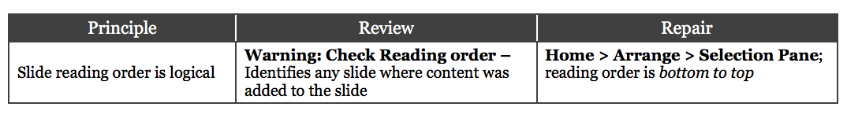

Be Flexible
This checklist will provide guidance during your evaluation process, but there is no “one way” to evaluate the accessibility of a document. You may choose a different approach based on a document’s existing structure, or lack of structure.
For instance, if you created a new document that follows the accessibility principles of this course, it may make sense to run the built-in checker, but further evaluation may not be necessary. On the other hand, if you are repairing a document with questionable or unknown structure, additional review will be necessary.
Your approach may also vary based on the document type. The most common issues in PowerPoint presentations—missing alternative text, missing or repeated slide titles, and incorrect reading order—are flagged by the accessibility checker. But many common issues for Word documents—such as headings that were created by changing the visual formatting of the text, instead of using the Styles gallery—will only be detected by manually reviewing the document.
You now have a high-level awareness of how to use the built-in checker and WebAIM’s accessibility checklist to evaluate Word and PowerPoint documents. The next step is to use these tools to evaluate some example documents, and repair the issues that you identify.

