View original page on Canvas

Video

Guide

Introduction to Optimizing PDFs: Part 2

Objectives
- Describe three conceptual PDF “layers.”
- Identify the process for adding the Tags panel to the Navigation pane.
- Describe the process for adding the Accessibility tools to the Tools pane.
- State the three steps for optimizing a well-structured PDF.

Understanding PDF “Layers”
Before I demonstrate the one-time additions to the user interface that are required for optimizing PDFs in Acrobat, I'll take a moment to introduce a conceptual framework that will help you understand—at a high level—how PDF accessibility works. Think of a PDF as having three imaginary “layers” that provide different types of information to users.

Visual

The visual layer is what is seen on the screen. For visual users, the main benefit of a PDF is that it maintains the layout and appearance of a well-structured source document. It will look the same when it is displayed—even across devices with different screen sizes—and when it is printed. Screen reading software does not receive information from this layer.

Content
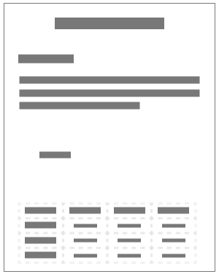
The content layer contains information on basic formatting applied to text, like fonts and colors, and text formatted as a list or a table. When a visual user chooses to “reflow” a document—for example, for a more usable view on a small screen—the content layer will be presented instead of the visual layer. I’ll demonstrate how to use Acrobat’s Reflow tool in an upcoming video.

Tags
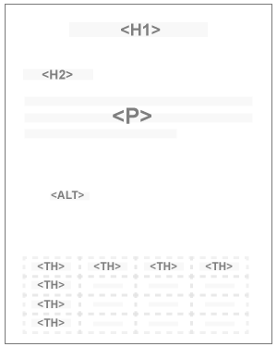
The tags layer defines the document’s structure that supports assistive assistive technologies. This includes headings, links, lists, and tables. Screen reading software provides users with access to these and other elements in a document through information received from this layer. For example, screen reading software users can navigate a document through text elements that are identified as headings.

Acrobat’s User Interface
Acrobat’s user interface is very similar on Windows and Mac. When there is a notable difference between the two, I’ll point it out. I’ll open the example file in Acrobat running on Windows. If you are following along by opening the example file on your computer, make sure you are using Adobe Acrobat Pro DC—NOT Acrobat Reader or Acrobat Standard. From this point forward, when I use the term "Acrobat," I am referring to Adobe Acrobat Pro DC. Older versions of Acrobat have a much different interface for visual users.

Two Panes
I’ll open the example file in Acrobat running on Windows. Within Acrobat, the term “pane” refers to the sidebars on either side of the application’s user interface. The Navigation Pane is on the left and the Tools Pane is on the right.
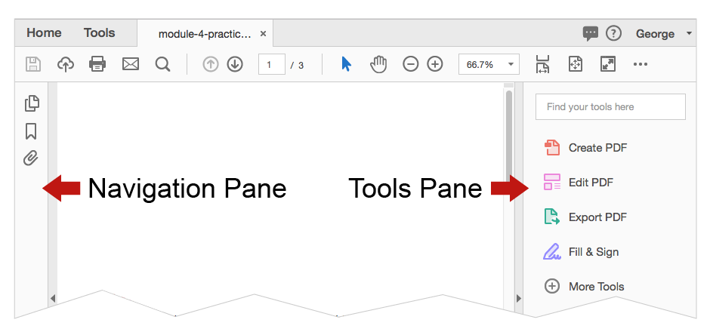
To have Acrobat properly configured to optimize a PDF, you will need to make some one-time additions to these panes.

Tags

Adding the Tags panel
As I previously mentioned, the tags “layer” defines document structure, and it is used by screen reading software to determine the correct reading order for content. To see a document’s tags, you will need to make the Tags panel available, as this panel is hidden by default. To show the Tags panel, I’ll right-click on an empty part of the Navigation Pane.
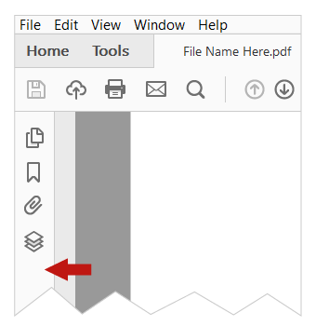
On the menu of the available navigation, I'll select "Tags.”
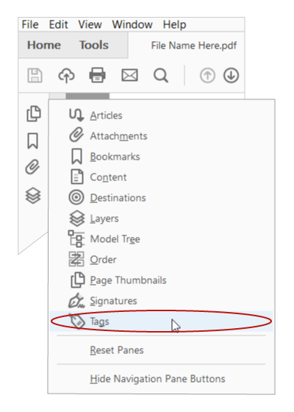
From this point forward, when any PDF is opened in this copy of Acrobat, the button for the Tags panel will be displayed.
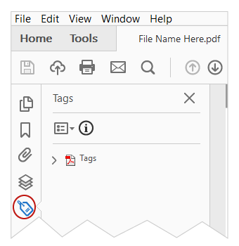

Tags tree
Tags are shown as an expandable "tree." The right and left arrow keys may be used to expand or collapse––or open or close––the different elements in the tags structure.
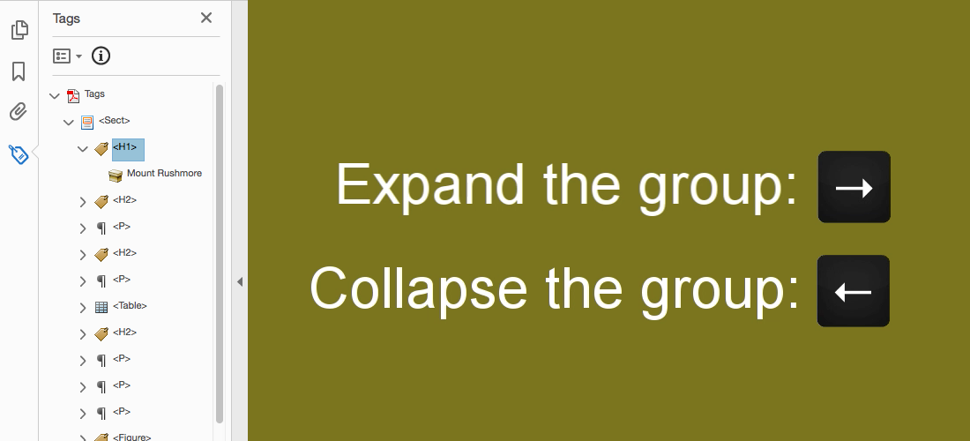
The up and down arrow keys can navigate forward or backward through the open elements in the structure.
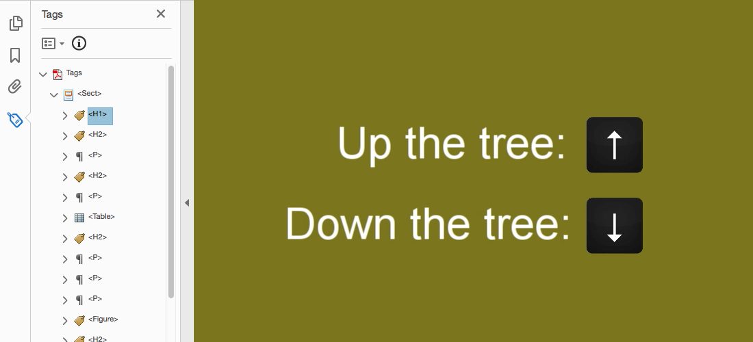
Our process for optimizing a PDF created from a well-structured source document requires only minimal interaction with the Tags panel.

Tag labels
Some of the labels in the tags tree are different from the terms used for structural elements in Word and PowerPoint. For example, text that is identified as a "Heading 2" in Word, or as a “Slide Title” in PowerPoint, will be tagged as "<H2>." As you gain experience in reviewing the tag structure of documents, these tag labels will become more familiar.

The function of Tags
There are two high-level concepts related to the function of tags:
- Screen reading software will only have access to document elements that are tagged.
- The order in which these elements are presented to screen reader users is determined by the order of the tags in the tree.

Tools
Next I will demonstrate how to add the Accessibility tools. To enable the Accessibility tools for the first time, on Acrobat’s toolbar I’ll click the “Tools” tab.
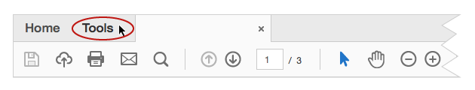
The Tool center opens in the application’s main workspace, displaying all of the available tools grouped into categories. In the search field at the top of the Tools center, I’ll type in “accessibility.” The Accessibility tool is listed as one of the search results. I’ll click the "Add" button.
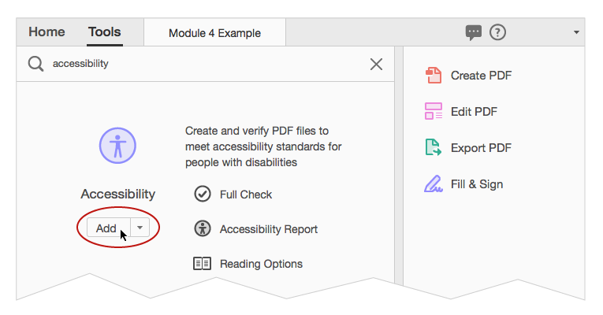
From this point forward, the Accessibility tools will be available in the Tools pane on the right-hand side of the user interface.
With Acrobat properly configured, you’re ready to learn how to implement WebAIM’s process for optimizing PDFs.

The Three Steps to PDF Accessibility
In the videos that follow, I’ll demonstrate how to optimize your well-structured PDF in three steps:
- Run Accessibility Check and review the report.
- Repair the document's structure with the Reading Order tool.
- Review and repair content order and tags order.

