View original page on Canvas

Video

Example Files
- Checking Accessibility Example (.pdf)
- Tab Order Failure Example (.pdf)
- Tagged Content Failed (.docx)
- Tagged Content Failed (.pdf)

Guide

Checking Accessibility
The first step in the PDF optimization process is:
- Run Accessibility Check and review the report.
This report is displayed in the Accessibility Checker panel, and it highlights common accessibility issues that may be present in a PDF. Since you've done most of your accessibility work already—by creating a well-structured source document—this report should come out pretty clean. But we recommend that you always run Accessibility Check and review the report––just to be sure your PDF does not have any issues that need to be fixed.

Objectives
- Identify the process for generating the report that is displayed in the Accessibility Checker panel.
- State two issues identified in the Accessibility Checker report that will always require a manual review.
- Identify the process for changing a PDF's Title.

Run Accessibility Check
I'll open the example PDF file in Acrobat running on a Mac. In the right-hand Tools sidebar, I will select Accessibility—
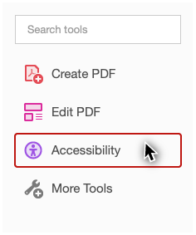
and then Accessibility Check.
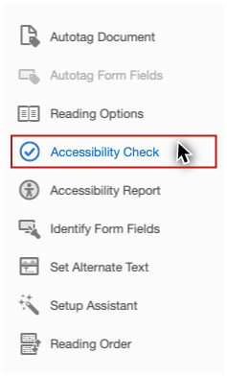
A dialog will appear with a number of options.
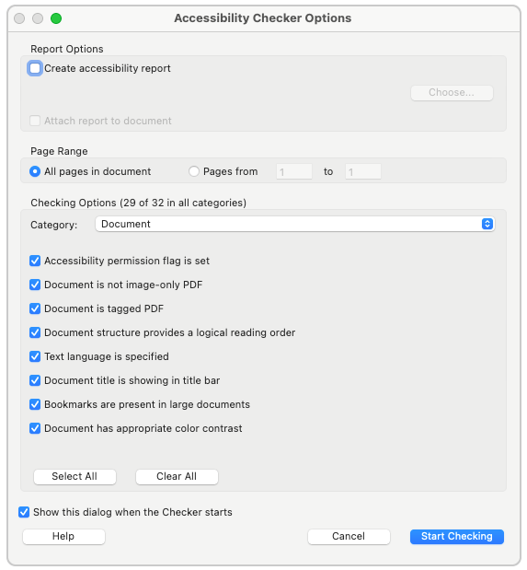
The “Create accessibility report” option will create an HTML document describing the accessibility rules, and—for each rule—whether this document passes, fails, or needs a manual check. This option is checked by default, but I’m going to uncheck it, because Acrobat will present the same information within the application. If you feel that this report is useful, you may want to leave this option checked. I'll click “Start Checking” to create the report.

Accessibility Checker Results
In the Navigation Pane on the left side of the application, the results are presented in the Accessibility Checker panel.
This report is organized into seven sections:
- Document
- Page Content
- Forms
- Alternate Text
- Tables
- Lists
- Headings
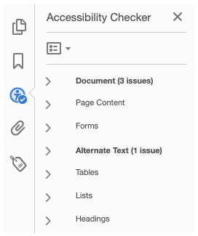
Sections that are labeled with bold text have one or more issues—such as an item that has failed—or an item that needs a manual check. If a section is not labeled with bold text, then everything in that section has passed. I can use the arrow keys to expand and collapse each section, and move up and down the items, or I can navigate with the mouse. When you are connected to the internet, you can right-click on any item in the report and select "Explain."
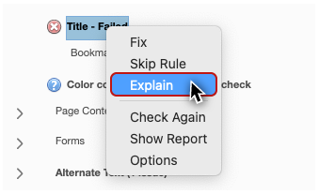
An Adobe web page with information about the item will open up in a browser window.

Common Issues
Even a PDF created from a well-structured source document may have a few failures. This doesn't necessarily mean that you did anything wrong. For example, in this PDF the “Title” is shown as a failure. I know I added a descriptive Title to the original Word document, but in this case, Acrobat did not recognize the Title automatically. I will right-click this item and select “Fix.”
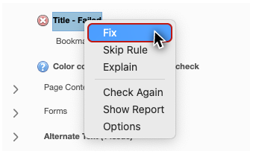
Acrobat should then locate the Title text and apply it to the document's properties. To check that the Title is now properly identified, I can save the PDF, and the document's filename displayed in the Title bar should be replaced with the document's Title. If this didn't fix the issue, or if I want


To change the Title of a PDF in Acrobat Pro:
- Select File > Properties from the application menu.
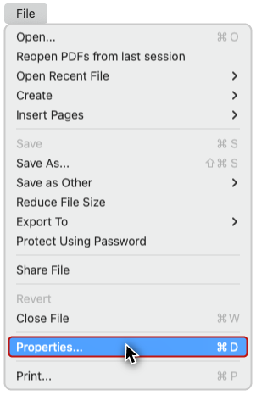
- in the Document Properties dialog, on the Description tab, add or change the text in the Title field.
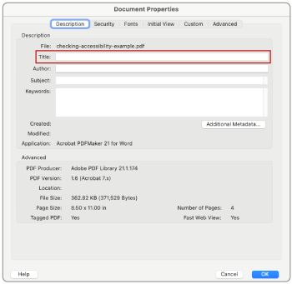
- Click "OK".
The accessibility checker will always flag two items that require manual evaluation:
- Logical Reading Order
- Color contrast
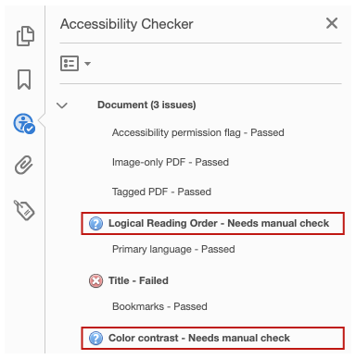

Logical Reading Order
Only a person can conclusively determine whether a document's content is presented in the correct sequence. Because I created this PDF from a source document that is structured correctly, this reading order should be correct. That being said, we do recommend reviewing the logical reading order at least once—after reviewing and repairing the document’s structure. Further reviews should not be necessary, unless you make subsequent changes to this structure. I will demonstrate how to review and repair logical reading order in an upcoming video.

Color Contrast
Acrobat prompts the user to manually check “Color contrast.” This item isn't flagged based on any information gathered from the PDF—but rather it's a notification that contrast must be checked manually. Because I have already reviewed my source document to ensure that it meets the contrast requirements in the Web Content Accessibility Guidelines, I'll right-click this option and select "Pass."
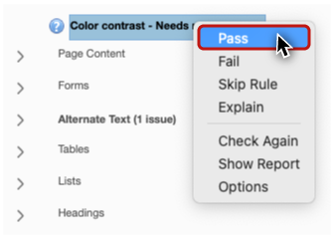
If I had not previously reviewed for contrast, I would return to my source document, ensure that the guidelines covered in the Contrast video are met, and re-export the PDF if any fixes were made.

Other Errors

Tab Order
At times, a failure in “Tab order” may be indicated in the "Page Content" section—even when the source document was created properly. I'll open the "Tab Order Failed” example on a Mac and run the Accessibility Check.


To fix a Tab Order error in Acrobat Pro:
- In the Accessibility Checker panel open the "Page Content" section.
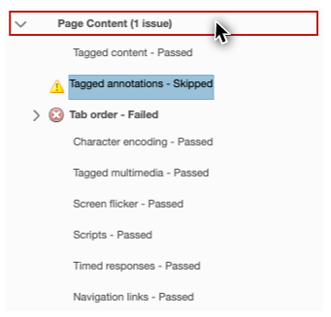
- Right-click this error, and select "Fix."
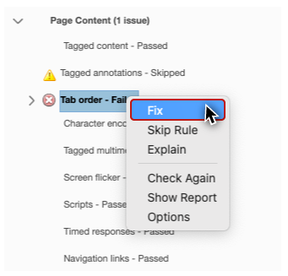
A dialog stating “Tab order set to match structure order in all pages successfully” will open. I’ll click “OK” to close the dialog.
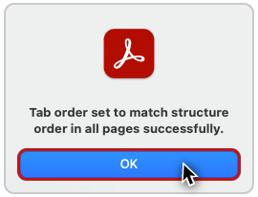

Alternative Text
Heading back to the main example file, the "Alternate Text" section indicates that I have an issue. When I open the section, I see that "Figures alternate text" has failed.
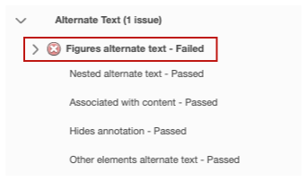
Accessibility Check will flag any Figure that does not have alternate text, unless it has been marked as decorative in Word or PowerPoint. I'll click on this error, and Acrobat places focus on the image of Theodore Roosevelt.
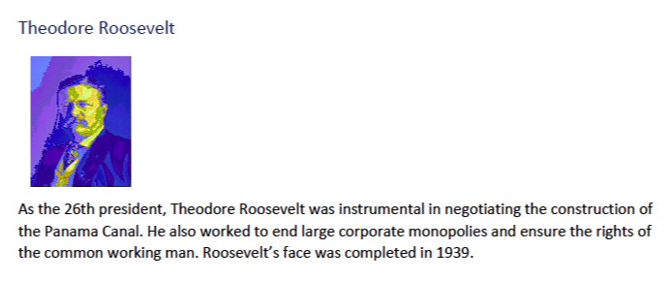
The four images of the presidents were linked to Wikipedia articles in a previous example. To create this example PDF, in the source document I removed these links. The images no longer have a function, and the alternative text for their content is being supplied by heading text. I marked these images as decorative—except this image of Roosevelt—which I will address in the next video.

PDF Conversion Settings
If you see an error that reads "Tagged content - Failed", a problem occurred when the PDF was created.
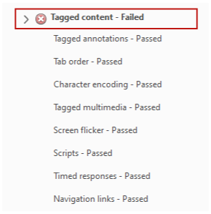
This is unusual, but it can happen.

Repairing in Word (Windows only)
This error is NOT repairable on a Mac. I'll demonstrate how to address this issue in a source document, by opening up the “Tagged Content Failed” example on Word for Windows. On the Ribbon, I'll click the Acrobat tab, and then I'll click Preferences. A dialog appears. I'll make sure the "Enable Accessibility and Reflow with tagged Adobe PDF" checkbox is checked, click “OK”, and then re-export the PDF.

Repairing in Acrobat
When a PDF with this issue was created using Acrobat, a setting that is used in the conversion process will need to be enabled. I'll open the “Tagged Content Failed” PDF example in Acrobat on Windows. On the Acrobat application menu I select Edit > Preferences >
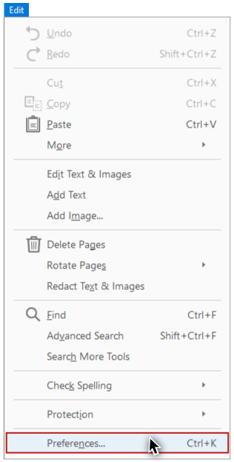
Categories: Convert To PDF.
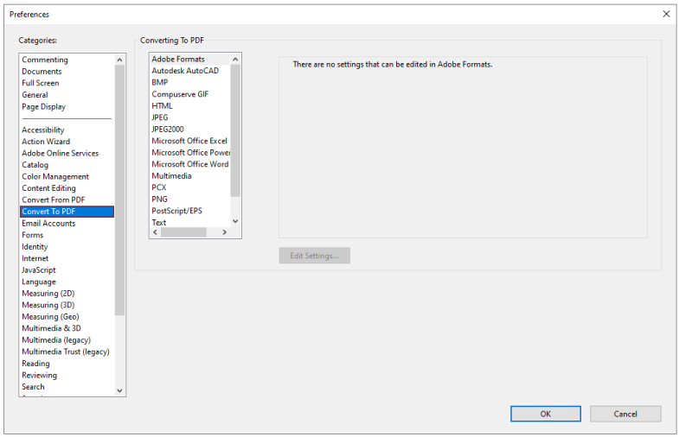
From there, I choose "Microsoft Office Word", and click the “Edit Settings…” button.
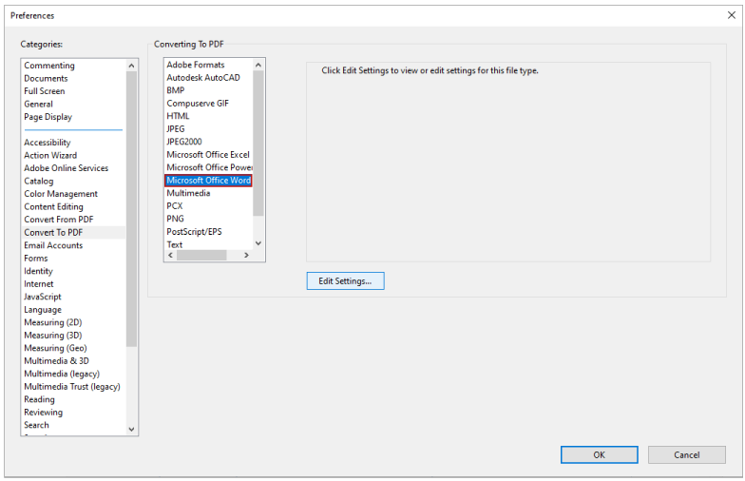
A dialog appears. I see the “Enable accessibility and reflow” checkbox is unchecked, so I check it.
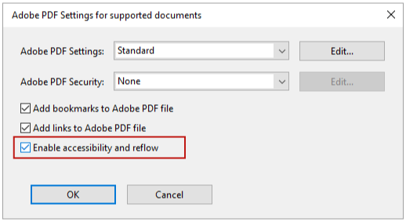
I'll click “OK” on this dialog, and click "OK" on the Preferences dialog.
After you have completed the first step in the optimization process, you are ready for step two:
- Review and repair the tag structure with the Reading Order tool.

