View original page on Canvas

Video

Example Files
- Sheets & Tables (.xlsx)

Guide

Sheets & Tables
In this video I will demonstrate best practices for creating accessible Sheets. I will also demonstrate the process for structuring a grid of information with headers as an accessible data table.

Objectives
- State the process for naming a Sheet.
- Describe a method for creating a Sheet description.
- Identify how to add headers to a Table.

Workbooks
A workbook is a file that contains one or more worksheets to help you organize data. There are a number of best practices for accessibility that are applied at the workbook level, generally as the final steps before evaluating its accessibility. These recommendations are covered in the Optimizing Workbooks video. I'll open a new worksheet in Excel 2016 on Windows.

Sheets

Naming a Sheet
A new workbook has one Sheet open by default. Each sheet has a tab located at the bottom of the user interface:
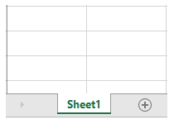
The tab's default name (e.g., "Sheet1") should be replaced with a descriptive name as soon as it is created.


To add or change the name of Sheet:
- Right-click on the Sheet's tab.
- Select "Rename".
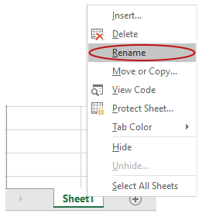
- Type in text that provides a high-level description of the Sheet's content.
I'll name this sheet "Getting Started".
When a screen reading software user enters the workbook area, the sheet's name functions in Excel like the Title element does in a PowerPoint slide. However, unlike Title in PowerPoint, there is no structural element in Excel that is converted to a heading tag when exported to PDF.
To create an additional sheet, I'll use the "new sheet" button. This button is located on the right side of the tab of the last sheet that was created, and it is labeled with the "plus" symbol:
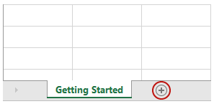
It is important that a workbook does not have any sheets that do not contain data, so I will right-click on this blank sheet that I just created, and select "Delete" from the menu:
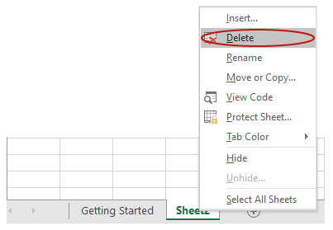

Describing a Sheet
Adding a text description directly into a sheet can benefit users in the same way that a Heading 2 functions in a Word document. Although this text description is not a requirement, it will provide a visual user with a high-level description of the sheet, the same way that the sheet's name functions for screen reading software users. This text should be clear, succinct, and unique in the workbook. If you feel that your spreadsheet should have a description, we recommend placing it at the top of the sheet.


To add a description to a Sheet:
- Click on the top-left cell (typically A1, unless a row and/or column is left blank for visual spacing).

- Add the Sheet description.

I'll use the text "Getting Started".

Cell Styles
On the Hᴏᴍᴇ tab on the Ribbon, clicking on the "Cell Styles" button will open a gallery of available styles:
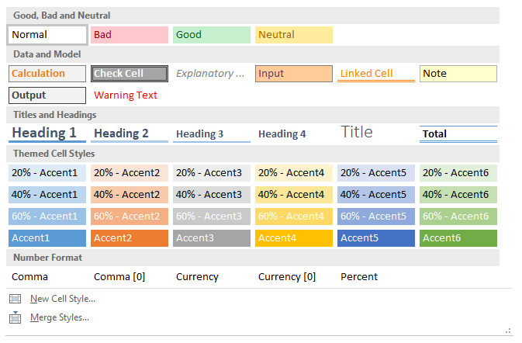
In the "Titles & Headings" section there are styles for Heading 1 through Heading 4. Unlike heading styles in Word, applying a heading style in Excel style only changes the formatting of text. This text will not be presented as a heading to a user navigating in Excel with screen reading software, and this text will not be tagged as a heading in a PDF Export. As I discussed earlier in this video, a Sheet is identified by its name, entered into the field on its tab.
The main advantages to using cell styles are the ease of applying consistent formatting to similar elements in a workbook. For example, I want uniform formatting for the descriptive text in my sheets, so I will apply the Heading 2 style to the "Getting Started" text on this sheet. This will also allow me to update the formatting on these descriptive text elements by modifying the Heading 2 style. For information on modifying any style in the Cell Styles gallery, please review the Modifying Headings video.

Tables
If a spreadsheet contains a grid of information with headers, you will want to present this to users as a Table. To demonstrate how to create a table, I'll open the example file in Excel 2016 running on Windows. When there is a difference in the user interface in this version of Excel running on a Mac, I will point this out.

Formatting a Table
I'll start by selecting the grid of text starting in cell A4. I can do this with a mouse by clicking on cell A4 and dragging diagonally to cell C11. I can also use Shift + click on the top-left and bottom-right corners.With the text selected, I'll select "Format as Table" on the Hᴏᴍᴇ tab, and choose a table style that has good contrast, such as this black and white style:
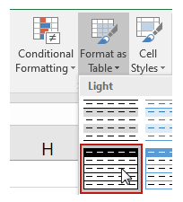
The "Format As Table" dialog will open up. I will make sure the "My table has headers" checkbox is selected, and then click "OK":
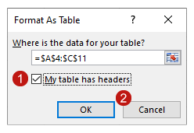

Identifying Headers
Now that I have created this table, a new tab appears in the ribbon. It is called "Design" in Windows:

In Mac, it's called "Table":

There are a group of checkboxes in this tab—and this is where the Headers within this table are identified:
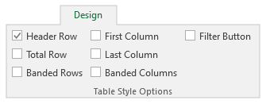
The "Header Rows" checkbox is selected by default. This table has Headers along the top row—most tables do—so I'll leave this checked. There is also a "First Column" checkbox. Since the cells in the first column of this example are Headers for the rows, I'll also check this setting:
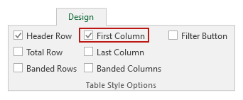
Identifying this text as row headers will also apply bold formatting to the content in these cells.
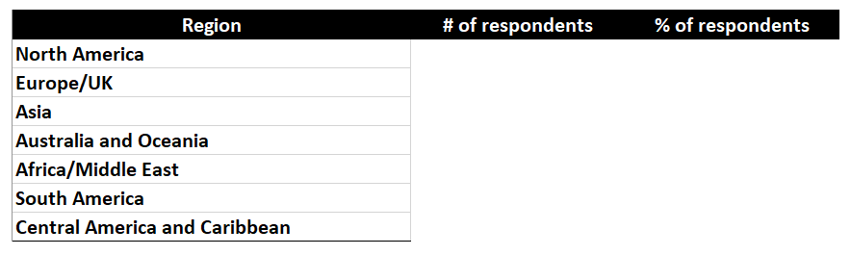

Providing a Caption
In this example, the text "Respondent Regions" functions as a caption for the table. This text should be centered visually by placing it in the second column of this three-column table. Screen reading software can identify cells that have been merged, and because the caption applies to the whole table, I want to have the text in a cell that spans all three columns.
I'll select cells A3 to C3 and then in the Home tab, I'll select "Merge and Center":
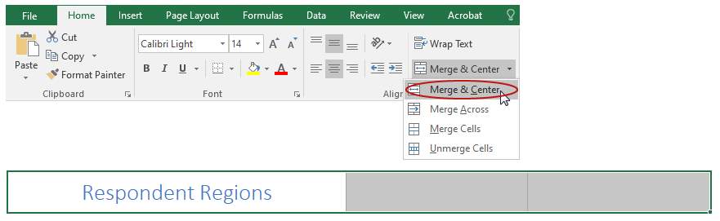
Now a screen reader user would hear—"Respondent Regions A3 through C3"—and understand that this content is a caption for a three-column table.
Be careful with spanned cells within grids or tables of information. Screen reader users typically expect one column header and one row header for a single cell, and merging cells can make this very confusing.

Table Support in Screen Reading Software
At this time, full support for table structure is provided by two screen reading applications: JAWS for Windows and VoiceOver for Mac. The most commonly-used screen reader––NVDA for Windows—did not recognize tables in our latest round of testing.
In the next video I will demonstrate best practices for providing alternative text for images, and for optimizing the accessibility of Hyperlinks.

