View original page on Canvas

Video

Example File
- Images & Links (.xlsx)

Guide

Images & Links
Graphic elements are not as common in spreadsheets as they are in Word and PowerPoint files—with the exception of Charts—which are addressed in a separate video. Providing equivalent alternative text for graphic elements that have content is vital for users that have visual disabilities, such as blindness or low vision.
Hyperlinks, or "links", are more common in spreadsheets. The default display text created for links by Excel is often difficult to understand. Providing displayed text that is descriptive will increase a link's accessibility for many users.

Objectives
- Identify the correct technique for adding alternative text to an image with content.
- Identify how to add and edit Hyperlinks.

Images
For the purposes of this video, the term "image" will be used generically to refer to graphic elements that may present content such as Pictures, Shapes, Icons, and Smart Art. As was demonstrated in the Navigating in Excel video, graphic elements are not associated with a single cell, or group of cells. Because a graphic element "floats" above the cells in a sheet, it can be very difficult for a screen reader software user to navigate to it.

In general, images should NOT be used in Excel spreadsheets.
When an image is used in Excel, it must be determined if the image requires alternative text.

Alternative Text
I'll open the example file in Excel 2016 running on Windows. When there is a difference in the user interface in this version of Excel running on a Mac, I will point this out. Toward the top of the sheet, I have an image:

If an image has content, it needs alternative text. To determine if this image has content, I will ask myself two questions:

- Does the image have text?
- What text would I use to replace the image?
The answer to question number 1 is: "Yes. This image has the text 'WebAIM: web accessibility in mind'." My answer for question number 2 is : "WebAIM: web accessibility in mind." Because the WebAIM logo is shown, I could add in the word "logo" if I wanted.

Effective Alternative Text
In most cases, effective alternative text...
- ...uses just a few words. Long alternative text can make it more difficult for a screen reader software user to get through a page.
- ....does NOT duplicate nearby document text. Otherwise, the information will be read twice by the screen reading software.
- ...avoids phrases such as "image of...", or "graphic of...". Screen reading software already says something like “graphic” when it comes to an image, so this is unnecessary.

Adding Alternative Text


To add to an image in most versions of Excel:
- Right-click on the image.
- Select Format Picture from the menu:
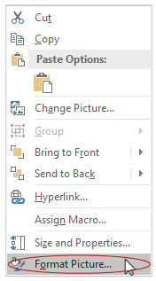
- Click on the Size & Properties icon.
- Expand the Alt Text section.
- Enter the alternative text in the "Description" field—NOT the "Title" field.
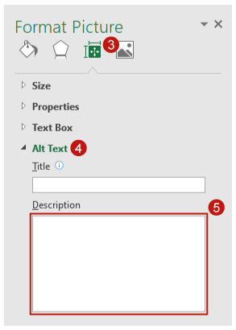


To add to an image in a newer version of Excel:
- Right-click on the image.
- Select Edit Alt Text:
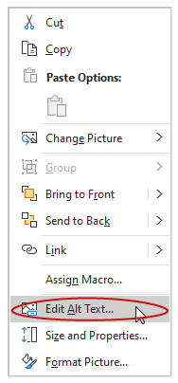
- Add the alternative text into the field that appears in the right sidebar.
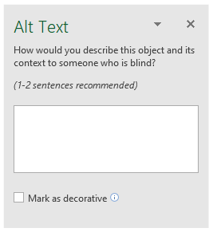

Links
In Excel, links may connect to:
- A webpage or a file
- A cell in the document
- An email address
At the bottom of the "Image & Links" sheet, there is a link to a webpage: webaim.org/projects/screenreadersurvey8.

Default Display Text
When I pasted this URL into a cell, and pressed "Enter", Excel automatically created a link. Often, a link's default display text may not make much sense by itself. In most cases, a link's default text should be replaced with text that is descriptive and easily understood the first time it is read or heard.

Adding Descriptive Link Text
The URL in our example document is fairly descriptive on it own, but I will change the display text to "Results from Screen Reader User Survey #8 at webaim.org" to increase the link's accessibility.


To replace a URL with more descriptive text:
- Right-click on the link.
- Select Edit Hyperlink:
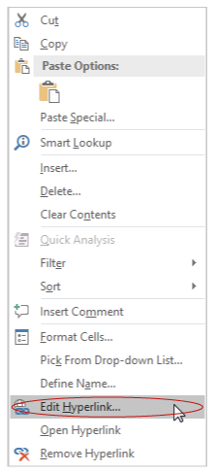
- Enter descriptive text in the "Text to display" field.
- Click "OK".
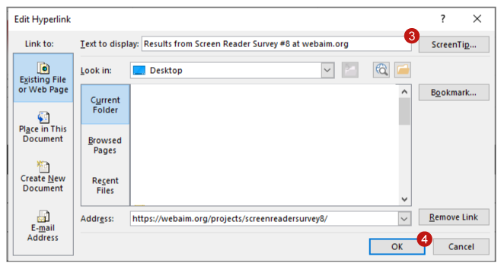

Hyperlinked Images
When an image is used to create a Hyperlink, the alternative text for that image should present:
- the purpose of the link
- the content of the image
Now that you have learned how to use Office's Alt Text to provide information about images that have content and/or function, you are ready to learn how to provide alternative text for images that contain large amounts of information.

