View original page on Canvas

Video

Example Files
- Creating-Accessible-Charts-Part-1 (.xlsx)

Guide

Creating Accessible Charts: Part 1
While images should generally not be used in Excel documents, Charts are a great way to provide a visual representation of data. Excel offers many different types of charts to choose from. In fact, in the latest versions of Excel there are nearly two dozen!
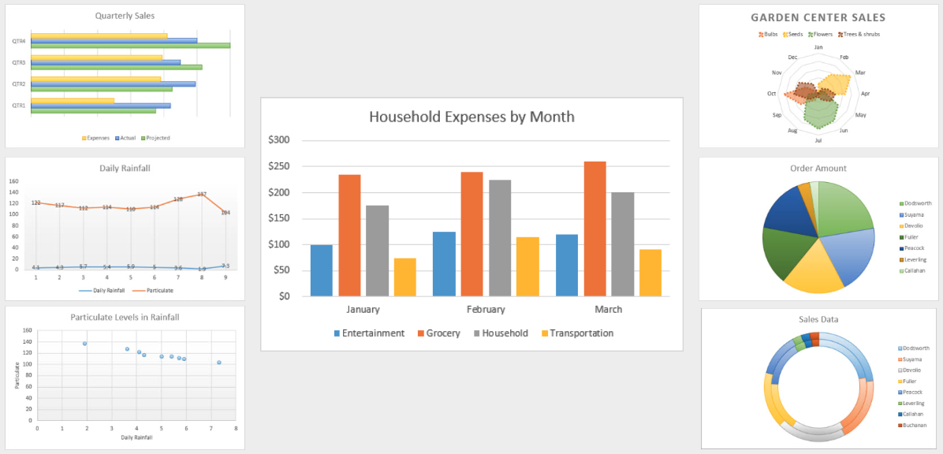
It is outside the scope of this course to review this broad spectrum of chart types.
There are many factors that may influence the type of chart you select, including the type of data you have, your purpose for a visual display of data, and your intended audience.
We have provided Resource Links on the page for this Section that can assist you in selecting a chart type.
This video and the next will focus on creating charts in Excel. A third video will cover using Excel charts in Word and PowerPoint. To minimize the length of these videos, I will NOT be demonstrating the following processes step-by-step:
- Changing the color of fonts.
- Identifying color values in Office on Windows and Mac.
- Using the WebAIM Color Contrast Checker.
- Adding an Alt Text value to a complex image.
If you are unfamiliar with any of these processes, please stop here and review the Contrast video and/or the Images: Part 3 video.
Over the next two videos, I'll review four keys for accessibility that you can implement with any type of chart. In this video, I'll cover the first two keys
- Provide the chart data in text format.
- Optimize the chart's default elements.
In the video that follows this one, I will cover the other two keys:
- Add data labels if needed.
- Follow accessibility principles for non-text chart elements.

Objectives
- State four keys for accessible charts.
- Identify two methods for providing access to a chart's data in text format.
- Describe one method for increasing a chart's whitespace.

Provide the chart data in text format
There have been significant advances in the accessibility of charts in the latest versions of Excel. Nonetheless, at this time—

The text of the data used to generate a chart is the most usable and reliable format for providing a chart's content to all users.
Presenting this data as text supports blind users, and screen reading software users, and it is often helpful to other users with and without disabilities.
All Excel Charts are generated from a range of data text. When appropriate, this data should be formatted as a table, as shown in the Sheets & Tables video. Data text should also be presented according to the requirements and recommendations presented in the Legible Documents, Contrast, & Color Reliance videos.
When possible, the chart data should be positioned so that it is easy to navigate to with the keyboard, and presented on the same sheet as the chart.
I'll open the example file in Excel 2016 running on Windows. On the "Spending on U.S. Pets by Type" sheet, the first element to receive focus is the table caption text in a cell that spans the four columns of the data table:
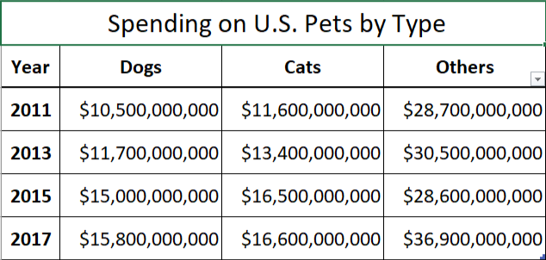
I'll switch to the "Data table after chart" sheet. The chart is the first element on this sheet. The data table is placed "after" it in the columns to the right:
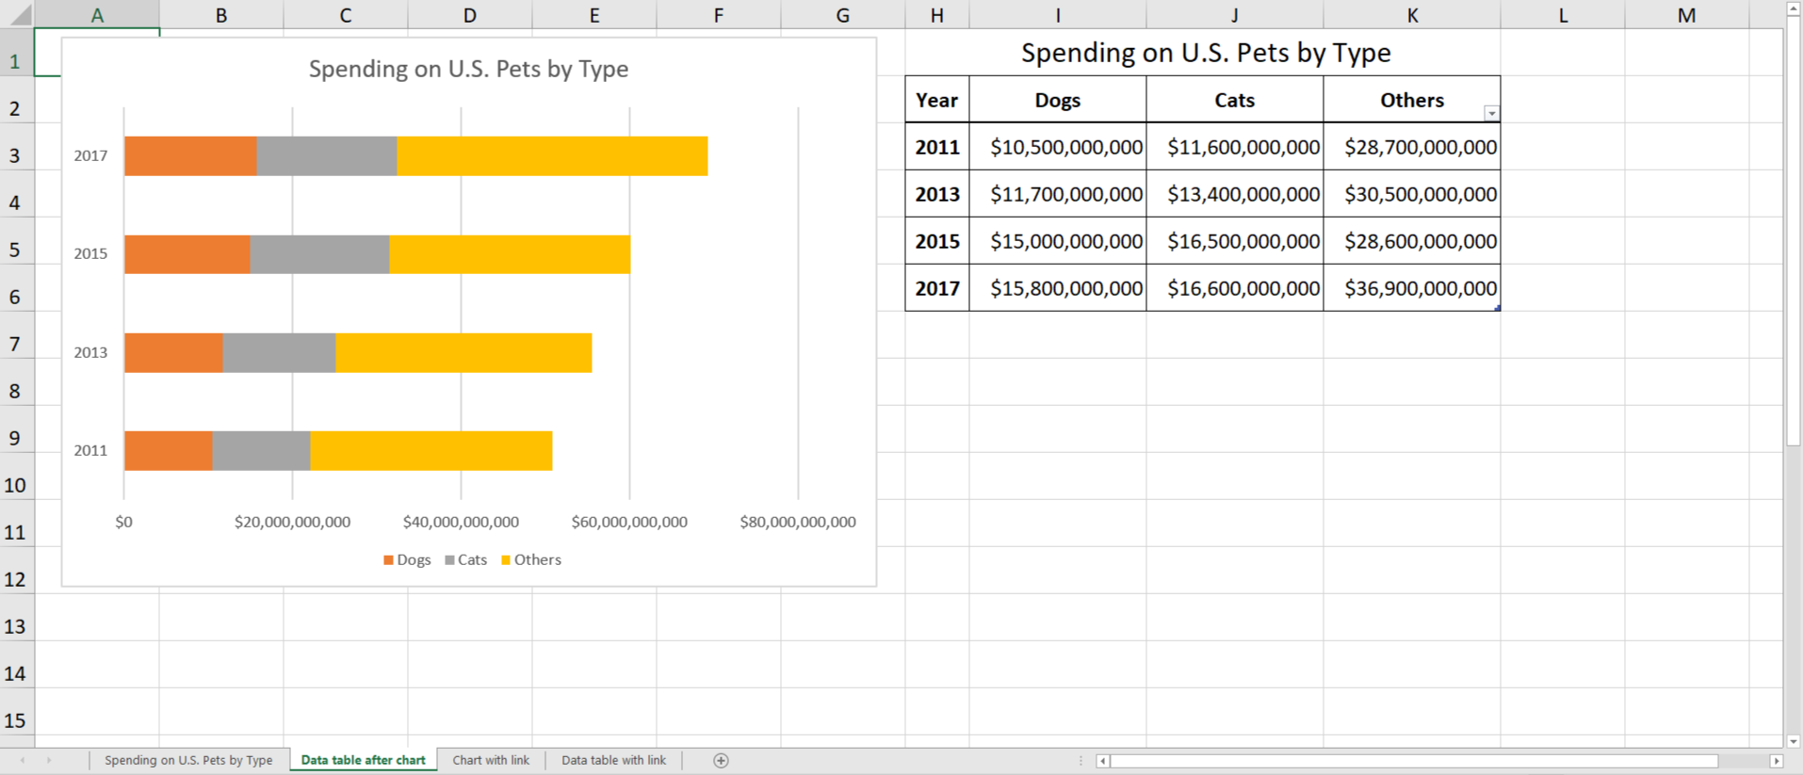

How would this presentation of a chart's data impact a keyboard user?
As you may recall from the Navigating in Excel video, charts are "floating elements". In this case, a keyboard user would have to navigate through a series of blank columns to access the data table.
For various reasons, it may not always be possible to place the chart data in the same sheet. When this is the case, we recommend placing a descriptive link to the data located in another sheet. I'll switch to the "Chart with a link" sheet in the example workbook. The first element on this sheet is a link with the text "chart data for 'Spending on U.S. Pets by Type'":
When I click on this link I am taken to the data table for this chart on a separate sheet. For the convenience of your users, you may want to provide a link back to the sheet with the chart. Below this data table there is a link with the text "'Spending on U.S. Pets by Type' chart":
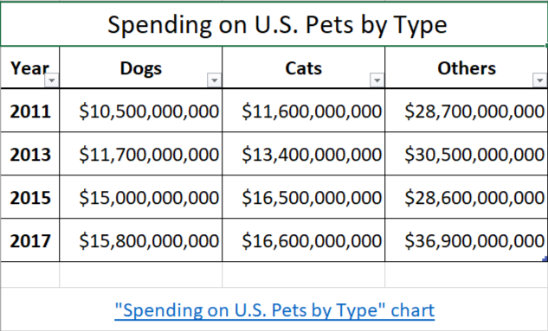

Optimize the chart's default elements
Next, I'll demonstrate some of the tools in Excel that are commonly used to optimize a chart's default elements. I'll also note some general principles for accessibility that can guide this process. There are often many variables to consider when optimizing charts. These techniques are just one approach to increasing the accessibility of an example chart.
I'll switch back to the "Spending on U.S. Pets by Type" sheet. This example is a stacked bar chart that shows the amount of spending on pets in three categories: Dogs, Cats, and Others:
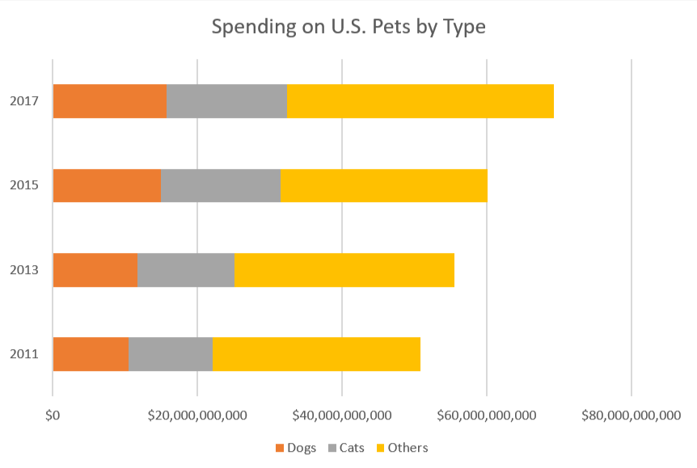
The default 9-point font used in many charts should be increased when possible. I'll navigate to the Hᴏᴍᴇ tab on the Ribbon, and use the "Font Size" dropdown to increase all text in this chart to a minimum of 10 points:
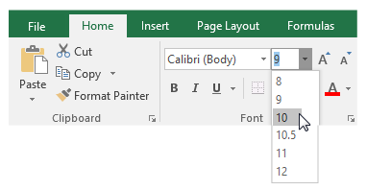
Although the default text in charts will often meet the requirement for contrast when the chart has a white background, check manually if you are unsure. Unfortunately, as I will cover in the next video, the default text for some charts will NOT meet the minimum contrast ratio with default colors for one or more shapes. Because this chart is being presented in a video, I'll increase the contrast for all of its text elements.

Display units tool
The data used to create this chart is in billions of dollars. In my opinion, the presence of nine zeros for each label on the horizontal axis is not a good use of the chart space, and may present too much visual information for some users. I'll address these issues by assigning a display unit to the labels.


To use the "display units" tool:
- Select the horizontal axis.
- Right click and select "Format Axis" from the menu.
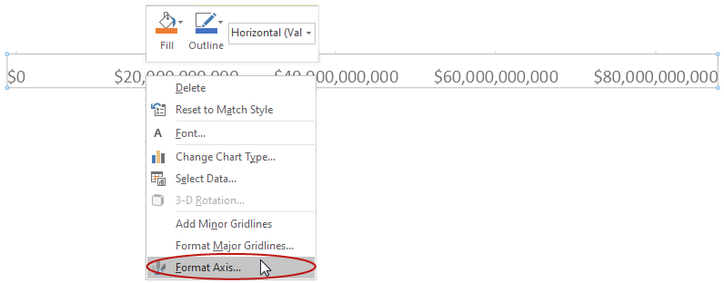
- On the "Axis Options" tab, select "Billions" from the "Display units" drop-down menu.
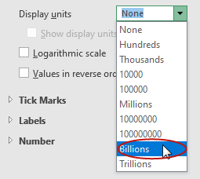
- Check the "Show display units label on chart" option if it is not already checked.
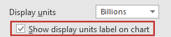
Nine zeroes have been removed from the labels on the horizontal axis, and a new label for this axis with the text value "Billions" has been added:
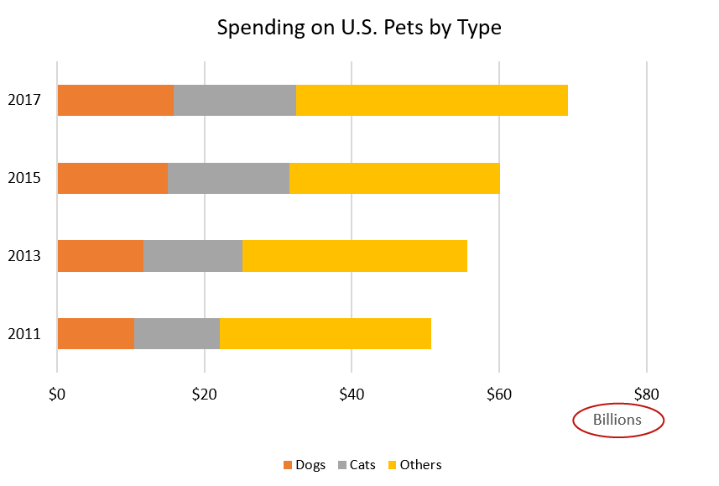
For lengthy non-numerical axis labels, consider using standard abbreviations.

Whitespace
All users benefit when there is sufficient whitespace between chart elements. The default position of a chart's elements may vary based on its type.
When a new element is added to a chart, its default position may often be improved upon.
For instance, the "Billions" label that was added to this chart has been placed near the bottom corner of the plot area. I'd like to increase the whitespace around it by centering it on the horizontal axis, above where the legend is now.
Rather than having this label stacked "on top" of the legend, I'll first reposition the legend to separate these two chart elements.


To reposition the legend:
- Select the legend.
- Right-click and select "Format Legend" from the menu.
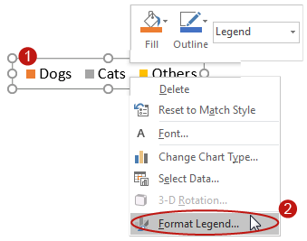
- On the "Format Legend" side panel, I'll click the "Legend Options" tab, and select a new "Legend Position" (for this example I'll select "Right").
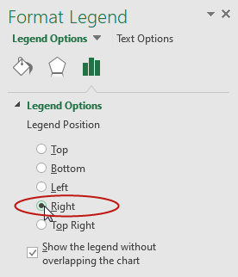
The "Show the legend without overlapping the chart" option is selected by default, so Excel resizes and repositions the chart's plot area automatically:
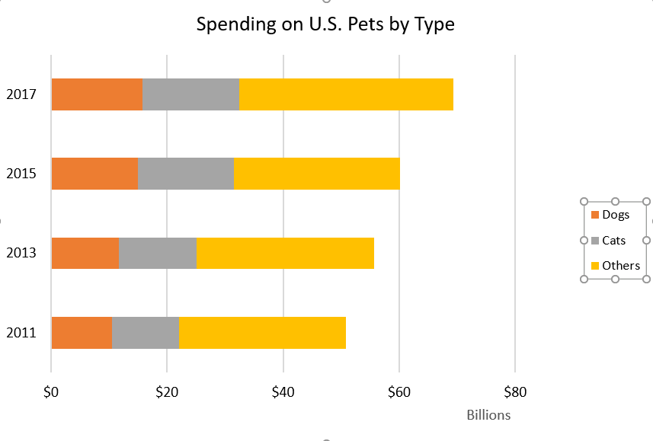
Next I'll center the "Billions" label on the horizontal axis by clicking and dragging it. I'll also increase the size and contrast of this label. Then I'll increase the whitespace between the vertical and horizontal axes, and the edge of the chart area, by decreasing the width and height of the chart's plot area.
When I hover over one of the plot area's corners, the mouse icon changes to a two-headed arrow, indicating that I can click and resize the plot area:
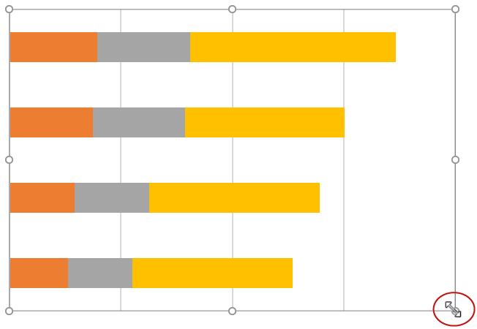
I'll click the plot area on the corner, and drag the corner toward the plot area's center. A dashed outline appears, indicating that the default elements associated with the plot area will also be resized proportionately:
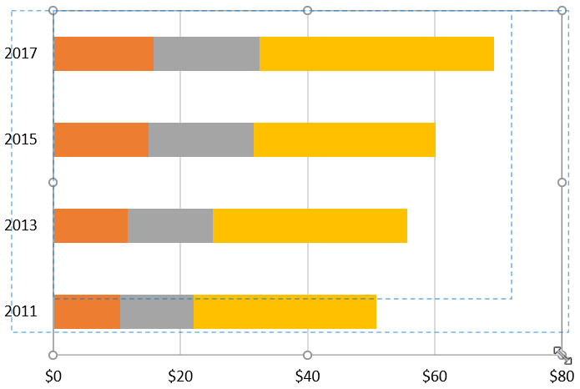
When I select the plot area away from its corners, a 4-way arrow is displayed with my mouse icon, indicating that I can click and drag the plot area:
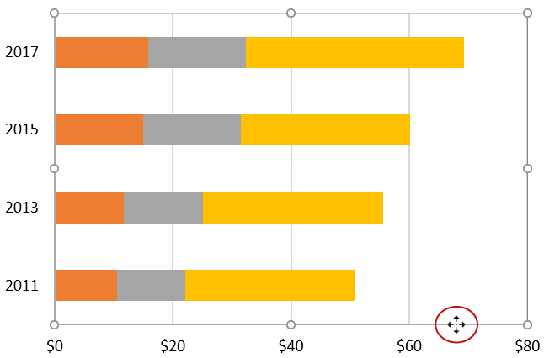
I'll move the plot area to a new location to evenly distribute the whitespace around it.
Finally, I will reposition the horizontal axis label that I added, and as well as the title and legend, so that they are all centered between the edge of the chart area and the plot area:
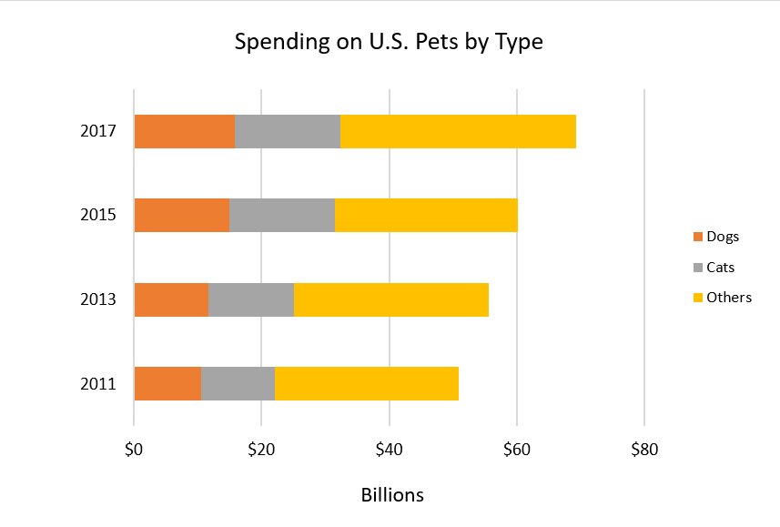
In the next video, I'll cover the two remaining keys:
- Add data labels if needed.
- Follow accessibility principles for non-text chart elements.

