View original page on Canvas

Video

Example Files
- Creating Accessible Charts: Part 3 (.xlsx)
- Creating Accessible Charts: Part 3 (.docx)
- Creating Accessible Charts: Part 3 (.pptx)

Guide

Creating Accessible Charts: Part 3
This video will cover how to use a chart that was created in Excel in a Word or PowerPoint file. I'll be using the stacked bar chart that was created in the first two videos in this section.
This video will NOT cover creating charts in Word or PowerPoint using the "Insert Chart" tool. If you decide to use this tool, the methods for inserting a chart and its data table into a destination file will be different from those shown in this video.
I'll be demonstrating with Office 2016 applications running on Windows. Where there is a difference in the user interface with these applications running on Mac, I'll point it out.

Objectives
- Identify the process for pasting an Excel chart into Word and PowerPoint.
- Identify the processes for pasting an Excel data table into Word or PowerPoint.
I'll open the example file in Excel 2016 running on Windows. I'll also open the Excel example file from the Part 1 video. When I compare the default chart and the finished chart side-by-side, I can review the changes that were made:
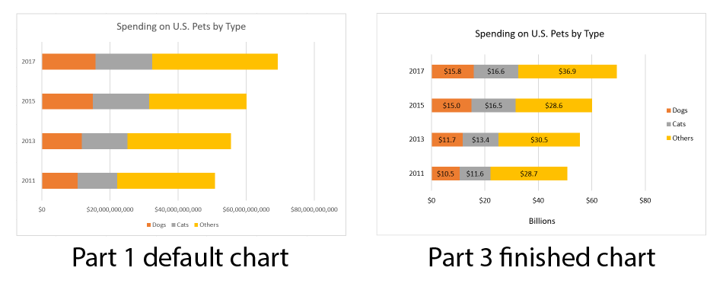
- Font size and contrast were increased.
- Data labels were added and number formatting for data text was applied to all labels.
- Chart information was simplified with display units;
- Label text was changed to a darker color to address insufficient contrast with yellow and orange sections of the data bars.
- Default elements were resized and relocated to increase whitespace.
If this chart were to be created using the "Insert Chart" tool, the Excel tools built into Word or PowerPoint would need to be used to implement the four keys to accessibility.

Source and Destination: Applications and Formatting
In this video, Excel is the source application and Word and PowerPoint are destination applications. When I copy elements from Excel, and paste them into Word or PowerPoint, I will have the option to select the formatting for these elements from the source application or the destination application. In this video I'll be pasting the chart and its data table with the "source" formatting. This will allow me to maintain a visual consistency between these elements in the source file and the destination files.

Paste the Chart into the Destination File

Word
I'll close the file with the default chart, and open the example file in Word 2016 running on Windows. I'll resize both applications so that the Word example and the Excel example are displayed side-by-side.


To paste a chart into a Word document:
- Make a space in the Word document.
- Select the Chart Area in Excel.
- Right-click and select "Copy" from the menu.
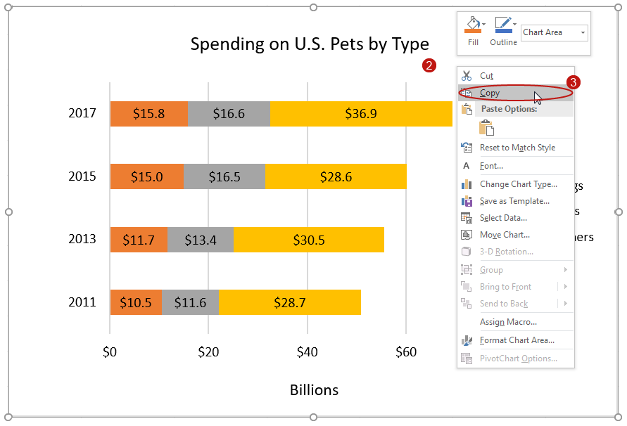
- Return to Word and click the Home tab on the Ribbon.
- Click the "Paste" tool.
- On the "Paste Options" menu, select "Keep Source Formatting and Embed Workbook".
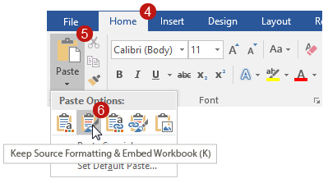
On Windows, on both Word and PowerPoint, the "Paste Options" menu has icons, and text is only displayed on mouse hover:
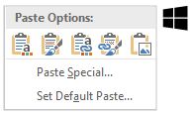
On Mac, on both Word and PowerPoint, both icons and text are displayed on the "Paste Options" menu:
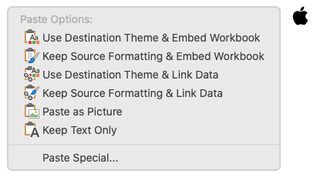
Please note that the chart's default "Wrap Text" style of "In Line with Text" must not be changed, as covered in the "Positioning Images" video.

PowerPoint
Next, I'll minimize Word, and open the PowerPoint example. I'll resize the PowerPoint example so that it and the Excel example are displayed side-by-side. I'll navigate to the "Spending on U.S. Pets by Type" slide.


To paste a chart into a PowerPoint presentation:
- Use a slide Layout with a Content Placeholder, and select the Content Placeholder.
- Select the Chart Area in Excel.
- Right-click and select "Copy" from the menu.

- Return to PowerPoint and click the Home tab on the Ribbon
- Click the "Paste" tool.
- On the "Paste Options" menu hover select "Keep Source Formatting and Embed Workbook".
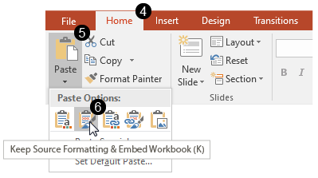
With my chart in place, I'm noticing a few issues. The chart's title duplicates the slide's title. Because the size of my chart is different from the size of my Content Placeholder, the chart has been "stretched" to fit, and the categories in the key are out of visual alignment. Also, the text in my chart is too small for this context.
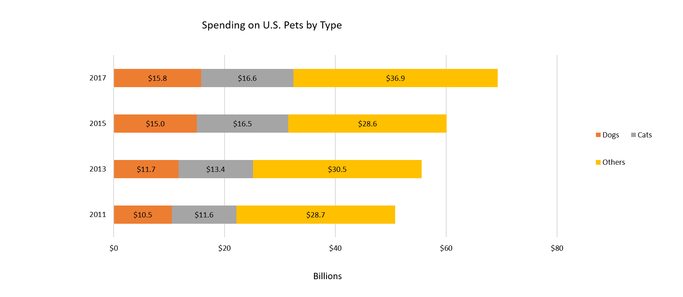
Normally I would have addressed these issues in Excel before I copied and pasted this chart, but I can make these changes directly to the workbook that I just embedded.
I'll right-click the Content Placeholder, select "Edit Data", and then "Edit Data in Excel". The embedded workbook opens in Excel in a window on top of my example files.


To resize a chart in Excel:
- Right-click the Chart Area and select "Format Chart Area".
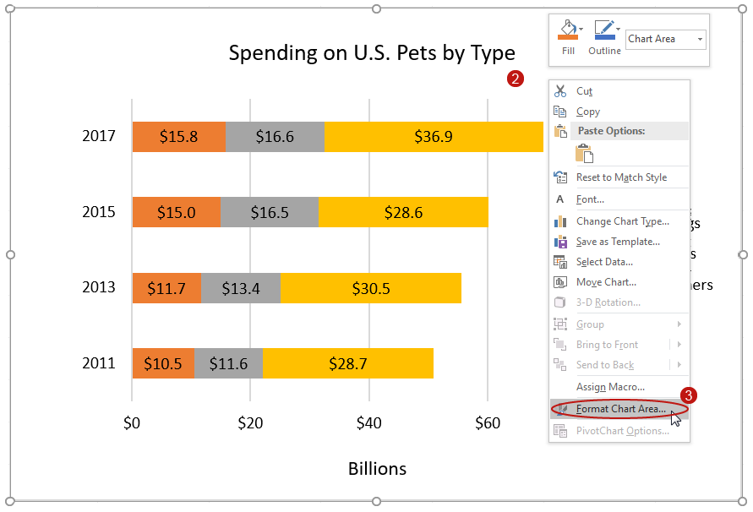
- Select the "Chart Options" tab on the "Format Chart Area" sidebar.
- Select the "Size & Properties" tab and expand the "Size" section.
- Type in the height and width values (for this example I'll type in 5 inches for the height and 11 inches for the width to match the size of the Content Placeholder on my slide).
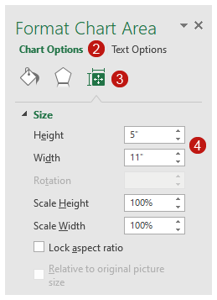
Next I'll delete the redundant chart title, increase the size of the text, reposition the chart's elements to evenly distribute the whitespace, and copy the chart. I'll return to PowerPoint, delete the existing chart, and paste in the new version.

Paste the Data Table into the Destination File
As we covered in the Part 1 video, at this time—

The text of the data used to generate a chart is the most usable and reliable format for providing a chart's content to all users.
In the Word example file I'll demonstrate pasting a data table nearby a chart. It's not always possible to place a data table nearby a chart, so in the PowerPoint example file I'll demonstrate how to provide access to the data table located on a separate slide.

Word
I'll close the Excel window where I edited the chart, minimize PowerPoint, and return to the Word example file.


To paste a data table into a Word document:
- Make a space in the Word document (when possible place the data table nearby the chart).
- Select the data table in Excel.
- Right-click and select "Copy" from the menu.
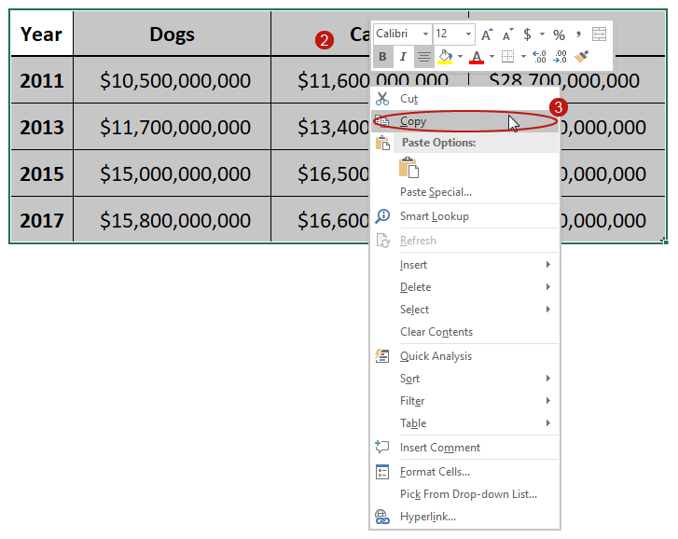
- Return to Word and click the Home tab on the Ribbon.
- Click the "Paste" tool.
- On the "Paste Options" select "Keep Source Formatting".
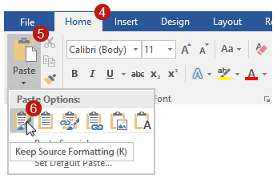

PowerPoint
I'll close Word and return to PowerPoint. In a presentation, try to locate a data table on the same slide as the chart, or on the next slide. But as I previously mentioned, sometimes this is not possible. For this example, I'll create a new slide at the end of the presentation for the data table, and give it the title "Appendix".


To paste a data table into a PowerPoint presentation:
- Use a slide Layout with a Content Placeholder, and select the Content Placeholder.
- Select the data table in Excel.
- Right-click and select "Copy" from the menu.

- Return to PowerPoint and click the Home tab on the Ribbon
- Click the "Paste" tool.
- On the "Paste Options" menu select "Keep Source Formatting".
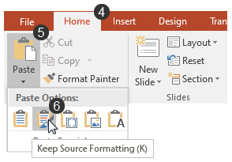
To provide access to the data table, I'll navigate back to the slide with the chart and create a link to the appendix. Following a standard convention for slides, I'll place the link at the bottom.


To insert a Hyperlink into a PowerPoint slide:
- Click the Insert tab on the Ribbon.
- Select the "Text Box" tool.
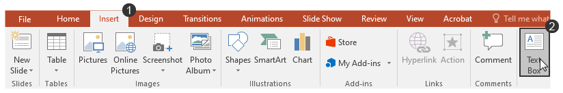
- Drag a shape for the text box location.
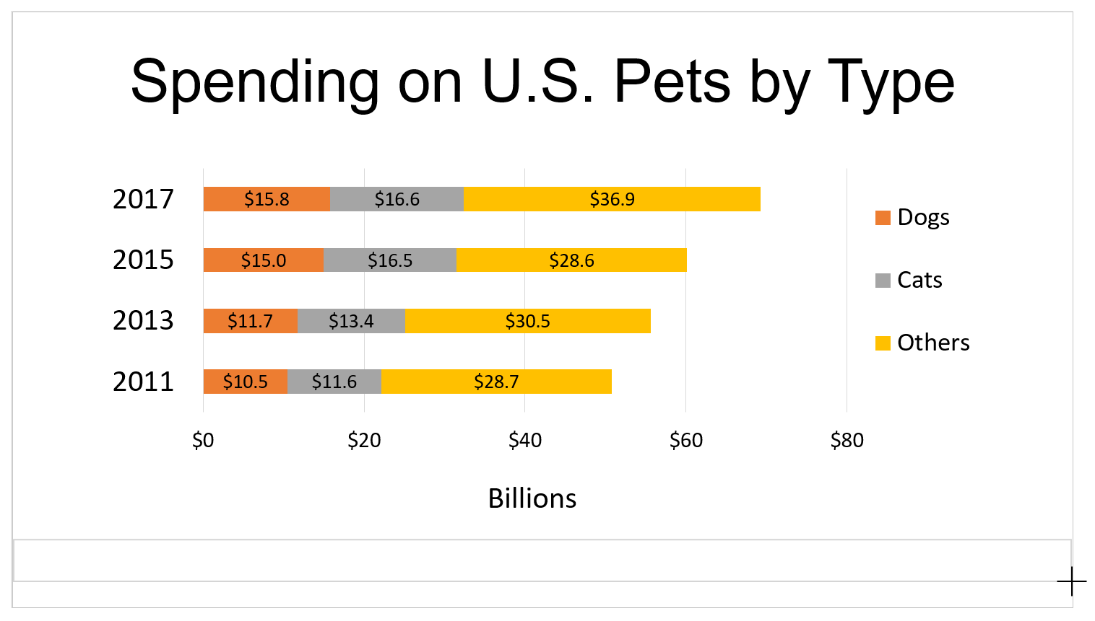
- Click the text box and type in descriptive link text (for this example I'll use "chart data for 'Spending on U.S. Pets by Type').
- Select the text, right-click, and select "Hyperlink" from the menu.
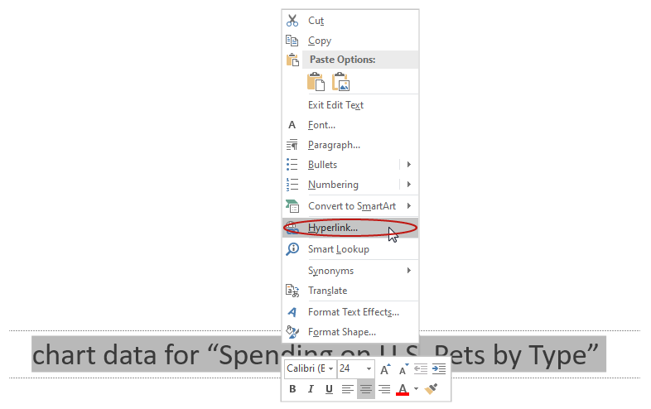
- On the "Insert Hyperlink" dialog, click "Place in This Document".
- In the "Select a place in this document" section, select the slide to link to (for this example I will select the "Appendix" slide).
- Click "OK".
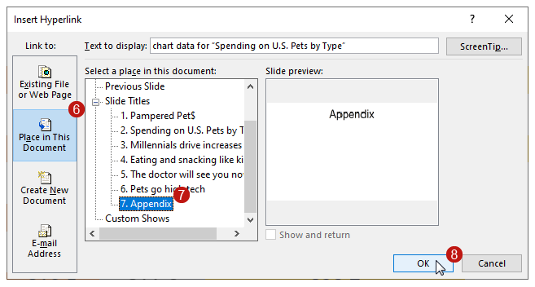
For the convenience of the presentation's users, I will repeat this process to insert a hyperlink back to the chart on the "Appendix" slide. For this return link I'll use the descriptive text "'Spending on U.S. Pets by Type' chart".
In the next video you will learn principles and processes for optimizing a workbook, the final step before evaluating a workbook's accessibility.

