View original page on Canvas

Video

Example Files
Optimizing Workbooks (.xlsx)

Guide

Optimizing Workbooks
In this video I will discuss some techniques for optimizing Excel workbooks. It is important to note that none of these techniques are specifically required to meet current web accessibility guidelines. In the same regard, whether or not a technique is appropriate for a workbook must be determined on a case-by-case basis. Use your best judgement based on the information you have about a spreadsheet's function and intended audience.

Objectives
- Identify the process for creating sufficient visual space around text.
- Describe when freezing a column and/or a row may be appropriate.
- Identify the process for hiding unused rows and columns.
- State the process for adding a workbook Title.

Visual Space Around Text
In a previous video you learned about legibility. For the purposes of this course it is defined as "...how easy text is to see and comprehend based on its visual presentation”. A common legibility issue in Excel workbooks is minimal spacing around text.
I'll open up the example file in Excel 2016 running on Windows. The "Visual Spacing" sheet should be open by default. This sheet shows a table with the default spacing for the columns and rows:
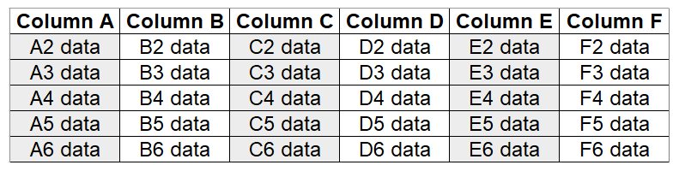
I'll switch to the "Freeze Top Row" sheet to demonstrate the impact of increasing the column widths and row heights:
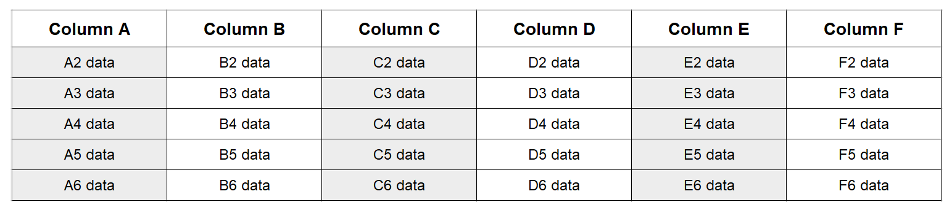
Some users will find this visual presentation easier to process. I'll switch back to the "Visual Spacing" sheet.


To increase the width of columns:
- Place focus on the populated columns by selecting their column labels.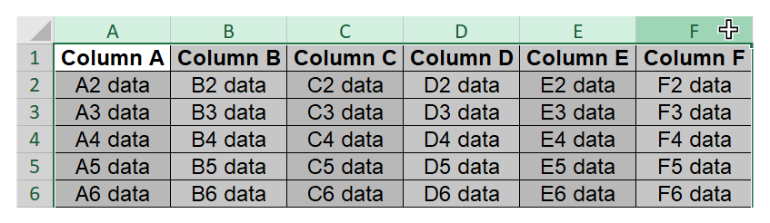
- Right-click on any selected column and select "Column Width" from the drop-down menu.
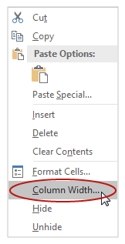
- Increase the numerical value in the "Column Width" dialog box (for this example I'll change the column width from "10 points" to "20 points").
- Click "OK".
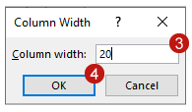
Because the populated rows extend beyond the visible area, I'll use a different technique to select them.


To increase the height of rows:
- Select the whole sheet with the keyboard shortcut Control + A.
- Right-click on any row label and select "Row Height" from the drop-down menu.
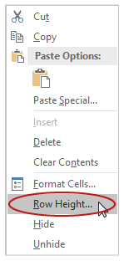
- Increase the numerical value in the "Row Height" dialog box (for this example I'll change the row height from "15 points" to "25 points") .
- Click "OK".
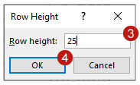

Columns & Rows
With some spreadsheets, managing how columns and rows function, and their visibility, will provide benefits for some users. I will demonstrate three techniques for managing columns and rows in Excel workbooks:
- Freeze columns and rows
- Hide unused columns and rows
- Delete empty rows
These techniques are applied at the sheet level, so the columns and rows in each sheet of a workbook must be evaluated separately.

Freezing Columns & Rows
When a sheet has populated columns and/or rows that extend beyond the visible area, a user must scroll with the keyboard or mouse to see all of the sheet's contents. In this circumstance we recommend that you use one or more of Excel's "freeze" tools.
I'll switch to the Vɪew tab on the Ribbon. In the fourth section from the left there are three "freeze" tools:
- Freeze Top Row
- Freeze First Column
- Freeze Panes
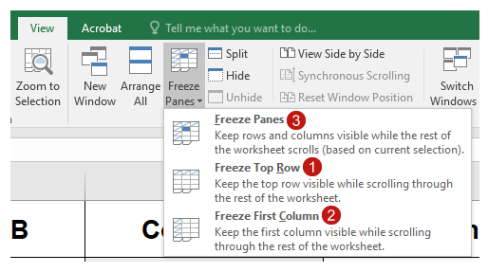

Freeze Top Row
I'll start working with the "Freeze Top Row" sheet. This sheet has a table with column headers, and rows of information that extend beyond the visible area:
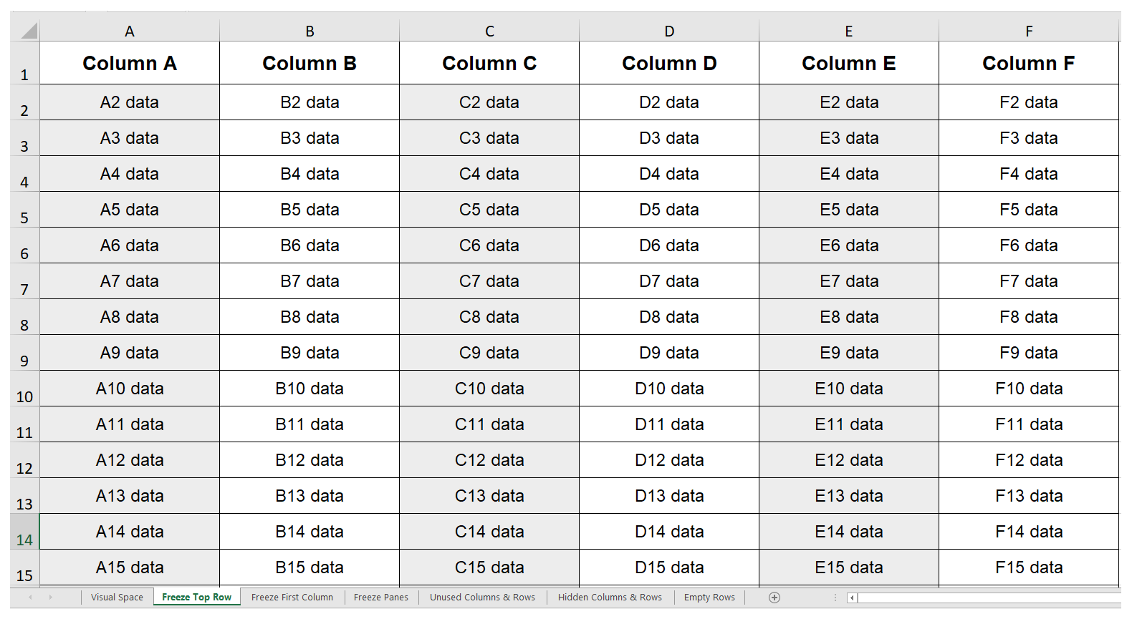
The column headers are labeled with generic text that corresponds to Excel's built-in labels: Column A, Column B, Column C, etc.—
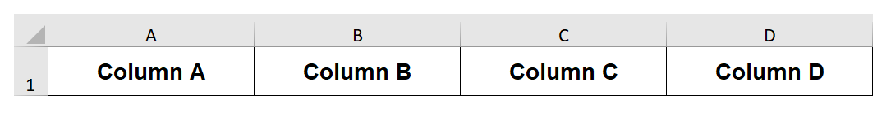
Starting at the left, the data cells are labeled: A2 data, B2 data, C2 data, etc.—
The same convention is used in the other sheets in this workbook.
When I scroll down to see the all the rows in the table, the column headers are no longer visible:
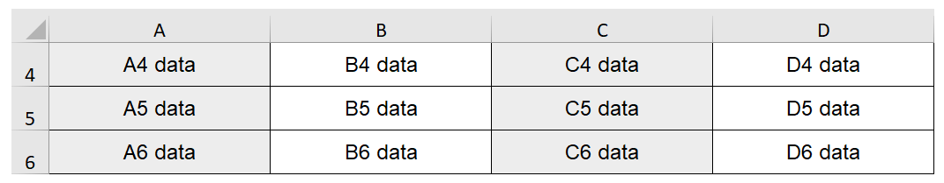
To prevent this, I'll click "Freeze Top Row" on the Vɪew tab on the Ribbon:
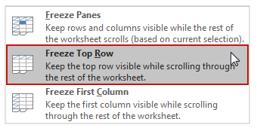
Now when I scroll down, the column headers remain visible and the rows appear to slide under them:
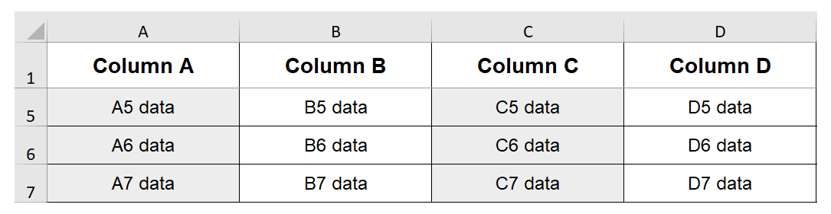

Freeze First Column
Next I'll click on the "Freeze First Column" sheet, which has a table with row headers, and columns of information that extend beyond the visible area:
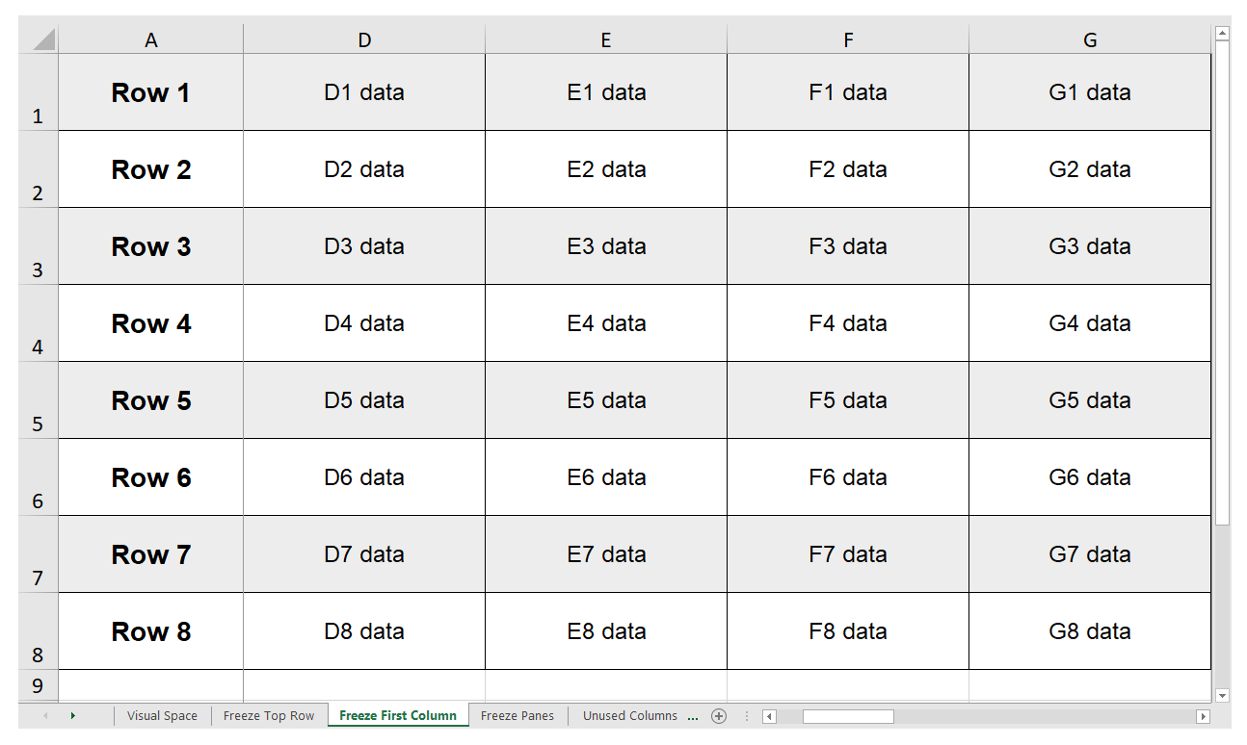
When I scroll across to see more columns, the row headers are moved out of the visible area:
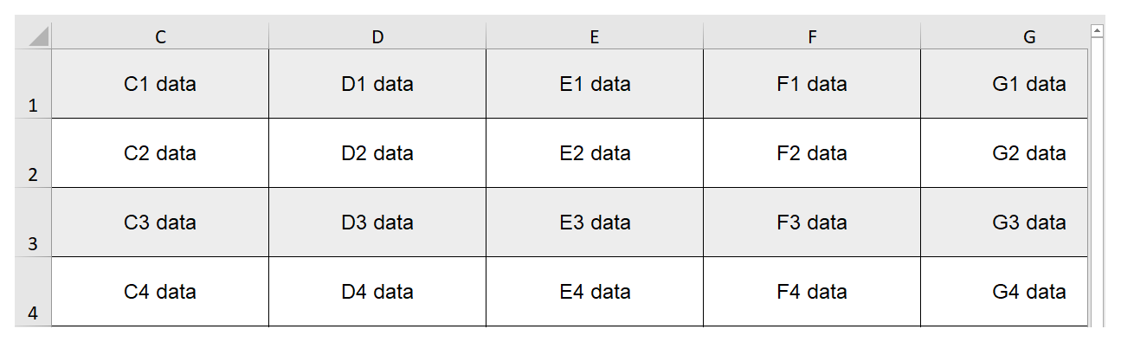
By returning to the View tab and clicking "Freeze First Column"—
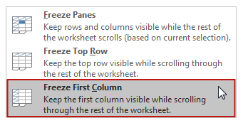
—the row headers remain visible as I scroll right—
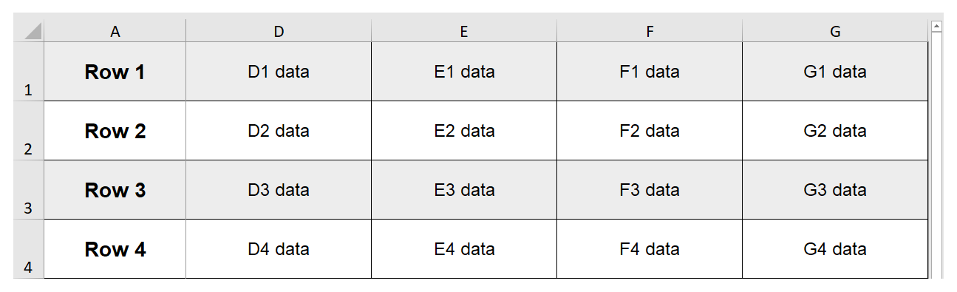

Freeze Panes
There may be times when you want to freeze more than one column and/or row at a time. I'll click on the "Freeze Panes" sheet. This sheet has descriptive text—"Freeze Panes"—in the upper-left corner, which in this case is cell B1, in the first row of the sheet. The column headers are in cells B2 to Z2, in the second row of the sheet, so I'm going to freeze the first two rows:
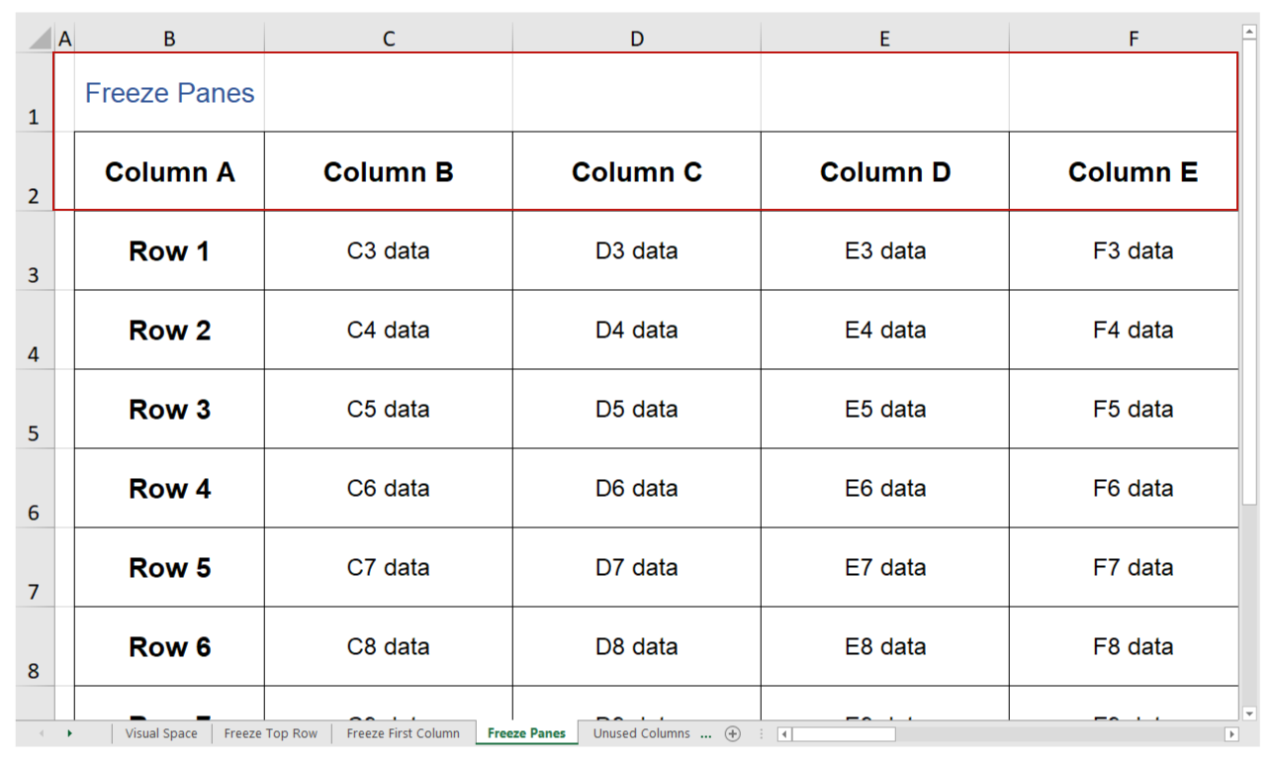
The first column of this sheet has been left empty to provide some visual spacing for the table. There are row headers in cells B3 to B10 in the second column of the sheet, so I'm also going to freeze the first two columns:
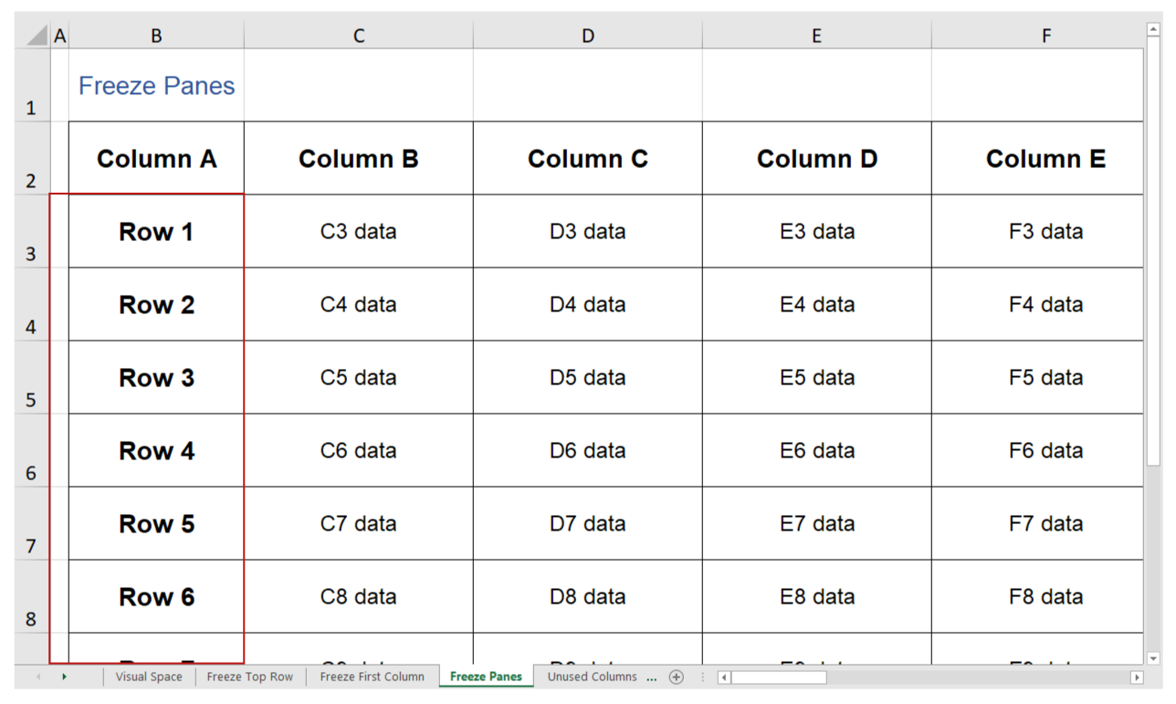


To freeze more than one column and/or row:
- Place focus on the first data cell (in this example, the first data cell is located at C3 and has the text "C3 data").
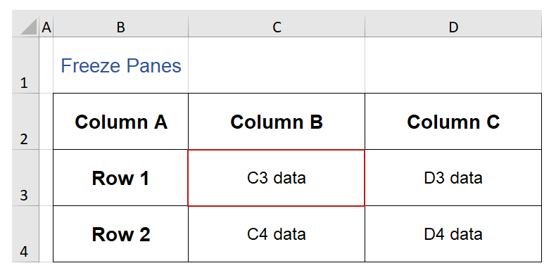
- Click "Freeze Panes" on the View tab.
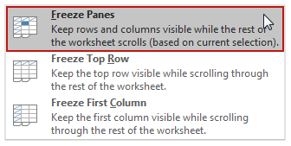
Now, when I scroll vertically or horizontally, the two columns and rows of interest remain static.

Hiding Unused Columns & Rows
By default, a new Sheet has more than sixteen thousand blank columns and over a million blank rows. The visual information created by the borders of the cells in unused columns and rows may be distracting for some users. This would include users with some cognitive or learning disabilities, which is the largest category of disability.
I'll open the "Unused Columns & Rows" sheet. Compare the difference between this table surrounded by empty cells—
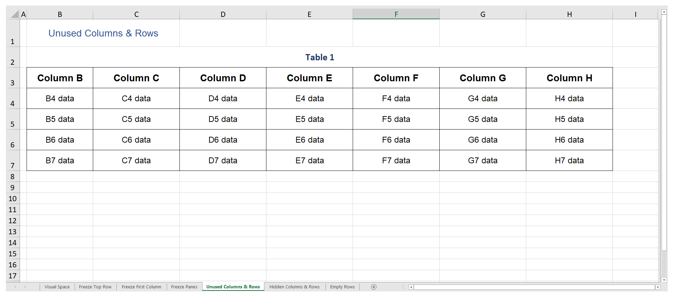
versus that same table in the "Hidden Columns & Rows" sheet where the unused columns and rows have been hidden—
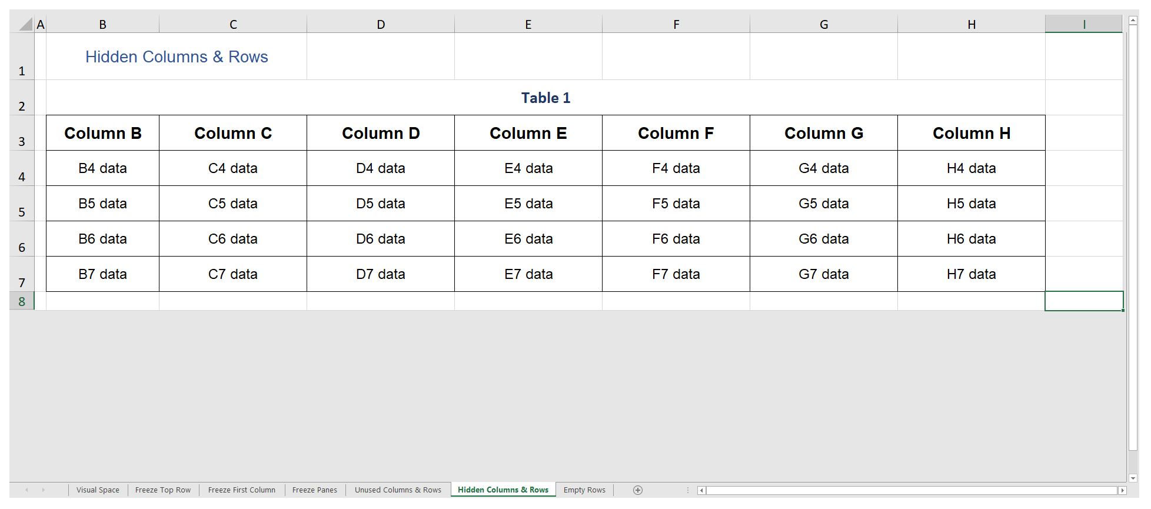
If you will not be continually adding information to a spreadsheet, consider hiding unused columns or rows as part of the optimization process. I'll return to the "Unused Columns & Rows" sheet.


To hide multiple unused columns:
- Select the first column to hide by clicking on it.
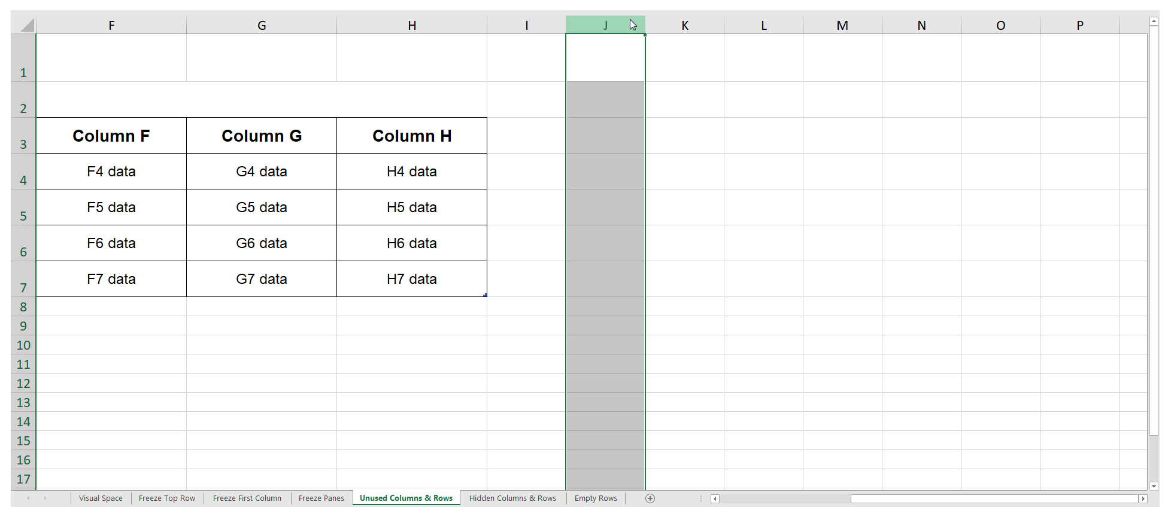
- Select the remaining default columns with a keyboard shortcut: Shift + Control + right arrow.
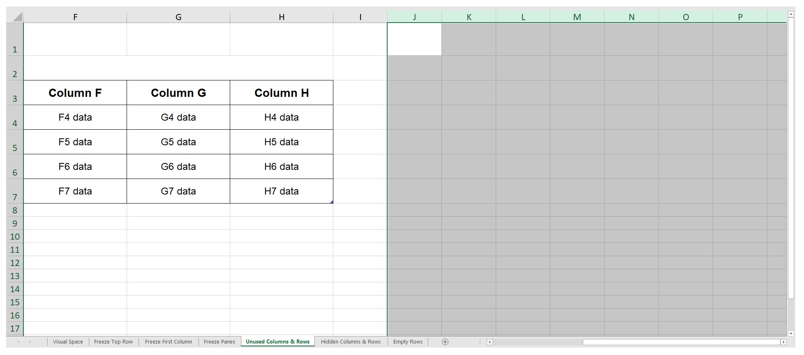
- Right-click on any highlighted column label and select "Hide" from the menu.
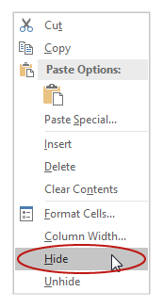

To hide multiple unused rows:
- Select the first row to hide by clicking on it.
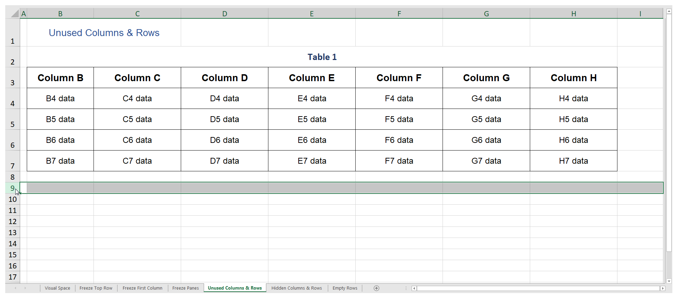
- Select the remaining default rows with a keyboard shortcut: Shift + Control + down arrow.
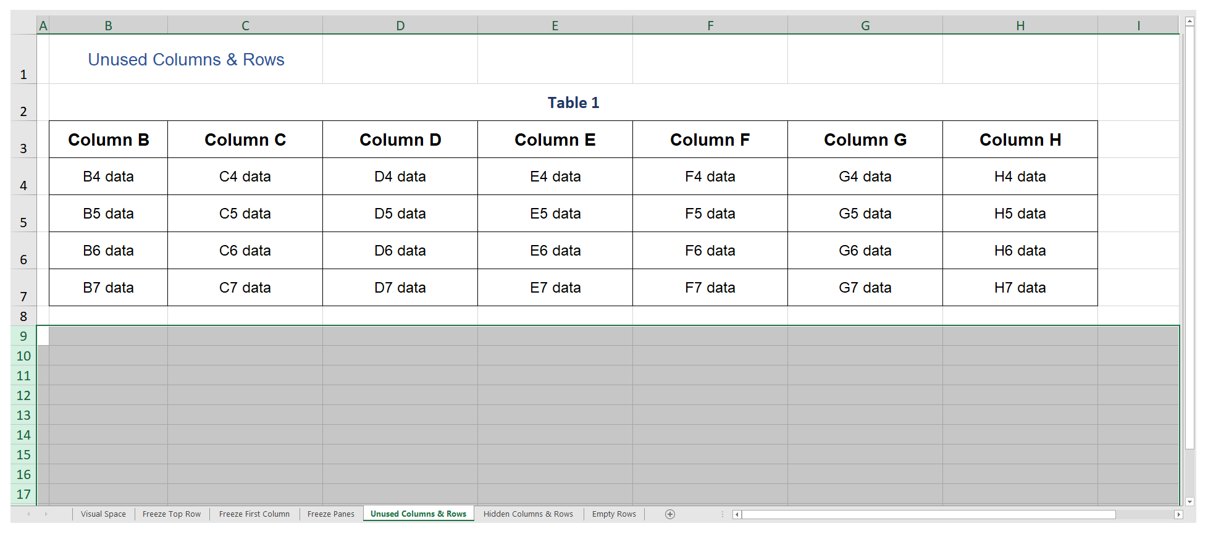
- Right-click on any highlighted row label and select "Hide" from the menu.
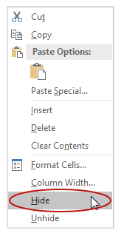
If I need to unhide all rows or columns, I'll select the entire sheet by clicking where the columns and row labels meet in the top-left corner right-click—
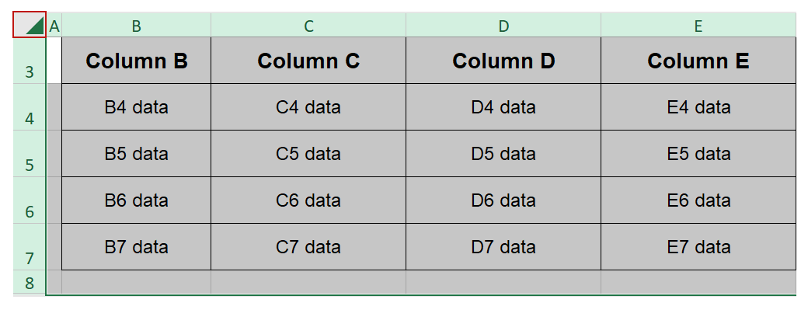
either the columns or the rows, and select "Unhide":
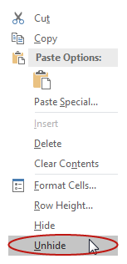

Eliminating Empty Rows
Another potential issue is the presence of empty rows between elements on the same sheet. I'll click on the "Empty Rows" tab. On this sheet, there are two tables with generic labels—"Table 1" & "Table 2". The unused columns and the unused rows at the bottom have already been hidden. But there are six empty rows between the last row on Table 1, and the label for Table 2:
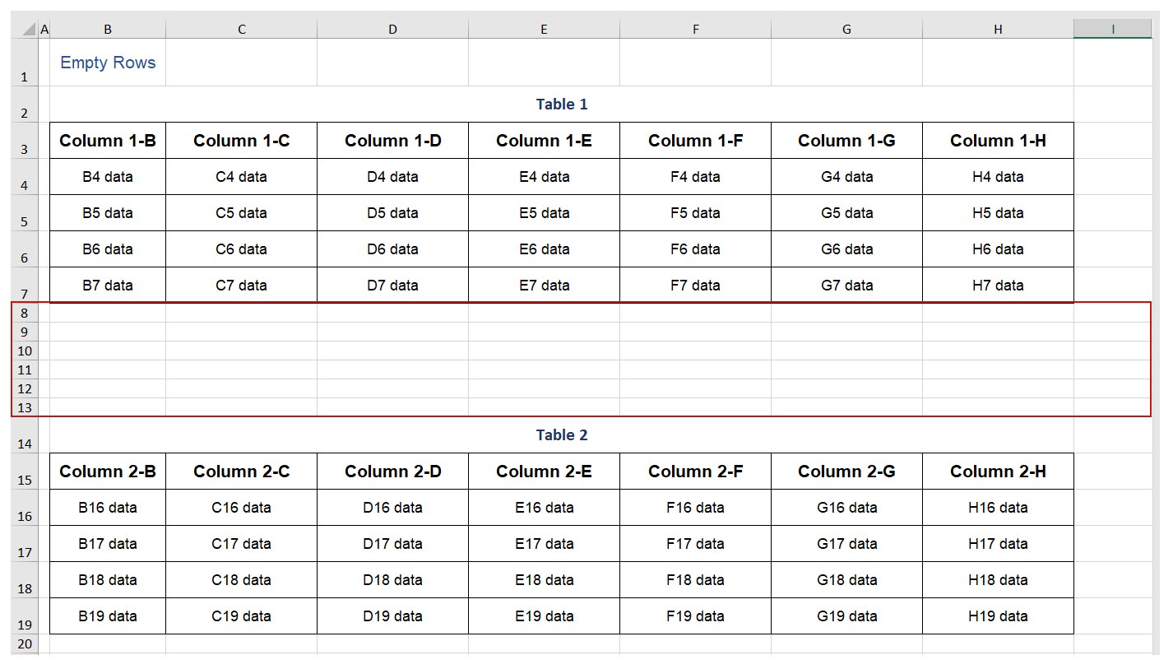
A screen reading software user encountering a series of empty rows may mistakenly assume that there is no more content on this sheet. I'll select and delete all but one row between elements on the same sheet:
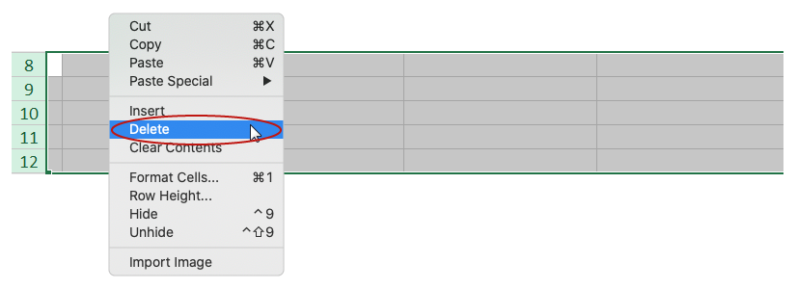
Leaving one row between elements as a way to provide some visual space is common and appropriate practice.

Adding a Workbook Title
Adding a Title provides metadata describing the workbook's contents. This information is required if the workbook will be exported to PDF.

To add a Title on Windows:
- Click the Fɪʟᴇ tab on the Ribbon.
- Select "Info" from the sidebar.
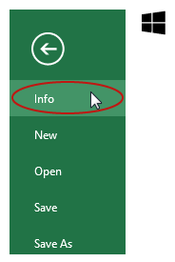
- Add the Title text in the "Title" field in the Properties section (for this example I'll enter the text "Optimizing Workbooks examples).
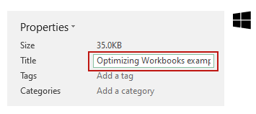

To add a Title on Mac:
- Click on File from the application menu, and select "Properties".
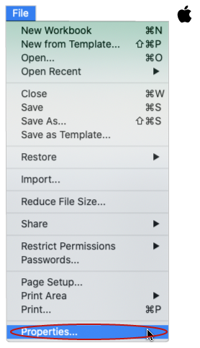
- Click on the "Summary" tab of the document properties dialog.
- Add in the Title text.
- Click "OK".
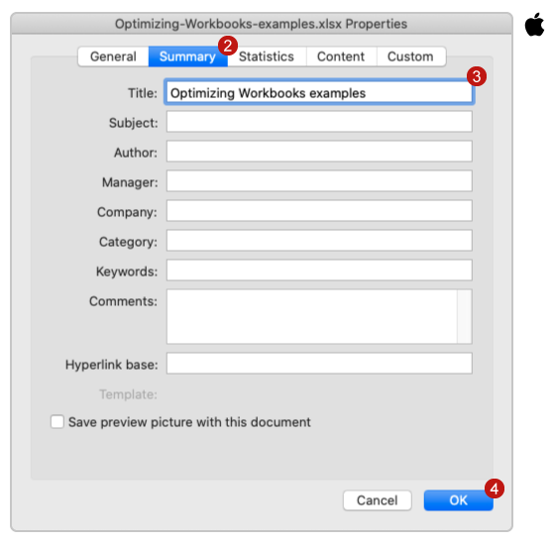
In the next video, I will demonstrate how to use the built-in Accessibility Checker and a manual checklist to evaluate the accessibility of your workbooks.

