View original page on Canvas

Video

Example File
- Evaluating Accessibility in Excel (.xlsx)

Checklist
- Excel Accessibility Checklist (.pdf)

Guide

Evaluating Accessibility in Excel
In this video, I will demonstrate how to use the Accessibility Checker in Excel. I will run the checker on an example file, and examine the Inspection Results. I'll also introduce WebAIM's Evaluation Checklist for Excel, and invite you to use it to find issues in the example workbook.

Objectives
- Identify the processes for running the Accessibility Checker in Excel.
- State the Accessibility Checker Error associated with images and charts.
Excel has a built-in checker that will identify accessibility issues, and potential issues. The process for starting the checker is different on Windows and Mac. I'll demonstrate both processes, starting on a computer running Windows.

Starting the Checker


To open the Accessibility Checker on Windows:
- Select the File tab.
- Click "Check for Issues".
- Select "Check Accessibility
from the dropdown options.
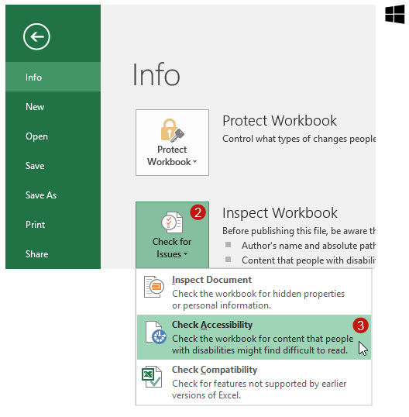


To open the Accessibility Checker on Mac:
- Select the Rᴇᴠɪᴇᴡ tab on the Ribbon.
- Click "Check Accessibility".
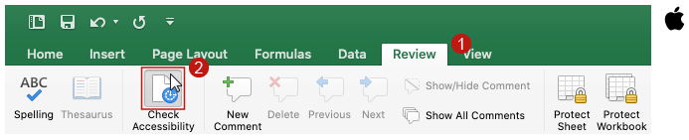
The "Check Accessibility" tool has also been added to the Rᴇᴠɪᴇᴡ tab on newer versions of Windows Office applications:
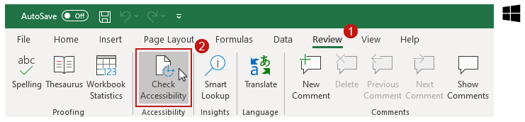
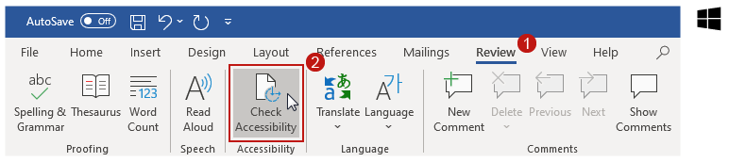
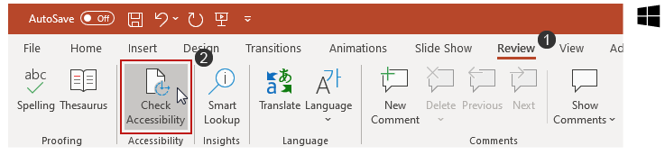

Accessibility Checker Rules
The Accessibility Checker in Excel has the same functionality and rule set for classifying issues as other Office 2016 applications. This information is covered in the Evaluating Accessibility video in Module 3. You may want to review this information before I discuss the Inspection Results for the example file.

Due to the nature of the issues in the example file, many of them will not be identified by the built-in checker.

Inspection Results
I'll open the example workbook in Excel 2016 running on Windows. I'll make sure the "Example #1" sheet is open, and run the checker.
In the Inspection Results, there are three "Missing Alt Text" Errors listed:
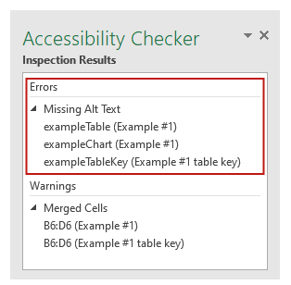
Two of the Errors are for the same table (one instance on the example sheet, and the other on the key sheet). This Error has been removed from the checker in the latest versions of Office because tables do not require Alt Text, so these two Errors can be disregarded. The third "Missing Alt Text" Error is for the chart, and this Error should be addressed as shown in the Creating Accessible Charts: Part 2 video.
There are also two Warnings about merged cells on cells B6:D6 (again, one instance on the example sheet, and the other on the key sheet):
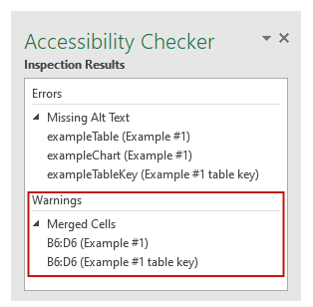
These cells contain the text "PDF Issues", and function as a caption for the table that starts on the next row. As you learned in Sheets & Tables video, merging caption text across the columns of a table is appropriate, so this issue can be disregarded.

Using the Manual Checklist
Next, I'll open our Evaluation Checklist for Excel. The checklist groups accessibility issues into a series of categories such as Tables, Links, and Charts. The information for each category is organized into a table with three columns: principles, review, and repair—
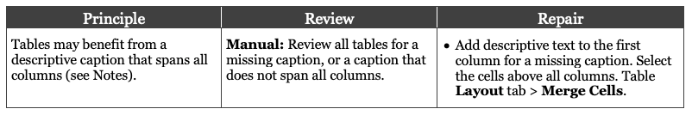
As you review the checklist, you will notice that most of the accessibility issues in our evaluation checklist will not be detected by the Accessibility Checker. That being said, because an error like a chart with missing alternative text may have a severe impact on users, and running the built-in checker takes very little effort, we recommend doing it every time.

Find the Remaining Issues
The Example #1 worksheet has seven issues. One issue has been identified, and we invite you to use the Evaluation Checklist to identify the remaining issues. When you are ready to check your work, there are two "key" sheets that you can review, one for the table, and the other for the chart. These "keys" identify the issues and provide the steps for repairing them.
As you have seen throughout the videos for this module, many elements used in Excel have accessibility issues by default. Fortunately, as you gain experience implementing the principles and processes for accessible workbooks, there will be less issues for you to address in this final step.

