View original page on Canvas

Video
[Video: Course Orientation (08:04)]

Guide

Course Orientation
Welcome to the Accessible Documents: Word, PowerPoint, & Acrobat course. In this video, I'm using the Chrome browser to interact with the Canvas learning management system. Canvas is optimized for Chrome. If you use a different browser, some parts of the user interface may have a different visual appearance than the one shown in this video.
This video will cover three main topics:
There is a new sentence here.
- Canvas's user interface
- Start Here activities
- Course Design

Canvas's User Interface
Canvas's user interface is divided into two parts. The main content area, and the course navigation menu, located on the left side of the interface.

Main Content Area
Each time you open the course you will see the "Home" page—where I am right now––displayed in the content area. The Home page has links to the "Start Here" activities, Modules 1 - 4, and Module 5, which is a bonus module. At the bottom of this page is the WebAIM logo. At webaim.org you can learn more about our organization, and access many accessibility resources.

Course Navigation Menu
The Course Navigation Menu has two links: Home and Grades.

Home
The Home button is a handy way to navigate back to the main page from other parts of the course.

Grades
I'll click the "Grades" link to display the page where your scores will be posted as you complete quizzes and exams. There is a widget that will allow you to determine the display order for these assessments. This "Arrange By" filter is set to "Due Date" by default.
To display your quizzes and exams in the order in which you will take them, you'll need to

Change the filter by:
- Clicking the filter tool.
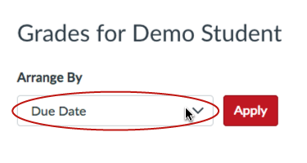
- Selecting "Assignment Group" from the drop-down list.
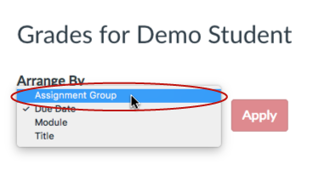
- Clicking the "Apply" button.
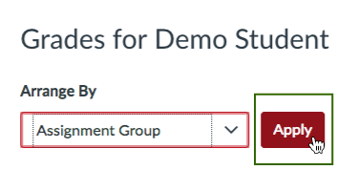
I'll use the Home link to return to the main course page.

Start Here Activities
There are three "Start Here" activities that you must complete in order to unlock the course modules:
- Course Orientation
- Course Details
- Terms of Use
Because you are watching this video, you are well on your way to completing the Course Orientation.

Course Details page
After you have finished the Course Orientation, read the Course Details page for important information on:
- Course Dates
- Course Design
- Software Requirements
- Course Resources
- Certificate of Completion

Certificate of Completion
A Certificate of Completion can be earned by meeting the following criteria:
- All Section Quiz scores are 100%.
- All Module Exam scores are 80% or higher.

Earned Certificates
There is a grading item called "Certificate of Completion Status."
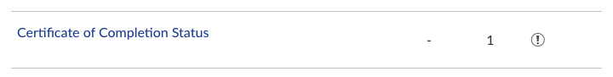
After the fourth week of the course, each participant's grades will be reviewed periodically. When a participant has met the quiz and exam score criteria, their status will be marked as "Earned."
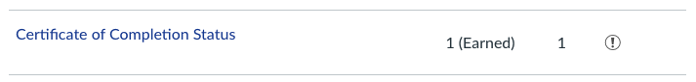
Certificates will only be issued for participants that have earned them BEFORE an issue date.
When you have finished reviewing the Course Details page, use the inline "Next" button at the bottom of the page to go to the final Start Here activity—reviewing and accepting the Terms of Use.

Terms of Use page
You will need to accept the Terms of Use before you can start on Module 1. First, carefully read through the information provided on the page. You will accept the Terms of Use by completing a quiz. I'll click on the Terms of Use quiz link and use the same procedure that I demonstrated for the Course Certificate Request quiz. I'll click the "Return" button in the upper-left corner of this results page, and then click the Home link. Module 1 is now unlocked, so I'll click its link on the Home page to view it.

Modules
Module pages have three parts:
- Objective
- Sections
- Exam

Objective
The Module 1 Objective is: "Review basic principles and processes for optimizing the accessibility of document content in Microsoft Word and PowerPoint." Each Module has several topic-based Sections. I'll click on the "Section 2: Images" link to view a Section page.

Sections
Most Section pages have four parts:
- Objectives
- Learning Activities
- Resource Links
- Quiz

Objectives
The section's objectives are listed in the order that they are covered in the Learning Activities. Section objectives identify core concepts that will be measured in quizzes and exams.
Next, I'll click on the "Images: Part 1" link to view a Learning Activity page.

Learning Activities
Most Learning Activity pages have three parts:
- Video
- Example File(s)
- Guide

Video
Videos are viewed through an embedded player. Start the video by navigating to the "Play clip" button through the keyboard and pressing "Enter", or by clicking with the mouse. The player has controls for volume, video speed, quality settings, and entering full screen mode. As the video plays, its quality setting will be adjusted automatically according to your connection speed. All videos have "open captions"—text information that is displayed in a black band at the bottom of the video.

Example Files
Next on the page, a link to any example file, or files, is provided. Clicking on a file's link will open the document in an embedded viewer. You can click the "Download" link on the document viewer to save a copy to your computer. On the Learning Activity page, another option is to click the image with the down arrow after the file's link to download the document.

Guide
The Guide functions as a transcript for the video, and features graphic elements, as well as links to any course content that is referenced. Step-by-step instructions are provided for any process demonstrated in a video. At the top and the bottom of a Learning Activity page there are buttons to return to the section page. I'll click one of these buttons to return to the Section 2 page.

Resource Links
Some sections have Resource Links. These are links to external resources related to the Section's content. For example, Section 2 has links to information from Microsoft.

Quiz
You must complete ALL of a section's learning activities before you take the section's quiz. In this case, after completing the "Images: Part 2" and "Images: Part 3" learning activities, I would click the "Next" button at the bottom of the page to take the quiz for Section 2.
All Section Quizzes:
- Are open notes—you may use any resources that you have developed
- Have between four (4) and eight (8) multiple-choice questions that assess your mastery of the section's objectives
- Are timed—six (6) minutes per question
- Require a score of 100% to earn a certificate
- Unlimited attempts
To start this Quiz, I'll click on the "Take the Quiz" button. For this demonstration, I'm going to select the first answer for each question. After I have answered all of the questions, I'll click the "Submit Quiz" at the bottom of the page. Canvas shows me which questions I answered incorrectly:
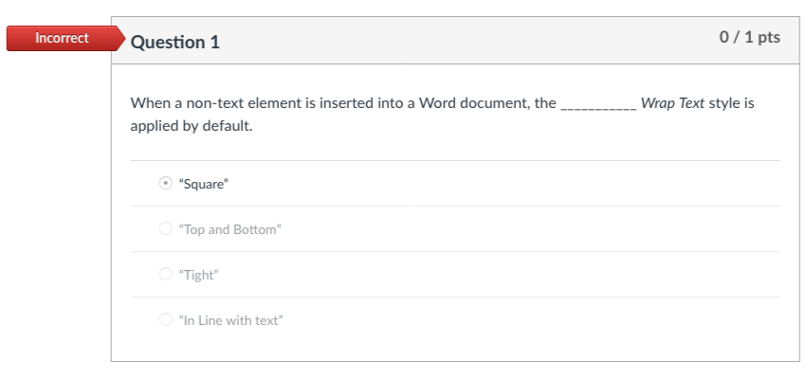
Because I want to answer all the questions correctly before moving on to the next section, I will need to retake this quiz.
Once you have completed all of the Section Quizzes, you will take the Module Exam. I will use the inline "Next" buttons to skip past Sections 3, 4, & 5—and their quizzes—to reach Exam 1.

Exam
All Module Exams:
- Are open notes
- Have ten (10) multiple-choice questions that have been selected at random from each of the module's section quizzes
- Are timed—six (6) minutes per question, for a total time of sixty (60) minutes
- Require a score of 80% or better to earn a certificate
- One retake
Now that you have completed the Course Orientation, you are ready to move on to the Course Details page. If you're ready to do that now, scroll past the guide for this video, and click on the "Next" button at the bottom of the page.

