Installation instructions for RTC-Tools on Windows computers
  - Bernhard Becker, Deltares

Introduction
RTC-Tools is a Python package. You can start RTC-Tools from a Python installation on your computer. Python 3.9 is the recommended version, other versions might result in conflicts with solvers:
- Python 3.9:
https://www.python.org/downloads/
Alternatively, we have a compiled a self-containing WinPython package.
Furthermore, we have some third-party software that we use to visualize the RTC-Tools models, the code, and the results:
- Veusz, a scientific plotting package:
https://veusz.github.io/download/
- OpenModelica Connection Editor to visualize and to edit the model schematization:
https://openmodelica.org/
- PyCharm (community version) to edit Python code:
https://www.jetbrains.com/pycharm/download/download-thanks.html?platform=windows&code=PCC

Installation von RTC-Tools

Option 1: Use the WinPython package.
If the WinPython package is included in your RTC-Tools training material, you’ll find this folder on the same level as the RTC-Tools model:
Python_3910_casadi356.zip
Extract this to
Python_3910_casadi356

Option 2: Installation in a virtual environment with the help of batch file

Modify the batch file for installation of RTC-Tools
The batch file
InstallRTC-Tools.bat
is located in the same directory as this document. This batch file installs RTC-Tools in a virtual environment. Python 3.9 must be installed on the computer (see Section 1).
Look for the path where Python is installed on your computer.
Open the batch file
InstallRTC-Tools.bat
in a Text editor. The batch file looks as follows.
cd ..
echo(
@echo Installation of Python virtual environment
python.exe -m venv venvRTC-Tools
@echo Created virtual environment venvRTC-Tools
echo(
@echo Activating virtual environment
call .\venvRTC-Tools\Scripts\activate
@echo Virtual environment activated
pause

echo(
@echo Installing RTC-Tools (Python package)
python -m pip install rtc-tools rtc-tools-channel-flow rtc-tools-interface > install_rtc-tools_log.txt 2>&1
@echo Installed RTC-Tools, please check log file if installation was successful
pause

Starting an RTC-Tools model

From a batch file in a virtual environment
To start a run in a Python virtual environment (see Section 2.2), execute
runBlueRiver-venv.bat
This batch file activates the virtual environment installed previously
venvRTC-Tools
and all output is directed to
logs\venv-log.txt

From a batch file under WinPython
To start a run in a Python virtual environment (see Section 2.2), execute
runRTC-Tools-WinPython.bat
This batch file runs RTC-Tools from the WinPython
Python_3910_casadi356
and all output is directed to
logs\WinPython-log.txt

Within a Python shell
Alternatively, the RTC-Tools run can be executed via PyCharm or other Python shells. This allows debugging. Chapter 5 explains how to configure PyCharm.

Configuration of the Open Modelica Configuration Editor (OMEdit)

Select the Modelica Standard Library (MSL)
The latest version of OMEdit comes with a Modelica version that is not used by RTC-Tools. RTC-Tools models cannot be built or validated with the latest version of OMEdit without changing to a previous version of the Modelica Standard Library before.
Carry out the following steps:
- Under Tools → Options, select Libraries
- Under "System libraries automatically on startup":
  - Make sure that "Load latest Modelica version on startup" is deactivated
  - On the the right side of the Options window, click on the button "Add"
  - In the "Name" field select Modelica
  - Select "3.2.3+maint.om" as "Version
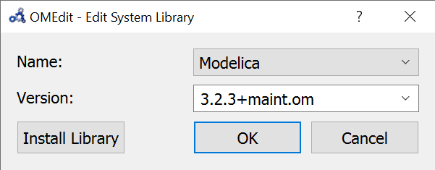
The Libraries window should now show an entry "Modelica 3.2.3+maint.om" under "System libraries automatically on startup":
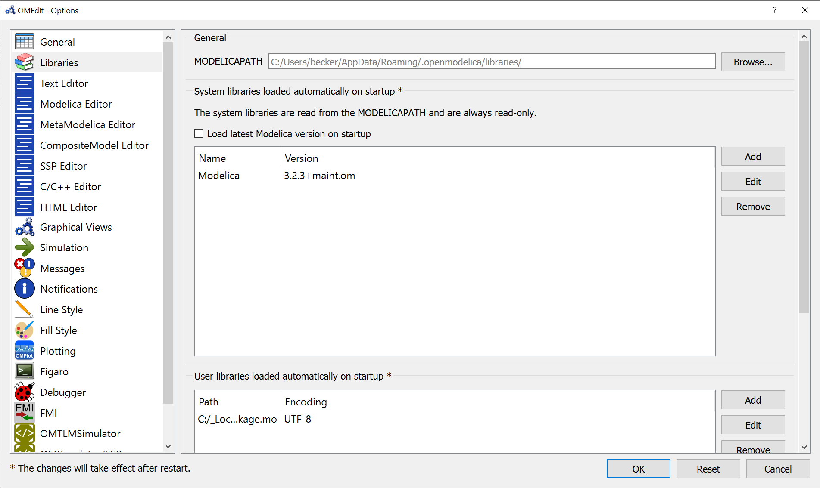

Add the Deltares libraries as user libraries
The hydraulic model uses model objects from the Deltares channel flow library. This library is part of the RTC-Tools installation “channel flow”:
Python_3910_casadi356\Lib\site-packages\rtctools_channel_flow\modelica\Deltares
Load this library via File à Open.
Adding the library under Tools à Options: Load OpenModelica library on startup
loads the library on every start of OMEdit.
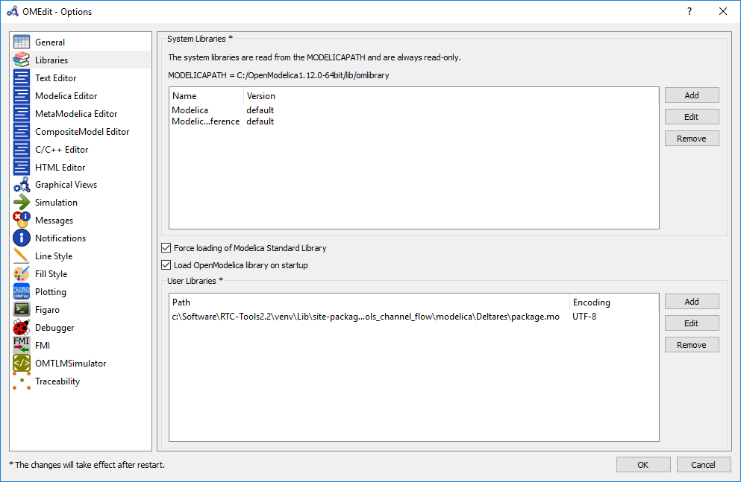

Configuration of PyCharm

Python Interpreter
File à Settings for new projects shows so-called Project Interpreters. The Python installation, either as virtual environment (Section 2.2) or WinPython package (Section 2.1), must be added here.
Under “Project”, select “Project Interpreter”:
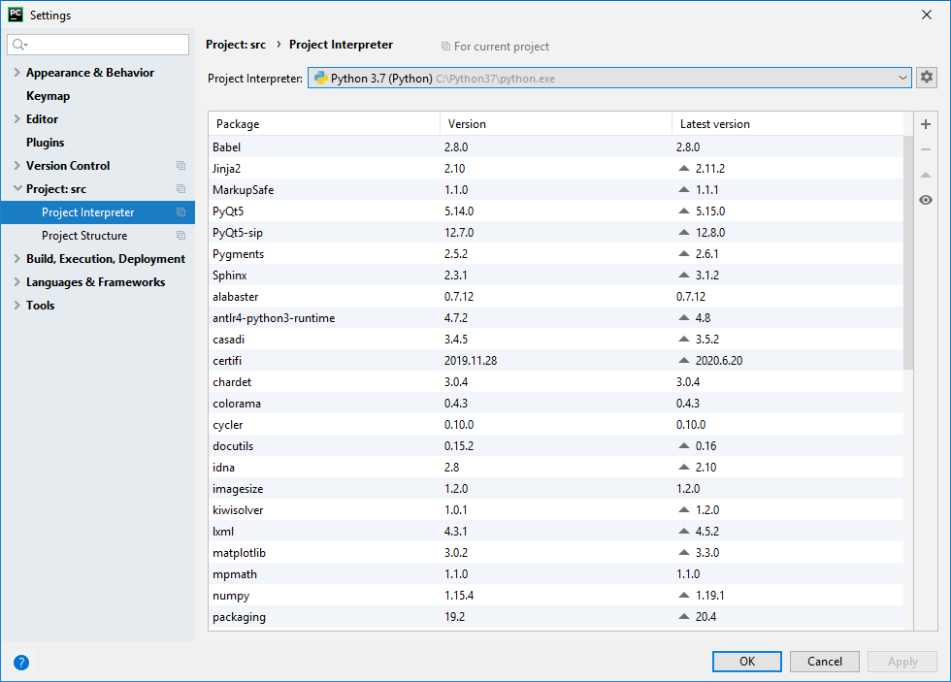
Open the list of Project Interpreters:
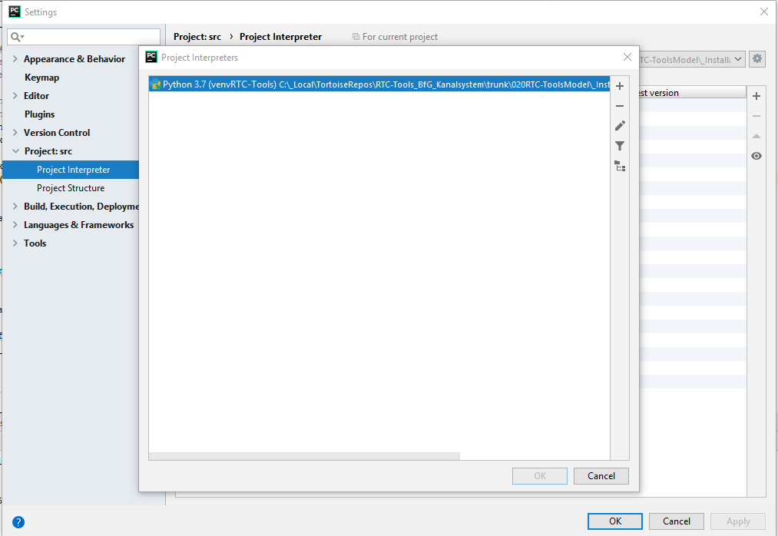
Add a new Project Interpreter by hitting the plus sign (+):
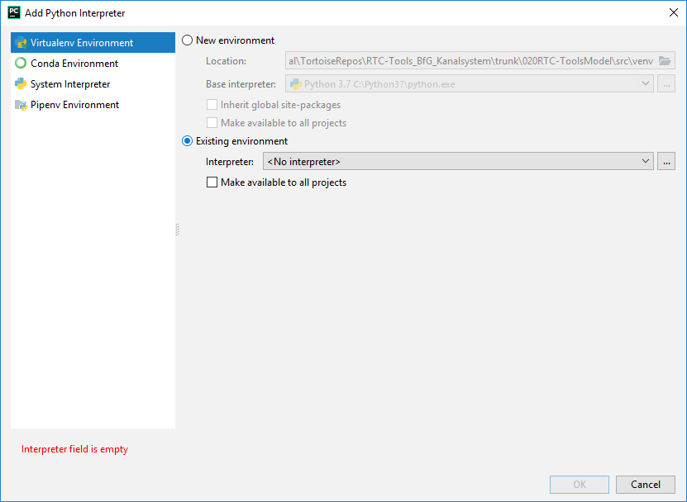
Choose “Existing Environment” and add the path to the Python script.
For the virtual environment (Section 2.2), the path is:
<installation directory>\venvRTC-Tools\Scripts\python.exe\Scripts\python.exe
In case of WinPython (Section 2.1), the path is:
<installation directory>
\Python_3910_casadi356\scripts\python.bat
Check “Make available to all projects“.
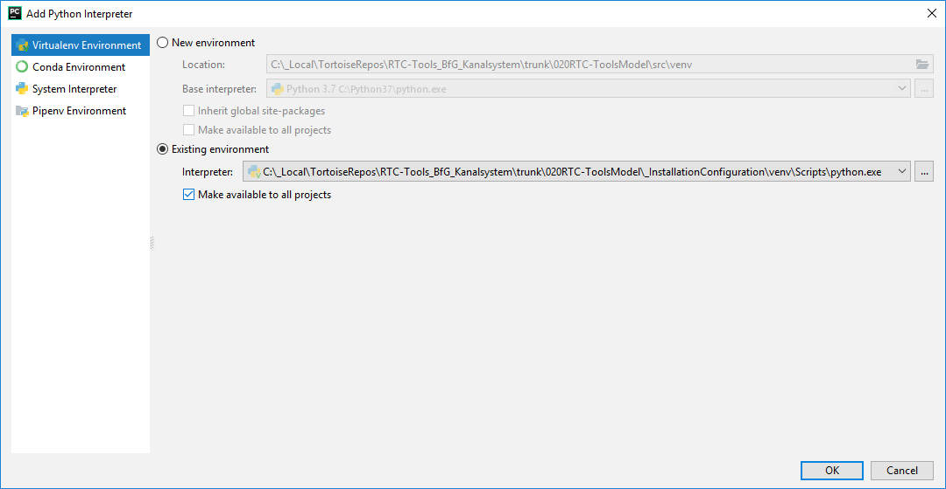
Change the name with the help of the Edit feature in the list of Project Interpretors (see above).
Note: In this settings environment you can
- create a virtual environment (see also Section 2.2)
- and install the Python package RTC-Tools into the virtual environment (Section 2.2).

Run/Debug Configuration
Open the Python file. In the project explorer select ‘Create’ in the context menu:
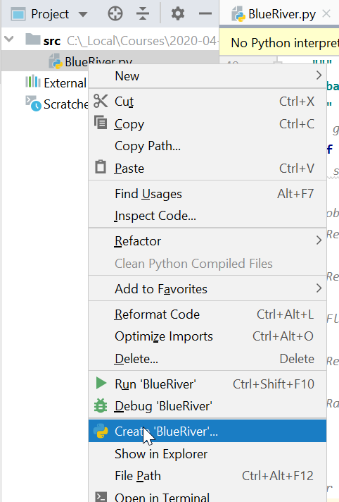
This sets up a Run/Debug Configuration:
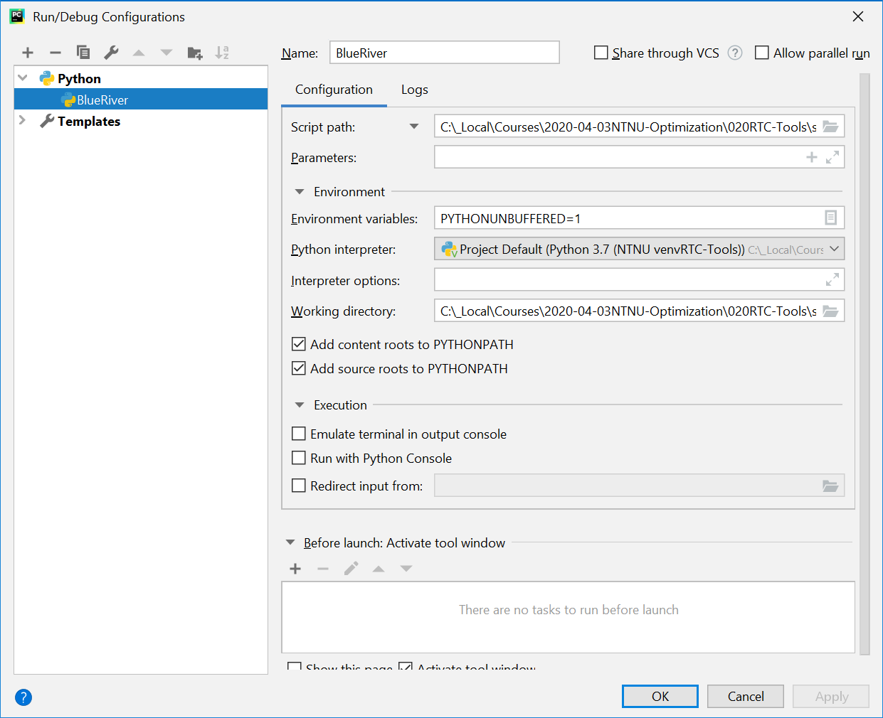
Script path and Working directory will be set automatically.
Select the Python interpreter according to your configuration from Section 5.1.

Run and debug
A Python file can be executed by running the corresponding Run/Debug configuration.
