Article

Zooplankton functional diversity changes across lake trophic status: a size-abundance relationship approach

Vojsava Gjoni 1,2*, Jeff Wesner1, and Bastiaan Ibelings 2

|  |
| --- |
| **Citation:** Lastname, F.; Lastname, F.; Lastname, F. Title. *Diversity* **2022**, *14*, x. https://doi.org/10.3390/xxxxx  Academic Editor: Firstname Lastname  Received: date  Accepted: date  Published: date  **Publisher’s Note:** MDPI stays neutral with regard to jurisdictional claims in published maps and institutional affiliations.    **Copyright:** © 2022 by the authors. Submitted for possible open access publication under the terms and conditions of the Creative Commons Attribution (CC BY) license (https://creativecommons.org/licenses/by/4.0/). |

1. Department of Biology, University of South Dakota, Vermillion, South Dakota, USA
2. Department F.-A. Forel for Environmental and Aquatic Sciences, University of Geneva and Institute for Environmental Sciences, Geneva, Switzerland.

**\*** Correspondence: [vojsava.gjoni@unige.ch](mailto:vojsava.gjoni@unige.ch).

**Abstract:** The size-abundance relationship been documented in most major environments and taxa, showing a consistent negative relationship of slope -0.75. Here, we are using this negative slope of -0.75 used to make quantitative predictions to reveal the effect of the environmental status and functional diversity at higher biological organization such as community level. To do so, we tested for differences in the size-abundance relationship attributable to amount of energy using zooplankton communities among lake trophic status. We tested for differences in the size-abundance relationship among three function diversity groups of zooplankton. Finally, size-abundance relationship among four function diversity groups incorporating the effect of four lake trophic status.

We found that size-abundance relationship of zooplankton communities changed across functional diversity, but not across trophic status there was a week change. However, the size-abundance relationship among the three trophic guilds changed across the trophic status. This implies that the trophic status of the lake ecosystems changes the energy flow of the functional diversity groups that, in turn, are able to explain this variation in the size-abundance relationship of zooplankton community.

**Keywords:** body size; abundance; zooplankton; functional diversity; trophic status; lakes.

1. Introduction

The importance of the linkage between biodiversity and ecosystem functioning, thus mechanisms associated with diversity or traits of the dominant species that determine functioning remained at the core of our understanding of ecology for more than 20 years (Loreau et al. 2001). Increasing diversity increases the probability that a community will include a species whose traits, and not diversity per se, are strongly correlated with ecosystem functioning (Givnish 1994; Aarssen 1997; Huston 1997). One of the most well-known traits that may contribute to ecosystem functioning is the organismal body size (Huston 1997, Tilman 1996).

Body size is a phenotypic, synthetic, individual trait, which is also related to many important biological traits, including the overwhelming important metabolic rate (Kleiber 1932), life-history traits (Blackburn et al. 1996) and physiological traits (Peters 1983). Body size is also related with abundance showing a consistent negative relationship of slope -0.75 (Damouth 1991, 19981, Nee). This is the exact inverse of the well-known size-scaling of metabolism (slope of 0.75 on a log scale) characterized by the Metabolic Theory of Ecology (MTE; Brown et al. 2004), a fundamental and well-supported theory in ecology. Thus, the slope of this relationship indicates a potential underlying mechanism because it derives from metabolic constrains. The mechanism suggests that the amount of the energy that is available in a system, is used by the species regardless their body size. This implies that the species present in a community used the same amount of energy if they have different body sizes. This assumption is well known as “energetic equivalence rule” (EER - Nee et al. 1991).

Therefore, the relationship between body size and abundance has been extensively examined because it has broad implications for the structure of and energy flow in ecological communities (Damuth 1981, 1987; Brown and Maurer 1987; Pagel et al. 1991; Illius and Gordon 1992; Taper and Marquet 1996) and qualifies the proportion of the large and the small species in the community. For this reason, the focus of many studies has been chiefly on the scaling exponent and whether it matches the theoretically predicted value of -0.75, where the slope may deviate from the theoretical value. Although, it has been documented in most major environments and taxa, and across spatial scales ranging from single trees and ponds to entire continents (Damuth 1981; Gaston and Blackburn 1996; Greenwood et al. 1996), the mechanisms beyond the relationship and its observed deviation from EER remain obscure (Cotgreave 1993; Blackburn and Gaston 1997; Marquet 2000).

These deviations may occur if the EER is not obeyed, and this could be driven by size asymmetries in competition (Nee et al. 1991; Cotgreave 1993; Russo et al. 2003) or from differences in the supply of resources to differently sized organisms (Holling 1992; Ernest 2005). For example, a less steep slope may occur if large species acquire more energy than smaller species. In contrast, a steeper slope may occur if small species acquire more energy than larger species (Biblio). These deviations from that expected by the EER show that the amount of energy used is not the same for all species. This deviation may result from the effects of various biotic and abiotic environmental factors, but the mechanism underlying this variation is poorly understood (Cotgreave 1993; Blackburn and Gaston 1997; Marquet 2000).

Here, we have used size-abundance relationship across communities to test quantitative predictions of the EER to expand our understanding of how the trophic status and trophic guilds influence community level processes. Using the size-abundance relationship, deviations can be measured as departures from quantitative EER predictions and provide evidence to understand how the community structure and the energy flow may change across the different trophic status and trophic guilds. Specifically, we addressed three questions. Does the slope of the relationship between body size and population abundance differ significantly from the slope of -0.75 expected by EER? If differ, do the amount of energy in the lake ecosystems, using as a proxy the trophic status of the lake explain this variation in size-abundance relationship? If differ, do the different resource of energy, using as a proxy the functional diversity, explain this variation. Finally, do the slopes of the relationships between body size and abundance vary among trophic status and trophic guilds? To do so, we tested for differences in the size-abundance relationship attributable to amount of energy using zooplankton communities among lake trophic status. We tested for differences in the size-abundance relationship among three trophic guilds of zooplankton. Finally, we tested size-abundance relationship among three trophic guilds incorporating the effect of four lake trophic status.

The ecological attributes of the lake trophic status in an ecological guild may affect size-abundance relationships. This is because the trophic status varies in resource availability both temporally and spatially. Specifically, trophic status is used as a proxy of the amount of energy available in the lake ecosystems. It categorizes productivity and indicates the energy is added to the bodies of organisms in the form of biomass. Trophic status ranges from early successional to lake successional lakes and are four: oligotrophic, mesotrophic, eutrophic and hypereutrophic (Carlson 1977). Specifically, oligotrophic lakes are characterized by poor nutrients and are often located in higher elevations. Mesotrophic and eutrophic lakes are characterized by higher productivity than oligotrophic lakes and they have greater nutrient loads. Furthermore, aquatic plants are more abundant in those lakes because of the rich nutrients and as a consequence more herbivore fishes are supported as well (Rodhe 1969, Smith et al. 1999). However, hypereutrophic lakes that are characterized by the highest productivity levels, where the biological equilibrium present in meso- and eutrophic lakes, is compromised (Hasler 1969, Schindler and Vallentyne 2008).

Such resource variability across lake trophic status is well known to affects zooplankton species composition or population abundances. However, we expect that a measure of the functional diversity in zooplankton communities will be more responsive to gradients of resource variability in time and space. This is because resource variability is closely related with feeding behavior and life history of species (Abrams 1984, Anderies and Beisner 2000). Specifically, functional diversity of zooplankton communities is well known to change across the trophic status of the lakes. Many studies that have focused on the relationship between zooplankton biodiversity and lake ecosystem function found that functional diversity measures explain a greater percentage of variation in lake ecosystem function (e.g., Tilman et al. 1997, Walker et al. 1999). Therefore, as a proxy for the functional diversity we have grouped the zooplankton species into tree trophic guilds, such as: herbivores, omnivores, and predators. Zooplankton species that are primarily herbivores feed on plants, such as phytoplankton and/or algae. However, predatory zooplankton species consume other small animals or small zooplankton, whereas omnivores will consume plants, small animals, or/and detritus (decaying organic matter).

2. Materials and Methods

We used observational data from >1000 US lakes to model the relationship between body size and abundance of zooplankton communities. We used data from continental US lakes collected as part of the 2012 National Lakes Assessment survey conducted by the US Environmental Protection Agency (Fig. 2). NLA is a synoptic sampling program of lakes, reservoirs, and ponds implemented across the continental US (Pollard et al. 2018). The lakes were sampled once in the summer (June–September) and were selected 132 from the National Hydrography Database (https://nhd.usgs.gov/). At each lake, an extensive set of environmental variables was measured, but we provide sampling details only for variables used in our analysis. Field crews used standardized sampling methods across all sites, with collections made during the morning to early afternoon. All data are freely available online (https://www.epa.gov/national-aquatic137-resource-surveys/data-national-aquatic-resource-surveys ).

Water is transferred from the sampling device to a triple rinsed 4 L cubitainer. Once full, a sample aliquot is collected for common water chemistry. Then, separate aliquots are collected for chlorophyll a (Chl a). Each sample, we have 5000 estimates of chlorophyll a for each lake in the context of our chlorophyll a model. Those values have bene converted to trophic states such as: oligotrophic (≤ 2 μg/L), mesotrophic (> 2 and ≤ 7 μg/L), eutrophic (> 7 and ≤ 30 μg/L) and hypereutrophic (> 30 μg/L). Detailed descriptions of all water quality analyses are found in the NLA 2012 Laboratory Operations Manual (Section 9, USEPA 2012).

Zooplankton are collected during the day with separate fine (50 μm) and coarse (150 μm) Wisconsin mesh nets, each towed vertically for a total length of 5 m, where depth adjustments are made in lakes < 7 m deep, to sample the same volume in each lake. Zooplankton are identified to the lowest level of taxonomic resolution, usually species. For quality assurance among taxonomists and between laboratories, a random 10% of all samples are reidentified by independent taxonomists. Any differences among taxonomists are reconciled before the final zooplankton data set was compiled. Zooplankton abundance is estimated from the number of individuals counted and the volume of water sampled, standard length-width relationships (references listed in Section 10.5, USEPA 2012).

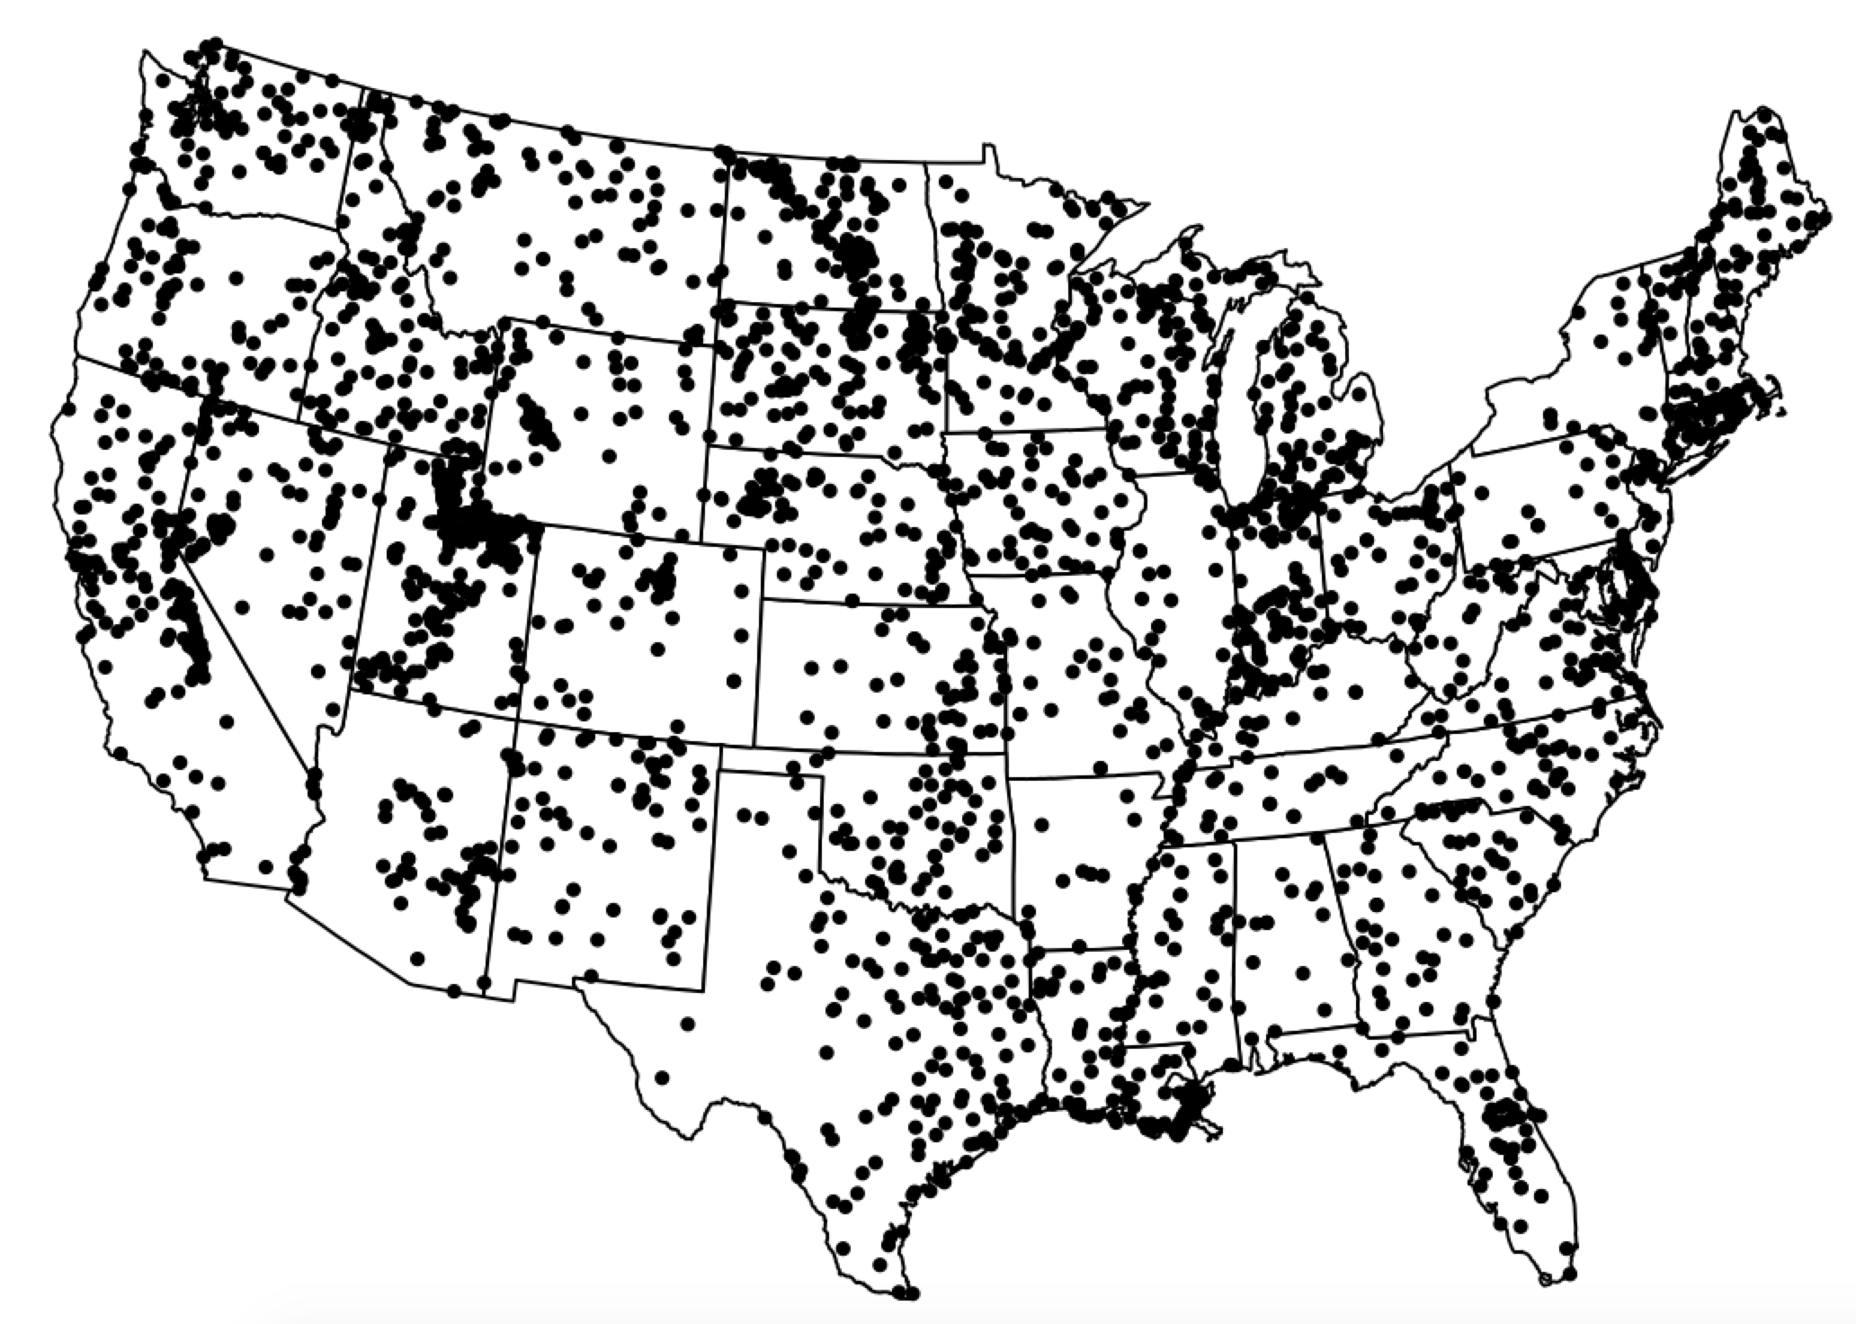

**Figure 1.** Map of the sampling site distribution of National Lakes Assessment data used.

Furthermore, to identify the functional diversity of zooplankton, we followed the functional feeding group of each zooplankton taxon labeled by the expert who identify the species. However, the functional feeding group labeling was only applied to adult zooplankton. The functional feeding group (e.g. trophic guilds) included herbivore, omnivore, and predator. There were 516 species of zooplankton encountered in 2012 and 308 species were herbivore, 125 species were omnivores, 44 species were predators.

The NLA sampling of both biotic and abiotic components and sample processing procedures are described in detail and discussed elsewhere (https://www.epa.gov/national-aquatic-resource-surveys/manuals-used-national-aquatic-resource-surveys).

3. Results

The size-abundance relationship across zooplankton communities showed a shallower slope (*b* = -0.47) relative to the expected value of -0.75. This variation in size-abundance relationship was partially explained by functional diversity of zooplankton (i.e., feeding groups = 22%), and even more by lakes environmental conditions (i.e., trophic status = 34%). While both of them were able to explain most of the variation in size-abundance slope (feeding groups x trophic status = 57%; Table 1). This suggesting that in lake ecosystem the zooplankton communities show a higher proportion of large species relative to the proportion expected by the MTE (Figure 2; Table 1 and 2). Furthermore, functional diversity and lake conditions may be able to explain this higher proportion of larger species present in zooplankton communities.

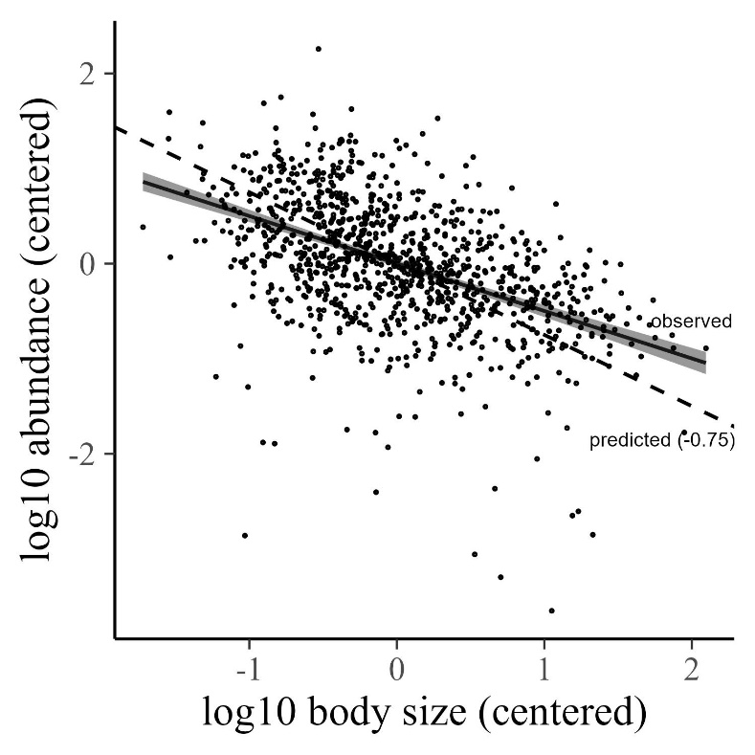

**Figure 2.** The relationship between average body size and population abundance across zooplankton communities inhabiting the 1048 lakes of the continental United States of America.

Therefore, the size-abundance relationship was different among the three functional groups. Specifically, the slope of omnivorous zooplankton was consistent with the value of -0.75 (*b* = -0.64), while herbivorous (*b* = -0.39), and predatory zooplankton (*b* = -0.29) was higher than the value of -0.75 (Figure 3; Table 2). This implies that that proportion of the small and the large species for omnivorous zooplankton was consistent with the expected from the MTE did not change among the three functional feeding groups. However, the proportion of the larger species for herbivorous and predatory zooplankton was higher than expected from MTE. Although, across functional diversity the size-abundance relationship showed strong and different relationships, across lake trophic status did not (Table 3; Figure 4). This suggests that the trophic status has a week effect on zooplankton communities.

However, grouping zooplankton community into functional diversity group the size-abundance showed different patterns across lake trophic status. Specifically, size-abundance relationship of omnivorous zooplankton was consistent with the values of -0.75 of MTE for hypereutrophic lakes (*b* = -0.55), while for the oligotrophic (*b* = -0.29), mesotrophic (*b* = -0.38), and eutrophic lakes (*b* = -0.39) was shallower than the values -0.75 (Figure 5; Table 3). This suggests that, in hypereutrophic lakes, the omnivorous zooplankton communities show the same proportion of large and small species as expected by MTE. While in oligotrophic, mesotrophic, and eutrophic lakes show a higher proportion of large species than expected. The size-abundance relationships of herbivorous zooplankton communities showed similar shallow slope across lake trophic status, suggesting that trophic status do not have an effect on herbivorous zooplankton communities Similarly, in oligotrophic lakes, size-abundance relationship was shallower than -0.75 (*b* = -0.50), suggesting a higher proportion for larger species than expected While, for the other three lake trophic status, predatory zooplankton communities showed not significant or positive relationships (Figure 5; Table 3).

**Table 1.** Mixed model statistics for the relationship between average body mass and population density for zooplankton in four feeding groups and four lake trophic status.

|  |  |  |
| --- | --- | --- |
| **Table 2.** Marginal posterior slopes and intercepts of log10 body size in relation to log10 population density of zooplankton communities across trophic guilds included in Figure 2 and 3. Values represent medians and 95% credible intervals in parentheses. | | |
| **size-abundance relationship** | **slope (95% CrI)** | **intercept (95% CrI)** |
| all guilds | -0.5 (-0.55 to -0.45) | 0 (-0.04 to 0.04) |
| oligotrophic status | -0.3 (-0.43 to -0.17) | -0.44 (-0.53 to -0.35) |
| mesotrophic status | -0.4 (-0.49 to -0.3) | -0.08 (-0.13 to -0.02) |
| eutrophic status | -0.46 (-0.54 to -0.37) | 0.08 (0.02 to 0.14) |
| hypereutrophic status | -0.56 (-0.66 to -0.45) | 0.26 (0.19 to 0.33) |
| omnivorous guild | -0.57 (-0.67 to -0.46) | 0.2 (0.12 to 0.29) |
| herbivorous guild | -0.41 (-0.5 to -0.32) | 0.7 (0.61 to 0.78) |
| predator guild | -0.13 (-0.43 to 0.18) | -0.79 (-1 to -0.58) |

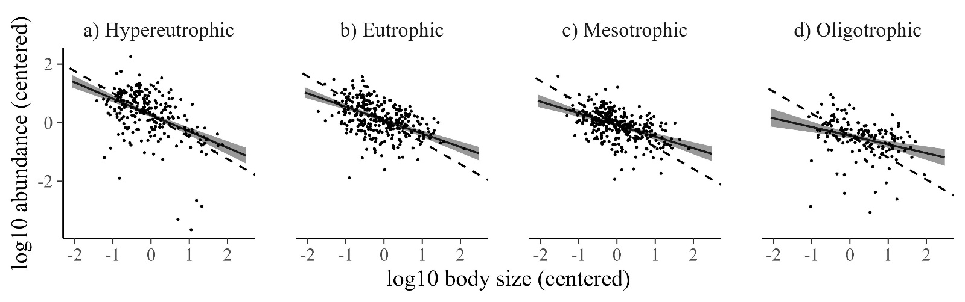

**Figure 3.** The relationship between average body size and population abundance ofzooplankton communitiend across trophic stuatus. Data represent 1048 lakes of the continental United States of America. The dashed line is the theoretical prediction (slope = -0.75). The regression line and shading is the emperical result representing the marginal median slope and 95% credible interval.

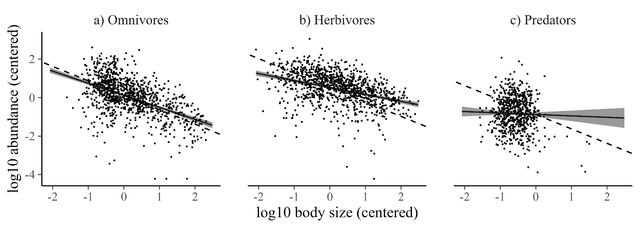

**Figure 4.** The relationship between average body size and population density across trophic guilds of zooplankton inhabiting the 1048 lakes: **A.** omnivorous, **B.** herbivorous, and **C.** predatory zooplankton. The dashed line is the theoretical prediction (slope = -0.75). The regression line and shading is the emperical result representing the marginal median slope and 95% credible interval.

|  |  |  |  |
| --- | --- | --- | --- |
| **Table 4**. Marginal posterior slopes and intercepts of log10 body size in relation to log10 population density of zooplankton communities across trophic guilds and trophic states. Values represent medians and 95% credible intervals in parentheses. | | | |
| **trophic guild** | **trophic status** | **slope (95% CrI)** | **intercept (95% CrI)** |
| omnivores | oligotrophic | -0.54 (-0.68 to -0.39) | -0.38 (-0.5 to -0.27) |
|  | mesotrophic | -0.63 (-0.75 to -0.52) | 0.02 (-0.06 to 0.11) |
|  | eutrophic | -0.57 (-0.67 to -0.46) | 0.2 (0.12 to 0.29) |
|  | hypereutrophic | -0.77 (-0.89 to -0.66) | 0.64 (0.54 to 0.74) |
|  |  |  |  |
| herbivorous | oligotrophic | -0.27 (-0.4 to -0.14) | 0.14 (-0.01 to 0.29) |
|  | mesotrophic | -0.41 (-0.51 to -0.32) | 0.6 (0.52 to 0.69) |
|  | eutrophic | -0.41 (-0.5 to -0.32) | 0.7 (0.61 to 0.78) |
|  | hypereutrophic | -0.34 (-0.47 to -0.23) | 0.66 (0.56 to 0.76) |
|  |  |  |  |
| predators | oligotrophic | -0.49 (-0.8 to -0.18) | -1.57 (-1.76 to -1.39) |
|  | mesotrophic | 0.28 (0 to 0.56) | -0.76 (-0.93 to -0.58) |
|  | eutrophic | -0.13 (-0.43 to 0.18) | -0.79 (-1 to -0.58) |
|  | hypereutrophic | 0.04 (-0.33 to 0.44) | -0.38 (-0.68 to -0.08) |

4. Discussion

*4.1 Size-abundance relationship of lake zooplankton communities*

The patterns of the size-abundance across communities of the zooplankton communities inhabiting the >1000 lake ecosystem showed a slope what a value of -0.47, was shallower than the value of -0.75 predicted by EER (Damuth 1981, 1991,1993, Nee 1991). Our patterns were consistent with several studies that suggested that the relationship between body size and abundance is much shallower than the value of -0.75 for aquatic macroinvertebrate communities (e.g. biblio) and other aquatic communities (e.g., biblio). However, the shallower slopes found were no consistent with the EER. This deviation implies that zooplankton communities have a relatively higher proportion of large individuals than is predicted by the EER. Specifically, larger individuals of zooplankton communities use the larger amount of energy in lake ecosystems.

We found that this variation of the size-abundance relationship of lake zooplankton communities can be explained by the different trophic guilds of the zooplankton and less by the trophic status, where together are able to explain the ~50% of the variance.

One of the factors most seriously influencing densities and taxonomic composition of crustacean zooplankton may be fish predation. However, as it was shown in observations on two oligotrophic lakes in southcentral Ontario (Ramcharan et al. 1995), in lakes with long-time persistence of planktivores compensatory responses of prey populations tend to diminish the impacts of fish populations.

Ramcharan C.W., McQueen D.J., Demers E., Popiel S.A., Rocchi A.M., Yan N.D., Wong A.H., Hughes K.D. 1995. A comparative approach to determining the role of fish predation in structuring limnetic ecosystems – Arch. Hydrobiol. 133: 389–416.

*4.2 Size-abundance relationship across trophic guilds*

Based on functional diversity analyses, trophic guilds differed in the slope of the size-abundance relationship (Figure 4, Table 2). The slopes of all guilds except for omnivorous zooplankton communities were significantly different from the -0.75-slope expected by EER. Relative to the omnivore guild, the slopes for the other two guilds (i.e., herbivore and predators) were much shallower, suggesting that larger species in herbivore and predators’ guilds are more abundant than would be predicted based on EER energetics. These results would not be expected if the EER were a significant factor affecting population densities in these guilds.

Our finding implies that in lake zooplankton communities, that herbivore and predators had more positive slopes of the size-abundance relationship than did omnivores, populations of larger species tended to use more resources than those of smaller species, especially in the predatory guild. The hypothesis that competitive dominance of shared resources by larger species, either now or in the evolutionary past, may adversely affect the population densities of smaller species has been suggested to explain the lack of negative size-abundance slopes observed in a wide range of organisms (Brown and Maurer 1986; Nee et al. 1991; Pagel et al. 1991; Cotgreave and Harvey 1992, 1994; Cotgreave 1994, 1995).

Large body size can provide advantages in interspecific interactions involving either interference or exploitation competition, especially when resources are spatially clumped (Maurer 1984; Petren and Case 1996). The hypothesis that the benefits of large body size in competition are responsible for shallow slopes of the size-abundance relationship and the positive slope relative to EER expected sloe value within guilds has

received considerable support in analyses of size abundance relationships (Russo et al. 2004, Nee et al. 1991; Cotgreave 1994,1995; Cotgreave and Harvey 1994). Costs of interspecific competition have been documented as well (Abramsky et al. 2000, 2001), but ultimately, evidence for a population-level effect, in terms of reduced demographic parameters such as survival or fecundity of small, relative to large, competing species, would be most convincing.

*4.3 Size-abundance relationship across trophic status*

Based on functional diversity analyses, the slopes showed different shape across the trophic status. Specifically, hypereutrophic lakes showed the steeper slope in relation to the other trophic status consistent with the EER expected value. This implies that the portion of the small individuals is higher under high trophic status. Eutrophic and mesotrophic lakes showed a similar shape that were shallower than the hypereutrophic lakes, whereas the oligotrophic lakes showed an even more shallow than the other trophic status. Furthermore, they showed different abundance where the hypereutrophic showed the higher abundance independent of body size, followed by the mesotrophic and eutrophic. Finally, the oligotrophic lakes showed the lower abundance independent of body size among the other lake trophic status.

Therefore, our findings are consistent with other studies that have shown that the increase on the productivity caused a decrease in the body size of the zooplankton present in the community (Bays and Crisman 1983, Karabin 1985) and an increase in the total population abundance of zooplankton communities (Patalas 1972, Pinto-Coelho et al. 2005) independently. However, few studies have shown both a decrease of the average body size and an increase of the abundance of zooplankton communities in high trophic lakes (Karabin 1985). Furthermore, is predicted that an increase on the productivity may cause changes in the species structure of zooplankton communities which may be related with changes of the slope across the trophic guilds among the four-lake trophic status (Pejler 1965, Hakkari, 1972, Karabin 1985, Hofmann 1996). Our results related with this hypothesis described on the next subchapter.

The trophic status of the lakes is an important indicator of the primary production, where the higher trophic status may lead to intense blooms of Cyanoprokaryota and water pollution. This is because of the increased nutrients that lead to eutrophication where the body sizes and the abundance of zooplankton communities are affected (Bays and Crisman 1983). Our finding, showed those changes represented by the slope of size-abundance relationship of zooplankton communities across the trophic status. Therefore, zooplankton communities’ slope changes may play an important role as an indicator of those changing trophic conditions (Gulati 1983, Hsieh et al. 2011, Gjoni et al. 2016, 2019, Gjoni and Basset 2018, Gjoni et al. 2020).

Bays J. S., Crisman T.L. 1983 – Zooplankton and Trophic State Relationships in Florida Lakes – Can. J. Fish. Aquat. Sci. 40: 1813–1819.

Karabin A. 1985a – Pelagic zooplankton (Rotatoria + Crustacea) variation in the process of lake eutrophication. I. Structural and quantitative features – Ekol. pol. 33: 567–616.

Patalas K. 1972 – Crustacean plankton and the eutrophication of St. Lawrence Great Lakes – J. Fish. Res. Bd. Canada, 29: 1451–1462.

Pinto-C oelho R .M., B ezerra-Neto J.F., Morais Jr C.A. 2005a – Effects of eutrophication on size and biomass of crustacean zooplankton in a tropical reservoir – Brazilian J. Biol. 65: 325–338.

Pejler B. 1965 – Regional-ecological studies of Swedish fresh-water zooplankton – Zool. Bidrag. Uppsala, 36: 407–515.

Hakkari L. 1972 – Zooplankton species as indicators of environment – Aqua Fennica, 1: 46–54.

Hofmann W. 1996 – Empirical relationships between cladoceran fauna and trophic state in thirteen northern German lakes: analysis of surficial sediments – Hydrobiologia, 318: 195–201.

Gulati R .D. 1983. Zooplankton and its grazing as indicators of trophic status in Dutch lakes – Environ. Monit. and Assess. 3: 343–354.

Hsieh C.H., Sakai Y., Ban S., Ishikawa K., Ishikawa T., Ichise S., Yamamura N., Kumagai M. 2011 – Eutrophication and warming effects on long-term variation of zooplankton in Lake Biwa – Biogeosciences Discuss, 8: 593–629.

Gjoni, V.; Cozzoli, F.; Rosati, I.; Basset, A. Size-density relationships: A cross-community approach to benthic macroinvertebrates in Mediterranean and Black Sea lagoons. Estuar. Coast 2016, 40, 1142–1158.

Gjoni, V.; Ghinis, S.; Pinna, M.; Mazzotta, L.; Marini, G.; Ciotti, M.; Rosati, I.; Vignes, F.; Arima, S.; Basset, A. Patterns of functional diversity of macroinvertebrates across three aquatic ecosystem types, NE Mediterranean. MMS 2019, 20, 703–717.

Gjoni, V.; Basset, A. A cross-community approach to energy pathways across lagoon macroinvertebrate guilds. Estuar. Coast 2018, 41, 2433–2446.

Gjoni, V.; Glazier, D.S. A perspective on body size and abundance relationships across ecological communities. Biology 2020, 9, 42.

*4.3 Size-abundance relationship across trophic guild and status*

Specifically, the high trophic increased the zooplankton abundance, with a high proportion of trophic level indicator species, including rotifers Keratella quadrata, Brachionus angularis and Trichocerca similis (Ejsmont-Karabin, 2012) and crustaceans Daphnia cucullata, Bosmina longirostris, Chydorus sphaericus, Diaphanosoma brachyurum and Thermocyclops sp. (Ejsmont-Karabin & Karabin, 2013). It should be noted that some functional traits of above-mentioned bioindicator species were previously correlated with water trophy. For example, Obertegger & Manca (2011) and Oh et al. (2017) positively correlated the morphological traits (trophi type) of the genera Keratella and Brachionus and Polyarthra and Trichocerca with high trophic-level parameters and productivity (Chl-a). In turn, the smaller body size of Cladocera and Copepoda indicator species (Bosmina, Eubosmina Chydorus, Thermocyclops) were previously correlated with higher lake trophy (Barnett & Beisner, 2007; Sodre & Bozelli, 2019).

However, oligotrophic lake ecosystems lead first of all the decrease of the total zooplankton abundance observed for all trophic guilds (Baranyi et al., 2002). However, in these lakes with low trophic characteristic, rotifers are generally more abundance because of they are characterized by a short life cycle and low nutritional requirements in comparison the other zooplankton groups (Goździejewska et al., 2010; Goździejewska et al., 2016, Goździejewska et al. 2021). Indeed, the abundance of omnivore rotifers species showed smoother shifts of their abundance which may have directly resulted from the absence of predatory flagellates that their abundance where very low. Furthermore, herbivore species composed by large plankton crustaceans that filtering feeders and grazers didn’t show change in their abundance. This may have contributed to the lower abundance of omnivores that effectively competed for those same food resources (Sommer et al., 2003 Balvert et al., 2009).

5. Conclusions

Productivity of lakes ecosystems is well studied, and it is widely accepted that as nutrient inputs increase, productivity increases and lakes transition from lower trophic state (e.g., oligotrophic) to higher trophic states (e.g., eutrophic). For biomonitoring of lake ecosystems, the use of functional diversity has been proposed as an alternative to more highly resolved taxonomic identification. Zooplankton functional diversity was related to their trophic groups and the trophic status of the lake ecosystem, showing that zooplankton size-based community is strongly associated with trophic conditions of the lake. Therefore, the use of size–abundance relationships may play an important role as an indicator of those changing trophic conditions by linking functional diversity with ecosystem functioning. This study offers a potential method of how to monitor planktonic communities across the different trophic status of lake ecosystems. Therefore, developing a sampling technique that can approach better size-abundance relationship, allow to improve our ability to make prediction about the size-based community architectures. We may be able to predict how changes in the trophic status if lake ecosystems may change planktonic communities in the future. This of course will benefit research, as well as management policies of aquatic ecosystems for their conservation of biodiversity.

6. Patents

This section is not mandatory but may be added if there are patents resulting from the work reported in this manuscript.

**Supplementary Materials:** The following supporting information can be downloaded at: www.mdpi.com/xxx/s1, Figure S1: title; Table S1: title; Video S1: title.

**Author Contributions:** For research articles with several authors, a short paragraph specifying their individual contributions must be provided. The following statements should be used “Conceptualization, X.X. and Y.Y.; methodology, X.X.; software, X.X.; validation, X.X., Y.Y. and Z.Z.; formal analysis, X.X.; investigation, X.X.; resources, X.X.; data curation, X.X.; writing—original draft preparation, X.X.; writing—review and editing, X.X.; visualization, X.X.; supervision, X.X.; project administration, X.X.; funding acquisition, Y.Y. All authors have read and agreed to the published version of the manuscript.” Please turn to the [CRediT taxonomy](https://img.mdpi.org/data/contributor-role-instruction.pdf) for the term explanation. Authorship must be limited to those who have contributed substantially to the work reported.

**Funding:** This research was funded by a Swiss National Foundation grant called “Scientific Exchange” awarded to Vojsava Gjoni in support of her research visit at the University of Geneva in Switzerland.

**Data Availability Statement:** In this section, please provide details regarding where data supporting reported results can be found, including links to publicly archived datasets analyzed or generated during the study. Please refer to suggested Data Availability Statements in section “MDPI Research Data Policies” at https://www.mdpi.com/ethics. If the study did not report any data, you might add “Not applicable” here.

**Acknowledgments:** In this section, you can acknowledge any support given which is not covered by the author contribution or funding sections. This may include administrative and technical support, or donations in kind (e.g., materials used for experiments).

**Conflicts of Interest:** The authors declare no conflict of interest. The funders had no role in the design of the study; in the collection, analyses, or interpretation of data; in the writing of the manuscript, or in the decision to publish the results.

**Appendix A**

The appendix is an optional section that can contain details and data supplemental to the main text—for example, explanations of experimental details that would disrupt the flow of the main text but nonetheless remain crucial to understanding and reproducing the research shown; figures of replicates for experiments of which representative data is shown in the main text can be added here if brief, or as Supplementary data. Mathematical proofs of results not central to the paper can be added as an appendix.

**Appendix B**

All appendix sections must be cited in the main text. In the appendices, Figures, Tables, etc. should be labeled starting with “A”—e.g., Figure A1, Figure A2, etc.

References

References must be numbered in order of appearance in the text (including citations in tables and legends) and listed individually at the end of the manuscript. We recommend preparing the references with a bibliography software package, such as EndNote, ReferenceManager or Zotero to avoid typing mistakes and duplicated references. Include the digital object identifier (DOI) for all references where available.

Citations and references in the Supplementary Materials are permitted provided that they also appear in the reference list here.

In the text, reference numbers should be placed in square brackets [ ] and placed before the punctuation; for example [1], [1–3] or [1,3]. For embedded citations in the text with pagination, use both parentheses and brackets to indicate the reference number and page numbers; for example [5] (p. 10), or [6] (pp. 101–105).

1. Author 1, A.B.; Author 2, C.D. Title of the article. *Abbreviated Journal Name* **Year**, *Volume*, page range.
2. Author 1, A.; Author 2, B. Title of the chapter. In *Book Title*, 2nd ed.; Editor 1, A., Editor 2, B., Eds.; Publisher: Publisher Location, Country, 2007; Volume 3, pp. 154–196.
3. Author 1, A.; Author 2, B. *Book Title*, 3rd ed.; Publisher: Publisher Location, Country, 2008; pp. 154–196.
4. Author 1, A.B.; Author 2, C. Title of Unpublished Work. *Abbreviated Journal Name* year, *phrase indicating stage of publication (submitted; accepted; in press)*.
5. Author 1, A.B. (University, City, State, Country); Author 2, C. (Institute, City, State, Country). Personal communication, 2012.
6. Author 1, A.B.; Author 2, C.D.; Author 3, E.F. Title of Presentation. In Proceedings of the Name of the Conference, Location of Conference, Country, Date of Conference (Day Month Year).
7. Author 1, A.B. Title of Thesis. Level of Thesis, Degree-Granting University, Location of University, Date of Completion.
8. Title of Site. Available online: URL (accessed on Day Month Year).