**Section 1: IPiB Community Climate**

Q1 In your opinion, how committed is IPiB to diversity and inclusion?

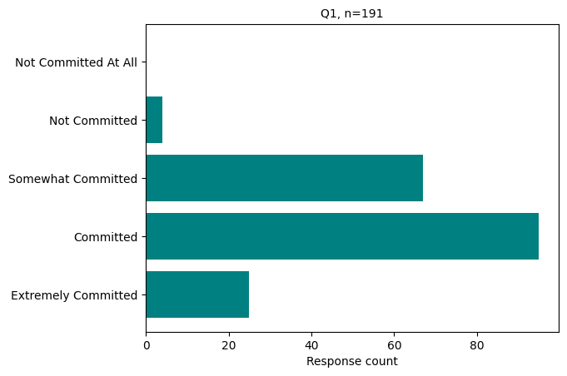

Q2 How important is it to you that IPiB is committed to diversity and inclusion?

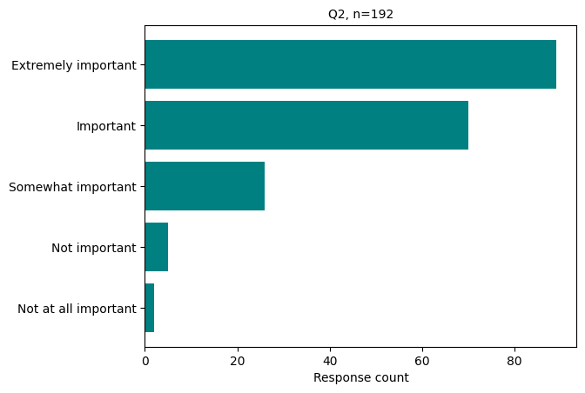

Q3 In the last 5 years, how often have you felt welcomed and respected by trainees, faculty, and staff in the program?

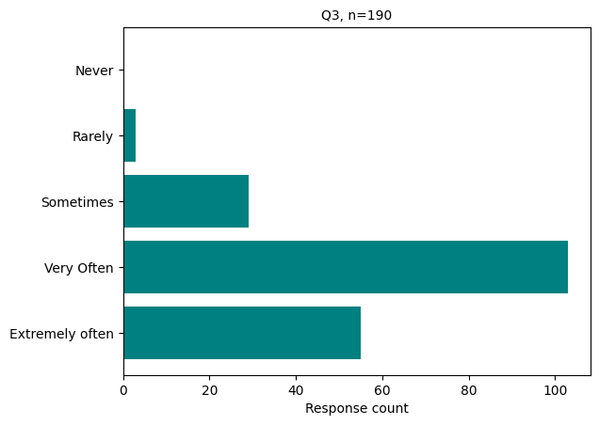

Q4 In the last 5 years, how often have you felt included and that you belong in the IPiB/ Biochemical Sciences community?

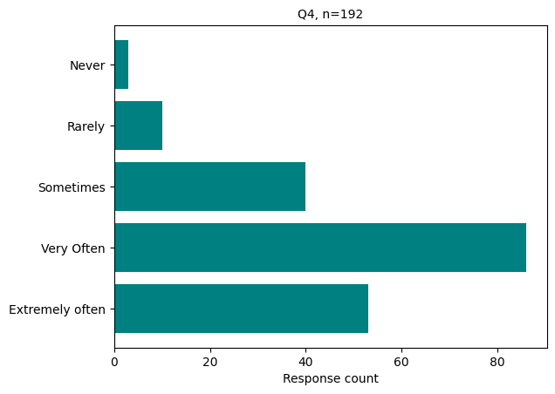

Q5 Please indicate the degree to which you agree with this statement: "When I share thoughts, opinions, or questions at IPiB/Biochemical Sciences community functions (e.g. staff or lab meetings, program receptions, colloquia), I feel they are respected and valued."

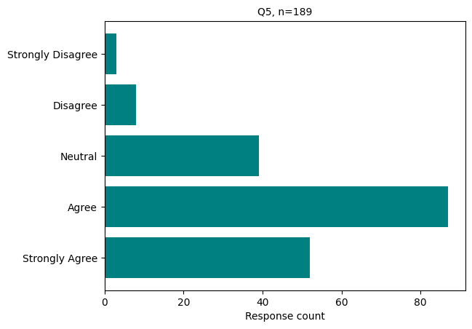

Q8 Please indicate the extent to which you agree with the following statement: "I have someone in the IPiB/ Biochemical Sciences community with whom I feel comfortable talking about my problems/concerns."

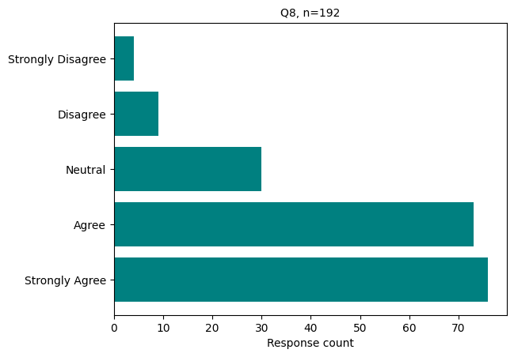

Q9 Who is this person in relation to you?

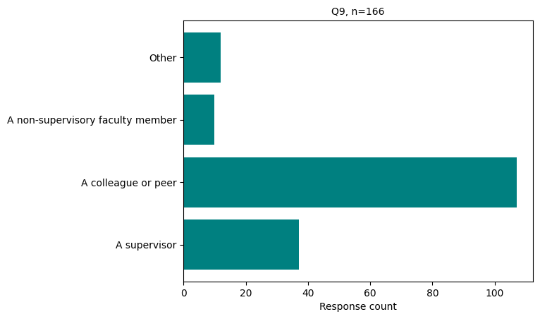

Q10 Please indicate the extent to which you agree with this statement: "My supervisor/advisor genuinely cares about and supports my chosen path (including career goals)."

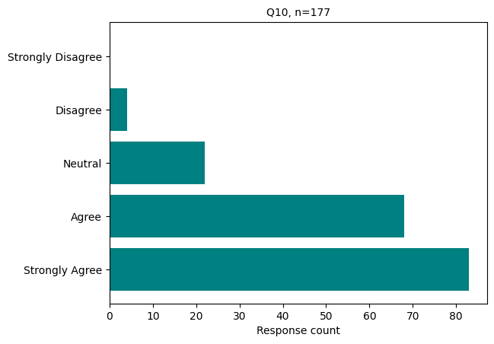

Q11 Please indicate the extent to which you agree with this statement: "My supervisor/advisor genuinely cares about and supports my well-being."

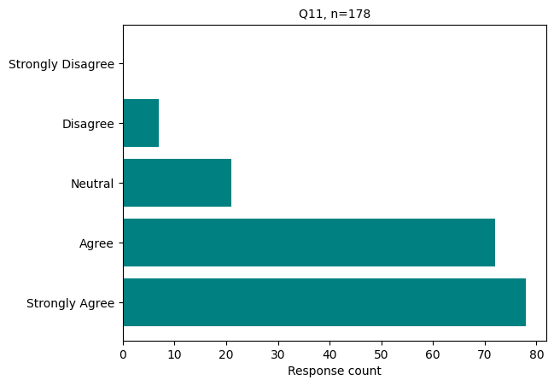

Q15 Please answer this question if you are a student or faculty member of IPiB: Does IPiB provide you with appropriate access to resources for furthering a mission for diversity and inclusivity?

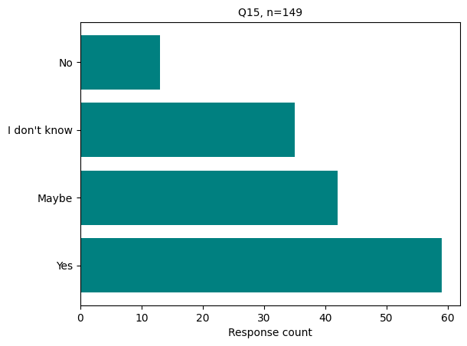

Q16 Please indicate the extent to which you feel you have good information about mental health services available to you (as a trainee, faculty, or staff member) through the University of Wisconsin-Madison.

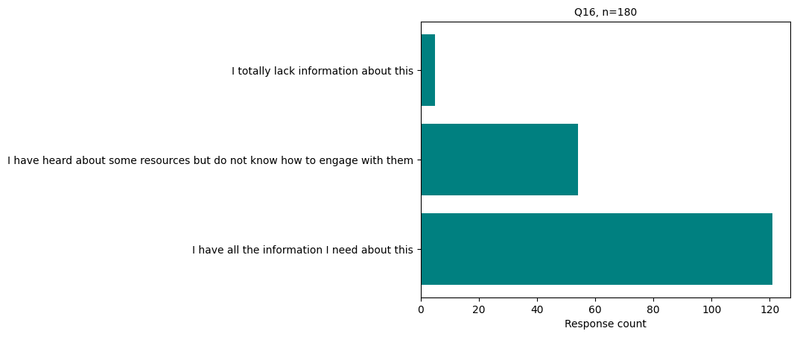Q17 Please indicate the extent to which you feel you have good information about the process for reporting sexual harassment and hostile or intimidating behavior at the University of Wisconsin-Madison.

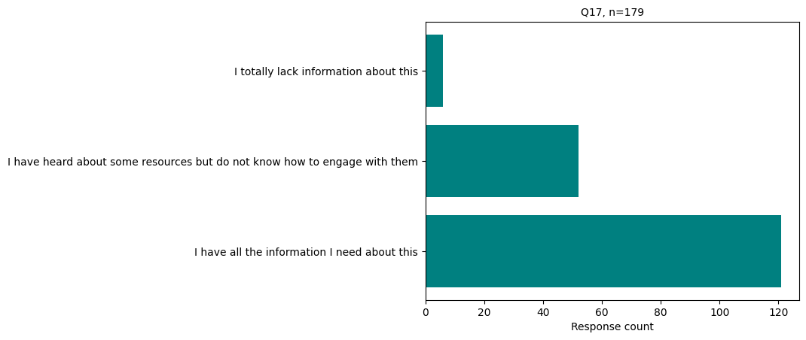

Q18 Please indicate the extent to which you feel you have good information about the process for reporting incidents of bias or discrimination at the University of Wisconsin-Madison.

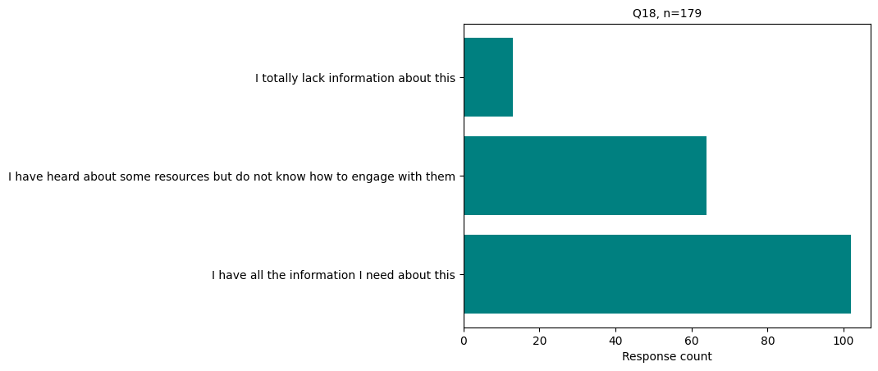

**Section 2: Microaggressions**

Q20 Have you personally experienced microaggressions by people in the IPiB/ Biochemical Sciences community at UW-Madison that made you feel uncomfortable, unwelcome, or slighted (in the last 5 years)?

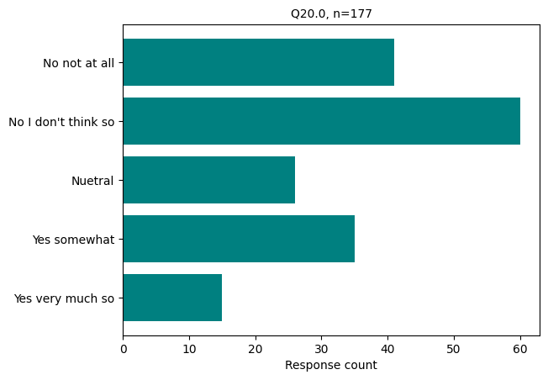

Q21 At what frequency have you experienced these behaviors?

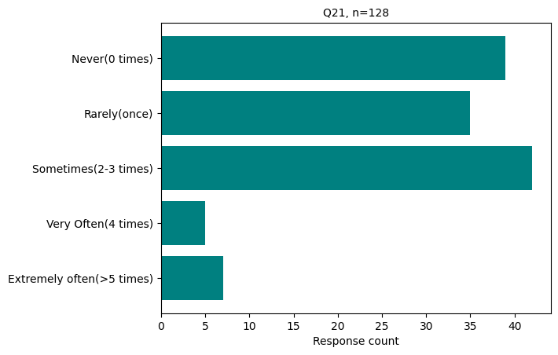

Q22 Why do you think you were targeted? Check all that apply.

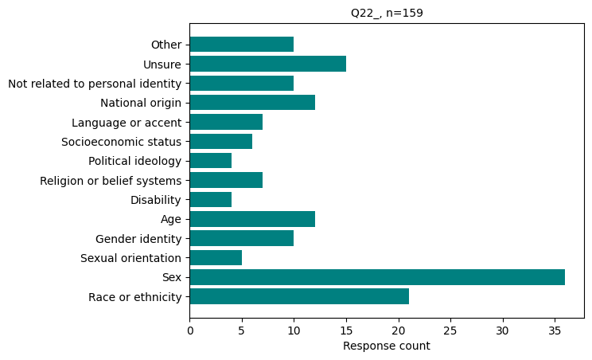Q23 Who engaged in the microaggression(s)? Check all that apply.

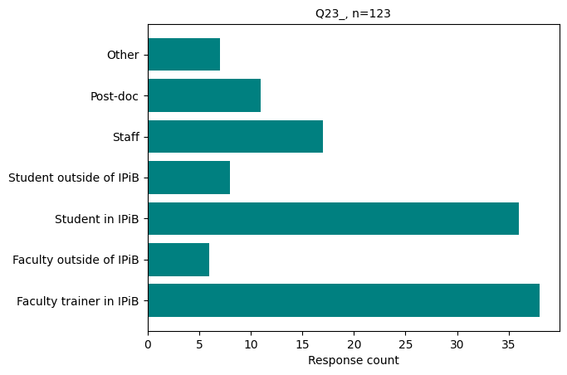

Q25 Have you observed microaggressions or behaviors among people in the IPiB/ Biochemical Sciences community that made others (those around you) feel uncomfortable, unwelcome, or slighted (in the last 5 years)?

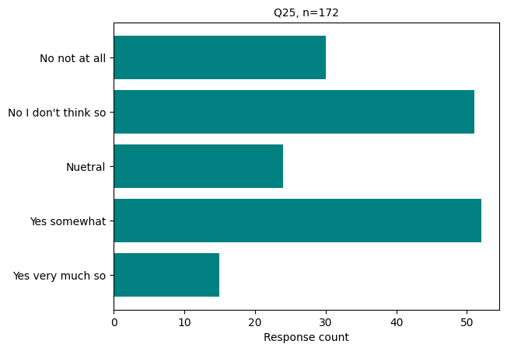

Q26 At what frequency have you observed these behaviors?

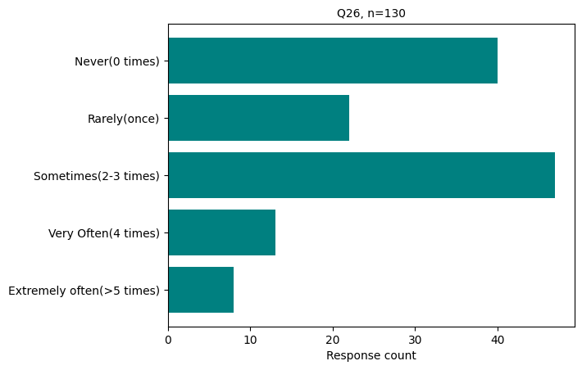

Q27 Why do you think the other person/group was targeted? Check all that apply.

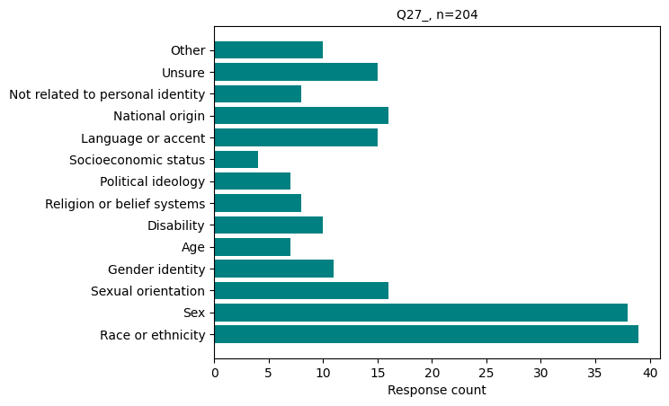Q28 Who engaged in the microaggression(s)? Check all that apply.

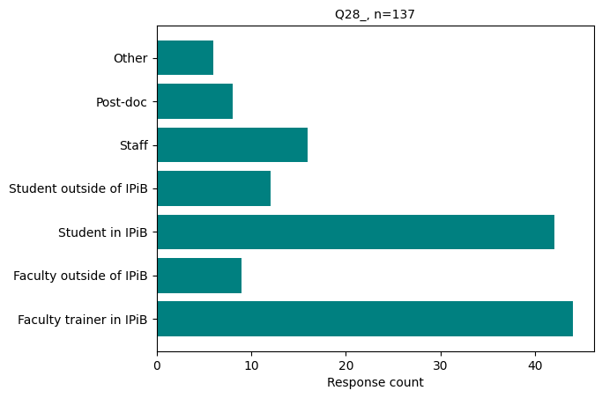

**Section 3: Hostile Behavior**

Q30 In the last 5 years in the IPiB/Biochemical Sciences community, have you personally experienced anything that you would consider to be an act of hostile, intimidating, and/or discriminatory behavior (including sexual harassment)?

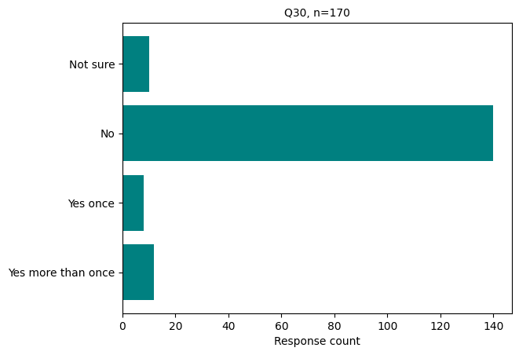

Q31 Why do you think you were targeted? Check all that apply.

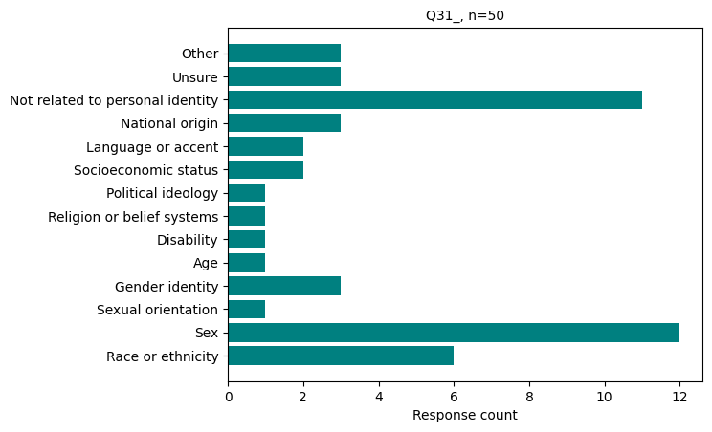

Q32 Who displayed the hostile behavior? Check all that apply.

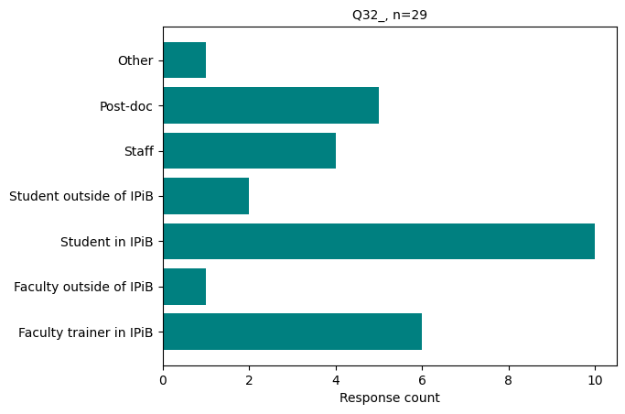

Q34 In the past 5 years in the IPiB/Biochemical Sciences community, have you personally witnessed anything that you would consider to be an act of hostile, intimidating, and/or discriminatory behavior toward another person?

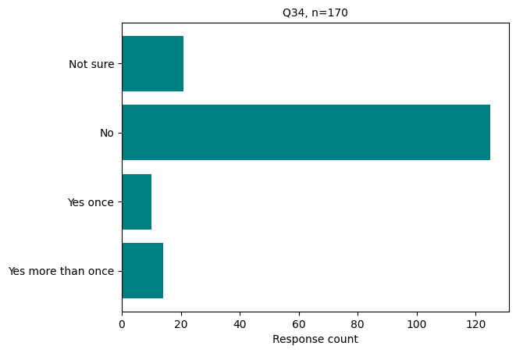

Q35 Why do you think the person was targeted? Check all that apply.

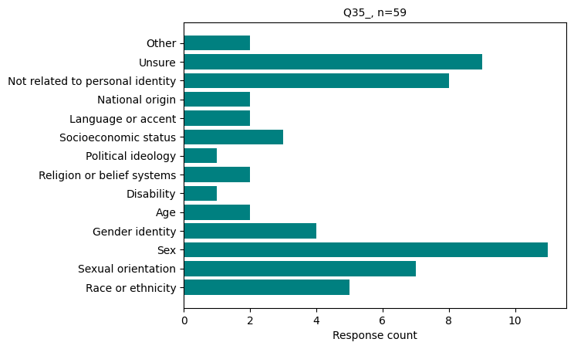

Q36 Who displayed the hostile behavior? Check all that apply.

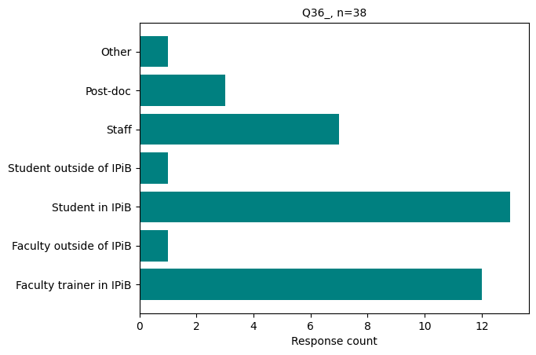

Q38 If you were to experience microaggressions or hostile behavior, would fear of retaliation hold you back from reporting?

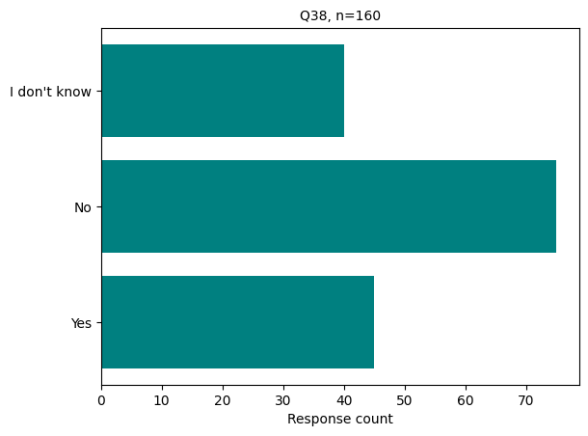

Q39 Based on what you have witnessed and/or experienced, to what extent do you agree that IPiB provides a comfortable and welcoming climate for:

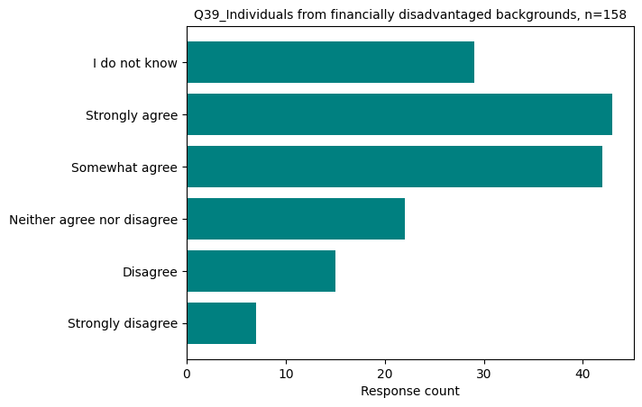

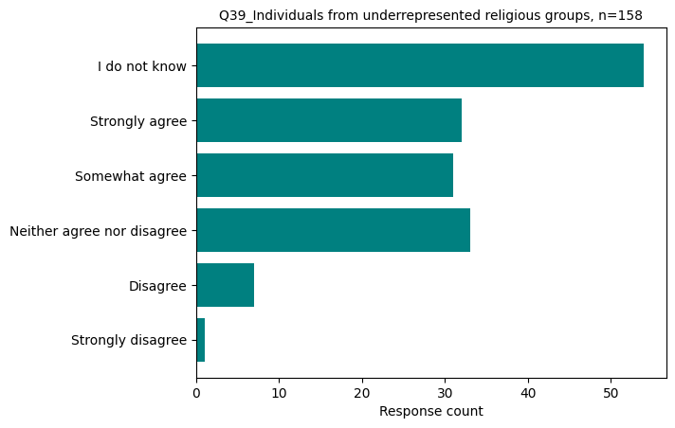

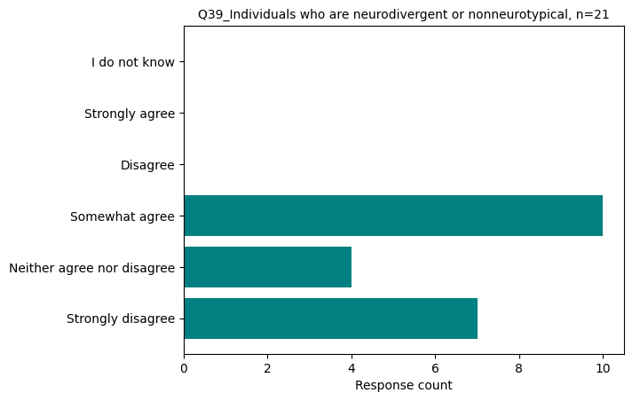

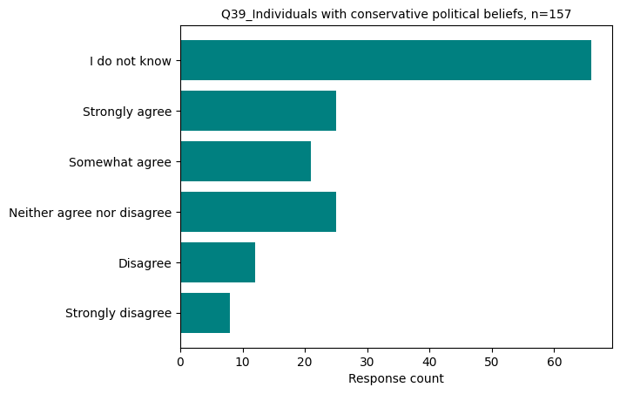

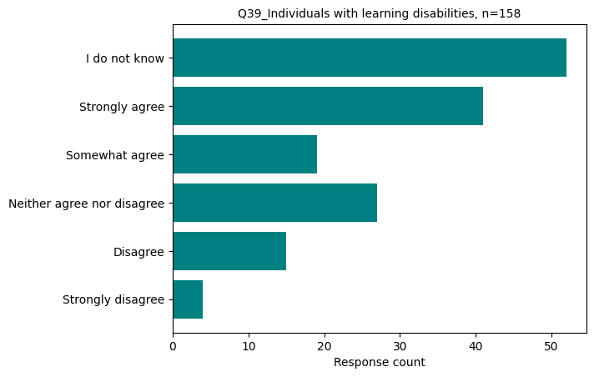

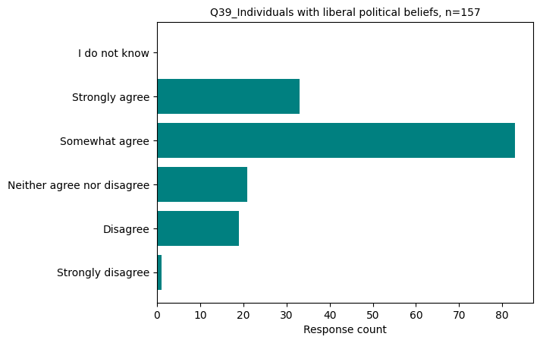

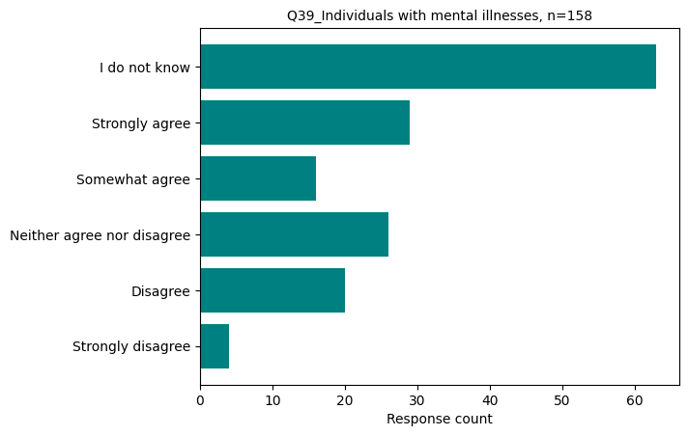

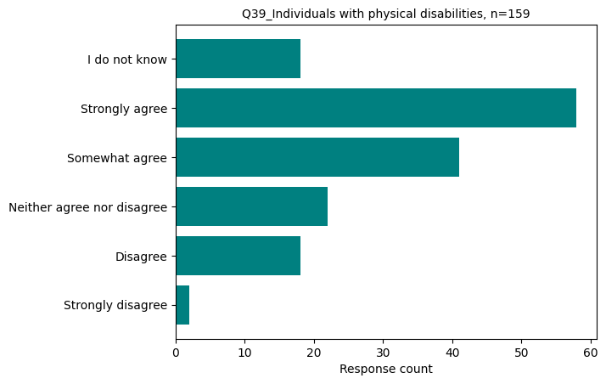

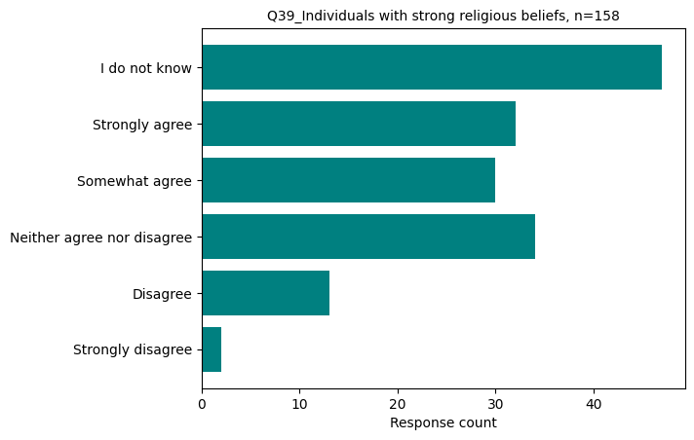

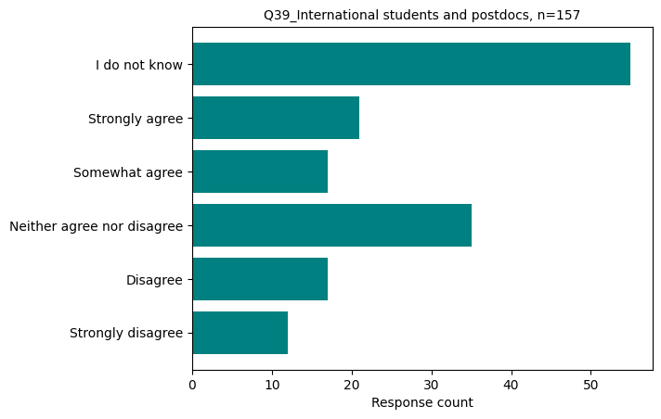

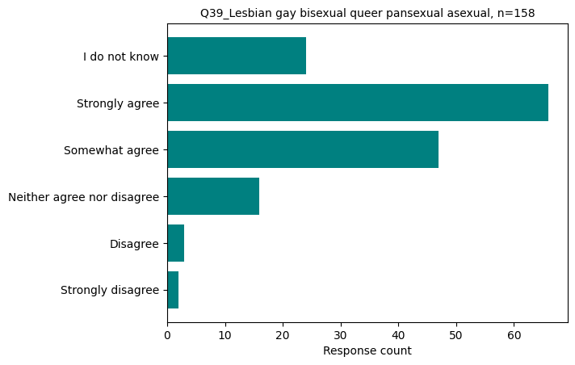

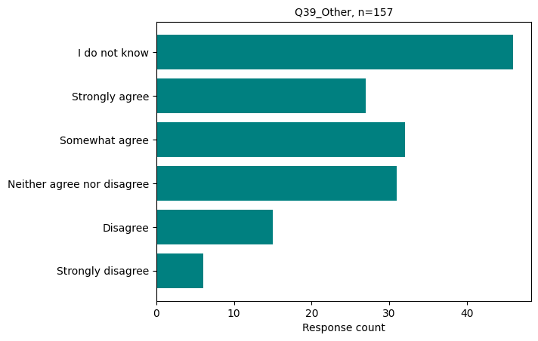

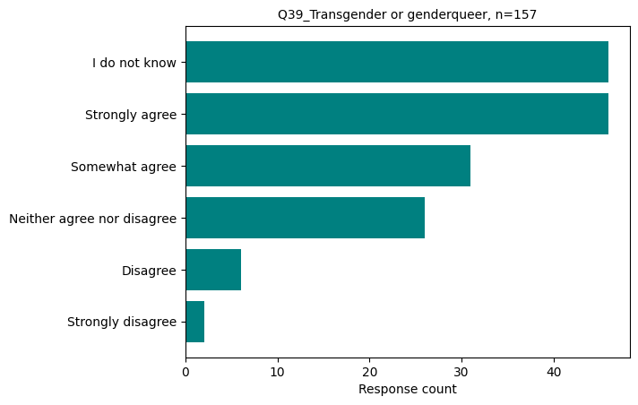

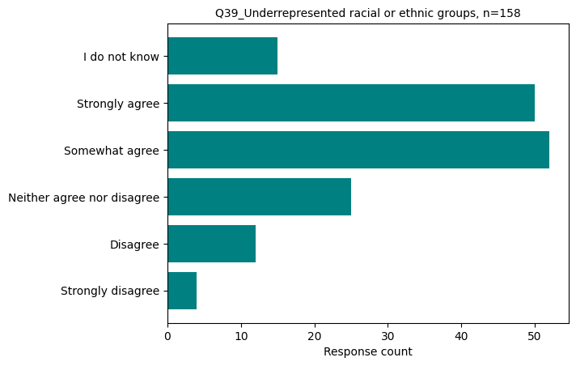

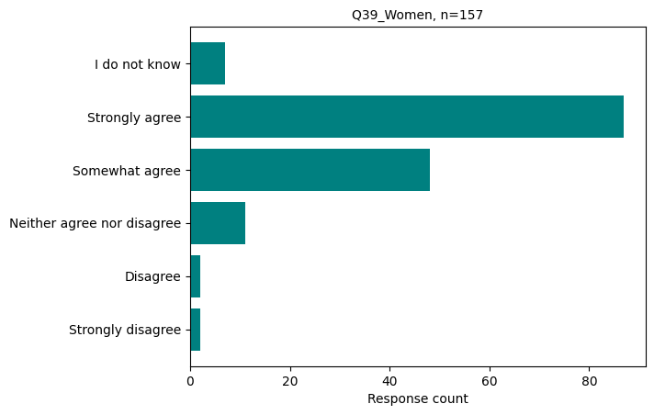

**Section 4: Accommodations**

Q40 In the last 5 years, have you requested an accommodation from an instructor, advisor, or staff member for a disability?

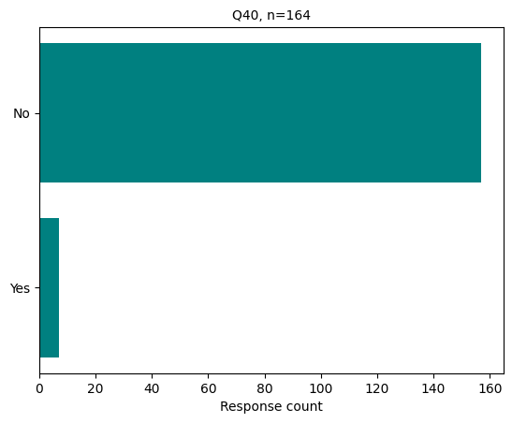

Q41 Were your requests for accommodation granted?

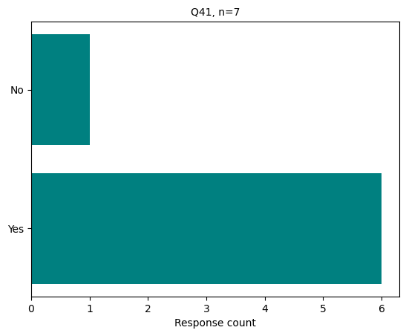

Q42 In the last 5 years, have you requested an accommodation from an instructor, advisor, or staff member for a religious observance?

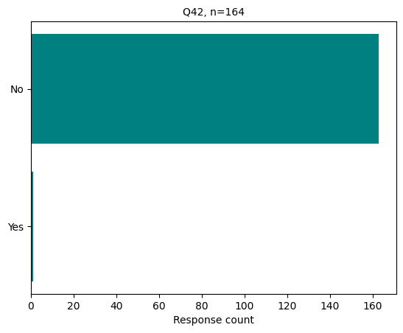

Q43 Were your requests for accommodation granted?

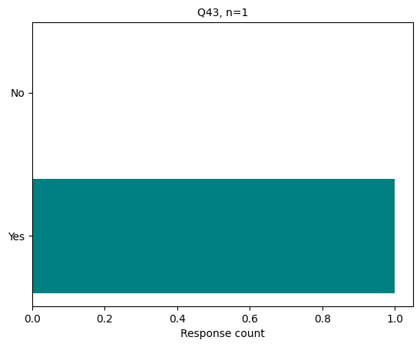

Q44 In the last 5 years, have you requested an accommodation from an instructor, advisor, or staff member for a personal or family reason?

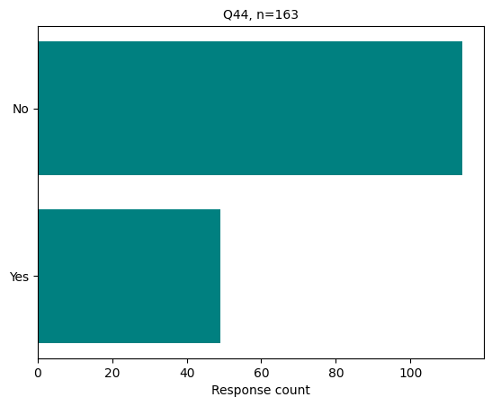

Q45 Were your requests for accommodations granted?

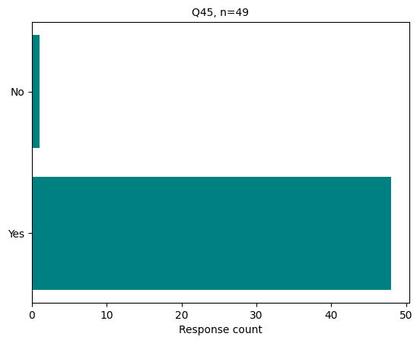

Q46 Were your request(s) addressed in a timely manner?

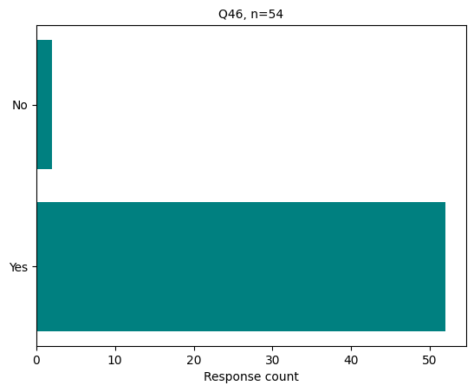

Q52 In the past 5 years, have you witnessed any member of the IPiB/Biochemical Sciences community calling out microaggressions or hostile behavior?

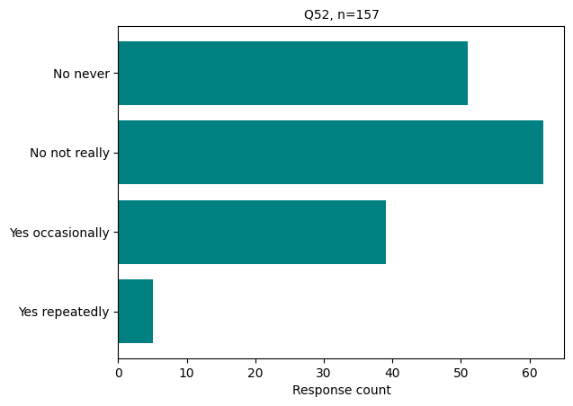

Q53 Have you witnessed any member of the IPiB/Biochemical Sciences community going above and beyond to ensure all members are respected, welcomed, and included?

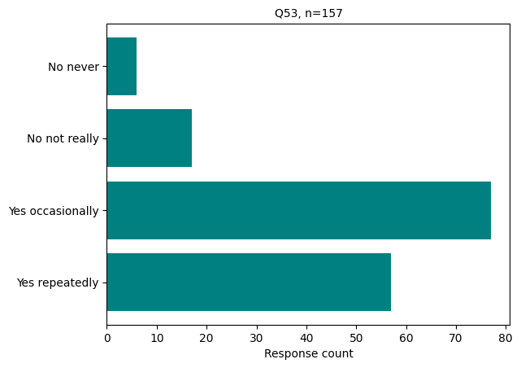

Q54 Do you feel the environment in the IPiB/Biochemical Sciences community has improved over the past year in terms of welcoming and inclusive behavior?

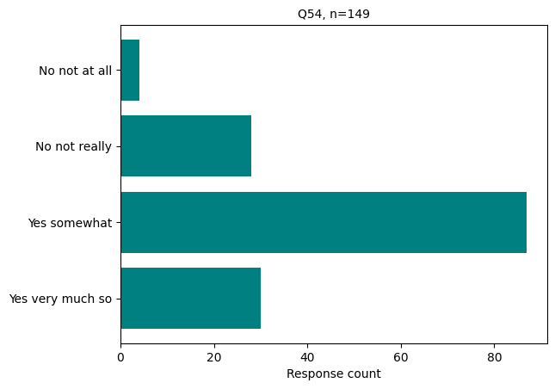

**Section 7: Leaving IPiB**

Q56 If you are a graduate student, have you considered leaving IPiB in the past year because you felt unwelcome or unsupported?

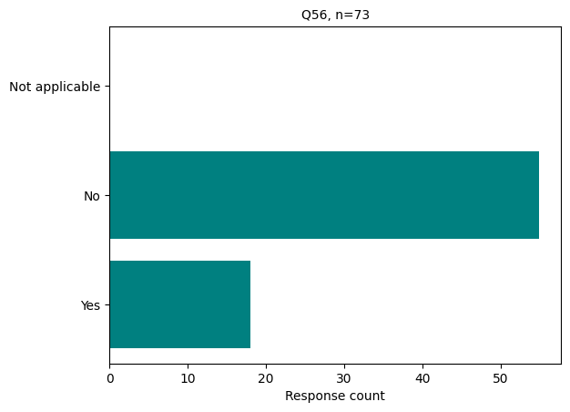

**Section 8: Assessing attitudes in the IPiB/Biochemical Sciences community over time**

Q13 Based on your perception, what percent of graduate students in IPiB laboratories do you think fall into each of the following six categories? Your responses should add up to 100%.

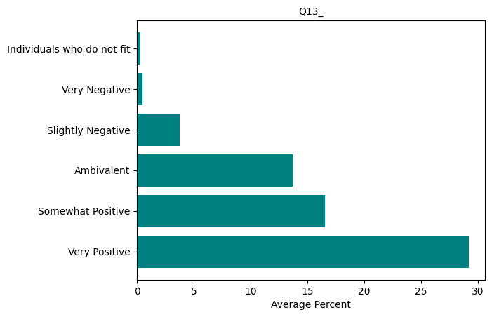

Q14 Based on your perception, what percent of **IPiB faculty** do you think fall into each of the following six categories? Your responses should add up to 100%.

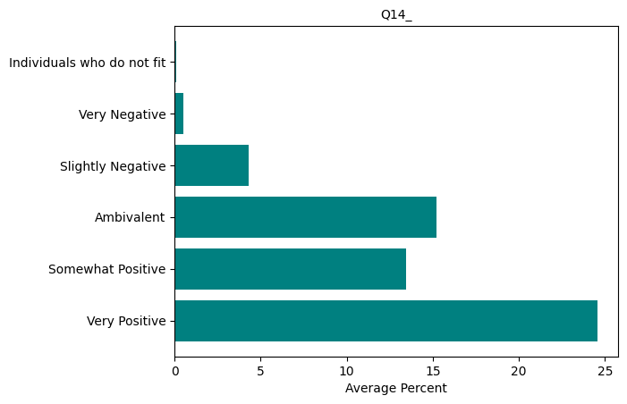

**Section 9: Demographic Information**

Q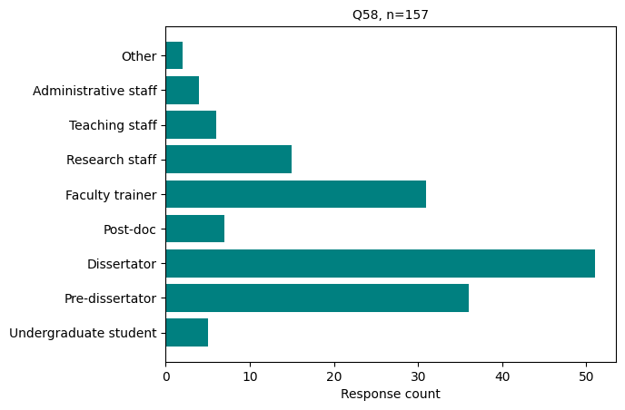58 Your current status is:

Q61 Do you identify as a member of the LGBTQ+ community?

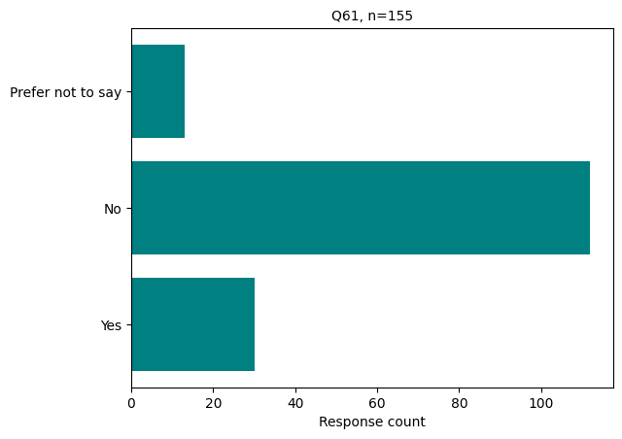

Q62 Do you identify as a member of a marginalized racial or ethnic

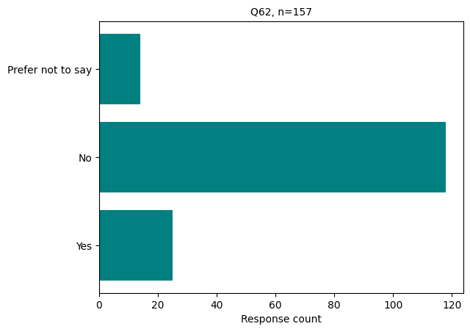

Q63 Were you a first-generation college student?

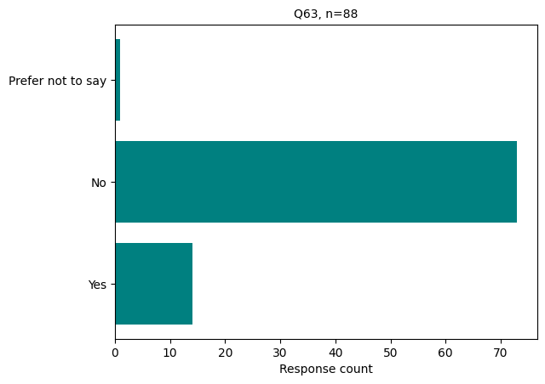

Q64 Are you an international graduate student?

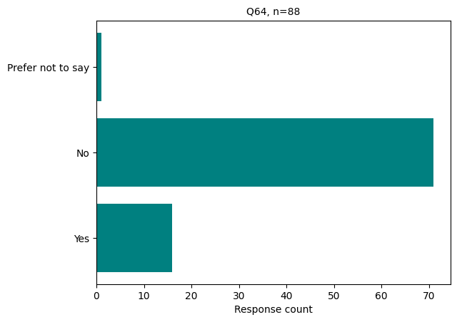

Q65 Were you comfortable disclosing your experiences in this survey?

