Columns and elutions:
- Miniprep: blue columns (30-40uL)
- PCR Cleanup after Backbone PCR: blue columns (20-40uL)
- PCR Cleanup after Digest: qiagen purple columns (10-15uL)
- Gel purification: qiagen purple columns (30uL)
- Inserts – elute in 20uL for PCR2 and 15uL for nucleotide cleanup of overnight digest, both in qiagen purple columns (PCR2 works fine with the other purple as well; haven’t tried for digest)

Things I’ve tried:
Lower cycle test – 15 cycles seems to work well, but I only get a low amount of DNA
- cleanups on x2 PCRs in 20uL gets ~20ng/ul using blue columns
Annealing test – 55.3C, 56.3C, 58.3C, 60C; all worked, but running with 55.3C
- Also ran a couple of annealing tests with other backbones that didn’t work, so once you have a good backbone best to just roll with it
Higher annealing temp – NEB suggested annealing temp 3 degrees higher than the highest for Phusion reactions
- didn’t work, still long smear
Thermocycler test (run on black vs white) – no difference, thermocycler seems fine
No DMSO in backbone PCR – works, no smear
- Digest with BamHI-HF and NheI-HF for 15 minutes, cleanup with qiagen purple columns, ligation does not work
- Digest with BamHI-HF, NheI-HF, and Dpn1 for 1 hour, cleanup with nucleotide kit and qiagen purple columns led to low amounts of DNA
Higher cycle test – 32 cycles, works with no DMSO
- cleanups on x2 PCRs in 20uL gets ~50ng/ul using blue columns
Gel Purification – gel purify from a combination of BBPCRs and digest
- doesn’t work, lost most of my DNA during digestion (using NheI-HF, BamHI-HF, and DpnI for 1 hour)
DMSO in backbone PCR – seems to work with proper templates, but always has a smear
- Digest with BamHI-HF, NheI-HF, and Dpn1 for 1 hour, cleanup with nucleotide kit and qiagen purple columns elution in 13uL led to 85ng/ul, ligation worked but not well enough (~x20)

PCR Setup:
1uL template (Can dilute template to ~10ng/ul and it has worked for me prior)
10uL 5x HF Buffer
1uL dNTPs
2.5uL Forward Primer
2.5uL Reverse Primer
32.5uL H2O
0.5uL Phusion

Cycling:
98 x 3’
98 x 30’’
55.3 x 30’’
68 x 8’
x15 cycles/32cycles to step 2
72 x 10’
10 x forever

Things that I would like to try:
- Backbone PCR with different % of DMSO below 3% (maybe 1uL or 0.5uL)
- Run with DMSO (1.5uL per reaction), digest, cleanup, and gel purify and use that as a template for ligation
  - likely need a lot of DNA. For successful digests where I’ve gotten DNA back, I usually recover ~60% of the initial DNA I’m cutting. Not sure how much of that you would lose in a gel purification
- Run with DMSO and use the nucleotide cleanup kit after the digest

Templates that work: DH10B#1 glycerol streak and DH10B#2 glycerol streak minipreps

Annealing test
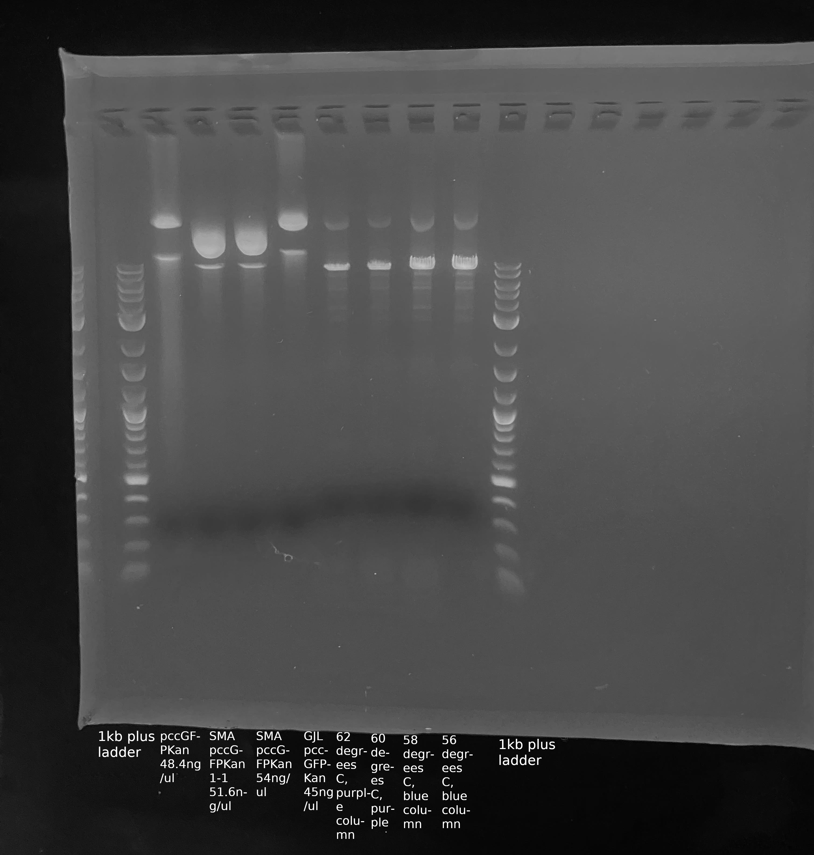

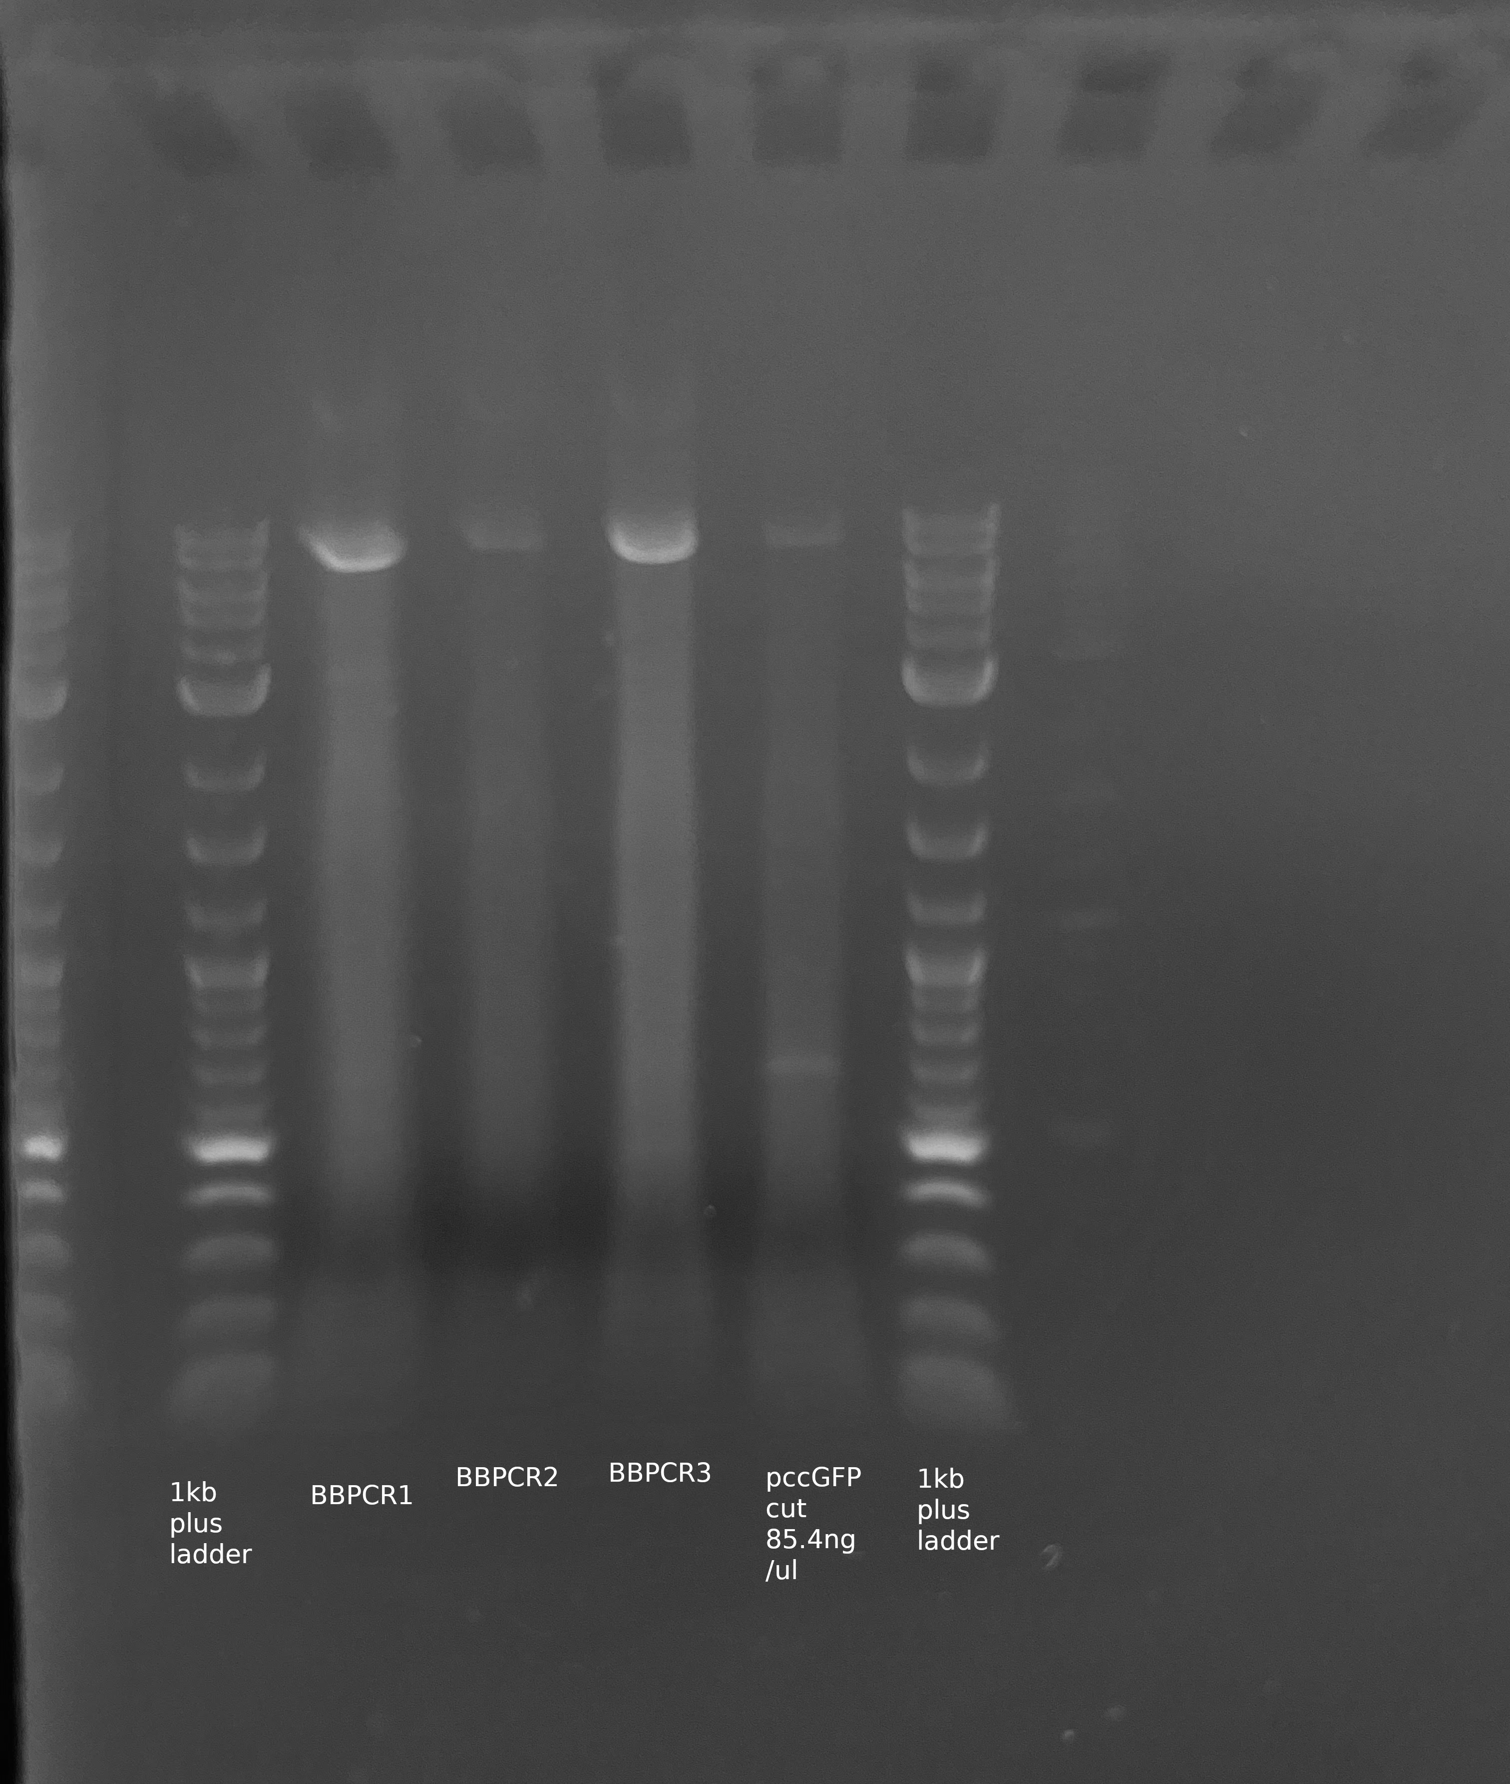
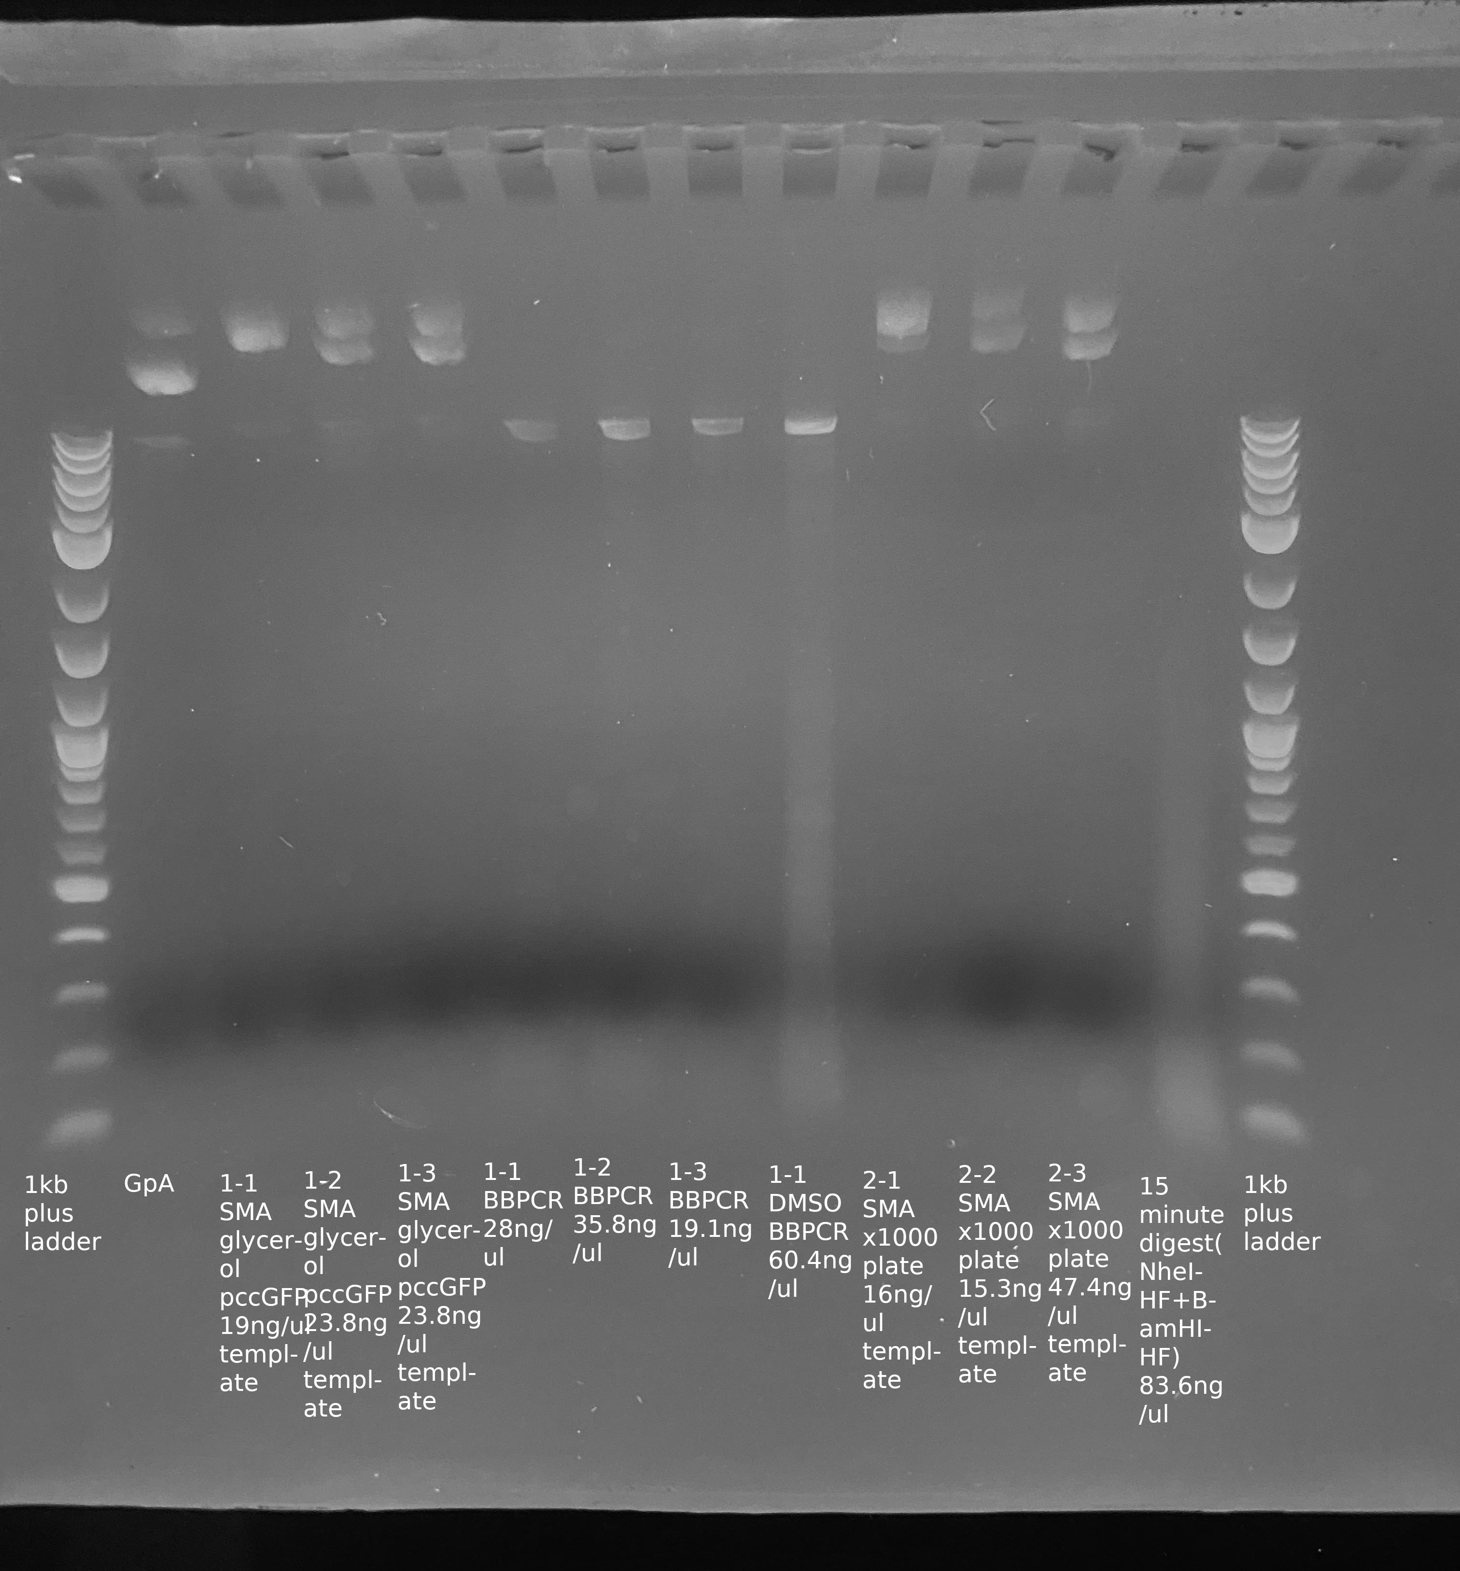
Good digest from BBPCR w/ DMSO run using DH10B#1 Low smearing BBPCRs without DMSO

