Figure 1

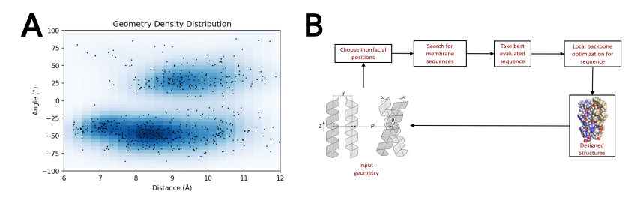
Figure 1. Membrane protein dimer design. (a) Helices within close contact (define how) were extracted from all membrane protein dimers submitted to the PDB in (date; 2019). Orientations of Proteins in membranes (OPM, cite) was used to only choose the proteins found in membranes. These geometric terms are plotted and overlaid over the density of these in space. (b) Design algorithm…

Figure 2
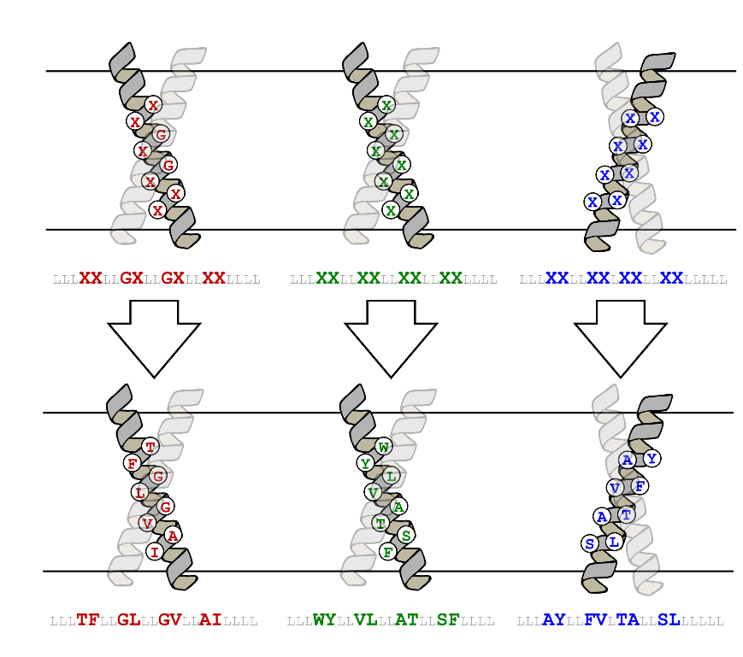

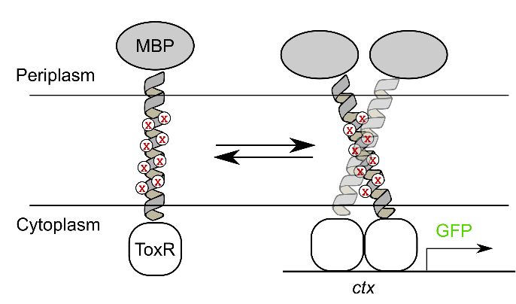

Figure 2. Controlling for expression and insertion variability. (a) [Design algorithm name] was run on a poly-leucine backbone, allowing for 8 variable amino acid positions. GASright and right handed positions are identical, while left handed positions are based on knobs into holes packing motifs found within coiled coils. (b) TOXGREEN fuses the designed protein to maltose binding protein (MBP) in the periplasm and ToxR, a dimeric transcription factor, in the cytoplasm. Dimerization of designs results in the dimerization of ToxR, and subsequently the transcription and translation of GFP as a readout of association strength.

Reconstructed fluorescence vs TOXGREEN Conversion

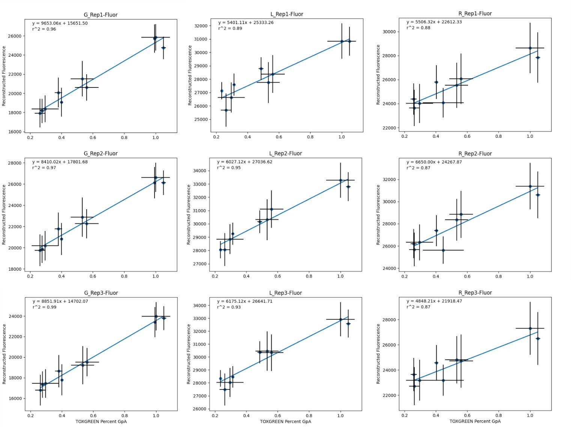

A randomized set of structures were run individually in low throughput TOXGREEN. These were then correlated to the reconstructed fluorescence for each individual sorting run and used to transform the reconstructed data for analysis.

Energy and Geometry data. Cutoffs: 0 < Percent GpA < 2, standard deviation < .15

All Data

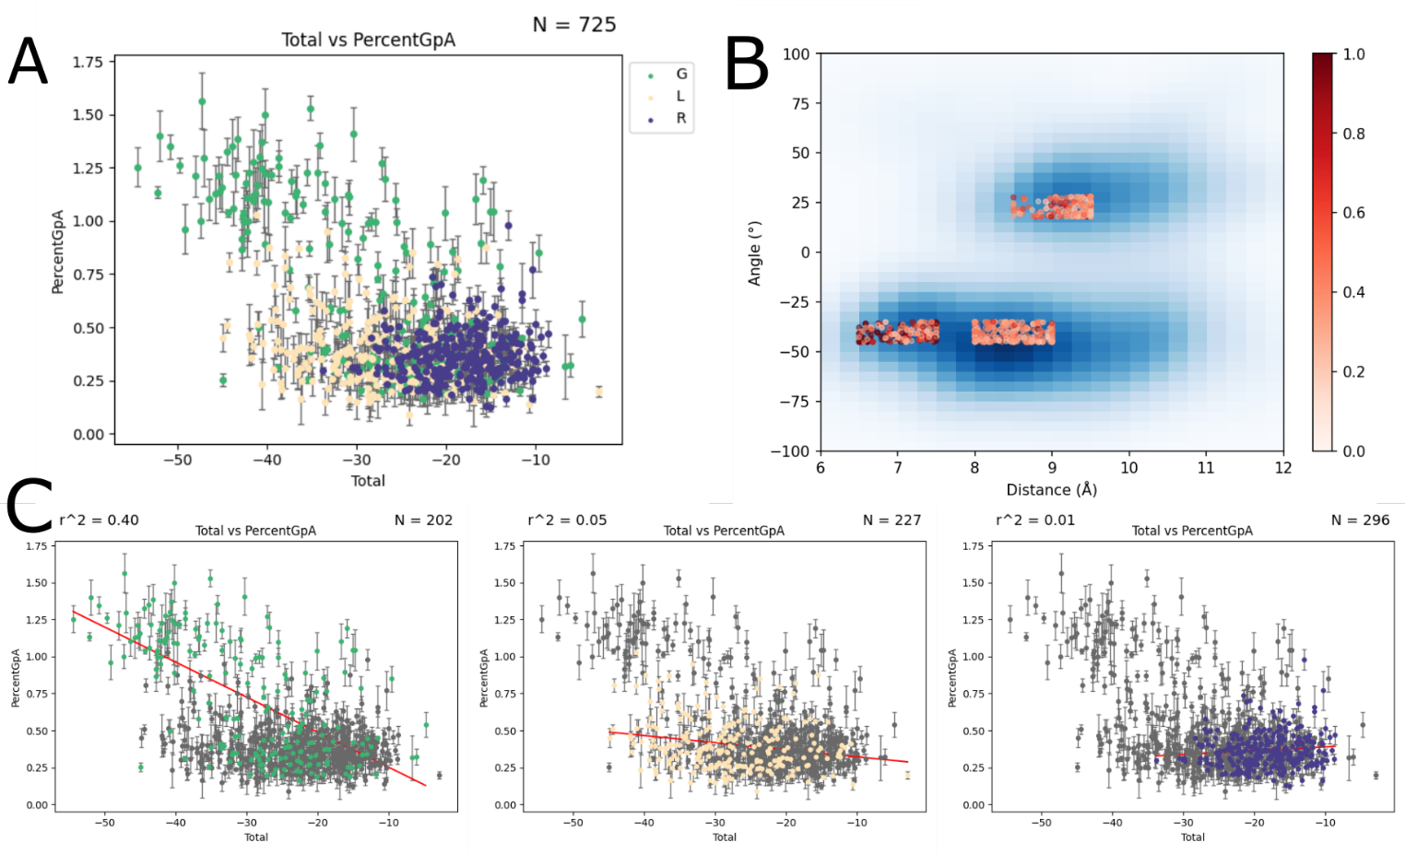

All reconstructed design sequence data. A) Predicted energy score vs Fluorescence in terms of Percent GpA. B) Geometric distribution of designs with distance on the x-axis and angle on the y-axis, with each point showing Percent GpA as the redness of the point increases. C) Separated distributions and correlation coefficients of energy score vs fluorescence for each design region

Clashing data v1: At least 1 clashing mutant must be below 35% GpA or less than 50% GpA of the WT design.
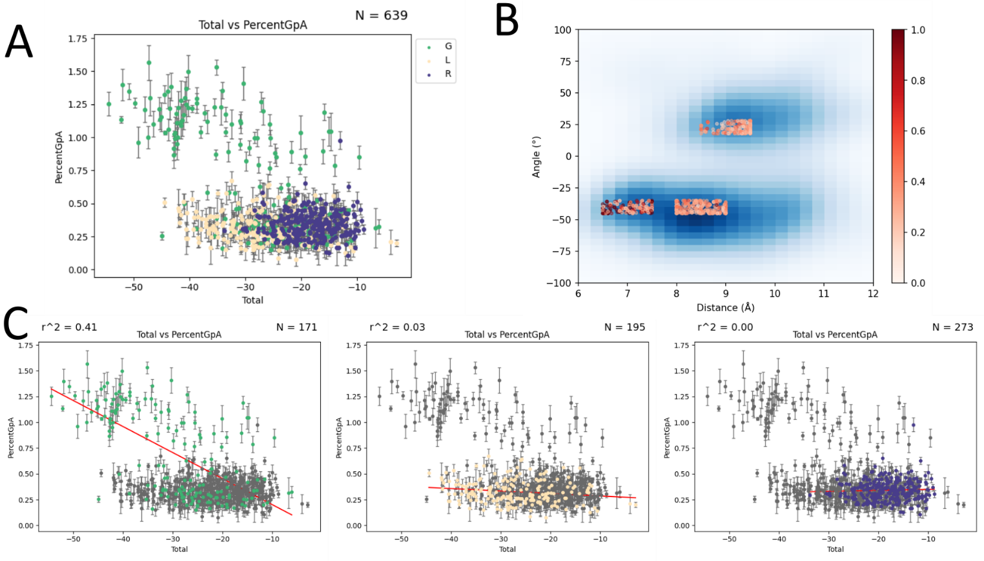

Clashing data v2: At least 2 clashing mutants must be below 35% GpA or less than 50% GpA of the WT design.
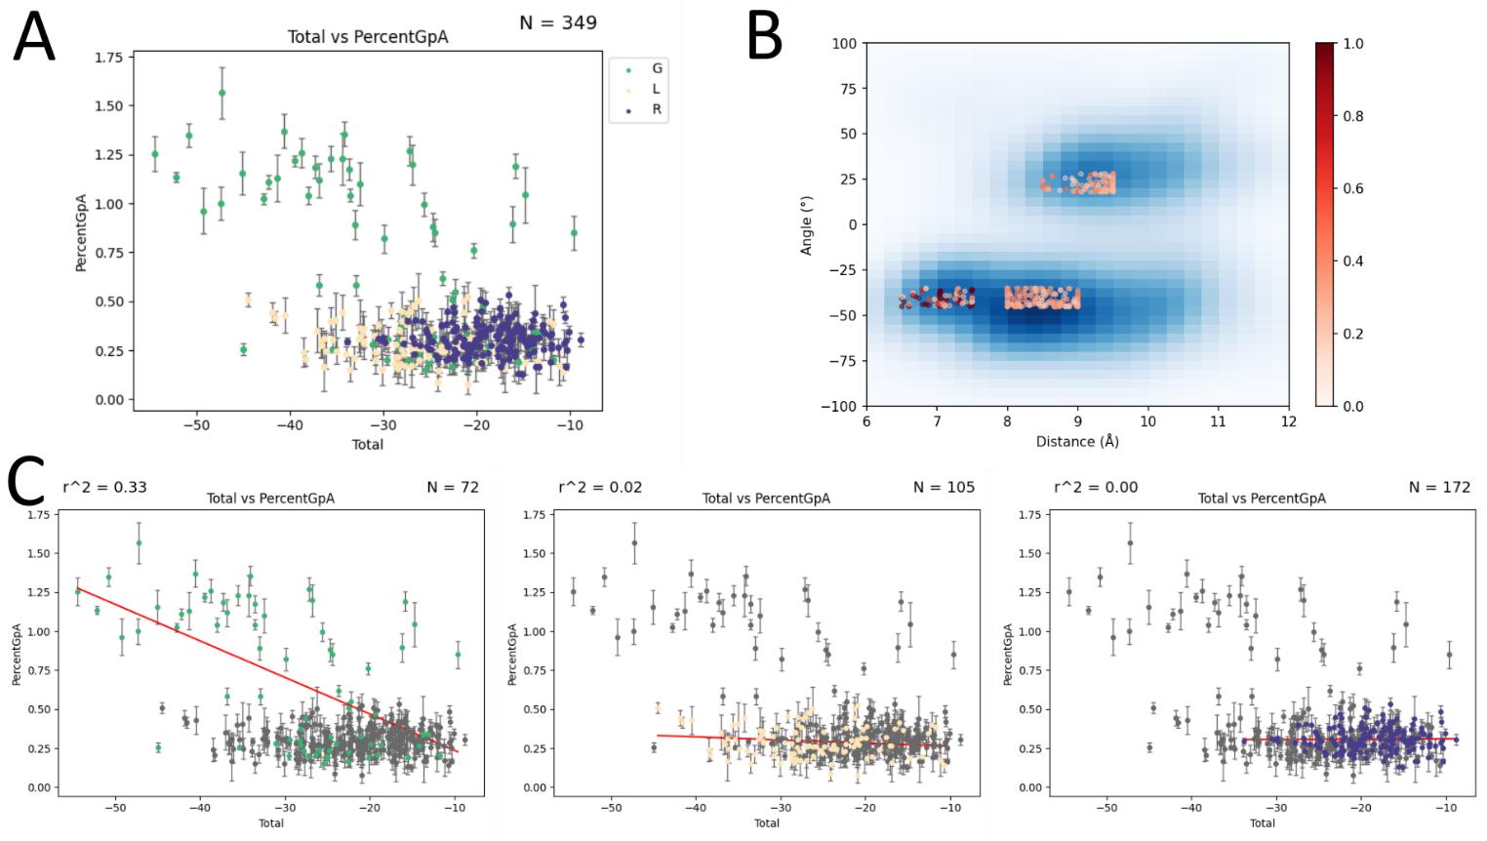

Clashing data v3: At least 1 clashing mutant must be below 35% GpA or less than 75% GpA of the WT design.
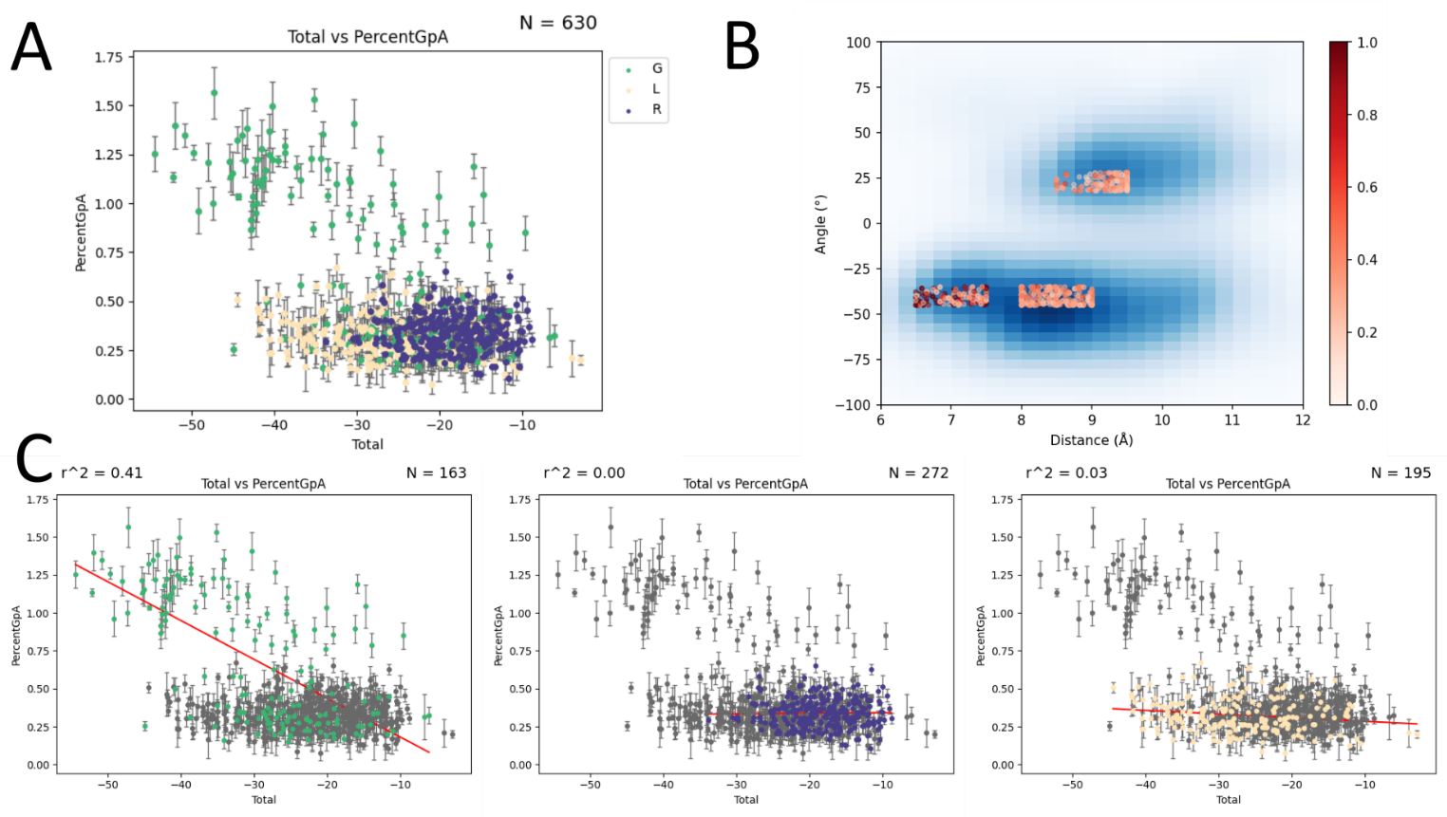

Clashing data v4: At least 2 clashings mutant must be below 35% GpA or less than 75% GpA of the WT design.
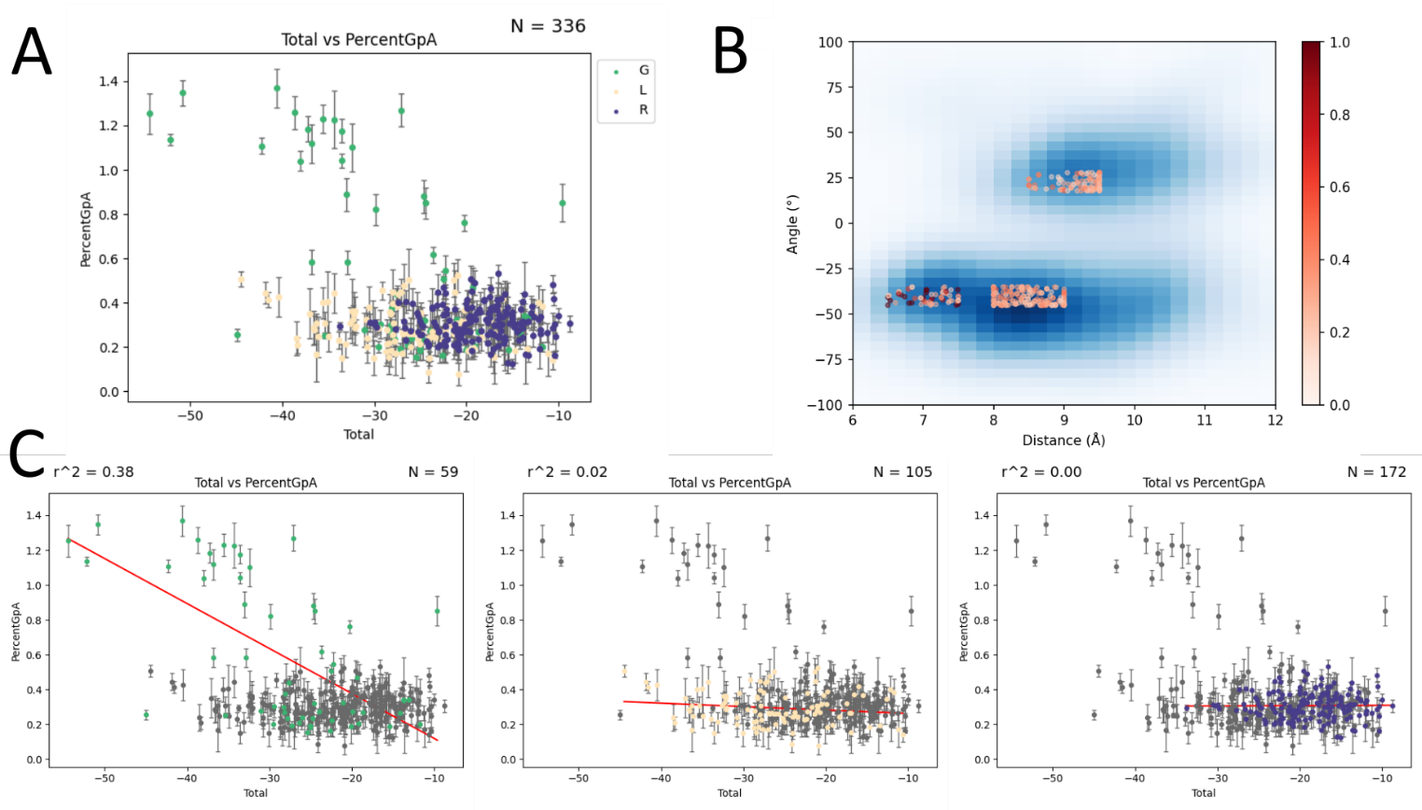

Sequence analysis
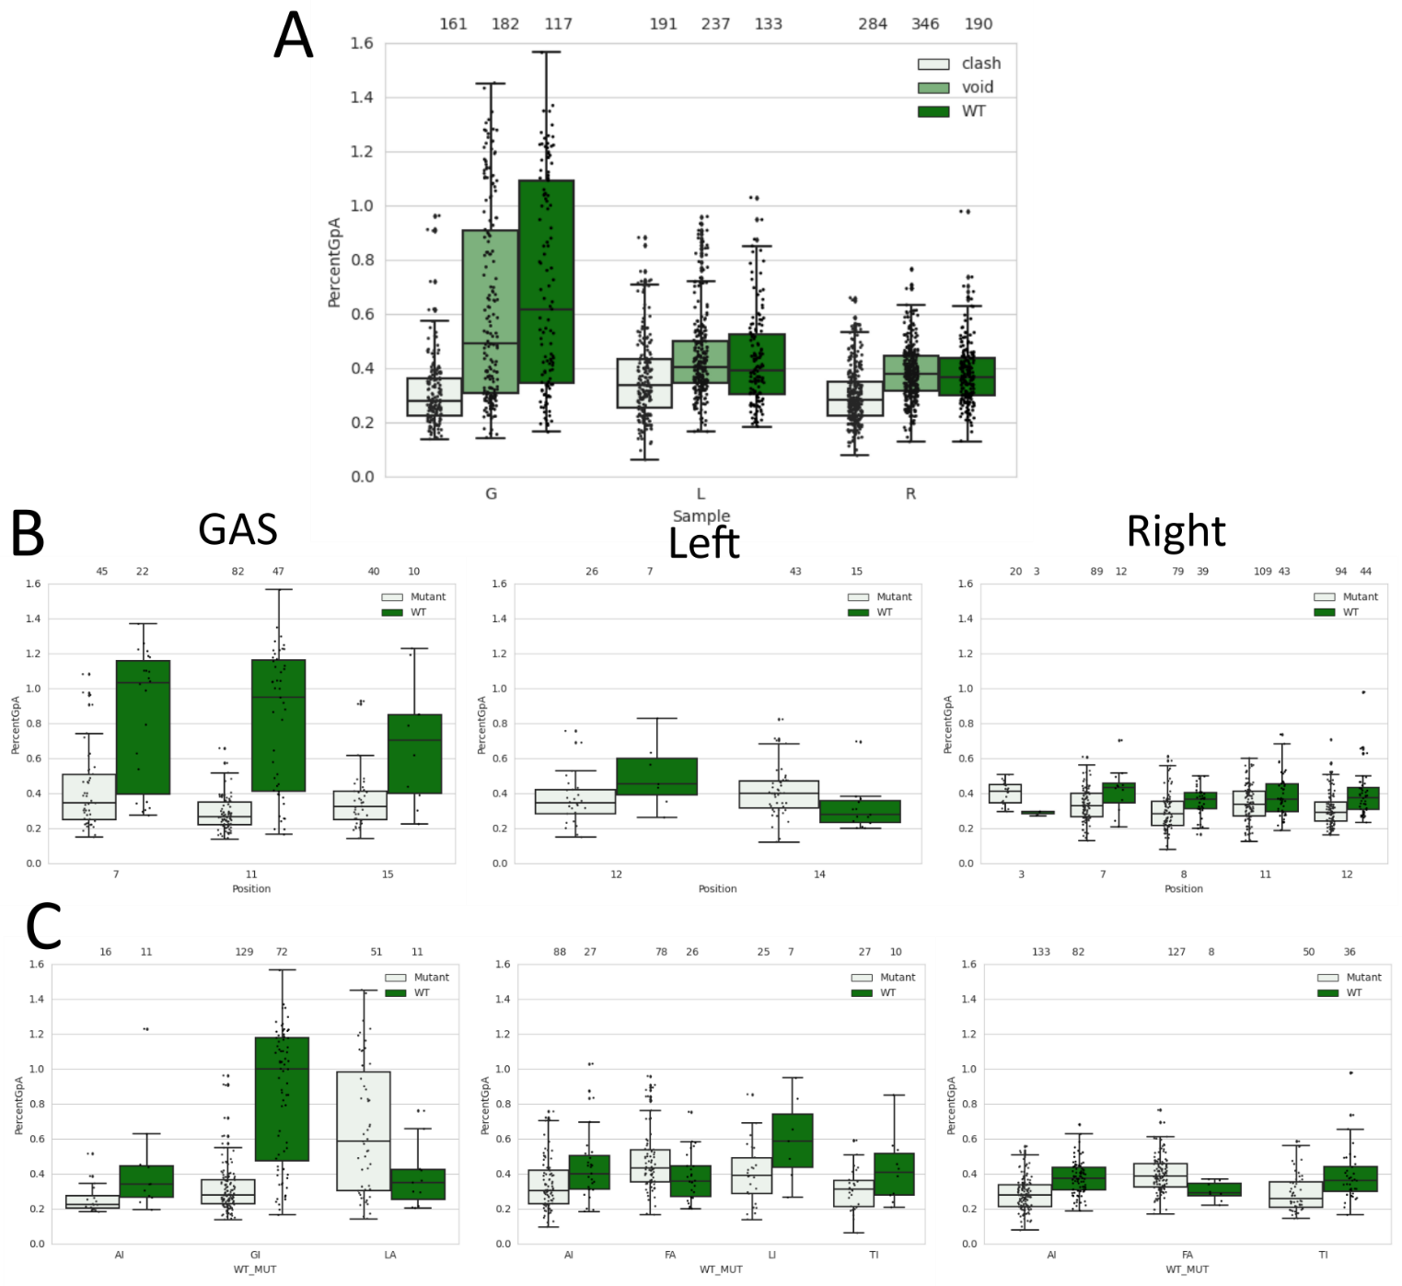
Designed sequences with at least 1 clashing and 1 void mutant present in the reconstruction were analyzed to determine sequence rules for each designed region of interest. A) Plot shows the fluorescence distribution of WTs vs mutants as separated by mutant type (clash and void). B) Plots show fluorescence distribution of mutant positions that have significant difference between the mutant and WT designs. C) Plots show fluorescence distribution of WT amino acid to mutant amino acid combinations that have significant difference between the mutant and WT designs. p-value < 0.05 for each region. GASrights are known to have a GxxxG sequence signature, which is validated in figure B. Additionally when glycine is mutated to isoleucine, there is a significant decrease in fluorescence. This data may suggest that these are significant positions/amino acids for association in the left handed and right handed design regions. For B and C, the p-value for each x-axis value is calculated between mutants and WT designs. Each of the combinations in B and C have a p-value < 0.05.

