* Lyrics: ***TW Cen MT***
* Titles:

**Why I’m writing this chapter-Flipside postlude**

A PhD ends in a finish full of triumphs: a published paper that will be used to inform the world of your research and a final defense that allows you to showcase all you’ve learned as an expert in your field. These triumphs are the fruits of intense labor and rigorous mental fortitude, but more often than not research is presented without mentioning the mental toll and important life moments that it took to succeed. Throughout graduate school I’ve missed out on holidays with family and friends, I write this chapter to identify with anyone who has ever felt inadequate, who has suffered from imposter syndrome, and who throughout failure nearly gave up. This chapter highlights my journey into a world of knowledge and success that I never thought I would have, and I hope it gives you some perspective on the daunting process that it takes to become an expert in an area of learning.

More personally, I feel that I haven’t truly been alive for most of my graduate school career. I’ve ignored family, friends, and the world in a way that I’ve never had to do before simply to try to succeed. The rest of the thesis is research and work, and when I saw this opportunity to write a personalized chapter, I couldn’t say no. I wanted to have a way to share more of my experiences with the people who haven’t gone through it and anyone who is curious about the mental toll that it takes to complete a PhD. Of course this experience isn’t universal I’m sure, but if you’re at all interested in what a minority experiences or feels throughout a graduate school experience, I hope to give you a bit of perspective by reflecting through music.

Before I started writing this chapter, I asked myself how I could best personify this experience in a form that I feel embodies what I have gone through over the past 6 years. I’ve always been a fan of writing lettersAlongside these songs, I’ve shared reflections on my journey filled with the joys, the learning, and the despair that I’ve personally experienced throughout my PhD. Feel free to read this chapter however you like (I preferred writing them with the songs of interest on repeat!), and I hope you enjoy the songs and stories that I’ve placed here. Thanks again for reading, and best of luck on whatever journey you are currently facing :D.

**Definitions**

Imposter syndrome

Protein design

Atom

Training grant

Dear PhD,

And so we begin. We’re going to be together for the next 5, 6, maybe 7 years, so I thought that it would be a good idea to start writing. Even if it’s just for myself as something to look back at afterwards, I want to have some of these learning experiences written down to reflect on. I know you can’t write back, but writing to you feels like it will be cathartic. I guess first off: Thank you for accepting me. I never thought that I would do a PhD. My undergraduate mentor told me that it might be a good fit for me, but even now that I’ve been accepted I don’t feel completely at ease.

Early on in elementary school, I told my mom that one day I would become a doctor. I don’t know if it was slightly based on Asian stereotypes, or because I thought that I would like to help people, but doctor felt right to me. At that time I only knew of medical doctors and I know that this PhD doctor isn’t the same, but it’s a bit validating to see the path to something that I imagined years ago coming into view. Although I still know so little about a PhD: What’s the end goal here? A lot of the interviews talked about doing independent research on a project, and I’ve dabbled with my own project in undergrad, but how is this process different? I guess I don’t know what it means to be a PhD yet, but I think if anything I’m excited to meet people who are excited about learning.

Oh! And in each of these letters, I thought it would be a cool little detail to share a song that I feel captures the content for the letter. So here goes:

**I do**

These are lyrics from a song called **Flipside-postlude by Kid Quill**. The song follows an argument between two people, where one person doesn’t seem to understand the importance of records to another. It eventually culminates in this passionate remark “I do”. To me, this song is about having ideas, passions, and experiences that you want to share, but not being able to do so. It’s about wanting to be heard. I hope these letters reach you and that you’re able to understand the experiences that you’re putting me through from my perspective.

Thanks for reading and I’ll catch you next time!

Gilbert

**Something Comforting by Porter Robinson**

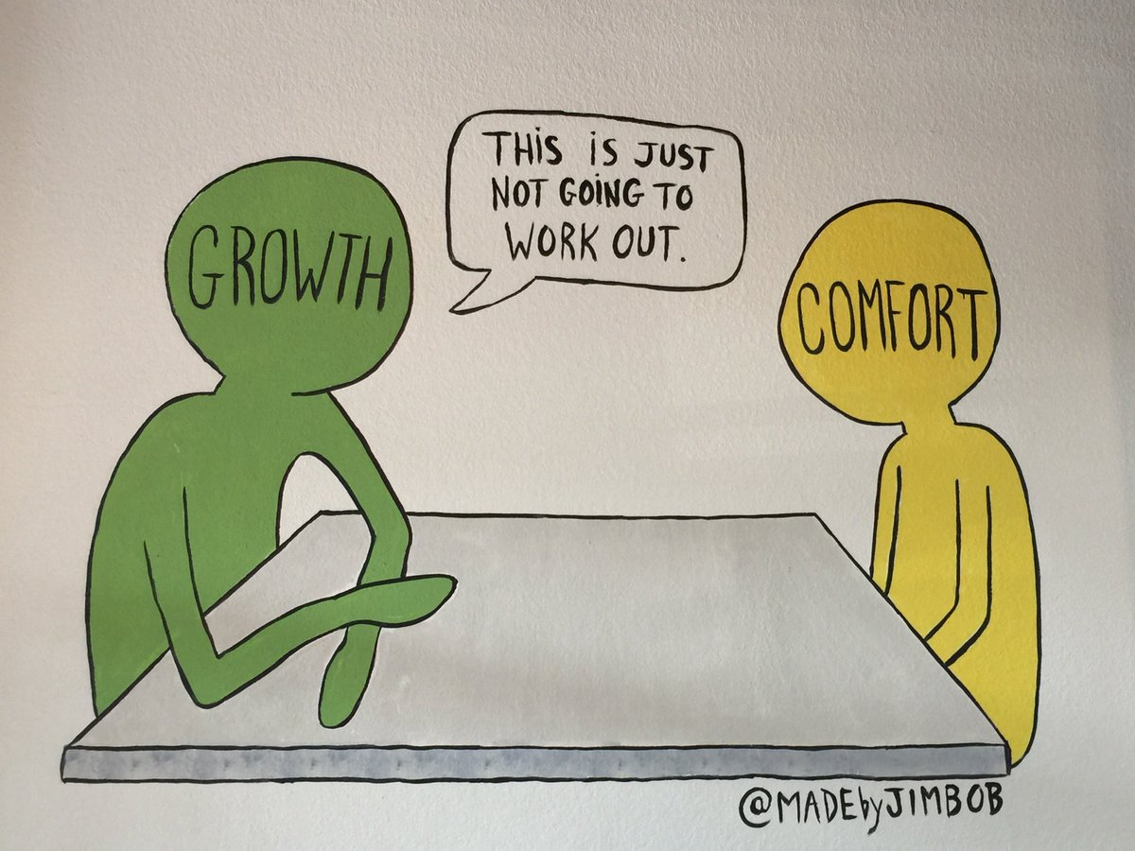

Dear PhD,

I found this little cartoon about growth and comfort, and I think it kind of embodies what I need to do to maximize my experience in graduate school. So here in my first year of graduate school, I noticed something different about the classes. Instead of lectures, professors hold classes as an open conversation; the lesson plan isn’t strict, aiming to maximize the time we had to discuss what we as students were most curious about.

“What are your goals with your graduate education?”

Instead of talking strictly about hardcore science, one of our professors gave us an opportunity to share some personal goals in an open space. But no one raised a hand.

“Gilbert, what about you?”

“…I’m not sure”

“That’s okay, just say anything that feels right.”

*After what felt like 5 minutes of silence:*

“I want to find a way to replace PowerPoint.”

“Okay! Why is that?”

“I feel like there are some weaknesses in how it is used to teach and I think it would be cool if there were something better.”

I look back on that day with a bit of fondness. I’ll likely never revolutionize the way that presentations are being done. But being asked to speak my mind and to share an idea of a thought really empowered me. Rather than allowing me to be comfortable and not even try to share my thoughts, I was called on and it allowed me to grow. And by my professor asking “why” instead of “what?”, my mind was allowed to drift and think around a non-fully formed idea.

I know I’m just getting started, but I wonder if experiences like these are what helps mold us into PhDs. Hear me out for a second: this growth mindset out of situations that might not necessarily be comfortable could help embolden me in the future. I’ve never really raised my hand or asked questions in classes, but I recall past experiences where I’ve found the most comfort in a class when I’m called on to share. It’s like the teacher’s confidence in me builds me up to be more confident in myself. And then on the other half of this experience: My professor asked me “why”. And I’ve started to see other professors doing the same thing. A lot of questions in graduate school haven’t been looking for a particular answer, but rather having me question why things are as they are.

And that brings me to my research. I don’t need to tell you much since, well, you are my research. But this question “How is membrane protein association influenced be van der Waals packing?” is quite a complex one. I’m beginning to wonder what the why’s of my research might be, and hopefully I’ll have an answer to that in the future.

***'Cause getting made you want more  
And hoping made you hurt more  
Oh, there must be  
Something wrong with me***

*Something Comforting* by Porter Robinson

This time around I picked Something Comforting by Porter Robinson. I think it kind of fits this idea of growth out of your comfort zone, but it also matches that feeling with this feeling of doubt. I’m currently excited to learn, and happy to ask why. But I think with experiences like this there are likely going to be some difficult times ahead. Times when I’ll tell myself that something is wrong with me for staying on this path of learning despite being so outside of my comfort zone.

Gilbert

**Prelim 1**

**Atlas by keshi**

Hey PhD,

It’s been a minute.

I just had my preliminary exam, which is kind of the test that puts me on track to really be able to succeed here. The preliminary exam put me into a room with 5 professors who each have many scientific publications to each of their names. For an hour and a half, I stood in front of them talking about the beginnings of my project that I’m supposed to be the expert of AND complete within the next 4-6 years. They asked me questions about tiny details I hadn’t yet thought about, and expected me to tell them the right answers:

“What’s the definition of van der Waals?”

“What will you do if this experiment doesn’t work as you expect?”

“If a tree falls in a forest and no one is around to hear it, does it make a sound?”

I left the room to allow my mentors to discuss how I did. D*eflated, exasperated, mind afloat*, *I finally remembered to breathe.*

“Did you just finish your prelim?”

I nod to the student passing by in the hall.

“Congratulations, the worst part is over”

After a what felt like an hour, I’m called back into the room.

“Gilbert we’d like to thank you for the presentation. We think your progress has promise, but we can’t give you a pass at this time. There are some weaknesses…”.

I started tuning the rest out. They didn’t say the word, but I knew what it meant. *I failed.*

“…However, we do think that you’re making progress and look forward to seeing you have another opportunity next year.”

In my last letter I said that I expected some difficult times ahead…but this is far from what I expected. Not only do I not pass, but I actually get another opportunity to try again. For many prelim exam failures, there is no second chance. And even with this second opportunity, knowing I have to move on from this grueling, heartbreaking moment just to do it all again admittedly just makes me even more anxious. And with this anxiety comes along many suppressed observations creeping in my head:

* I’m one of the few black people in my research program
* I’m one of the few people who fail prelim
* I’m one of the few people who get’s a second chance
* Could the reason that I’m one of the few black people here be because I’m not actually supposed to be here?

***I don’t belong here, let me start over***

***I wanna sleep so wake me up when I’m older***

*atlas* by Keshi

Picture of atlas

I think this song fits how I’m feeling: wanting to cry all the time, this feeling of being overwhelmed, with a hint of just wanting to be better. Keshi alludes to these feelings by using the titan Atlas, known in Greek mythology for being condemned to hold up the sky. Having an immense and what feels like impossible weight on your shoulders and having to live with it. These lyrics play in the second verse, and I feel them constantly pulsing through my head. Why do I feel like I don’t belong here? Why do I just want to sleep everything off? Thanks for taking the time to read through these blurry thoughts.

Gilbert

**Black in STEM/Imposter Syndrome**

**p r i d e . i s . t h e . d e v i l by J. Cole**

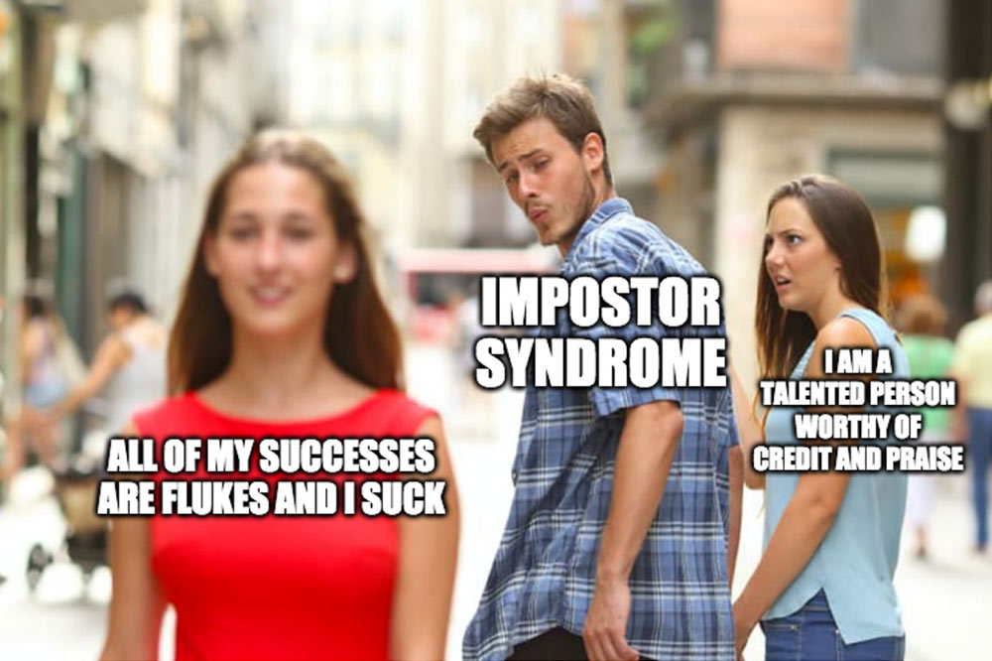

Hey PhD,

I know we’re not on the best of terms right now, but I’d like to share with you some of the things that are causing this rift between us.

One of the most difficult parts of being in grad school in Wisconsin is the lack of diversity. Whether it be in the types of food or people, this place has a small amount of students that look like me. And when things go either positively or negatively, I wonder if it partially has something to do with my race and ethnicity.

At the end of my first year in graduate school, I applied for a program that would fund my graduate research. The application and interview process were quite interesting, asking me to give an elevator pitch on my research. Friends of mine also interviewed for the program and we eagerly awaited the response, hoping that we’d all get in. When the email arrived, I scrolled down to the accepted names and saw mine, but no names of any of the my friends. The next time I ran into one of them, we chatted about this and the interview process, and they wondered aloud why I was accepted instead of them. And I personally felt how engrained this idea was in the moment when I responded:

“They’re going through a review process this year, and there aren’t many minorities in the program, so they might have wanted to increase diversity”

I attribute both successes (this program) and failures (prelim) to my identity rather than my entire self. It’s not that I don’t I think I have the ability to succeed, but because I know how the world perceives me, I perceive myself in the same way.

***Terrified, paranoid, I'll put you over everything to fill the void  
And when you’re gone, will I have anything or will I be destroyed?***

So this is kind of the thing that is sticking with me right now: … Graduate school has taught me to see myself in a slightly different light: I’m made up of my experiences, and many of those experiences have been quite negative to my perception of myself. Like imagine … allusion/movie reference. In order to figure it out I realized that I would have to focus even more on myself. Shutting out many relationships in order to get past this part of my life. I wanted to learn enough to pass my second prelim, and to do so I needed to learn a lot of science and about myself. (can I tie this in to earlier with my learning about my voice?) …needs work here…

**Post prelim I always wanna die sometimes**

Hey PhD,

I think you’ve pushed me both emotionally and intellectually than I’ve ever been pushed before. And I’m not yet sure if it’s a good thing or not.

A few months ago as I was waiting for the bus, I had this dark notion. My head felt heavy and everything appeared to go black. I could feel that my eyes were open, yet things looked motionless, grayscale. Intrusive thoughts flitted in and out while I waited for the bus.

“What if”

*You’re just tired*

“you could”

*you’ll be okay soon*, “just” *a bit longer*

*…but it’s more than a bit*

“jump”

*…there’s a lot left* “in front of” *you to do…*

*should you eat today*

“the bus” *is here*

I’ve had bouts with depression in the past, but this time was different. Life felt…emptier. I’ve wanted to disappear before, but never to the extent that these intrusive thoughts would be so clear and relentless. And after a month of being unable to shake them, I returned to therapy.

Stating things is freeing. Usually I’m able to listen to the thoughts in my head, rationalize and reflect on them. But this time was different. After failing my prelim, I’ve been more of a shell of myself than ever before. I don’t want to spend time searching for new things to do, and I’ve lost a lot of enjoyment in the things I loved. I’ve struggled to hold myself together: friendships are dying because I feel inadequately supported, I don’t eat anything because I’m too focused on getting past this event, my mental health is fading and I can feel myself losing motivation to live. I’m not sure if it’s a result of a combination of these things or something entirely different, but I’ve recently found myself having moments of paralysis: Moments where I’m unable to get my brain to move my body. It’s a scary thing: to be able to think “Move”, “get up”, “go over there” but my body instead lies motionless, unresponsive.

In therapy I’ve been able to share these thoughts with another person, to voice them out loud and hear feedback from an unbiased party. I told my therapist that I wasn’t eating, that I found it difficult to move, that even though I don’t know what type of support I need to be better, my lab, family, and the right friends around me have really helped. After a couple months of sessions, my therapist was able to help me start my journey back to myself with two words of advice: “Take risks”.

And so now I pose this question that I asked myself to you: Is it riskier to remove myself from this situation and leave grad school OR to stay and continue down this difficult road I have ahead and give myself the opportunity to see what happens in my second prelim? I decided on the latter. Rather than give up now and find a way to regain some semblance of comfort in my life, I decided that the riskier decision is to push away from comfort and continue on. If sacrificing my mental health for this isn’t riskier, then I’m not sure what is. This could have been a goodbye letter, but I guess I’m not ready to let go just yet.

***You build it to a high to say goodbye***

***Because you’re not the same as them***

*I Always Wanna Die (Sometimes)* by The 1975

My limits are being tested here, mentally, physically, emotionally. But I’m still here. I’ve never acted on my intrusive thoughts, and I hope that it continues this way. But the risk is there. Outside of the obviousness of the song title and the lyrics alluding to suicide, the sounds of this song are what really resonate with me. It The strings fill me with a hopeful melancholy, accentuated by the strain in Matty Healy’s voice. It makes me picture the first stages of growth of a daisy where the seed roots out of the ground and the petals begin to take shape.

Dear reader,

Hi! Thanks for indulging me and reading through these letters. I appreciate you taking the time to share a bit of my journey with me and thought this would be a nice place for a break. As you likely know now, graduate school has been quite an pensive and emotional journey, one that has taught me many things. There have been times when I’ve been completely lost and broken by the PhD, and others where I’ve been excited for what’s to come.

*Into the Woods* by Mree

Yet, despite how different those feelings are, I’ve found myself closing my eyes and finding respite in listening to this song on repeat. To me it channels both the fear of walking through a foggy set of woods as well as the excitement of the discovery waiting ahead. Whether you’ve read through and identify with me in some way, are just curious and wanted to understand my graduate school experience, or if you’re a random person reading this for entertainment, thanks for being here now. I hope that wherever you are on your journey that you’re able to find some solace and happiness.

Thanks for reading and sending much love and support your way,

Gilbert

**Prelim 2**

**5 Year Plan by Chance the Rapper**

Dear PhD,

This song came out shortly after I passed my prelim, and I identified with it immediately. The chords remind me of a sunshower; the sprinkle of refracted sunlight, dancing on your skin.

While I was out for a walk an hour before my prelim, I thought of the following question: Did you ever think of how you could impact humanity as a child? I remember wondering how I could make some contribution, if that’s even possible for me to do. What does it take to do that and how do those people feel?

It’s not the biggest thing, and my research likely isn’t going to be used for anything impactful. But it’ll be a small bubble on the expansion of human knowledge.

Know what you don’t know. This was the motto that Alessandro preached to me as we got closer to my second prelim. …details on this here…maybe just what it means to me and how it helped me? With the addition of defining it properly and how it’s been impactful?

***Time has come, take it all in***

Add in an image of how I picture the expansion of knowledge (little blip on a bubble)

**The Chase + Burnout**

**When you’re breaking my heart**

I just had a committee meeting with my professors, those very same ones who almost ... And this time, they said: “We can see the story forming, and we think you’ll be able to graduate in spring.” My data for once looks good, and I have the acknowledgement of my mentors that I’m close to finishing up. For once on this grand journey, the end is actually near.

But when I started to think about it, I became more frustrated with myself. In a lot of ways, I’ve begun to picture my PhD as a person. We’ve built this kind of intense relationship: I do what I can to fulfill its needs, give it all the time that I have, and don’t allow my feelings or needs to prevent me from succumbing to it. For 7 years, I’ve been in love with the idea of this thing and in a lot of ways it has become my reason for living. But now that I’m getting praise back from it, I don’t know how to feel about it.

***'Cause is it really love if it don't tear you apart?  
Now somethin' is different  
You're sayin' you're all in  
But I think I like you better when you're breakin' my heart***

In this song, Gatlin realizes that she loved the chase of a relationship with someone more than the person itself. This whole time, I didn’t know that the idea of the PhD was what kept me going, more so than the feeling of being fulfilled by it. Prior to this most recent meeting, I knew I had my best data, and likely the closest chance of being finished. Yet all I could think about was leaving. It’s like as soon as I started to get some love back from the PhD with some successful experiments, I realized that I didn’t actually want it. The work, the learning, and the chase of it all is what kept me here. And I never realized that near the end, it would lead to such an intense combination of depression and burnout.

[Burnout](https://www.psychologytoday.com/us/basics/burnout): state of emotional, mental, and physical exhaustion brought on by prolonged/repeated stress. In my case, I like to picture it as the fire that kept me going slowly fading out. With the chase nearing its end, I find myself waking up after another sleepless night making efforts to start my day. I browse reddit and Youtube, my alarm goes off around 9am, then I continue lying in bed. Hours pass. I try to go back to sleep, I mess around on my phone, I try to tell myself to just do one thing at a time. Every day it feels like I’m searching for something: what’s the one thing I’ll see/experience that will pull me out of bed? What about the goals that I want to accomplish: another thing to chase. Today I’m going to analyze this set of data, I’m going to write this part of my thesis. The goals get smaller as time passes: I’ll just prepare for this meeting, I can start by …, I’ll take out the trash and go grocery shopping, do my laundry for the first time this month, clean the kitchen and wash the dishes from the fried rice I made a week ago, feed my cat, eat SOMETHING, shower, brush my teeth. The goals get smaller until the only one left is to leave the comfort of my bed where my mind can just drift and not worry about all the things I need to do. And when the smallest goal becomes the most difficult, there’s suddenly nothing left to chase but the thoughts in my own mind.

What do you call it in your profession when you find yourself stuck in bed until 2pm every day, despite you putting your best intentions forward every night the day before? Maybe some will call it the privilege of academia, say that I’m unfit to be a part of American working culture. Yet despite all these anxieties bogging down my mind, I tell myself every day that I’ve done enough. It’s a nasty trick that I use to slow my intrusive thoughts and allows me to keep up my productivity in slow bursts. Now that I’m near the end and getting the acceptance, the …, I find myself struggling to do it. The chase is basically over, and I’m ready to move past this former love to chase something new.

Making it relatable: I’ve always been interested in the imagination. Something akin to animation, cartoons, pushing the boundaries of what people understand and can think about in a new format…relates me to the science

**I will miss you**

**Off day by Lyn Lapid**

For a couple of months during my final fall semester at UW, I felt a haze. My brain was deep in fog, causing me to actively search for a way out. It was constantly active, thinking of new ideas and wanting to work. And so I began to realize that I couldn’t sleep.

After a couple weeks of being unable to sleep well, I gave up. Instead of sitting in bed and doing nothing, I succumbed and decided: welp, if I can’t do anything else right now, might as well get some work done in lab.

I’ve been in during odd hours before to finish experiments at times when I’m not satisfied with my work, or when things have gone wrong, filled with anguish and hoping things work. But this time I didn’t feel stressed or in a rush. I felt calm. Like just knowing there’s an ending to this research, this experience, is allowing me to look back on these days a bit more fondly. Yes, the work is always on my mind, preventing me from thinking about anything else or not thinking at all. But it’s almost over and I’ll miss these moments.

***You don't cross my mind, you live in it***

I’ll miss taking days to think and test different ideas, to decide when to do an experiment, the freedom to work these odd hours.

Graduate school is quite a special place. This environment pushes you towards discovery: time is given to allow your brain to acclimate to the idea of working at the boundary of human knowledge, allowing you to excise your biases in pursuit of truth. Do you remember any days when you were a child? When you could just take the time to stare at the sky, and let thoughts freely flow in and out of your mind? I feel like graduate school harnesses this latent ability, allowing you to explore deeper within your current understanding of some subset of knowledge. More often near the end of this tenure I’ve wondered if I would recommend graduate school to others. I think it definitely depends on the person, but if you enjoyed those childlike moments of discovery and the time to think, it just might be for you.

This song to me expresses the current bout of feelings that I’m going through during grad school: the hook is particularly connecting with me, “you don’t cross my mind, you live in it”. It feels like it bundles you up in a freshly washed and dried blanket on a cold winter day. Comfortable and calm, reassuring warmth. My work is always on my mind, but the coziness of it fading allows me to reflect within these moments of peace.

**Meh**

**Autopilot by Tiffany Day**

Write about the day I realized that I’ve literally done 1000 so something in my grad school career

Over New Year’s I was finishing up a set of experiments and I realized something: I’ve done this same experimental process at least 1000 times. This experiment is known as a miniprep, where we purify DNA from bacteria (and walk through the process with an image).

I’ve gotten so comfortable with the process that I can basically do this and other parts of my research on autopilot. A lot of graduate school is based on thinking and learning, understanding problems that arise, and adjusting to them. But these parts of being an expert in a technique are just as important despite their simplicity. …what else to mention here…?

At the end of everyday I remind myself that I’ve worked hard enough today and that I’ve tried. It’s a trick I use to slow my intrusive thoughts. And the next day I do it all again, aiming to be more productive and usually failing to do so. It’s the pace I’ve been trying to increase as I move closer towards graduation, and yet it stays the same…

On days when I don’t feel so meh, it becomes so important to harness my mental energy into productivity.

**End**

**Even If It’s Lonely by Hazlett**

UW-Madison finds itself on an isthmus: a strip of land between the two lakes Monona and Mendota. When I first arrived here to visit and interview for grad school, my hosts took me to one of these lakes to show us how cold it really gets. In the middle of February, both lakes completely freeze over, making for fun winter sports like ice fishing, turkey bowling, and ice skating. But on this particularly night, it was cold and quiet, and they took us for a walk on the frozen lake. I stared into the darkness then closed my eyes, the only differences being the chill against my eyeballs and the phosphenes on the backs of my eyelids.

***Beware of people that say that they know everything about a subject  
Because, people that think that they know everything  
Are the ones that know nothing***

I think this might be it for the conclusion: talking about everything I’ve learned and then showing that as an expert one of the things I learned is that I know so little and I still know so little.

Other writing options:

**First day my design program worked**

* Details:
  + Days I would lay on my floor, imagining how atoms move and then crying because I’m unsure if I understand things properly

Admissions committee

SciMed

Finally a short list of the pros and cons of a PhD that I came up with

Pros:

* Learn more then you probably ever imagined could be learned
* Become a foundation for creating new knowledge
* Hone your ability to learn and know what you don’t know
* Freedom to work at your own pace and on your own time schedule

Cons:

* Low pay and LONG hours

Channel of negative thoughts. Sometimes it flips on and every channel is it

**Key questions:**

* How does it feel to almost receive a PhD as a minority in stem? What would you say surprised you the most about the experience?
* When did you most feel like an imposter?
* What did you learn from yourself whenever you burned out?
  + Kind works of encouragement for myself are needed/talking to myself through my problems and issues

**Guidelines for my writing**

* I think after here, it’s about getting punchy titles that work well with my song choice. It would be nice if the titles were tied to lessons of the stories that I aim to tell. This first example below is more of a lesson than a story, so I’ll have to change that around a bit.
* One thing that I’ve found myself not doing well is SHOWING the story. I think my memory right now is hinging on an experience rather than actually drawing out a specific portion of the memory. Draw out that first and then expound upon it.
* I think I figured it out. I’m going to picture I’m writing to TA, the person who I’ve wrote the most letters to in my life. I think that voice will flow out a bit more freely.
* And finally, end it with how the song fits by describing and picturing the sound (close your eyes, listen, and sing along)