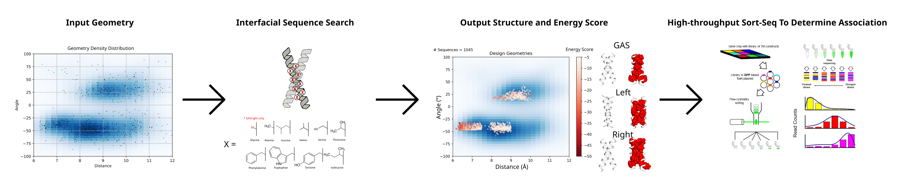
Working Title: Investigating the effect of sidechain packing on membrane protein association

Abstract
Membrane protein folding results from a balance (better word) of biophysical forces. Polar and charged interactions have the ability to drive folding within the hydrophobic environment of the membrane. The stabilizing effects of sidechain packing on membrane protein folding were deduced in a variety of foundational bacterhiorhodopsin studies, and sidechain packing as a driving force has been demonstrated through modern protein re-design of phospholamban. However, the extent at which packing can act as a driving force in general in membrane protein systems is not well understood. We investigate the impact of sidechain packing on membrane protein association by using computational design. By sampling dimer conformations from the PDB, we were able to design hundreds of sequences that self-associate. Structural characterization through mutations on a subset of these proteins suggests that packing can drive association in a variety of membrane protein systems.

Graphical Abstract

Premise/Intro
Proper membrane protein folding is regulated by a distribution of stabilizing hydrogen bonds, weak polar interactions, and van der Waals forces between the unfolded and folded states. Hydrogen bonding and polar interactions have been found to modestly stabilize both large protein complexes (cites) and association of smaller peptides such as glycophorin A (GpA) (cites). Mutations to key hydrogen bonding residues plays a role in promoting disease states such as (cites). Misfolding of membrane proteins has been found to be involved in several human diseases such as Parkinson’s, cystic fibrosis, and cancer (Gregersen et al., 2006; Sanders & Myers, 2004). Understanding how forces drive membrane protein folding is a critical task to further prevent disease. However, research is lacking on the contribution of van der Waals packing.
The contribution of van der Waals packing to membrane protein folding can be broken down into three distinct interactions: lipid-lipid packing, lipid-protein packing, and protein-protein packing. Protein-protein (or sidechain) packing, is a technically feasible starting point because of the ability to manipulate sequences and determine changes in stability due to mutation. Previous research has demonstrated that disruption of packing within the core of bacteriorhodopsin destabilizes protein structure, suggesting that it is a necessary force for proteins to reach optimal stability (Faham et al., 2004; Joh et al., 2009). Additionally, a recent study using membrane protein design has shown that optimized sidechain packing can stabilize the folded state of phospholamban, demonstrating that packing can drive protein stability (Mravic et al., 2019). Although these studies suggest that sidechain packing plays a role in stabilizing membrane proteins, there has not been much investigation of the thermodynamic contribution of packing outside of individual structures.
Research using homodimerization as a model system has measured the contributions of both hydrogen bonding and weak polar interactions in the membrane, determining that these forces drive membrane protein folding (Johnson et al., 2007; Yano et al., 2002; Zhou et al., 2001). In this study, we investigate the effect of sidechain packing within a multitude of dimer structures. Using large-scale computational design on the most common dimeric backbone geometries found within the PDB, we designed thousands of homodimer sequences and characterized their propensity to associate with a complementary high-throughput method, sort-seq (cite). Using this simple and tractable model system, successfully designed dimers that associate, suggesting that sidechain packing is a weak driving force involved in TM association.

Figure MP_design: Membrane protein dimer design. (a) Helices within close contact were extracted from the Orientations of Proteins in membranes (OPM) in September 2019. The geometric terms were extracted and overlaid over the kernel density estimation of the membrane protein contact space. (b) Interfaces for designs on poly-leucine backbones, where x is an interfacial position that can be designed using a library of the most prevalent amino acids in membrane proteins. Glycine is only used for GAS_{right} designs. (c) Structures undergo local backbone minimization by alternating 4 geometric parameters: distance (d), angle (θ), axial rotation (ω), and Z shift. (d) Design geometries overlaid on the helix-helix density distribution in panel a. Each point is colored by their respective design energy score.
Results
Extracting membrane protein geometries from the Protein Databank (PDB)
To identify the most common, and thus most likely designable, interaction motifs for dimeric proteins, we investigated the geometry of all helix-helix interactions found in known membrane protein structures. Any two helices in close contact in the structures were considered as an individual helical pair and the conformational parameters of each pair were computed (angle θ, distance Å, axial rotation ω, z-shift, see Methods).
Figure MP_design A illustrates the resulting helix-helix interaction landscape, plotted as a scatterplot of the crossing angle and interhelical distance. We selected for our designs the three major high-density regions. In the left-handed region, helical pairs are found to interact most frequently in the range between 8.5 to 10 Å of interhelical distance and 20 to 40° of crossing angle (“Left” box in Fig. MP_design A). The right-handed region presents a much broader range of distances from 6.5 to over 10 Å of distance and crossing angles between -30 and -60°. We selected the maximum density region, between 7.75 and 9.5 Å and -30 to -60°) angle (“Right” box).
The third region identified corresponds to the GAS_{right} region, which is characterized by very short interhelical distance (6.5-7.5 Å) and crossing angles of -25 to -55° angle. GAS_{right} is a well characterized dimerization motif. It is sequence signature is the presence of small amino acids (Gly, Ala, Ser) at the dimer interface, forming its characteristic GxxxG and similar sequence motifs (GxxxA, SxxxG, etc.). These small amino acids allow for the short interhelical distance, which the helical backbones coming to contacts, which allow the formations of networks of interhelical weak hydrogen bonds between the helices. We previously showed that van der Waals interactions are important for GAS_{right} stability but these motifs are also stabilized by weak hydrogen bonding.

Computational Design Strategy
For each region, we identified positions at the helix-helix interface to be designed. Figure MP_design B illustrates our design strategy for each region, with 8 designable positions stitched onto a 21 amino acid poly-Leu backbone. The noninterfacial positions of the backbone are standardized to Leucine, reducing variability in hydrophobicity. Keeping the noninterfacial residues constant results in consistent expression and insertion into the membrane. Additionally, a pure poly-Leu sequence has low propensity for association in TOXCAT based assays, reducing the risk of association outside of our designed interface (Zhou et al., 2000; Zhou et al., 2001; Ruan et al., 2003).
Previous research on GAS_{right} proteins has shown that replacing interfacial residues in an LLLxxLLxxLLxxLLxxLLLL pattern is sufficient for dimerization (Anderson et al., 2017). We applied the same interface to the Right design region, which outside of a larger interhelical distance, has similar geometry. In the Left design region, we observed three different interfaces dependent on the crossing angle and z-shift. These interfaces correspond to common dimerization motifs such as leucine zippers, knobs-into-holes, and coiled coils (Ash et al., 2004; Bornberg-Bauer et al., 1998; Walshaw & Woolfson, 2003), and we opted to design sequences for each interface.
We developed an algorithm to design membrane protein homodimers by combining fixed backbone design with iterative backbone refinement (Huang et al., 2022; Kuhlman et al., 2003; Kulp et al., 2012; Nash et al., 2015; Senes, 2011). 10000 backbone conformations were randomly generated within the high-density regions as inputs for our design algorithm (Methods). Each designed position was limited to amino acids commonly found in membrane proteins as an additional way to control for protein hydrophobicity (Liu et al., 2002). The three amino acids often found in GAS_{right} interfaces (Gly, Ala, and Ser) are included in this list, with Gly only permitted for GAS_{right} to prevent the occurrence of interhelical hydrogen bonding in the Right and Left regions (Figure MP_design B).
Each protein interface was designed by iteratively switching amino acids and evaluating each sequence using a computational energy score composed of van der Waals packing, hydrogen bonding, and implicit solvation (Krivov et al., 2009; Lazaridis, 2003; MacKerell et al., 1998). Sequences with the best energy underwent a local backbone refinement to find the most stable structure for the designed interface (Figure MP_design C). Our design algorithm resulted in a set of 1045 wild type (WT) design sequences with a range of both structure and stability (Figure MP_design D).
Due to the large scale of this study, it would be difficult to determine the success of our design algorithm through experimental structure validation. As an alternative, each design was evaluated through mutagenesis, where a mutant position is expected to disrupt association of the given structure. For each of these designs, we mutated an interfacial position to either isoleucine or alanine (Figure primary_dataset A). Mutating to isoleucine results in significant clashes between atoms within the structure. Conversely, mutating to alanine produces a large void at the helix-helix interface. Both clash and void mutants were expected to decrease association, with clash mutants expected to result in drastic decreases as in previous studies (cite).

Experimental methods and filtering the dataset
A gene library coding for our designed sequences and mutants was cloned into E. coli and dimerization propensity measured using the high throughput TOXCAT based assay sort-seq (cite). This assay utilizes a combination of fluorescent activated cell sorting (FACS) and next generation sequencing (NGS) to measure the dimerization propensity of each sequence by reconstructing its fluorescence profile (Figure exp_method high throughput). To ensure the best possible reconstruction of the fluorescence signal by sort-seq, we compared the reconstructed signal of a set of 9-10 constructs with the fluorescence obtained from individual TOXGREEN. The resulting linear correlation (fig experimental_method) were used to calibrate the reconstructed signal of all constructs in each design region.
After running each of the libraries through sort-seq in triplicate, sequences were filtered for proper insertion in the membrane by their ability to survive in maltose media (cite sort-seq). Sequences present in maltose media after 36 hours of growth were evaluated against a set of maltose failing controls (Methods). Designs that pass the maltose test have properly inserted into the membrane.
949 of our 1045 WT designs (91%) were present in the NGS data, with 708 (68%) passing the maltose test (could add a table here or in the supplement for trimming data).

GAS_{right} are significantly more stable than other designs
Figure primary_dataset B shows the fluorescence distribution of the WT designs (dark green), clash mutants (white), and void mutants (light green) separated by design region. It is notable that the fluorescence within the GAS_{right} spans a larger range than both the Left and Right designs, demonstrating GAS_{right} propensity for strong self-association. Many proteins in both the Left and Right are above the fluorescence of the monomeric control (15% GpA/~3700 TOXGREEN fluorescence). Additionally, 52/126 (41%, GAS_{right}), 16/199 (8%, Left), and 10/276 (4%, Right) of these sequences reach a level of fluorescence that would be typical of proteins displaying significant dimerization in the TOXGREEN assay (>60% GpA/~14500 TOXGREEN fluorescence). This data suggests that GAS_{right} is a motif that is quite designable for stability, likely due to the contribution of hydrogen bonding. Sequences designed with van der Waals packing only are much weaker, but this data suggests that solely packing is enough for sequences to have a propensity to associate.
Figure primary_dataset. A) Mutations made to each WT design. Clash mutants result in atoms from one helix overlapping with atoms from the other helix, Void mutants result in pockets at the interface lacking atoms. B) The WT (dark green) fluorescence distribution is compared to the fluorescence distributions of their corresponding void (light green) and clash (white) mutants. p-values determining the significant difference between WT fluorescence and mutant fluorescence are shown over the corresponding boxplot.
To validate our designs, we observed the impact of each of our mutations on association. GAS_{right} clashing mutations result in a significant decrease in fluorescence, consistent with these associating according to our designed structures. We also see a smaller decrease in fluorescence when void mutants are introduced, as expected. Our results for the Left and Right design regions are similar, but because there are more monomeric designs with a smaller fluorescent range, differences are less dramatic. Void mutants do not show a decrease in fluorescence, likely due to the decreased range of association. However, statistical testing shows that there is a significant decrease in fluorescence between WT designs and clash mutants, suggesting that a large number of our constructs are interacting with the predicted interface.

Clashing mutant data results in many weak to mildly associating dimers
We filtered our data for designs with clashing mutants that significantly decrease association, identifying designs with validated structures. We limited this dataset to WT sequences with at least one clashing mutation with a mild monomeric cutoff (< 35% GpA/~8350 TOXGREEN fluorescence) or association at a level 50% GpA less than the WT design. 513 of our 1045 designs (49%) have one clashing mutant that passes at least one of the previous criteria. These designs sequences along with their mutants are analyzed in our datasets against our energetics.
Figure delta_g_data A shows scatterplots of the fluorescence of our WT designs against our energy score for each region, allowing us to evaluate the accuracy of our design method. It is apparent that GAS_{right} appear to follow our design principles better than the other regions. This suggests that our design energy score is not able to capture meaningful differences in the lower threshold of association where a majority of the Left and Right designs are found (7000-12000 normalized fluorescence). Additionally, many of the designs above a strong dimer threshold (>60% GpA) in the Left and Right regions are not found in this dataset. Clashing mutants for a majority of these proteins are not monomeric and have a smaller fluorescence difference than the threshold we set. Overall, this data suggests that our energetic parameters are not well tuned to evaluate the low levels of homodimer association that we were able to design in the Left and Right regions. However, the validation of our structures with clashing mutations suggests that these structures associate similar to our designed interfaces. The design geometries and their respective dimerization propensity in %GpA are plotted in figure delta G data B.

Conversion of fluorescence to ΔG

Figure delta_g_data: A) Design energy score plotted vs dimerization propensity in %GpA and ΔG. Dimerization propensity was converted to biophysical ΔG using methods from an in vitro FRET studying GAS_{right} association (Díaz Vázquez et al., 2023) B) Predicted geometry plotted against dimerization propensity in %GpA. C) Density histogram of predicted ΔG shows the spread of dimerization propensities for each design region. GAS_{right} dimerization distribution is clearly more stable than designs from other regions.
We converted the fluorescence to biophysical ΔG using a method from an in vitro study on GAS_{right} proteins (Díaz Vázquez et al., 2023). We then compared these ΔG values to the energetics from our design algorithm (figure deltaG data A). Although our energetics do not seem to capture the overall trend of stability, it allows us to visualize the distribution of the calculate biophysical stability of these sequences. This data shows that both Left and Right designs stabilized to a ΔG around -1 to -3, comparable to weak dimers (Díaz Vázquez et al., 2023). Additionally, many of the most stable GAS_{right} designs are calculated to have a ΔG -3 to -4, comparable to strong dimers (figure deltaG data A, C). GAS_{right} designs with a combination of interhelical hydrogen bonding and tighter packing due to a shorter helical distance result in stronger dimerization. Our designed sequences without hydrogen bonding have weak association, suggesting that packing is sufficient for membrane protein association.
Removing potential hydrogen bonds supports association by van der Waals packing
As a final approach, we aimed to determine if our designs are primarily stabilized by van der Waals packing. We filtered our dataset using a computational search for potential hydrogen bond formation on our interfaces (Methods). Positions on the interface that may hydrogen bond were mutated to a hydrophobic amino acid of similar size (Mut: Thr→Val and Ser→Ala). 13 WT designs and their respective interfacial and clashing mutations were expressed in E. coli and verified for their ability to associate using TOXGREEN.
Figure hbonding_interface_mutants: TOXGREEN data expressed in %GpA of designs and their respective interfacial mutants. 7 of 13 designs were found to associate at a higher level than mutations at the interface. 6 of 7 clashing mutations resulted in a noticeable decrease in association (calculate significance), and 3 of these 7 resulted in an increase in association when mutating hydrogen bonding amino acids on the interface. Sequences are shown on the right with hydrogen bonding amino acids mutated in red, and the clashing mutation in bold.
8 of 13 designs were found to properly associate according to our designed interface, where either the clash or interfacial mutations resulted in a noticeable decrease in association when compared to the WT (Fig hbonding_interface_mutants). 3 of these proteins displayed increased association when mutating Thr and Ser to hydrophobic amino acids. Additionally, 4 of these 8 proteins are composed of Tyr at the interface, which also has the potential to hydrogen bond. I chose to additionally mutate the Tyr to Phe (Y→F) alongside Thr and Ser interfacial mutants to ensure we are assessing the contribution of any potential hydrogen bonds on association. Each of the Y→F mutants on average displays decreased association when compared to WT. Although we are unable to predict association using our energy terms, we have successfully designed at least 3 proteins that associate without hydrogen bonding. This data suggests that van der Waals packing is driving the association of a variety of our designed membrane proteins.

Discussion
We investigate the impact of van der Waals packing on membrane protein association using a high-throughput protein design approach. We found that designs in the GAS_{right} region were the most stable, suggesting that interhelical hydrogen bonding contributes to much of GAS_{right} protein stability as shown previously. Sequences designed without hydrogen bonding were found to associate, suggesting that packing can drive association alone. However, many of these sequences were weakly associating, meaning that packing alone is a weak driving force.
We found that clashing mutations significantly decreased the fluorescence of our designs, suggesting that our sequences associate with our designed interfaces. We speculate that creating voids in dimers relying solely on sidechain packing to associate may not necessarily be destabilizing because of the potential for these sequences to undergo dimerization with an alternative structure that fills the void. Rather than creating a void at the interface, the smaller alanine may result in alternative structures that fills the void by allowing the helices to associate more tightly.
Although our energetics shows some correlation with GAS_{right,} overall the energy scores do not correlate well to dimerization propensity for proteins designed solely with van der Waals packing. This suggests that our energy score is unable to predict association found in weakly associating proteins. However, many of our proteins associate according to the designed interface, suggesting that our structures are accurate with the issue being energetics. In the future, taking these results and training using regression or machine learning could improve our energetics. We can design more proteins with these adjusted energetic terms to determine if there is improvement in our energy model.

Methods
Computational Design
The algorithm designs an interfacial sequence along a given backbone structure. Using a Monte Carlo sequence optimization, an interfacial position is switched to a random amino acid most prevalently found in membrane protein sequences. To ensure that these designed sequences are membrane sequences, we developed a sequence entropy term. The sequence entropy term evaluates the current interface as it’s likelihood to occur in membrane protein sequences, and converts this likelihood to an energy applied during the sequence search (Supplement or add separate method section?). Energetics for the dimer were calculated using the CHARMM22 van der Waals function, the IMM1 membrane implicit solvation term, and the hydrogen bonding function SCWR4. The side chain mobility was modeled using the energy based conformer library, with interfacial side chains given higher mobility than non-interfacial (Subramaniam & Senes, 2012). After the sequence is designed for the geometry, the structure undergoes Monte Carlo backbone optimization cycles where all parameters (distance, zShift, axialRotation, and crossingAngle) are varied. The final energy from backbone optimization is used to assess our designed constructs against their dimerization propensity.
Cloning for bacterial cell expression
Sequences were ordered as an oligo pool from Twist Biosciences. Individual segments were amplified using qPCR (PCR kit). Segments were digested using restriction enzymes Nhe1-HF and Dpn2. TOXGREEN vector was digested in preparation for ligation using restriction enzymes Nhe1-HF, BamH1-HF, and CIP from NEB. Plasmids were assembled by incubating segment DNA with TOXGREEN vector in a ratio for 2 hours with NEB Electroligase. 5uL of the ligation mixture were added to 50uL of NEB DH10B E. coli cells and cloned through electroporation (electroporator model), outgrown for 1 hour in 950uL NEB SOM media in 37C shaker, and diluted (ratio) before plating xuL on LB Amp 100 plates. Plates were grown for 14-16 hours at 37C and colony forming units (CFUs) calculated for each segment. XuL of segment sample were grown overnight in 3mL LB Amp 100 media. A CFU > x was accepted and overnight cultures corresponding to plates were spun down and miniprepped (kit). Segment plasmids were cloned through electroporation into 50uL in house mm39 cells for fluorescence readout, outgrown for 1 hour in 950uL SOC media in 37C shaker, and x uL plated on LB Amp 100 plates. X uL of segment sample were grown overnight in 3mL LB Amp 100 media. CFUs were again counted and any plates > x were accepted. Overnights for each segment were stored in 25% glycerol stocks. 50UL samples and controls from glycerol stocks were grown in 3mL LB Amp100 for 2-4 hours to reach ~0.1 OD600 and the corresponding number of sequences per sample used to calculate how much to add to a full library glycerol stock.
Sort-Seq and NGS Preparation Protocol
50uL of library glycerol stock were grown in 3mL LB Amp 100 overnight for 14-16 hours in 37C shaker. Samples were diluted in PBS buffer to appropriate concentration for recording 10000 events per second in Sony MA900 fluorescence activated cell sorter (UW Flow Center). Controls GpA, G83I, and NoTM were flowed to calibrate the instrument and determine proper gating to remove dead cells. Individual sample libraries were first flowed through the instrument and the fluorescence profile separated into 4 bins. 100000 events were sorted into bins 1-3, and 50000 events sorted into bin 4. Each library sample was sorted in triplicate from biological replicates of overnights. Sorted populations were grown for 1-5 hours to reach ~0.3 OD600 and minipreppred. Samples were prepared for NGS using PCR, amplifying each sample with individual primers/markers and sent for NGS (what type). (cite sort-seq)
Immunoblotting
Protein expression was confirmed for an assortment of designs and mutants using immunoblotting. Cell lysates were normalized by (BCA assay) and loaded onto NuPage 4-12% bis-tris SDS-PAGE gels (Thermofisher) and then transferred to PVDF membranes (VWR) for 1h at 100 millivolts. Blots were blocked using 5% milk (brand) in TBS-Tween buffer (50 mM Tris, 150 mM NaCl, 0.05% Tween 20) for 2 h at 4°C and incubated overnight with peroxidase-conjugated monoclonal anti-maltose binding protein antibodies (Sigma-Aldrich). Blots were developed with Pierce ECL Western Blotting Substrate Kit; 1mL of ECL solution was added to the blot and incubated for 90s. Chemiluminescence was measured using an ImageQuant LAS 4000 (GE Healthsciences).

References
Anderson, S. M., Mueller, B. K., Lange, E. J., & Senes, A. (2017). Combination of Cα-H Hydrogen Bonds and van der Waals Packing Modulates the Stability of GxxxG-Mediated Dimers in Membranes. J Am Chem Soc, 139(44), 15774-15783. https://doi.org/10.1021/jacs.7b07505
Ash, W. L., Stockner, T., MacCallum, J. L., & Tieleman, D. P. (2004). Computer modeling of polyleucine-based coiled coil dimers in a realistic membrane environment: insight into helix-helix interactions in membrane proteins. Biochemistry, 43(28), 9050-9060. https://doi.org/10.1021/bi0494572
Bornberg-Bauer, E., Rivals, E., & Vingron, M. (1998). Computational approaches to identify leucine zippers. Nucleic Acids Research, 26(11), 2740-2746. https://doi.org/10.1093/nar/26.11.2740
Carpenter, E. P., Beis, K., Cameron, A. D., & Iwata, S. (2008). Overcoming the challenges of membrane protein crystallography. Curr Opin Struct Biol, 18(5), 581-586. https://doi.org/10.1016/j.sbi.2008.07.001
Díaz Vázquez, G., Cui, Q., & Senes, A. (2023). Thermodynamic analysis of the GAS. Biophys J, 122(1), 143-155. https://doi.org/10.1016/j.bpj.2022.11.018
Fagerberg, L., Jonasson, K., von Heijne, G., Uhlén, M., & Berglund, L. (2010). Prediction of the human membrane proteome. Proteomics, 10(6), 1141-1149. https://doi.org/10.1002/pmic.200900258
Faham, S., Yang, D., Bare, E., Yohannan, S., Whitelegge, J. P., & Bowie, J. U. (2004). Side-chain contributions to membrane protein structure and stability. J Mol Biol, 335(1), 297-305. https://doi.org/10.1016/j.jmb.2003.10.041
Fleming, K. G., Ackerman, A. L., & Engelman, D. M. (1997). The effect of point mutations on the free energy of transmembrane alpha-helix dimerization. J Mol Biol, 272(2), 266-275. https://doi.org/10.1006/jmbi.1997.1236
Gregersen, N., Bross, P., Vang, S., & Christensen, J. H. (2006). Protein misfolding and human disease. Annu Rev Genomics Hum Genet, 7, 103-124. https://doi.org/10.1146/annurev.genom.7.080505.115737
Hong, H. (2014). Toward understanding driving forces in membrane protein folding. Arch Biochem Biophys, 564, 297-313. https://doi.org/10.1016/j.abb.2014.07.031
Huang, B., Xu, Y., Hu, X., Liu, Y., Liao, S., Zhang, J., . . . Liu, H. (2022). A backbone-centred energy function of neural networks for protein design. Nature, 602(7897), 523-528. https://doi.org/10.1038/s41586-021-04383-5
Joh, N. H., Oberai, A., Yang, D., Whitelegge, J. P., & Bowie, J. U. (2009). Similar energetic contributions of packing in the core of membrane and water-soluble proteins. J Am Chem Soc, 131(31), 10846-10847. https://doi.org/10.1021/ja904711k
Johnson, R. M., Hecht, K., & Deber, C. M. (2007). Aromatic and cation-pi interactions enhance helix-helix association in a membrane environment. Biochemistry, 46(32), 9208-9214. https://doi.org/10.1021/bi7008773
Krivov, G. G., Shapovalov, M. V., & Dunbrack, R. L. (2009). Improved prediction of protein side-chain conformations with SCWRL4. Proteins, 77(4), 778-795. https://doi.org/10.1002/prot.22488
Kuhlman, B., Dantas, G., Ireton, G. C., Varani, G., Stoddard, B. L., & Baker, D. (2003). Design of a novel globular protein fold with atomic-level accuracy. Science, 302(5649), 1364-1368. https://doi.org/10.1126/science.1089427
Kulp, D. W., Subramaniam, S., Donald, J. E., Hannigan, B. T., Mueller, B. K., Grigoryan, G., & Senes, A. (2012). Structural informatics, modeling, and design with an open-source Molecular Software Library (MSL). J Comput Chem, 33(20), 1645-1661. https://doi.org/10.1002/jcc.22968
Lazaridis, T. (2003). Effective energy function for proteins in lipid membranes. Proteins, 52(2), 176-192. https://doi.org/10.1002/prot.10410
Liu, Y., Engelman, D. M., & Gerstein, M. (2002). Genomic analysis of membrane protein families: abundance and conserved motifs. Genome Biol, 3(10), research0054. https://doi.org/10.1186/gb-2002-3-10-research0054
Lomize, A. L., & Pogozheva, I. D. (2017). TMDOCK: An Energy-Based Method for Modeling α-Helical Dimers in Membranes. J Mol Biol, 429(3), 390-398. https://doi.org/10.1016/j.jmb.2016.09.005
MacKerell, A. D., Bashford, D., Bellott, M., Dunbrack, R. L., Evanseck, J. D., Field, M. J., . . . Karplus, M. (1998). All-atom empirical potential for molecular modeling and dynamics studies of proteins. J Phys Chem B, 102(18), 3586-3616. https://doi.org/10.1021/jp973084f
Mravic, M., Thomaston, J. L., Tucker, M., Solomon, P. E., Liu, L., & DeGrado, W. F. (2019). Packing of apolar side chains enables accurate design of highly stable membrane proteins. Science, 363(6434), 1418-1423. https://doi.org/10.1126/science.aav7541
Nash, A., Notman, R., & Dixon, A. M. (2015). De novo design of transmembrane helix-helix interactions and measurement of stability in a biological membrane. Biochim Biophys Acta, 1848(5), 1248-1257. https://doi.org/10.1016/j.bbamem.2015.02.020
Popot, J. L., & Engelman, D. M. (1990). Membrane protein folding and oligomerization: the two-stage model. Biochemistry, 29(17), 4031-4037. https://doi.org/10.1021/bi00469a001
Ruan, W., Lindner, E., & Langosch, D. (2004). The interface of a membrane-spanning leucine zipper mapped by asparagine-scanning mutagenesis. Protein Science, 13(2), 555-559. https://doi.org/https://doi.org/10.1110/ps.03357404
Sanders, C. R., & Myers, J. K. (2004). Disease-related misassembly of membrane proteins. Annu Rev Biophys Biomol Struct, 33, 25-51. https://doi.org/10.1146/annurev.biophys.33.110502.140348
Senes, A. (2011). Computational design of membrane proteins. Curr Opin Struct Biol, 21(4), 460-466. https://doi.org/10.1016/j.sbi.2011.06.004
Subramaniam, S., & Senes, A. (2012). An energy-based conformer library for side chain optimization: improved prediction and adjustable sampling. Proteins, 80(9), 2218-2234. https://doi.org/10.1002/prot.24111
Walshaw, J., & Woolfson, D. N. (2003). Extended knobs-into-holes packing in classical and complex coiled-coil assemblies. 144(3), 349-361.
Yano, Y., Takemoto, T., Kobayashi, S., Yasui, H., Sakurai, H., Ohashi, W., . . . Matsuzaki, K. (2002). Topological stability and self-association of a completely hydrophobic model transmembrane helix in lipid bilayers. Biochemistry, 41(9), 3073-3080. https://doi.org/10.1021/bi011161y
Zhou, F. X., Cocco, M. J., Russ, W. P., Brunger, A. T., & Engelman, D. M. (2000). Interhelical hydrogen bonding drives strong interactions in membrane proteins. Nat Struct Biol, 7(2), 154-160. https://doi.org/10.1038/72430
Zhou, F. X., Merianos, H. J., Brunger, A. T., & Engelman, D. M. (2001). Polar residues drive association of polyleucine transmembrane helices. Proc Natl Acad Sci U S A, 98(5), 2250-2255. https://doi.org/10.1073/pnas.041593698

Supplementary Materials
Westerns

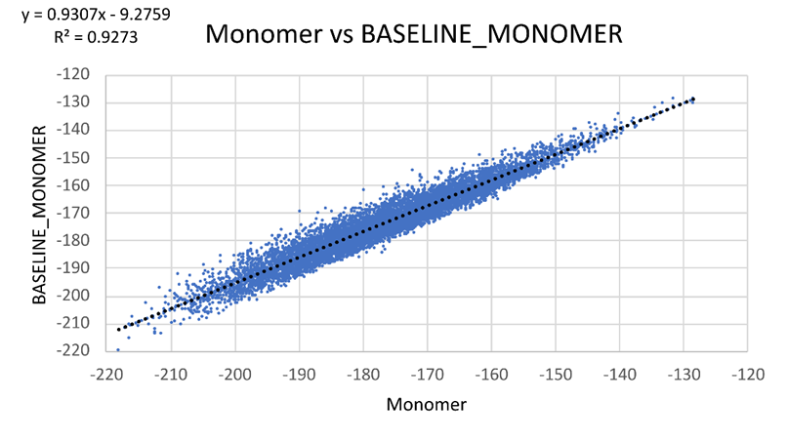
Baseline Energy Term

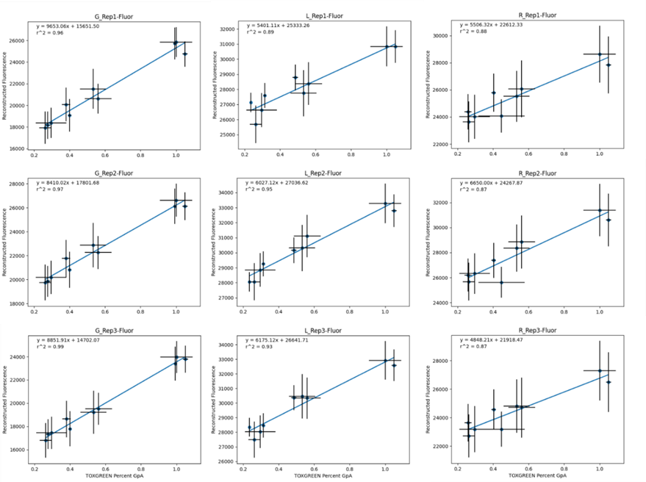
TOXGREEN Conversion

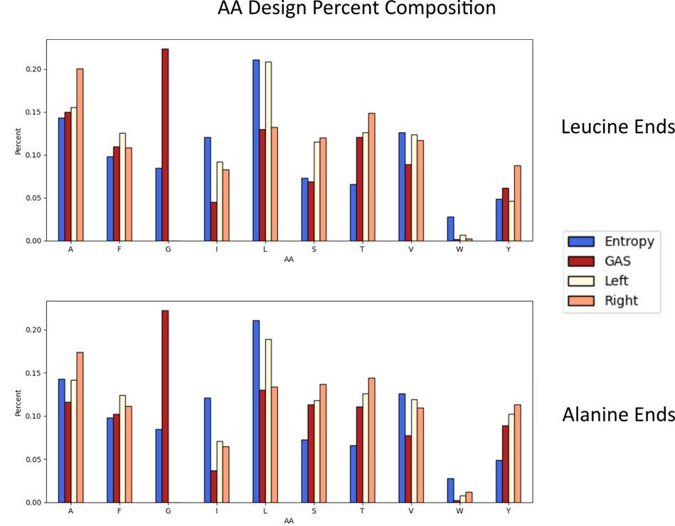
Amino Acid Percent Composition

Other potential Supplement
Tables for cloning/trimming sequences for analysis
Sequence Entropy
Subset of designed structures
Hbonding analysis structures
deltaG Conversion

