Investigating the effect of side chain packing on membrane protein association
Gilbert J. Loiseau^{1,2} and Alessandro Senes^{1,@}

¹Department of Biochemistry, University of Wisconsin-Madison, Madison, WI 53706
²Integrated Program in Biochemistry, University of Wisconsin-Madison, Madison, WI 53706

@Corresponding author: senes@wisc.edu

ORCID:
GJL: ?
AS: 0000-0002-3807-2275

Abstract
Membrane protein folding results from a balance (better word) of biophysical forces. Polar and charged interactions have the ability to drive folding within the hydrophobic environment of the membrane. The stabilizing effects of sidechain packing on membrane protein folding were deduced in a variety of foundational bacterhiorhodopsin studies, and sidechain packing as a driving force has been demonstrated through modern protein re-design of phospholamban. However, the extent at which packing can act as a driving force in general in membrane protein systems is not well understood. We investigate the impact of sidechain packing on membrane protein association by using computational design. By sampling dimer conformations from the PDB, we were able to design hundreds of sequences that self-associate. Structural characterization through mutations on a subset of these proteins suggests that packing can drive association in a variety of membrane protein systems.

Introduction
Proper membrane protein folding is regulated by a distribution of stabilizing hydrogen bonds, weak polar interactions, and van der Waals forces between the unfolded and folded states. Hydrogen bonding and polar interactions have been found to modestly stabilize both large protein complexes (cites) and association of smaller peptides such as glycophorin A (GpA) (cites). Mutations to key hydrogen bonding residues plays a role in promoting disease states such as (cites). Misfolding of membrane proteins has been found to be involved in several human diseases such as Parkinson’s, cystic fibrosis, and cancer (Gregersen et al., 2006; Sanders & Myers, 2004). Understanding how forces drive membrane protein folding is a critical task to further prevent disease. However, research is lacking on the contribution of van der Waals packing.
The contribution of van der Waals packing to membrane protein folding can be broken down into three distinct interactions: lipid-lipid packing, lipid-protein packing, and protein-protein packing. Protein-protein (or sidechain) packing, is a technically feasible starting point because of the ability to manipulate sequences and determine changes in stability due to mutation. Previous research has demonstrated that disruption of packing within the core of bacteriorhodopsin destabilizes protein structure, suggesting that it is a necessary force for proteins to reach optimal stability (Faham et al., 2004; Joh et al., 2009). Additionally, a recent study using membrane protein design has shown that optimized sidechain packing can stabilize the folded state of phospholamban, demonstrating that packing can drive protein stability (Mravic et al., 2019). Although these studies suggest that sidechain packing plays a role in stabilizing membrane proteins, there has not been much investigation of the thermodynamic contribution of packing outside of individual structures.
Research using homodimerization as a model system has measured the contributions of both hydrogen bonding and weak polar interactions in the membrane, determining that these forces drive membrane protein folding (Johnson et al., 2007; Yano et al., 2002; Zhou et al., 2001). In this study, we investigate the effect of sidechain packing within a multitude of dimer structures. Using large-scale computational design on the most common dimeric backbone geometries found within the PDB, we designed thousands of homodimer sequences and characterized their propensity to associate with a complementary high-throughput method, sort-seq (cite). Using this simple and tractable model system, successfully designed dimers that associate, suggesting that sidechain packing is a weak driving force involved in TM association.

Results

Figure MP_DESIGN. Membrane protein dimer design. (a) Helices within close contact were extracted from the Orientations of Proteins in membranes (OPM) in September 2019. The geometric terms were extracted and overlaid over the kernel density estimation of the membrane protein contact space. (b) Interfaces for designs on poly-leucine backbones, where x is an interfacial position that can be designed using a library of the most prevalent amino acids in membrane proteins. Glycine is only used for GASright designs. (c) Structures undergo local backbone minimization by alternating 4 geometric parameters: distance (d), angle (θ), axial rotation (ω), and Z shift. (d) Design geometries overlaid on the helix-helix density distribution in panel a. Each point is colored by their respective design energy score.

Selection of the backbone regions for the designs
The first step in the process was to select common region of helix-helix interaction conformational space, under the assumption that these would be the most designable regions. To identify these, we analyzed the geometry of all pairs of interacting helices found in known membrane protein structures. We used a database of 1541 membrane protein structures from Orientations of Proteins in Membranes, filtered by sequence similarity from the PDB (Lomize et al., 2006; Steinegger & Söding, 2017). Any two helices in close contact in the structures were considered as an individual helical pair and the conformational parameters of each pair were computed (i.e., the crossing angle θ, the inter-helical distance d, the axial rotation of each helix ω, and the displacement in along the helical axis or Z-shift, see Fig. MP_DESIGNa and Methods). Although similar analyses were performed previously [REFS], we restricted the analysis to the subset of helical pairs that interact through segments that adopt regular α-helix conformation. This restriction was introduced in part for consistency, since the helical backbones used for design were also restricted to canonical α-helix. In addition, the inclusion of segments that contain kinks, curvature, 3₁₀ helix and other deviations from standard α-helix, introduces errors in the parametrization (i.e. θ, d, ω, Z) of the configuration of the pairs, which assumes canonical helical configuration.
Fig. MP_DESIGNb illustrates the resulting helix-helix interaction landscape for parallel helical pairs (i.e. the pairs whose N-termini are on the same side of the membrane), plotted as a scatterplot of the crossing angle θ and interhelical distance d. Three major high-density regions are observed. In the left-handed region (positive crossing angle θ), the helical pairs are found to interact most frequently in the range between approximately 8.5 to 10 Å of interhelical distance and a 20 to 40° crossing angle (“Left” box in Fig. MP_DESIGNb). The right-handed region presents a much broader range of distances from 6.5 to over 10 Å of distance and crossing angles between -30 and -60°. We selected the maximum density region with inter-helical distance between 7.75 and 9.5 Å and a -30 to -60° crossing angle (“Right” box).
The section of the right-handed region with the closest inter-helical distance corresponds to the GAS_{right} motif, a well-know helix-helix dimerization and interaction motif that is characterized by very short interhelical distance (6.5-7.5 Å) and crossing angles of -25 to -55° angle (Mueller et al., 2014; Russ & Engelman, 2000). It is sequence signature is the presence of small amino acids (Gly, Ala, Ser) at the dimer interface, forming its characteristic GxxxG and similar sequence motifs (GxxxA, SxxxG, etc.). These small amino acids allow for the short inter-helical distance The helical backbones are in contacts, which, in turn, allow the formations of characteristic networks of interhelical weak hydrogen bonds between between activated Cα–H carbon donors and backbone carbonyl acceptor groups on the opposing helix (Cα–H∙∙∙O=C hydrogen bonds) (Senes et al., 2001). We previously showed that these networks of Cα–H are major contributor to the stability of GAS_{right} along with van der Waals interactions (Anderson et al., 2017). Since GAS_{right} can form strong dimers, we decided to use this region (G_{R} in Fig. MP_DESIGNb) as a positive control in our procedure for our van der Waals-only design based on the “Left” and “Right” regions.

Selection of backbones and Computational Design Strategy
A total of 10000 starting backbones were selected with crossing angle and inter-helical distance randomly assigned within the boundaries of the three regions highlighted in Fig. MD_DESIGNb. Since no specific trend was identified for the axial rotation ω, and the Z displacement, these two were also assigned randomly. In creating these constructs we followed an approach used previously in a TOXGREEN study (Anderson et al., 2017). The designs we based on a 21 amino acid hydrophobic segment, with the crossing point between the two monomers placed near the middle of the membrane. For each dimer, only 8 positions at the helix-helix interface were set as variable for the design. All non-interfacial positions of the backbone were standardized to Leucine. This standardization reduces variability in hydrophobicity, which helps obtaining consistent expression and insertion into the membrane of the TOXGREEN constructs. The poly-Leu backbone was used because this sequence has low propensity for association in TOXCAT based assays, reducing the risk of non-speficifc association outside of our designed interface (Zhou et al., 2000; Zhou et al., 2001; Ruan et al., 2003).
The pattern of variable and fixed position used for the constructs is illustrated in Fig. MP_DESIGNc. For the GAS_{right} region, we adopted the typical pattern that spaces two interfacial positions (x) with two fixed positions (L), resulting in a LLLxxLLxxLLxxLLxxLLLL pattern (Anderson et al., 2017; Mueller et al., 2014; Russ & Engelman, 2000). The same interface was applied to the Right region designs, which has similar geometry outside of a larger inter-helical distance. In the Left region, the interfacial positions follows the typical LxxLLxL heptad repeat that is typical in leucine zippers, knobs-into-holes, and coiled coils (Ash et al., 2004; Bornberg-Bauer et al., 1998; Walshaw & Woolfson, 2003). However, the specific registry of this pattern is dependent on the Z-shift and axial rotation coordinate of the dimer (see Methods). For this reason three different interfacial patterns, all consisting of 8 variable positions, were adopted for dimeric designs in this region (Fig. MP_DESIGNc).
The protein design was based on a Monte Carlo procedure that included an initial fixed backbone design, followed by an iterative local backbone refinement using the resulting design sequence (Huang et al., 2022; Kuhlman et al., 2003; Kulp et al., 2012; Nash et al., 2015; Senes, 2011) (see Methods). Each designed position was limited to amino acids commonly found in membrane proteins (G, A, V, F, W, L, I, S, T and Y) (Liu et al., 2002). Gly is a necessary amino acid in GAS_{right} interfaces, it was only permitted in GAS_{right} designs to prevent the accidental occurrence of GAS_{right} capable dimers in the designs of the Right and Left regions (Fig. MP_DESIGNb). As in our previous GAS_{right} prediction and design studies (Anderson et al., 2017; Mueller et al., 2014), each protein was evaluated using a computational energy score composed of a van der Waals function (MacKerell et al., 1998), hydrogen bonding (Krivov et al., 2009), and the IMM1 implicit membrane solvation (Lazaridis, 2003).
To control at least in part for the possibility that some of the constructs would associate through a different interface than their design, we designed mutations at position expected to disrupt association of the given structure. For each of these designs, an interfacial position to either small-to-large (isoleucine) or large-to-small (alanine) (Fig. PRIMARY_DATASETa). The isoleucine mutants were designed to create significant clashes within the structure, whereas the alanine mutations were designed to produces a significant packing defect (void) at the helix-helix interface. Both clash and void mutants were expected to decrease association, with clash mutants expected to result in drastic decreases as in previous studies (cite).

Experimental methods and filtering the dataset
We selected 1045 design sequences with a range of both structure and stability. The propensity for dimerization of these sequences and their mutants was assessed in the Escherichia coli membrane using the high throughput TOXGREEN sort-seq assay (cite). TOXGREEN (Armstrong & Senes, 2016) is the GFP-based version of TOXCAT, a widely used in vivo reporter assay that is sensitive to the relative association of TM dimers in a biological membrane. It is based on a chimeric protein in which the TM domain of interest is fused to the ToxR transcriptional activator. Dimerization of these constructs in the inner membrane promotes allows for ToxR binding to a specific promoter, resulting in the expression of chloramphenicol acetyltransferase (CAT, in TOXCAT) of GFP (in TOXGREEN). Quantification of these reporter proteins provides an indication of a TM domain’s propensity for oligomerization. We recently demonstrated that the TOXCAT signal of a series of GAS_{right} dimers based on a similar standardized poly-Leu backbone correlates well with their thermodynamic stability measured in vitro (Díaz Vázquez et al., 2023).

Figure PRIMARY_DATASET. A) Mutations made to each WT design. Clash mutants result in atoms from one helix overlapping with atoms from the other helix, Void mutants result in pockets at the interface lacking atoms. B) The WT (green) fluorescence distribution is compared to the fluorescence distributions of their corresponding clash (red) and void (orange) mutants. p-values determining the significant difference between WT fluorescence and mutant fluorescence are shown over the corresponding boxplot.
The recent development of a high-throughput TOXGREEN assay based on sort-seq [REF] allows for the measurement of thousands of constructs simultaneously. The assay utilizes a fluorescent activated cell sorting (FACS) to separate cells based on their GFP expression in bins. The relative frequency of a construct in the bins is then measured using next generation sequencing (NGS) and this profile is used to reconstruct the GFP fluorescence of each individual construct (supplement sort-seq figure; see Methods).

GAS_{right} are significantly more stable than other designs
The NGS analysis recovered 91% of the designed sequences. After removing the constructs that do not grow in maltose media (which controls for membrane insertion), we obtained reconstructed TOXGREEN fluorescence for a total of 596 designs and their respective mutants (124 GASright, 197 Left and 275 Right). Fig. PRIMARY_DATASETb shows the reconstructed GFP fluorescence distribution of the designs in the three regions (dark green) and their clash (red) and void mutants (orange). For guidance, the fluorescence of the strong dimer glycophorin A (GpA) and its monomeric G83I variants are indicated, as well a graphical indication of the range of fluorescence that corresponds to constructs that are monomeric, weakly or strongly dimeric in the E. coli membrane.
It is notable that the fluorescence of the “wild type” designs within the GAS_{right} region spans a larger range than both the Left and Right designs, confirming GAS_{right} propensity for strong self-association. In contrast, the majority of the designs in the Left and Right regions appear monomeric or have a weak propensity to oligomerize. For example, approximately 40% of the GAS_{right} designs have a reconstructed fluorescence above 60% of the GpA standard (14,500 fluorescent units in the figure), compared to only 8% and 4% of the Left and Right designs. These data suggests that indeed GAS_{right} is a motif that is designable for stability, which is likely due at least in part to the contribution of of its characteristic network of weak hydrogen bonds. Although the sequences designed solely around van der Waals packing are much weaker, the data suggests that solely packing is enough for sequences to have a propensity to associate.
Fig. PRIMARY_DATASETb shows the reconstructed TOXGREEN fluorescence of the clash (red) and void (orange). For the GAS_{right} designs, the introduction of clashing mutations result in a dramatic decrease in the distribution of fluorescence. Since these mutations were designed to be incompatible with their structural model the result is consistent with a majority of the design associating according to their designed structures. A statistically significant decrease in the reconstructed fluorescence distribution is observed also for the clash mutants of the Left and Right design regions, although the differences are less dramatic, as expected because their “wild type” construct already contain a large fraction of constructs that are monomeric or weakly dimeric.
Interestingly, the set of “void” mutants do not show a decrease in fluorescence for any of the design regions. These mutants consist of individual Ala substitutions of larger (generally F, L, Y, and I) that were designed to reduce the amount of packing by a small amount (Supplement), although they do not create cavities, given the nature of the long and narrow helix-helix interface. Large-to-small mutations are often well tolerated in mutagenesis of single pass TM dimers [REFS] but they can reduce dimerization. For this reason we hypothesized that we would observe a measurable shift of the fluorescence distribution. It is possible that the design procedure does not have sufficient precision for producing an effect from small alterations of packing.

Clashing mutant data results in many weak to mildly associating dimers
We filtered our data for designs with clashing mutants that significantly decrease association, identifying designs with validated structures. We limited this dataset to WT sequences with at least one clashing mutation with a mild monomeric cutoff (< 35% GpA/~8350 TOXGREEN fluorescence) or association at a level 50% GpA less than the WT design. 513 of our 1045 designs (49%) have one clashing mutant that passes at least one of the previous criteria. These designs sequences along with their mutants are analyzed in our datasets against our energetics.
Fig. DELTA_G_DATAa shows scatterplots of the fluorescence of our WT designs against our energy score for each region, allowing us to evaluate the accuracy of our design method. It is apparent that GAS_{right} appear to follow our design principles better than the other regions. This suggests that our design energy score is not able to capture meaningful differences in the lower threshold of association where a majority of the Left and Right designs are found (7000-12000 normalized fluorescence). Additionally, many of the designs above a strong dimer threshold (>60% GpA) in the Left and Right regions are not found in this dataset. Clashing mutants for a majority of these proteins are not monomeric and have a smaller fluorescence difference than the threshold we set. Overall, this data suggests that our energetic parameters are not well tuned to evaluate the low levels of homodimer association that we were able to design in the Left and Right regions. However, the validation of our structures with clashing mutations suggests that these structures associate similar to our designed interfaces. The design geometries and their respective dimerization propensity in %GpA are plotted in Fig. DELTA_G_DATAb.

Conversion of fluorescence to ΔG
We converted the fluorescence to biophysical ΔG using a method from an in vitro study on GAS_{right} proteins (Díaz Vázquez et al., 2023). We then compared these ΔG values to the energetics from our design algorithm (Fig. DELTA_G_DATAa). Although our energetics do not seem to capture the overall trend of stability, it allows us to visualize the distribution of the calculate biophysical stability of these sequences. This data shows that both Left and Right designs stabilized to a ΔG around -1 to -3, comparable to weak dimers (Díaz Vázquez et al., 2023). Additionally, many of the most stable GAS_{right} designs are calculated to have a ΔG -3 to -4, comparable to strong dimers (Fig. DELTA_G_DATAa,c). GAS_{right} designs with a combination of interhelical hydrogen bonding and tighter packing due to a shorter helical distance result in stronger dimerization. Our designed sequences without hydrogen bonding have weak association, suggesting that packing is sufficient for membrane protein association.

Figure DELTA_G_DATA: A) Design energy score plotted vs dimerization propensity in %GpA and ΔG. Dimerization propensity was converted to biophysical ΔG using methods from an in vitro FRET studying GASright association (Díaz Vázquez et al., 2023) B) Predicted geometry plotted against dimerization propensity in %GpA. C) Density histogram of predicted ΔG shows the spread of dimerization propensities for each design region. GASright dimerization distribution is clearly more stable than designs from other regions.

Removing potential hydrogen bonds supports association by van der Waals packing
As a final approach, we aimed to determine if our designs are primarily stabilized by van der Waals packing. We filtered our dataset using a computational search for potential hydrogen bond formation on our interfaces (Methods). Positions on the interface that may hydrogen bond were mutated to a hydrophobic amino acid of similar size (Mut: Thr→Val and Ser→Ala). 13 WT designs and their respective interfacial and clashing mutations were expressed in E. coli and verified for their ability to associate using TOXGREEN.
8 of 13 designs were found to properly associate according to our designed interface, where either the clash or interfacial mutations resulted in a noticeable decrease in association when compared to the WT (Fig. HBONDING_INTERFACE_MUTANTS). 3 of these proteins displayed increased association when mutating Thr and Ser to hydrophobic amino acids. Additionally, 4 of these 8 proteins are composed of Tyr at the interface, which also has the potential to hydrogen bond. I chose to additionally mutate the Tyr to Phe (Y→F) alongside Thr and Ser interfacial mutants to ensure we are assessing the contribution of any potential hydrogen bonds on association. Each of the Y→F mutants on average displays decreased association when compared to WT. Although we are unable to predict association using our energy terms, we have successfully designed at least 3 proteins that associate without hydrogen bonding. This data suggests that van der Waals packing is driving the association of a variety of our designed membrane proteins.

Discussion
We investigate the impact of van der Waals packing on membrane protein association using a high-throughput protein design approach. We found that designs in the GAS_{right} region were the most stable, suggesting that interhelical hydrogen bonding contributes to much of GAS_{right} protein stability as shown previously. Sequences designed without hydrogen bonding were found to associate, suggesting that packing can drive association alone. However, many of these sequences were weakly associating, meaning that packing alone is a weak driving force.
We found that clashing mutations significantly decreased the fluorescence of our designs, suggesting that our sequences associate with our designed interfaces. We speculate that creating voids in dimers relying solely on sidechain packing to associate may not necessarily be destabilizing because of the potential for these sequences to undergo dimerization with an alternative structure that fills the void. Rather than creating a void at the interface, the smaller alanine may result in alternative structures that fills the void by allowing the helices to associate more tightly.
Although our energetics shows some correlation with GAS_{right,} overall the energy scores do not correlate well to dimerization propensity for proteins designed solely with van der Waals packing. This suggests that our energy score is unable to predict association found in weakly associating proteins. However, many of our proteins associate according to the designed interface, suggesting that our structures are accurate with the issue being energetics. In the future, taking these results and training using regression or machine learning could improve our energetics. We can design more proteins with these adjusted energetic terms to determine if there is improvement in our energy model.

Methods

Membrane protein helical pair extraction
We developed a program in MSL that extracts helical pairs from PDBs from OPM. To ensure that we don’t extract redundant helical pairs, the MP structures from OPM were trimmed by sequence similarity. Only unique structures with less than 30% sequence similarity (Steinegger & Söding, 2017) were analyzed. We first identify the top and bottom z-axes of the membrane in the OPM structure. The segments of the protein within the membrane are then assessed for their helical nature. Cartesian points for quadruplets of Cα carbons are then assessed for their helical nature. The height (1.25-1.75Å), twist (90-110°), and radius (2.12-2.42Å) are measured, with loose restrictions against the ideal values (1.5Å, 100°, 2.27Å) for each parameter. These values allow us to determine corresponding Phi (-180 to -30°) and Psi (-80 to -45°) angles for right-handed α-helices. Helical segments composed of at least 13 AAs in length are extracted as individual helices, and the distance is measured between Cα carbons on each unique helical pair. Any two helices with at least 3 Cα carbons within 9Å of each other are extracted as an individual helical pair. The crossing angles and distances between these pairs are plotted on Fig._MP_DESIGNb.

Computational Sequence Design
The algorithm designs an interfacial sequence along a given poly-Leu backbone geometry. Using a Monte Carlo sequence optimization, an interfacial position is switched to a random amino acid most prevalently found in membrane protein sequences (Supp._SEQUENCE_SEARCH). The side chain mobility was modeled using the energy based conformer library, with interfacial side chains given higher mobility than non-interfacial (Subramaniam & Senes, 2012). To ensure that these designed sequences are membrane sequences, we developed a sequence entropy term. The sequence entropy term evaluates the current interface as it’s likelihood to occur in membrane protein sequences, and converts this likelihood to an energy applied during the sequence search. Energetics for the dimer were calculated using the CHARMM22 van der Waals function, the IMM1 membrane implicit solvation term, and the hydrogen bonding function SCWRL4. To estimate the free energy of the sequences during the search, we typically calculate the energy of a monomeric helix with the same sequence and subtract it from the dimer energy made of only these energetic terms.

However, we found that computing the monomer energy created a bottleneck during our sequence search. To account for this, we developed an energy term to estimate the monomer energy for each designed sequence. This baseline monomer energy was determined by measuring the CHARMM_VDW, IMM1, and SCWRL4_HBOND energies for each individual amino acid on a monomeric helix. The self (single AA) and pair (two AAs) energies were computed for 10000 random sequences and averaged. We found that there was a strong correlation between the computed monomer energy and this baseline monomer energy (Supp._BASELINE_MONOMER), and utilized this energy during our sequence search. The baseline monomer energy and the sequence entropy are subtracted from the dimer energy to find the sequence with the most stable energy during the sequence search.

After the sequence is designed for the geometry, the structure undergoes Monte Carlo backbone optimization cycles where all parameters (distance, z-shift, axial rotation, and crossing angle) are varied. The final energy from backbone optimization is used to assess our designed constructs against their dimerization propensity. The total energy for the refined structure is used as the acceptance criteria, with the BASELINE_MONOMER energy being replaced by the computed monomer energy and the SEQUENCE_ENTROPY term no longer applied:

These energies are what we used to evaluate our sequences against their dimerization in sort-seq.
Sequence Entropy
We developed a sequence entropy term that outputs an energy based on how similar a sequence is to the composition of natural membrane protein sequences. Previous studies have determined the amino acid composition of all membrane proteins, but we chose to evaluate the composition of amino acids found in our helical pair TMs. We determined the distribution of all amino acids present in our helical pairs. We first removed all amino acids that were represented less than 2% (C, P, H). We then trimmed the amino acid pool for amino acids unlikely to form disulfide bonds (M), hydrogen bonds (N, D, Q, E), and charged interactions (K, R), leaving us with a pool of 10 amino acids for design (Supp._SEQUENCE_ENTROPY). To convert the frequency of AAs in a membrane sequence to an energy term, I utilized the following equation based on the Boltzmann entropy formula:

where R is the gas constant and T is temperature defaulted to 298K (RT = 0.592). To compute the sequence entropy, I needed to calculate the probability that the sequence occurs in membrane. First, the number of each AA (AA1, AA2, etc.) is counted within the sequence. Using these values, I then calculated the number of possible permutations for the sequence. This is determined using the following equation:

where n is the number of positions, which is divided by the factorial for #AA in the sequence multiplied, or the total number of combinations possible. The probability is computed using the frequency of each AA in membrane protein sequences (freq_{AA}) to the power of the number of each AA in the sequence multiplied by the permutations:

This probability is inserted into the sequence entropy equation, returning a value that can be applied as an energy term during the sequence search.
Left Handed Interfaces
During visual inspection of our randomized backbone geometries, we found that left handed dimers were able to accommodate multiple interfaces. Interfaces differ based on the input axial rotation and z-shift (Supp._LEFT_INTERFACE). LLLxxLLxxLxxLLxxLLILI: 0-60° axial rotation and 1-6Å z-shift. LLLLxxLLxxLxxLLxxLILI: 60-100° axial rotation and 0-4.5Å z-Shift. LLLLxxLxxLLxxLxxLLILI: 0-60° axial rotation and 0-1Å z-shift; 60-100° axial rotation and 4.5-6Å z-shift.

Cloning for bacterial cell expression
Sequences were ordered as an oligo pool from Twist Biosciences. Individual segments were amplified using qPCR (Roche KAPA SYBR Fast). Segments were digested using restriction enzymes NheI-HF and DpnII. TOXGREEN vector was digested in preparation for ligation using restriction enzymes NheI-HF, BamHI-HF, and CIP. Plasmids were assembled by incubating segment DNA with TOXGREEN vector in a 1:10 backbone:insert ratio with ElectroLigase for 2 hours at room temperature and 10 minutes at 65°C to inactivate the enzyme. 5uL of the ligation mixture were added to 50uL of NEB DH10B E. coli cells and cloned through electroporation (BIO-RAD MicroPulser Electroporator), outgrown for 1 hour in 950uL NEB SOM media in 37°C shaker, and diluted 1mL in 4mL LB Amp 100. 50 uL of a 1:10 and 1:100 dilution were plated on LB Amp 100 plates. Plates were grown for 14-16 hours at 37°C and colony forming units (CFUs) calculated for each segment (# Colonies x dilution/# Sequences in segment). A CFU > 5 was accepted and overnight cultures corresponding to plates were spun down and miniprepped (Qiagen). Segment plasmids were cloned through electroporation into 50uL in house mm39 cells for fluorescence readout, outgrown for 1 hour in 950uL SOC media in 37°C shaker, and 100uL of 1:10 dilution plated on LB Amp 100 plates with the rest being grown overnight in 3mL LB Amp 100. CFUs were again counted and any plates > 5 were accepted. Overnights for each segment were stored in 25% glycerol stocks. 50uL samples and controls from glycerol stocks were grown in 3mL LB Amp100 for 2-4 hours to reach ~0.1 OD600 and the corresponding number of sequences per sample used to calculate how much to add to a full library glycerol stock. All enzymes acquired from NEB.

Sort-Seq and NGS Preparation Protocol
50uL of library glycerol stock were grown in 3mL LB Amp 100 overnight for 14-16 hours in 37C shaker. Samples were diluted in PBS buffer to appropriate concentration for recording 10000 events per second in Sony MA900 fluorescence activated cell sorter (UWCCC Flow Cytometry Laboratory). Controls GpA, G83I, and NoTM were flowed to calibrate the instrument and determine proper gating to remove dead cells. Individual sample libraries were first flowed through the instrument and the fluorescence profile separated into 4 bins. 100000 events were sorted into bins 1-3, and 50000 events sorted into bin 4. Each library sample was sorted in triplicate from biological replicates of overnights. Sorted populations were grown for 1-5 hours to reach ~0.3 OD600 and minipreppred. Samples were prepared for NGS using PCR and amplified with individual primers. The samples were then sent to the DNA Sequencing center at UW Biotech Center for library preparation and next generation sequencing. Library Preparation Services: Index PCR (TruSeq). Sequencing Services: Illumina (NovaSeq) Sequencing [2x150 Shared (10M read increments)]. (cite sort-seq)

Immunoblotting
Protein expression was confirmed for an assortment of designs and mutants using immunoblotting. Cell lysates were normalized by ThermoScientific Pierce Protein BCA Assay Kit and loaded onto NuPage 4-12% bis-tris SDS-PAGE gels (ThermoFisher) and then transferred to PVDF membranes (VWR) for 1h at 100 millivolts. Blots were blocked using 5% milk (Nestle Instant Nonfat Dry Milk) in TBS-Tween buffer (50 mM Tris, 150 mM NaCl, 0.05% Tween 20) for 2 h at 4°C and incubated overnight with peroxidase-conjugated monoclonal anti-maltose binding protein antibodies (Sigma-Aldrich). Blots were developed with Pierce ECL Western Blotting Substrate Kit; 1mL of ECL solution was added to the blot and incubated for 90s. Chemiluminescence was measured using an ImageQuant LAS 4000 (GE Healthsciences).

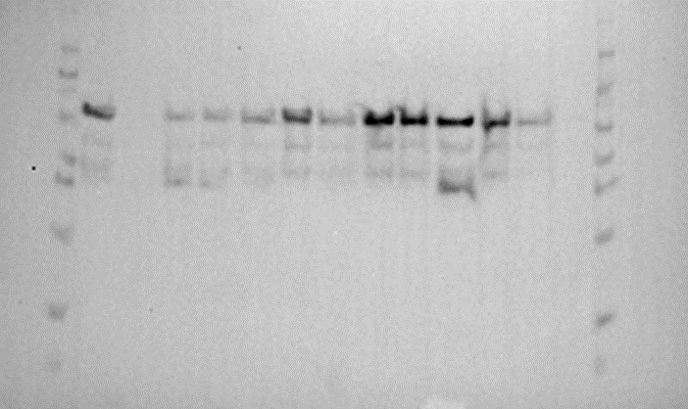
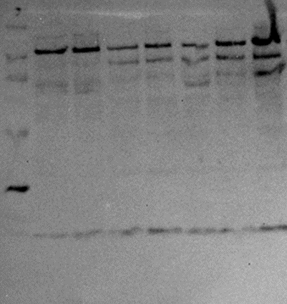
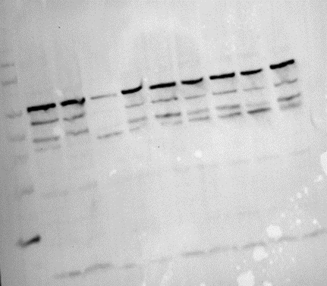
References
Anderson, S. M., Mueller, B. K., Lange, E. J., & Senes, A. (2017). Combination of Cα-H Hydrogen Bonds and van der Waals Packing Modulates the Stability of GxxxG-Mediated Dimers in Membranes. J Am Chem Soc, 139(44), 15774-15783. https://doi.org/10.1021/jacs.7b07505
Ash, W. L., Stockner, T., MacCallum, J. L., & Tieleman, D. P. (2004). Computer modeling of polyleucine-based coiled coil dimers in a realistic membrane environment: insight into helix-helix interactions in membrane proteins. Biochemistry, 43(28), 9050-9060. https://doi.org/10.1021/bi0494572
Bornberg-Bauer, E., Rivals, E., & Vingron, M. (1998). Computational approaches to identify leucine zippers. Nucleic Acids Research, 26(11), 2740-2746. https://doi.org/10.1093/nar/26.11.2740
Carpenter, E. P., Beis, K., Cameron, A. D., & Iwata, S. (2008). Overcoming the challenges of membrane protein crystallography. Curr Opin Struct Biol, 18(5), 581-586. https://doi.org/10.1016/j.sbi.2008.07.001
Díaz Vázquez, G., Cui, Q., & Senes, A. (2023). Thermodynamic analysis of the GAS. Biophys J, 122(1), 143-155. https://doi.org/10.1016/j.bpj.2022.11.018
Fagerberg, L., Jonasson, K., von Heijne, G., Uhlén, M., & Berglund, L. (2010). Prediction of the human membrane proteome. Proteomics, 10(6), 1141-1149. https://doi.org/10.1002/pmic.200900258
Faham, S., Yang, D., Bare, E., Yohannan, S., Whitelegge, J. P., & Bowie, J. U. (2004). Side-chain contributions to membrane protein structure and stability. J Mol Biol, 335(1), 297-305. https://doi.org/10.1016/j.jmb.2003.10.041
Fleming, K. G., Ackerman, A. L., & Engelman, D. M. (1997). The effect of point mutations on the free energy of transmembrane alpha-helix dimerization. J Mol Biol, 272(2), 266-275. https://doi.org/10.1006/jmbi.1997.1236
Gregersen, N., Bross, P., Vang, S., & Christensen, J. H. (2006). Protein misfolding and human disease. Annu Rev Genomics Hum Genet, 7, 103-124. https://doi.org/10.1146/annurev.genom.7.080505.115737
Hong, H. (2014). Toward understanding driving forces in membrane protein folding. Arch Biochem Biophys, 564, 297-313. https://doi.org/10.1016/j.abb.2014.07.031
Huang, B., Xu, Y., Hu, X., Liu, Y., Liao, S., Zhang, J., . . . Liu, H. (2022). A backbone-centred energy function of neural networks for protein design. Nature, 602(7897), 523-528. https://doi.org/10.1038/s41586-021-04383-5
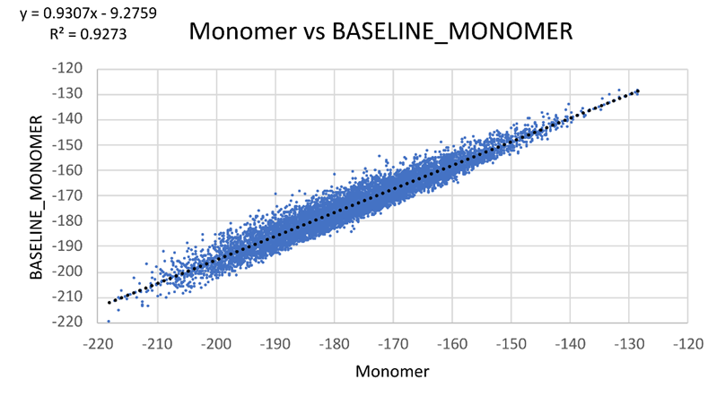
Joh, N. H., Oberai, A., Yang, D., Whitelegge, J. P., & Bowie, J. U. (2009). Similar energetic contributions of packing in the core of membrane and water-soluble proteins. J Am Chem Soc, 131(31), 10846-10847. https://doi.org/10.1021/ja904711k
Johnson, R. M., Hecht, K., & Deber, C. M. (2007). Aromatic and cation-pi interactions enhance helix-helix association in a membrane environment. Biochemistry, 46(32), 9208-9214. https://doi.org/10.1021/bi7008773
Krivov, G. G., Shapovalov, M. V., & Dunbrack, R. L. (2009). Improved prediction of protein side-chain conformations with SCWRL4. Proteins, 77(4), 778-795. https://doi.org/10.1002/prot.22488
Kuhlman, B., Dantas, G., Ireton, G. C., Varani, G., Stoddard, B. L., & Baker, D. (2003). Design of a novel globular protein fold with atomic-level accuracy. Science, 302(5649), 1364-1368. https://doi.org/10.1126/science.1089427
Kulp, D. W., Subramaniam, S., Donald, J. E., Hannigan, B. T., Mueller, B. K., Grigoryan, G., & Senes, A. (2012). Structural informatics, modeling, and design with an open-source Molecular Software Library (MSL). J Comput Chem, 33(20), 1645-1661. https://doi.org/10.1002/jcc.22968
Lazaridis, T. (2003). Effective energy function for proteins in lipid membranes. Proteins, 52(2), 176-192. https://doi.org/10.1002/prot.10410
Liu, Y., Engelman, D. M., & Gerstein, M. (2002). Genomic analysis of membrane protein families: abundance and conserved motifs. Genome Biol, 3(10), research0054. https://doi.org/10.1186/gb-2002-3-10-research0054
Lomize, A. L., & Pogozheva, I. D. (2017). TMDOCK: An Energy-Based Method for Modeling α-Helical Dimers in Membranes. J Mol Biol, 429(3), 390-398. https://doi.org/10.1016/j.jmb.2016.09.005
MacKerell, A. D., Bashford, D., Bellott, M., Dunbrack, R. L., Evanseck, J. D., Field, M. J., . . . Karplus, M. (1998). All-atom empirical potential for molecular modeling and dynamics studies of proteins. J Phys Chem B, 102(18), 3586-3616. https://doi.org/10.1021/jp973084f
Mravic, M., Thomaston, J. L., Tucker, M., Solomon, P. E., Liu, L., & DeGrado, W. F. (2019). Packing of apolar side chains enables accurate design of highly stable membrane proteins. Science, 363(6434), 1418-1423. https://doi.org/10.1126/science.aav7541
Nash, A., Notman, R., & Dixon, A. M. (2015). De novo design of transmembrane helix-helix interactions and measurement of stability in a biological membrane. Biochim Biophys Acta, 1848(5), 1248-1257. https://doi.org/10.1016/j.bbamem.2015.02.020
Popot, J. L., & Engelman, D. M. (1990). Membrane protein folding and oligomerization: the two-stage model. Biochemistry, 29(17), 4031-4037. https://doi.org/10.1021/bi00469a001
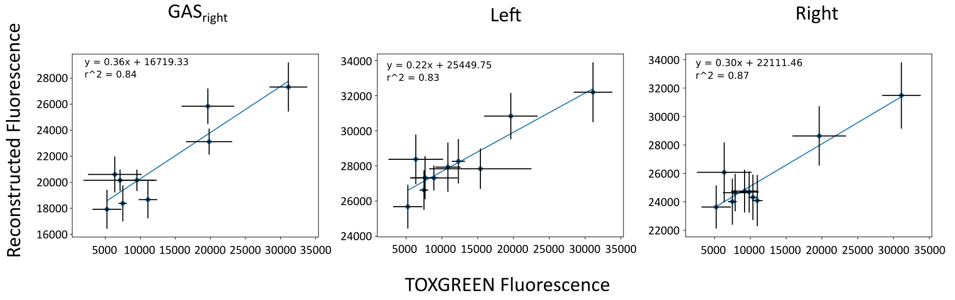
Ruan, W., Lindner, E., & Langosch, D. (2004). The interface of a membrane-spanning leucine zipper mapped by asparagine-scanning mutagenesis. Protein Science, 13(2), 555-559. https://doi.org/https://doi.org/10.1110/ps.03357404
Sanders, C. R., & Myers, J. K. (2004). Disease-related misassembly of membrane proteins. Annu Rev Biophys Biomol Struct, 33, 25-51. https://doi.org/10.1146/annurev.biophys.33.110502.140348
Senes, A. (2011). Computational design of membrane proteins. Curr Opin Struct Biol, 21(4), 460-466. https://doi.org/10.1016/j.sbi.2011.06.004
Subramaniam, S., & Senes, A. (2012). An energy-based conformer library for side chain optimization: improved prediction and adjustable sampling. Proteins, 80(9), 2218-2234. https://doi.org/10.1002/prot.24111
Walshaw, J., & Woolfson, D. N. (2003). Extended knobs-into-holes packing in classical and complex coiled-coil assemblies. 144(3), 349-361.
Yano, Y., Takemoto, T., Kobayashi, S., Yasui, H., Sakurai, H., Ohashi, W., . . . Matsuzaki, K. (2002). Topological stability and self-association of a completely hydrophobic model transmembrane helix in lipid bilayers. Biochemistry, 41(9), 3073-3080. https://doi.org/10.1021/bi011161y
Zhou, F. X., Cocco, M. J., Russ, W. P., Brunger, A. T., & Engelman, D. M. (2000). Interhelical hydrogen bonding drives strong interactions in membrane proteins. Nat Struct Biol, 7(2), 154-160. https://doi.org/10.1038/72430
Zhou, F. X., Merianos, H. J., Brunger, A. T., & Engelman, D. M. (2001). Polar residues drive association of polyleucine transmembrane helices. Proc Natl Acad Sci U S A, 98(5), 2250-2255. https://doi.org/10.1073/pnas.041593698

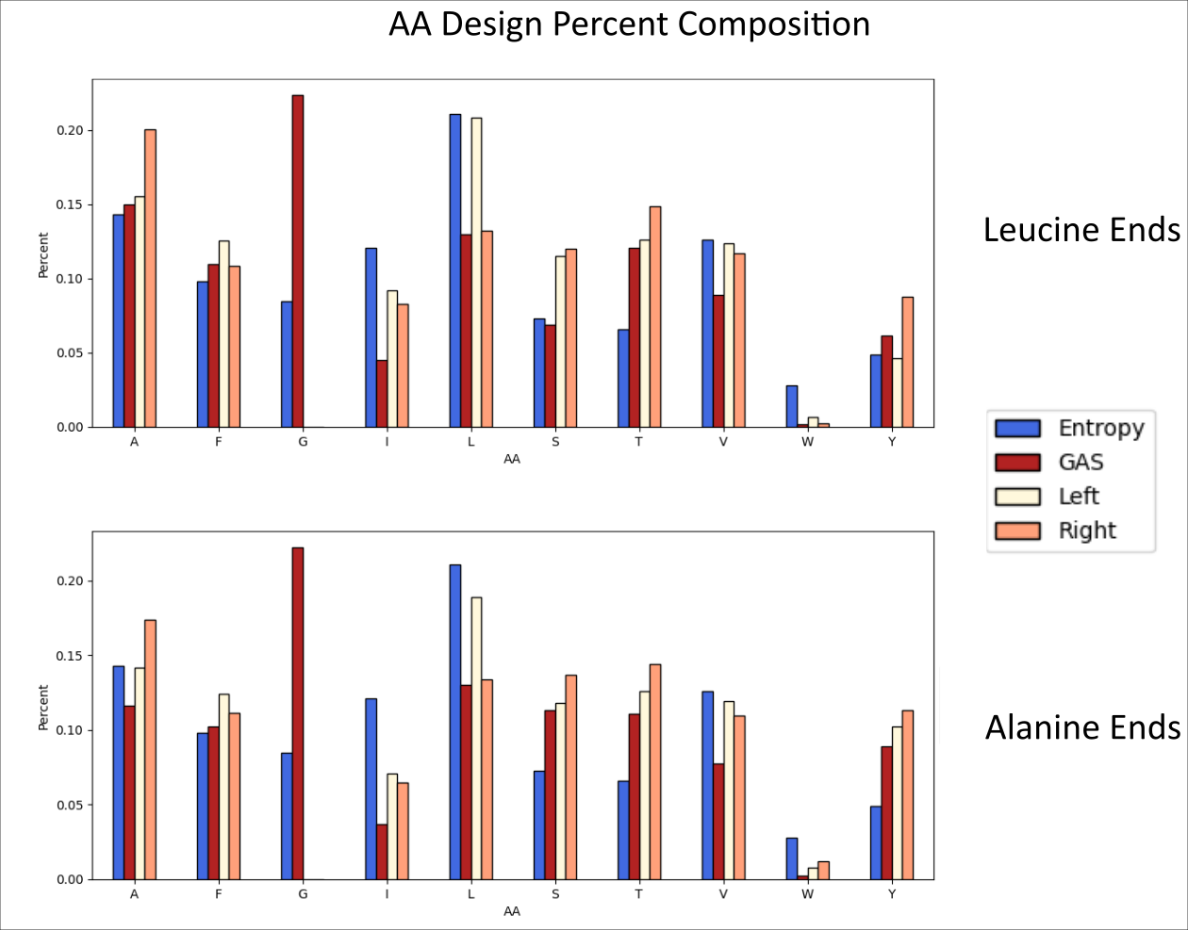
Supplementary Materials
Supp._WESTERNS

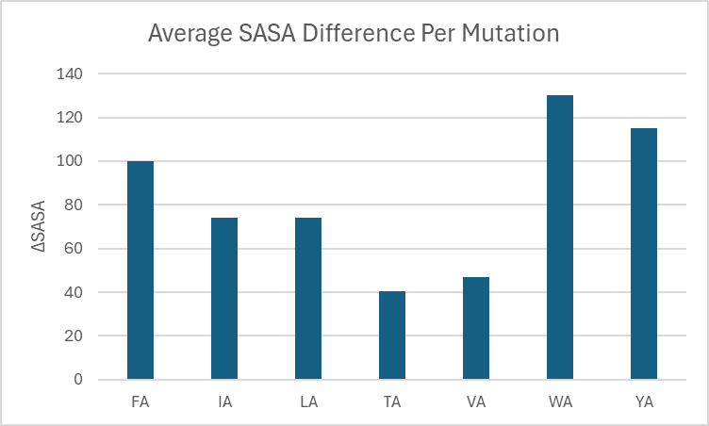
Supp._BASELINE_MONOMER

Supp._TOXGREEN_CONVERSION

Supp._AA_COMPOSITION

Supp._VOID_SASA_DATA

Other potential Supplement
Tables for cloning/trimming sequences for analysis
Sequence Entropy
Subset of designed structures
Hbonding analysis structures
deltaG Conversion

