Figure 1

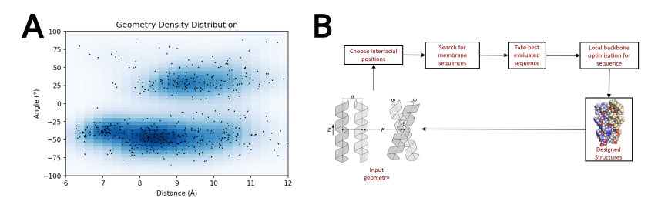
Figure 1. Membrane protein dimer design. (a) Helices within close contact (define how) were extracted from all membrane protein dimers submitted to the PDB in (date; 2019). Orientations of Proteins in membranes (OPM, cite) was used to only choose the proteins found in membranes. These geometric terms are plotted and overlaid over the density of these in space. (b) Design algorithm…

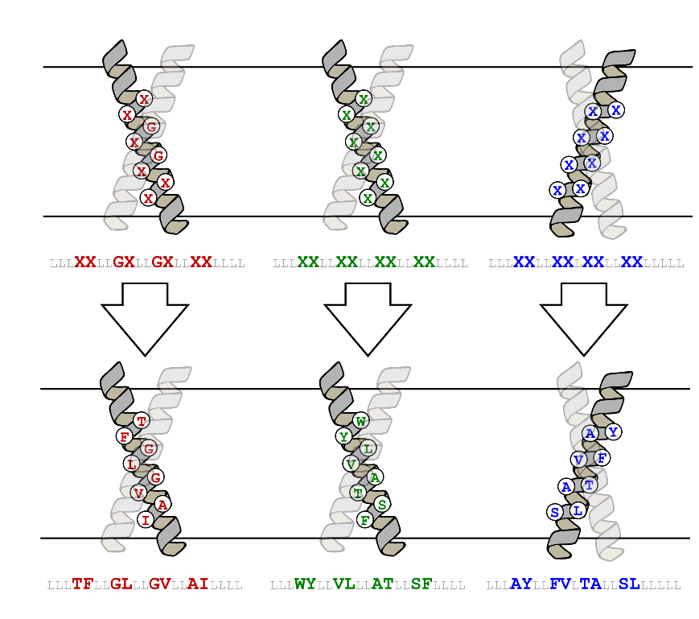
Figure 2
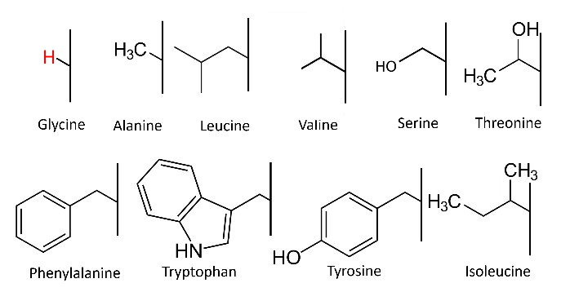
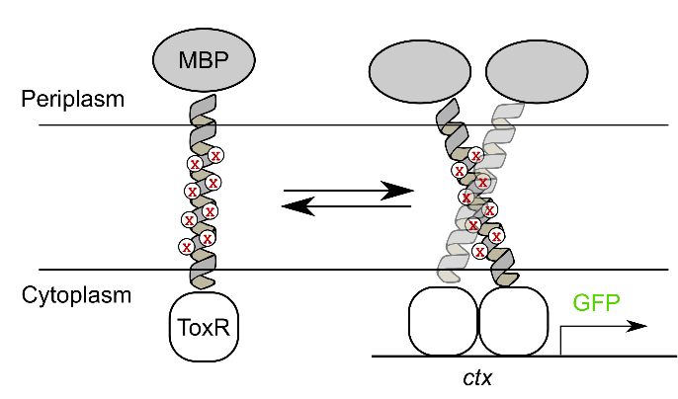

Figure 2. Controlling for expression and insertion variability. (a) [Design algorithm name] was run on a poly-leucine backbone, allowing for 8 variable amino acid positions. GASright and right handed positions are identical, while left handed positions are based on knobs into holes packing motifs found within coiled coils. (b) The variable amino acid positions were allowed to alternate between each of these amino acids, with GASrights designs being the only ones allowed to have glycine. (c) TOXGREEN fuses the designed protein to maltose binding protein (MBP) in the periplasm and ToxR, a dimeric transcription factor, in the cytoplasm. Dimerization of designs results in the dimerization of ToxR, and subsequently the transcription and translation of GFP as a readout of association strength.
Figure 3

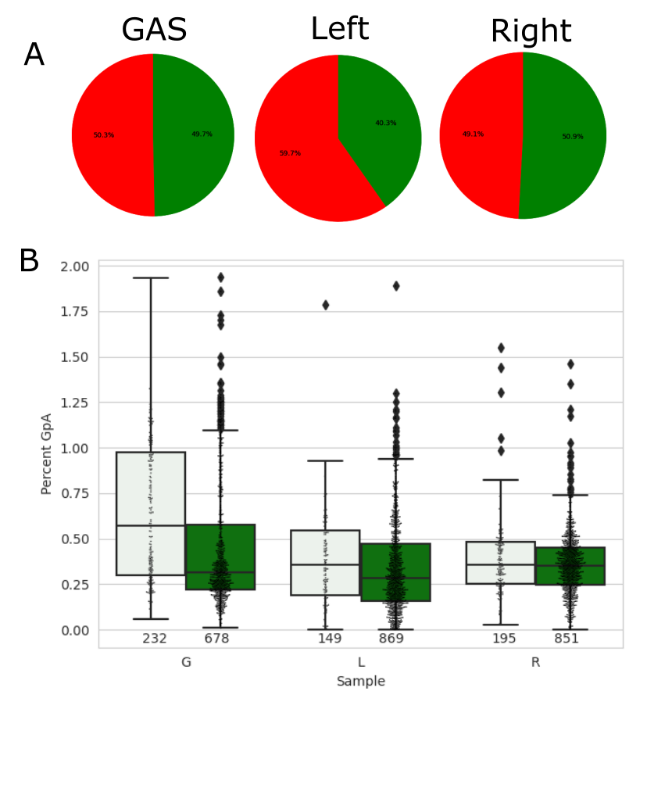

Figure 3. Association of designs and mutants. Utilizing high-throughput assay sort-seq, the fluorescence corresponding to the association of 3026 sequences was reconstructed. (a) Designed sequences are compared to a monomeric control and split into those with a fluorescence below (red) and above (green) monomer. (b) Designs (white) are compared to their corresponding mutants (green) in a boxplot that suggests that wt designs associate more than their mutants on average.

Figure 4

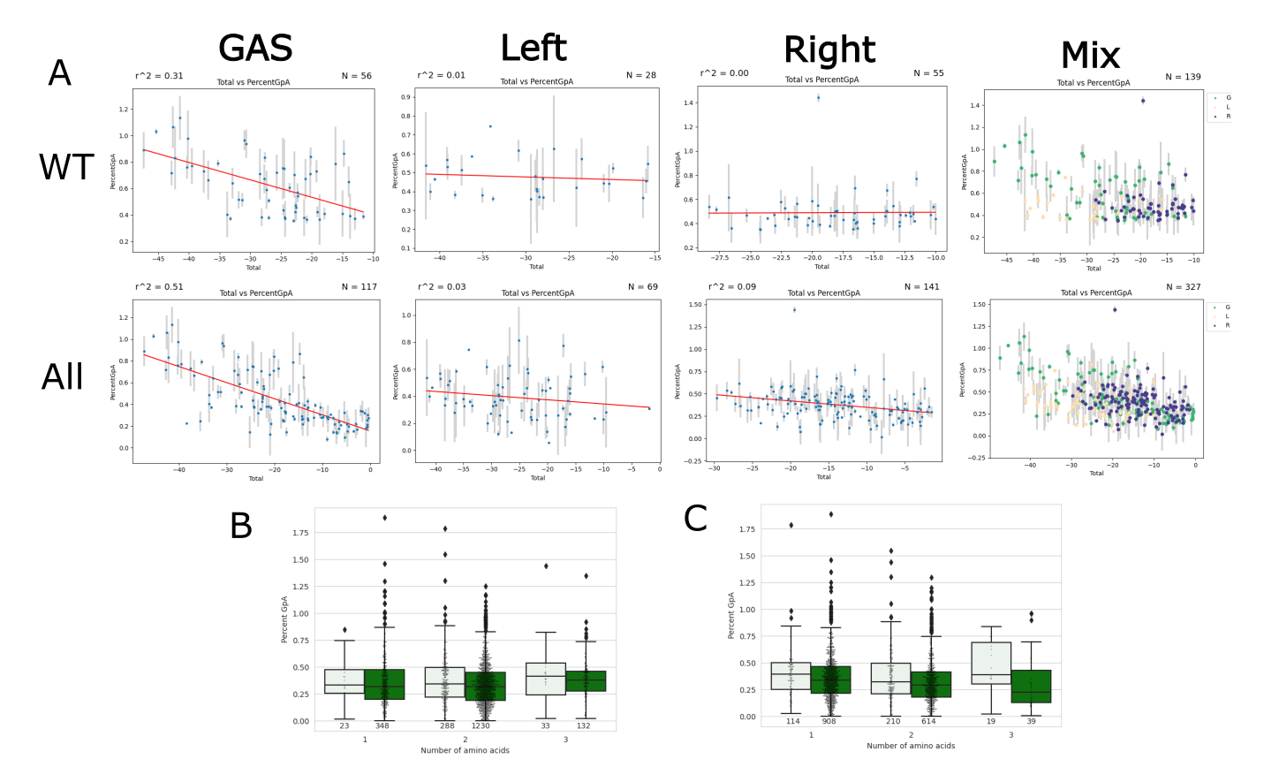
Figure 4. Evaluation of dimerization propensity as a function of van der Waals packing. (a) Graphs of energy score vs the dimerization of designed sequences separated by design region. WT are only wild type designs, and All includes WTs and their respective mutants. (b) Boxplots comparing the dimerization propensity based on the number of potential hydrogen bonding amino acids. This data suggests that association is not impacted by increasing numbers of hydrogen bonding amino acids. (c) Boxplots comparing the dimerization propensity based on the number of ring amino acids. This data shows that sequences with three ring amino acids may have increased association, which could be due to an increase in stability by electrostatics and/or steric bulk.

Figure 5
