Van der Waals packing facilitates membrane protein association

Abstract
- TBD
Graphical Abstract

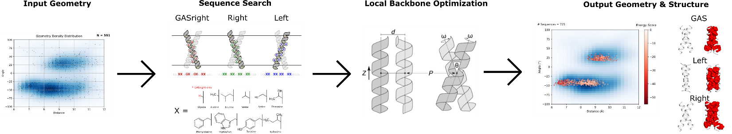
- Might need to find a way to combine 3 and 4 so I can add in fluorescence data as well
Premise/Intro
Membrane proteins comprise 25-30% of the proteins found within protein-coding genes of various organisms (Fagerberg et al., 2010). Proper membrane protein folding is critical for essential biological functions, including cell signaling, ion balance, and gene regulation. Misfolding of membrane proteins has been found to be involved in several human diseases such as Parkinson’s, cystic fibrosis, and cancer (Gregersen et al., 2006; Sanders & Myers, 2004). To understand how protein misfolding plays a role in disease states and progression, it is necessary to investigate how these proteins fold. However, studying membrane protein folding is inherently a difficult challenge because of their hydrophobic nature. Membrane proteins are difficult to express in yields high enough for biophysical experiments, and purification and solubilization of these proteins often lead to aggregation or unfolding (Carpenter et al., 2008). To combat these challenges, much of the research studying membrane protein folding is focused on understanding the biophysical forces that govern the folding process. Investigation of the biophysical forces that govern protein folding will allow us to determine why specific mutations result in diseases caused by misfolding. In addition, this knowledge can be applied to design new therapeutics that specifically target proteins in these misfolded states. Understanding the forces that enable membrane proteins to fold will contribute to our knowledge of how these fundamental forces are involved in human health and disease.

Proper membrane protein folding is regulated by a distribution of stabilizing hydrogen bonds, weak polar interactions, and van der Waals forces between the unfolded and folded states., but research is lacking on the contribution of van der Waals packing. This force is particularly important due to the nature of van der Waals interactions: Even if hydrogen bonding or polar interactions play a significant stabilizing role, because van der Waals occurs between any nonbonded atoms in close contact, it is a necessary force that is always present within the folded state. This means that van der Waals packing is essential for folding, but the extent at which packing can be a driving force for membrane protein folding is unclear. Without understanding the extent at which van der Waals packing contributes to folding, we cannot complete our understanding of how these other forces contribute to membrane protein association and folding.

The contribution of van der Waals packing to membrane protein folding can be broken down into three distinct interactions: lipid-lipid packing, lipid-protein packing, and protein-protein packing. Protein-protein (or sidechain) packing, is a technically feasible starting point because of the ability to manipulate sequences and determine changes in stability due to mutation. Previous research has demonstrated that disruption of packing within the core of bacteriorhodopsin destabilizes protein structure, suggesting that it is a necessary force for proteins to reach optimal stability (Faham et al., 2004; Joh et al., 2009). Additionally, a recent study using membrane protein design has shown that optimized sidechain packing can stabilize the folded state of phospholamban, demonstrating that packing can drive protein stability (Mravic et al., 2019). Although these studies show that sidechain packing plays a crucial role in stabilizing membrane protein structure in individual systems, the energetic contribution of sidechain packing to the folded state of membrane proteins more generally has not yet been determined (Hong, 2014). In this study, we use homodimerization as a simple and tractable model system to characterize the extent at which sidechain packing is a driving force for membrane protein association (Popot & Engelman, 1990). Previous research using this model system has measured the contributions of both hydrogen bonding and weak polar interactions in the membrane and determined that these forces can drive membrane protein folding (Johnson et al., 2007; Yano et al., 2002; Zhou et al., 2001). Using a large-scale computational design on common dimeric backbone geometries found within the PDB paired with a complementary high throughput method to measure transmembrane (TM) association, we have determined that sidechain packing is a weak driving force involved in TM association.
Results
Figure MP_design

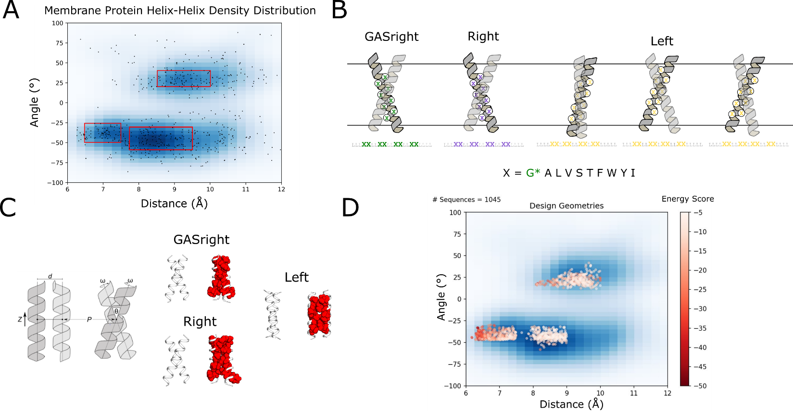Figure MP_design: Membrane protein dimer design. (a) Helices within close contact were extracted from the Orientations of Proteins in membranes (OPM) in September 2019. The geometric terms were extracted and overlaid over the kernel density estimation of the membrane protein contact space. (b) Interfaces for designs on poly-leucine backbones, where x is an interfacial position that can be designed using a library of the most prevalent amino acids in membrane proteins. Glycine is only used for GASright designs. (c) Structures undergo local backbone minimization by alternating 4 geometric parameters: distance (d), angle (θ), axial rotation (ω), and Z shift. (d) Design geometries overlaid on the helix-helix density distribution in panel a. Each point is colored by their respective design energy score.
Extracting membrane protein geometries from the Protein Databank (PDB)
To identify the most common, and thus most likely designable, interaction motifs for dimeric proteins, we investigated the geometry of all helix-helix interactions found in known membrane protein structures. Any two helices in close contact in the structures were considered as an individual helical pair and the conformational parameters of each pair were computed (Angle θ, distance Å, axial rotation ω, z-shift, see Methods).
Figure MP_design A illustrates the resulting helix-helix interaction landscape, plotted as a scatterplot of the crossing angle and interhelical distance. We selected for our designs the three major high-density regions. In the left-handed region, helical pairs are found to interact most frequently in the range between 8.5 to 10 Å of interhelical distance and 20 to 40° of crossing angle (“Left” box in Fig. MP_design A). The right-handed region presents a much broader range of distances from 6.5 to over 10 Å of distance and crossing angles between -30 and -60°. We selected the maximum density region, between 7.75 and 9.5 Å and -30 to -60°) angle (“Right” box),.
The third region identified corresponds to the GAS_{right} region, which is characterized by very short interhelical distance (6.5-7.5 Å) and crossing angles of -25 to -55° angle. GAS_{right} is a well characterized dimerization motif. It is sequence signature is the presence of small amino acids (Gly, Ala, Ser) at the dimer interface, forming its characteristic GxxxG and similar sequence motifs (GxxxA, SxxxG, etc.). These small amino acid allow for the short interhelical distance, which the helical backbones coming to contacts, which allow the formations of networks of interhelical weak hydrogen bonds between the helices. We previously showed that van der Waals interactions are important for GAS_{right} stability but these motifs are also stabilized by weak hydrogen bonding.

Computational Design Strategy
For each region, we identified positions at the helix-helix interface to be designed. Figure MP_design B illustrates our design strategy for each region, with 8 designable positions stitched onto a 21 amino acid poly-Leu backbone. The noninterfacial positions of the backbone are standardized to Leucine, reducing variability in hydrophobicity. Keeping the noninterfacial residues constant results in consistent expression and insertion into the membrane. Additionally, a pure poly-Leu sequence has low propensity for association in TOXCAT based assays, reducing the risk of association outside of our designed interface (cite).
Previous research on GASright proteins has shown that replacing interfacial residues in an LLLxxLLxxLLxxLLxxLLLL pattern is sufficient for dimerization (cite). We applied the same interface to the Right design region, which outside of a larger interhelical distance, has similar geometry. In the Left design region, we observed three different interfaces dependent on the crossing angle and z-shift. These interfaces correspond to common dimerization motifs such as knobs-into-holes and leucine zippers, and we opted to design sequences for each interface (cite).
We developed an algorithm to design membrane protein homodimers by combining fixed backbone design with iterative backbone refinement (Huang et al., 2022; Kuhlman et al., 2003; Kulp et al., 2012; Nash et al., 2015; Senes, 2011). 10000 backbone conformations were randomly generated within the high-density regions as inputs for our design algorithm (Methods). Each designed position was limited to amino acids commonly found in membrane proteins as an additional way to control for protein hydrophobicity (Liu et al., 2002). The three amino acids often found in GASright interfaces (Gly, Ala, and Ser) are included in this list, with Gly only permitted for GASrights to prevent the occurrence of interhelical hydrogen bonding in the Right and Left regions (Figure MP_design B).
Each protein interface was designed by iteratively switching amino acids and evaluating each sequence using a computational energy score composed of van der Waals packing, hydrogen bonding, and implicit solvation (Krivov et al., 2009; Lazaridis, 2003; MacKerell et al., 1998). Sequences with the best energy underwent a local backbone refinement to find the most stable structure for the designed interface (Figure MP_design C). Our design algorithm resulted in a set of 1075 wild type (WT) design sequences with a range of both structure and stability (Figure MP_design D).
Due to the large scale of this study, it would be difficult to determine the success of our design algorithm through experimental structure validation. As an alternative, each design was evaluated through mutagenesis, where a mutant position is expected to disrupt association of the given structure. For each of these designs, we mutated an interfacial position to either isoleucine or alanine (Figure primary_dataset A). Mutating to isoleucine results in significant clashes between atoms within the structure. Conversely, mutating to alanine produces a large void at the helix-helix interface. Both clash and void mutants were expected to decrease association, with clash mutants expected to result in drastic decreases as in previous studies (cite).

Experimental methods and filtering the dataset
A gene library coding for our designed sequences and mutants was cloned into E. coli and dimerization propensity measured using the high throughput TOXCAT based assay sort-seq (cite). This assay utilizes a combination of fluorescent activated cell sorting (FACS) and next generation sequencing (NGS) to measure the dimerization propensity of each sequence by reconstructing its fluorescence profile (Figure exp_method high throughput). To ensure the best possible reconstruction of the fluorescence signal by sort-seq, we compared the reconstructed signal of a set of 9-10 constructs with the fluorescence obtained from individual TOXGREEN. The resulting linear correlation (fig experimental_method) were used to calibrate the reconstructed signal of all constructs in each design region.
After running each of the libraries through sort-seq in triplicate, sequences were filtered for proper insertion in the membrane by their ability to survive in maltose media (cite sort-seq). Sequences present in maltose media after 36 hours of growth were evaluated against a set of maltose failing controls (Methods). Designs that pass the maltose test have properly inserted into the membrane.
853 of our 1075 WT designs (79%) were present in the NGS data, with 489 (45%) passing the maltose test. Finally, 248 (23%) have at least one clashing mutant that passes both criteria present. These sequences along with their mutants are analyzed in our datasets. (recheck these numbers)

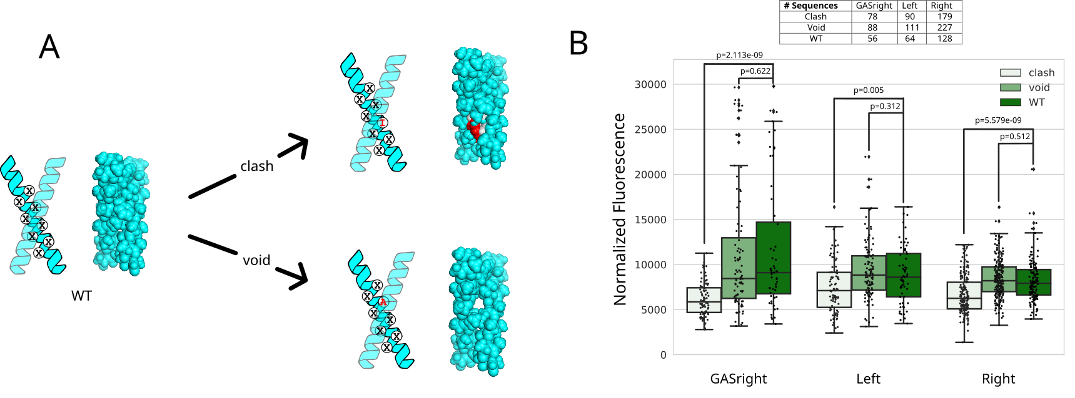Figure primary_dataset. A) Mutations made to each WT design. Clash mutants result in overlaps between atoms from each helix, Void mutants result in large pockets lacking atoms. B) The WT (dark green) fluorescence distribution is compared to the fluorescence distributions of their corresponding void (light green) and clash (white) mutants. p-values determining the significant difference between WT fluorescence and mutant fluorescence are shown over the corresponding boxplot.
GASrights are significantly more stable than other designs
Figure primary_dataset B shows the fluorescence distribution of the WT designs (dark green), void mutants (light green), and clash mutants (white) separated by design region. It is notable that the fluorescence within the GASright spans a larger range than both the Left and Right designs, demonstrating GASrights propensity for strong self-association. Many proteins in both the Left and Right are above the fluorescence of the monomeric control (25% GpA/~5000 normalized fluorescence). Additionally, 14/56 (25%, GASright), 5/64 (8%, Left), and 4/128 (3%, Right) of these sequences reach a level of fluorescence that would be typical of proteins displaying significant dimerization in the TOXGREEN assay (60% GpA/~14000 normalized fluorescence). This data suggests that GASright is a motif that is quite designable for stability, likely due to the contribution of hydrogen bonding. Sequences designed with van der Waals packing only are much weaker, but this data suggests that solely packing is enough for sequences to have a propensity to associate.
To validate our designs, we observed the impact of each of our mutations on association. GASright clashing mutations result in a significant decrease in fluorescence, consistent with these associating according to our designed structures. We also see a smaller decrease in fluorescence when void mutants are introduced, as expected. Our results for the Left and Right design regions are similar, but because there are more monomeric designs with a smaller fluorescent range, differences are less dramatic. Void mutants do not show a decrease in fluorescence, likely due to the decreased range of association. However, statistical testing shows that there is a significant decrease in fluorescence between WT designs and clash mutants, suggesting that a large number of our constructs are interacting with the predicted interface.

Clashing mutant data results in many weak to mildly associating dimers
We filtered our data for designs with clashing mutants that significantly decrease association, identifying designs with validated structures. We limited this dataset to WT sequences with at least one clashing mutation with a mild monomeric cutoff (< 35% GpA) or with fluorescence 50% less than the WT. Figure delta_g_data A shows scatterplots of the fluorescence of our WT designs against our energy score for each region, allowing us to evaluate the accuracy of our design method. It is apparent that GASrights appear to follow our design principles better than the other regions. This suggests that our design energy score is not able to capture meaningful differences in the lower threshold of association where a majority of the Left and Right designs are found (7000-12000 normalized fluorescence). Additionally, many of the designs above a strong dimer threshold (60%/14000 toxgreen fluor) in the Left and Right regions are not found in this dataset. Clashing mutants for a majority of these proteins are not monomeric and have a smaller fluorescence difference than the threshold we set. Overall, this data suggests that our energetic parameters are not well tuned to evaluate the low levels of homodimer association that we were able to design in the Left and Right regions.
Conversion of fluorescence to ΔG
Finally, we converted the fluorescence to biophysical ΔG using a method from an in vitro study on GASright proteins (Díaz Vázquez et al., 2023). We then compared these ΔG values to the energetics from our design algorithm (figure deltaG data). Although our energetics do not seem to capture the overall trend of stability, it allows us to visualize the distribution of the calculate biophysical stability of these sequences. This data shows that both Left and Right designs stabilized to a ΔG around -3 to -3.5, comparable to weak dimers (cite Gladys). Additionally, many of the most stable GASrights designs are calculated to have a ΔG -4 to -5, comparable to strong dimers. GASright designs with a combination of interhelical hydrogen bonding and tighter packing due to a shorter helical distance result in stronger dimerization. Our designed sequences without hydrogen bonding have weak association, suggesting that packing is sufficient for membrane protein association.
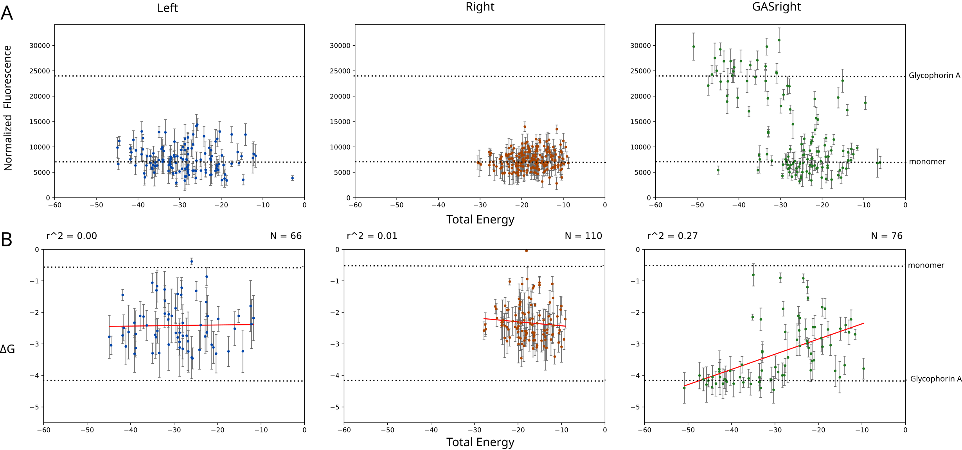Figure delta_g_data: A) Design energy score plotted vs normalized fluorescence. B) Design energy score vs fluorescence converted to biophysical ΔG as in Díaz Vázquez et al., 2023. (TODO: change this data to only the ones that pass clashing/maltose like in primary_dataset?)
Hbonding datasets
GASright

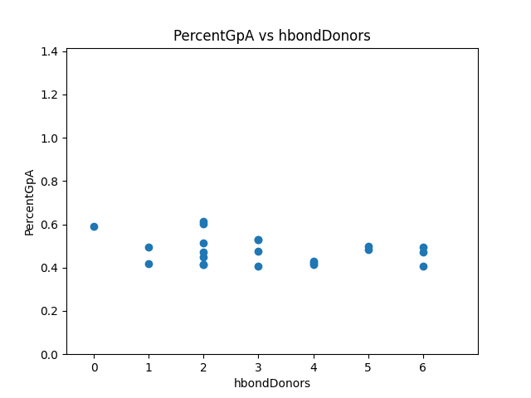
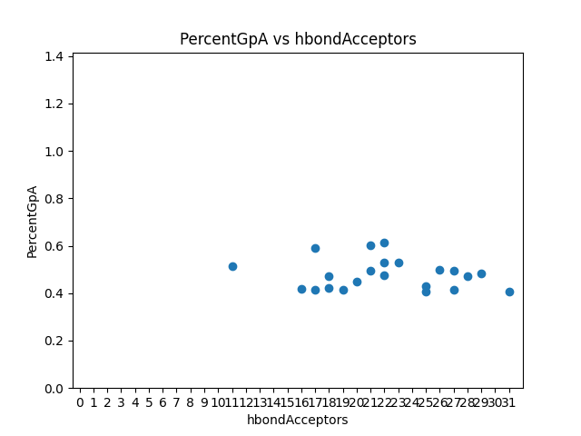
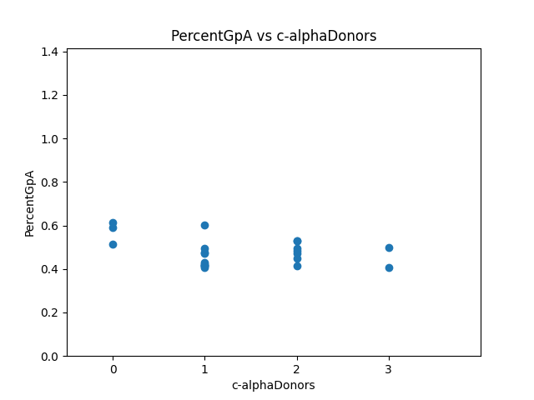
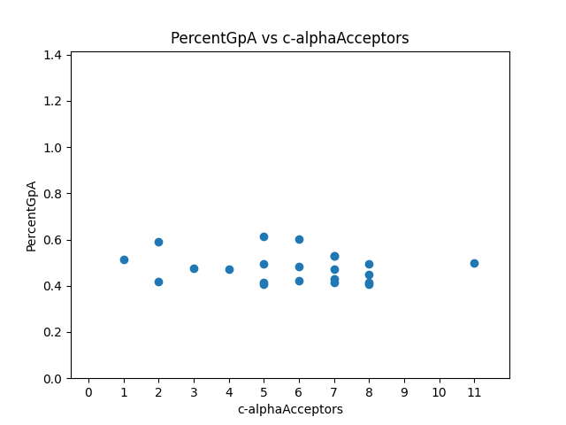
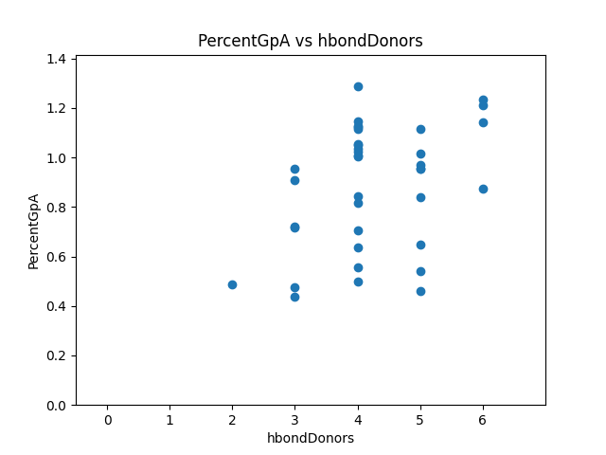
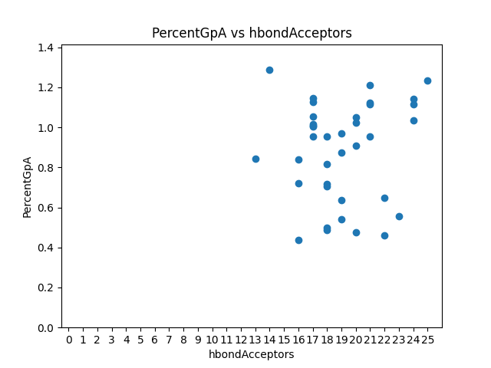
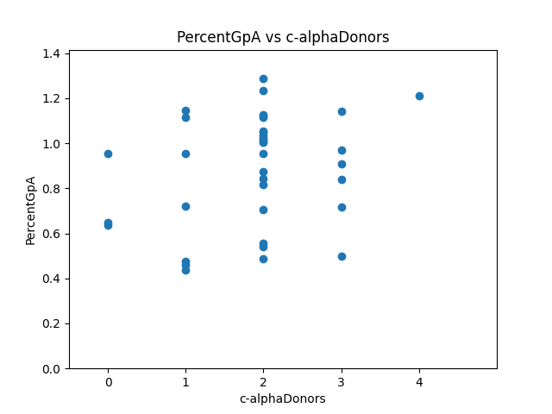
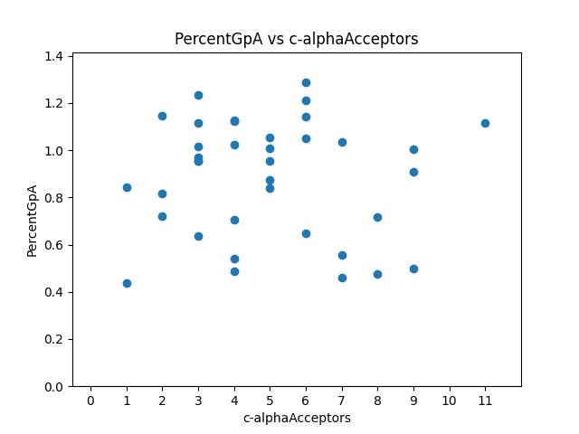

Left

Right

Discussion and Conclusion
…
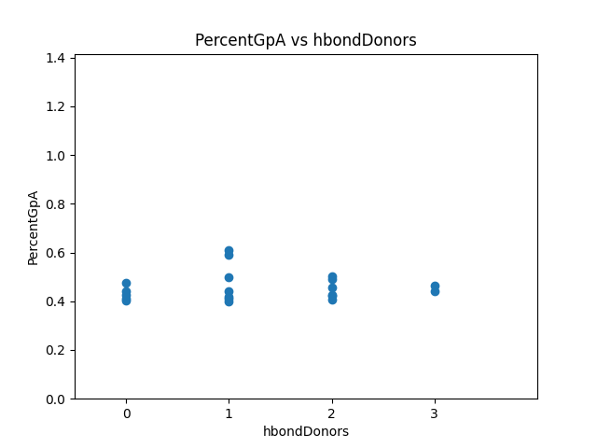
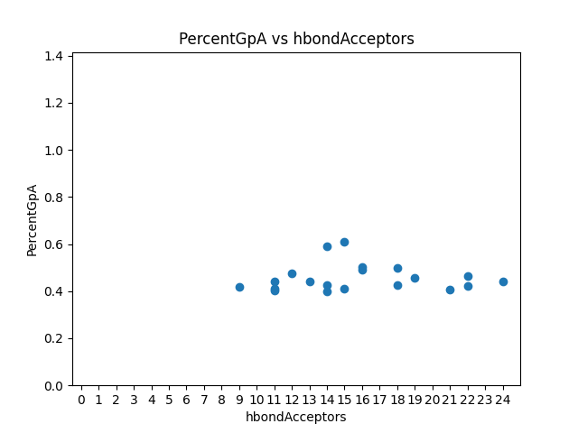
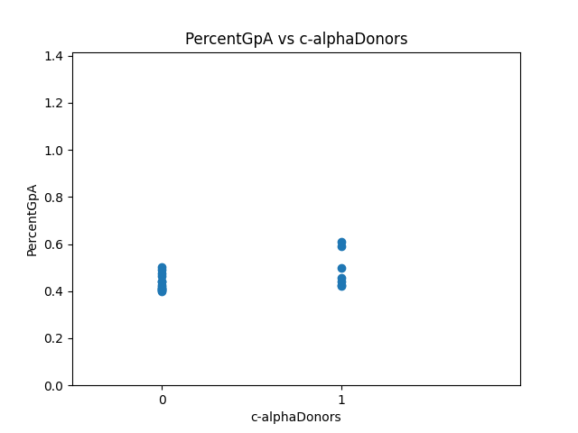
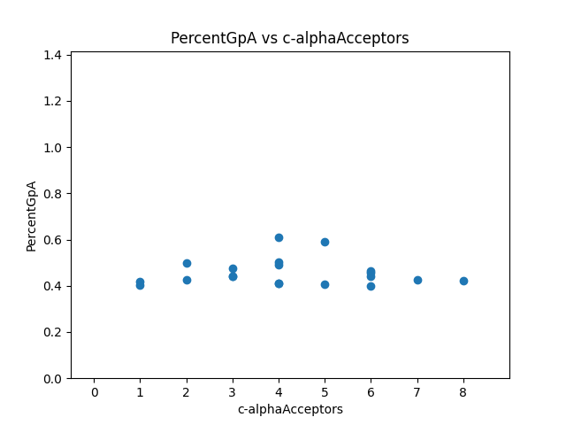
We speculate that creating voids in dimers relying solely on sidechain packing to associate may not necessarily be destabilizing because of the potential for these sequences to undergo dimerization with an alternative structure that fills the void. Rather than creating a void at the interface, the smaller alanine may result in alternative structures that fills the void by allowing the helices to associate more tightly.
GASright sequences expressed the most fluorescence of all three design regions, suggesting that interhelical hydrogen bonding is necessary for high level association in membrane proteins.
It is possible that GASright sequence stability is influenced by increased packing compared to the other regions and bolstered by increased stability with interhelical hydrogen bonding.
Other things that can be included:
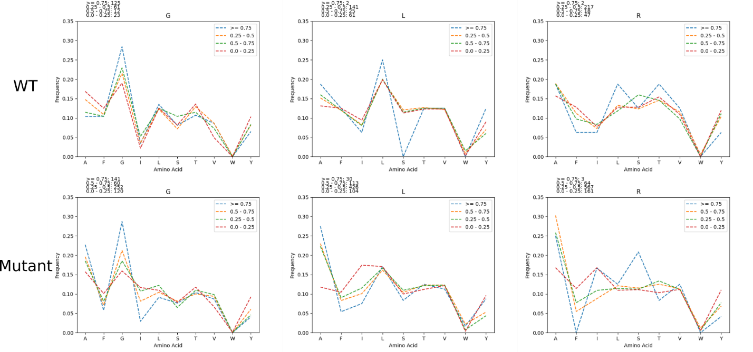
Amino acid distribution per Fluorescence

Figure: The amino acid frequency was calculated for sequences based on their fluorescence (>= 0.75, 0.5 – 0.75, 0.25-0.5, and < 0.25). This was done for designs and all mutant sequences.
- In all regions, isoleucine is more prevalently found in sequences with lower fluorescence
- Phenylalanine is also more prevalently found in mutant sequences with lower fluorescence
- Tyrosine is kind of variable, but more prevalently found in mutant sequences with lower fluorescence
  - Suggest that these AAs disrupt association
- Alanine is more prevalent in sequences with higher fluorescence
  - Suggests that it helps facilitate association
- Distributions of hbond AAs (Ser, Thr) are similar throughout, suggesting that potential hbonding by these AAs is not the main driving force for association

Figure experimental_methodology: Experimental methods from the cellular level to the interpreted fluorescent data. Plasmids coding for the transmembrane sequence of interest are expressed in E. coli cells. These are then grown overnight and can be evaluated for fluorescence using both a high and low throughput method. Using high throughput fluorescence activated cell sorting in combination with next generation sequencing, we are able to get fluorescence data for 1000s of sequences at a time. A subset of those sequences is evaluated using low throughput TOXGREEN run in a fluorescence plate reader. These sequences are normalized to our positive control GpA, allowing us to transform and normalize the data by our positive control.
Sequence logo info:
- Have these images somewhere for sequences from the PDB
We then took the WT sequences found in these dense regions and created sequence logos, aiming to determine if there are any common motifs to be used in design. These sequence logos show that the region in the bottom left of Figure MP_design A is the GASright, a well characterized dimerization motif with a known sequence signature where small amino acids glycine, alanine, and serine are typically found at the interface (Figure MP_design logos). This sequence signature of small amino acids allows GASright helices to come into close contact, resulting in stabilization by a combination of tight van der Waals packing and interhelical hydrogen bonding. There were no common motifs found in the other regions, but the GASright sequence motif will be used to design sequences in the GASright region.

Mutants:
We chose two of the least stable mutants by energy (clash) or largest differences in solvent accessible surface area (void) for each sequence (supplement methods).
Baseline term:
To reduce computational expense, we developed a baseline energetic term that functioned as an estimate for the energy of the monomeric state, allowing us to accept sequences with the best stability between the dimer-monomer state.

Delta Fluorescence Figure
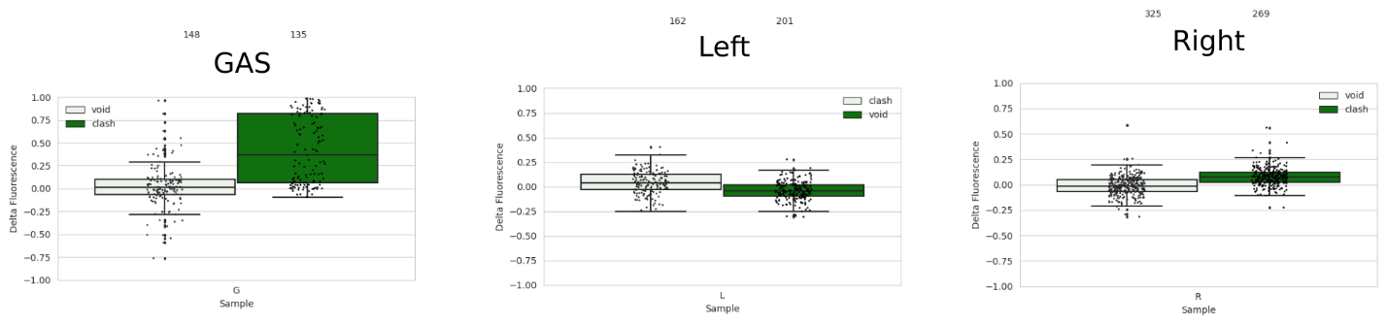
Fluorescence of wild type designs subtracted by fluorescence of their corresponding mutants is plotted above.
- Plot this as an x vs y plot, might likely be supplement of just a subset of the previous figure
  - However, there are a variety of sequences above the 40% GpA in both the right and left handed regions (conservative limit for association)
    - OR take the data for some of those sequences from TOXGREEN and compare them in an x vs y plot or something? If done here, then can also talk about the expression checks through westerns (Supplement western)

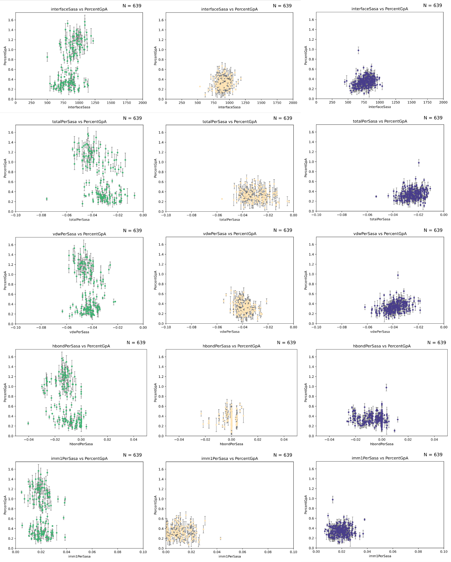
Percent SASA figure

Anderson, S. M., Mueller, B. K., Lange, E. J., & Senes, A. (2017). Combination of Cα-H Hydrogen Bonds and van der Waals Packing Modulates the Stability of GxxxG-Mediated Dimers in Membranes. J Am Chem Soc, 139(44), 15774-15783. https://doi.org/10.1021/jacs.7b07505
Carpenter, E. P., Beis, K., Cameron, A. D., & Iwata, S. (2008). Overcoming the challenges of membrane protein crystallography. Curr Opin Struct Biol, 18(5), 581-586. https://doi.org/10.1016/j.sbi.2008.07.001
Díaz Vázquez, G., Cui, Q., & Senes, A. (2023). Thermodynamic analysis of the GAS. Biophys J, 122(1), 143-155. https://doi.org/10.1016/j.bpj.2022.11.018
Fagerberg, L., Jonasson, K., von Heijne, G., Uhlén, M., & Berglund, L. (2010). Prediction of the human membrane proteome. Proteomics, 10(6), 1141-1149. https://doi.org/10.1002/pmic.200900258
Faham, S., Yang, D., Bare, E., Yohannan, S., Whitelegge, J. P., & Bowie, J. U. (2004). Side-chain contributions to membrane protein structure and stability. J Mol Biol, 335(1), 297-305. https://doi.org/10.1016/j.jmb.2003.10.041
Fleming, K. G., Ackerman, A. L., & Engelman, D. M. (1997). The effect of point mutations on the free energy of transmembrane alpha-helix dimerization. J Mol Biol, 272(2), 266-275. https://doi.org/10.1006/jmbi.1997.1236
Gregersen, N., Bross, P., Vang, S., & Christensen, J. H. (2006). Protein misfolding and human disease. Annu Rev Genomics Hum Genet, 7, 103-124. https://doi.org/10.1146/annurev.genom.7.080505.115737
Hong, H. (2014). Toward understanding driving forces in membrane protein folding. Arch Biochem Biophys, 564, 297-313. https://doi.org/10.1016/j.abb.2014.07.031
Huang, B., Xu, Y., Hu, X., Liu, Y., Liao, S., Zhang, J., . . . Liu, H. (2022). A backbone-centred energy function of neural networks for protein design. Nature, 602(7897), 523-528. https://doi.org/10.1038/s41586-021-04383-5
Joh, N. H., Oberai, A., Yang, D., Whitelegge, J. P., & Bowie, J. U. (2009). Similar energetic contributions of packing in the core of membrane and water-soluble proteins. J Am Chem Soc, 131(31), 10846-10847. https://doi.org/10.1021/ja904711k
Johnson, R. M., Hecht, K., & Deber, C. M. (2007). Aromatic and cation-pi interactions enhance helix-helix association in a membrane environment. Biochemistry, 46(32), 9208-9214. https://doi.org/10.1021/bi7008773
Krivov, G. G., Shapovalov, M. V., & Dunbrack, R. L. (2009). Improved prediction of protein side-chain conformations with SCWRL4. Proteins, 77(4), 778-795. https://doi.org/10.1002/prot.22488
Kuhlman, B., Dantas, G., Ireton, G. C., Varani, G., Stoddard, B. L., & Baker, D. (2003). Design of a novel globular protein fold with atomic-level accuracy. Science, 302(5649), 1364-1368. https://doi.org/10.1126/science.1089427
Kulp, D. W., Subramaniam, S., Donald, J. E., Hannigan, B. T., Mueller, B. K., Grigoryan, G., & Senes, A. (2012). Structural informatics, modeling, and design with an open-source Molecular Software Library (MSL). J Comput Chem, 33(20), 1645-1661. https://doi.org/10.1002/jcc.22968
Lazaridis, T. (2003). Effective energy function for proteins in lipid membranes. Proteins, 52(2), 176-192. https://doi.org/10.1002/prot.10410
Liu, Y., Engelman, D. M., & Gerstein, M. (2002). Genomic analysis of membrane protein families: abundance and conserved motifs. Genome Biol, 3(10), research0054. https://doi.org/10.1186/gb-2002-3-10-research0054
Lomize, A. L., & Pogozheva, I. D. (2017). TMDOCK: An Energy-Based Method for Modeling α-Helical Dimers in Membranes. J Mol Biol, 429(3), 390-398. https://doi.org/10.1016/j.jmb.2016.09.005
MacKerell, A. D., Bashford, D., Bellott, M., Dunbrack, R. L., Evanseck, J. D., Field, M. J., . . . Karplus, M. (1998). All-atom empirical potential for molecular modeling and dynamics studies of proteins. J Phys Chem B, 102(18), 3586-3616. https://doi.org/10.1021/jp973084f
Mravic, M., Thomaston, J. L., Tucker, M., Solomon, P. E., Liu, L., & DeGrado, W. F. (2019). Packing of apolar side chains enables accurate design of highly stable membrane proteins. Science, 363(6434), 1418-1423. https://doi.org/10.1126/science.aav7541
Nash, A., Notman, R., & Dixon, A. M. (2015). De novo design of transmembrane helix-helix interactions and measurement of stability in a biological membrane. Biochim Biophys Acta, 1848(5), 1248-1257. https://doi.org/10.1016/j.bbamem.2015.02.020
Popot, J. L., & Engelman, D. M. (1990). Membrane protein folding and oligomerization: the two-stage model. Biochemistry, 29(17), 4031-4037. https://doi.org/10.1021/bi00469a001
Sanders, C. R., & Myers, J. K. (2004). Disease-related misassembly of membrane proteins. Annu Rev Biophys Biomol Struct, 33, 25-51. https://doi.org/10.1146/annurev.biophys.33.110502.140348
Senes, A. (2011). Computational design of membrane proteins. Curr Opin Struct Biol, 21(4), 460-466. https://doi.org/10.1016/j.sbi.2011.06.004
Yano, Y., Takemoto, T., Kobayashi, S., Yasui, H., Sakurai, H., Ohashi, W., . . . Matsuzaki, K. (2002). Topological stability and self-association of a completely hydrophobic model transmembrane helix in lipid bilayers. Biochemistry, 41(9), 3073-3080. https://doi.org/10.1021/bi011161y
Zhou, F. X., Merianos, H. J., Brunger, A. T., & Engelman, D. M. (2001). Polar residues drive association of polyleucine transmembrane helices. Proc Natl Acad Sci U S A, 98(5), 2250-2255. https://doi.org/10.1073/pnas.041593698

