Why I’m writing this chapter
Early on in my PhD career, my advisor inspired me to train my brain to learn at the highest level with a simple credo: know what you don’t know.
To think about what you know so deliberately that you’re able to figure out what there is left to learn.
And it’s worked: I’ve finished my research and am working to publish my work as an infinitesimally small stamp in history. The PhD finish line is full of triumphs: a published paper, a final defense to showcase and explain your research, and recognition as an academic expert.
But PhDs typically aren’t straight forward. For me it’s been a long, intense personal journey: traversing the valleys and mountains of knowledge about cell membranes and biophysical forces. Sometimes, trekking and running energetically through a field of fluorescent green flowers. But more often, barely learning anything and feeling completely stuck, as if trudging through multiple feet of snow in the dark.
So when I saw the opportunity to include a chapter in my thesis about “the parts of the story of science that don’t get told in scientific publication”, I felt moved to write.
Sonder: the realization that everyone has a life as real and full as your own. It’s one of my favorite words, expressing how connected we are as humans, going through our own emotions and personal turmoil, figuring out our lives as we go. Research is typically presented without mentioning the rigorous mental fortitude, the exhaustive emotional toll, the strains on life that it takes to succeed. But with this opportunity, I wanted to flip that narrative and share some of the mental and emotional swings of my PhD journey.
10 years from now, I’m not sure how I’ll feel about graduate school. 7 whole years. A project that brought me deeper into the niches of science than I ever thought I could go. What is van der Waals packing anyways? This miniscule attractive force that relies on the periphery of atoms in space. I’ve spent years investigating subatomic interactions within both theoretical and physical experimentation and making sense of the results. And here, finally at the end, realizing that my thesis is a translation of my findings that this superficially nanoscopic (it’s actually smaller!) force has on membrane protein folding and association.
But discovery and novelty are extremely difficult to quantify, and even more so to describe at a level that makes sense to everyone. So I’ve melded two approaches that I felt comfortable with: The creation of a playlist that embodies the experiences I’ve had paired with personable letter writing. All aiming to answer the question:
What did it take for me to become a PhD?
Thank you to SciFun, Wisconsin Initiative for Science Literacy (WISL), and WISL staff for allowing me this opportunity to share transparent reflections on my PhD. Thank you to Professor Bassam Shakhashiri, Cayce Osborne, and Elizabeth Reynolds, for helping me to develop and analogize the bits of science included in here!
And additional thanks to my dear friends Diego Lanao and Tram-Anh Nguyen for critiquing and giving feedback on my drafts. I wouldn’t have been able to write something even semi-coherent without their help.
Thanks for reading, and best of luck on whatever journey you’re on. Sending love and good vibes your way :D.

Glossary
Science
- Protein – molecules necessary for many important biological functions: supporting cells, building immunity, sensing changes in environment
- Membrane protein – proteins found in the cell membrane (the biological membrane that separates the inside of the cell from the outside environment); important for helping cells adapt and react to change
- Van der Waals packing – “static” like attraction between proteins in close contact
- Algorithm – sequence of computational instructions I made to build models of proteins with different amounts of “static”
- Computational model – predicted, visual representations of what a protein looks like
- Associate/Association – when two proteins stick together, like partners coming together in a choreographed dance
- GFP – green fluorescent protein, can be used like a marker to measure biological experiments
- Cell sorter – machine that can measure the amount of GFP produced from individual cells
Other
- Frisson – aesthetic chills, psychogenic shivers; commonly tingling of the skin when listening to music
- Leitmotif – short, recurring musical theme accompanying a person, place, or idea
- Gjetost – Scandinavian cheese that tastes like caramel
- Tsundoku – the art of buying books and never reading them
- Preliminary exam – candidacy exam to verify that you have the potential to succeed in grad school
- Suicidal ideation – having ideas about committing suicide
- Interrobang – the combination of a question mark and exclamation point (‽ or ?!), for questions asked with a feeling of surprise or disbelief
- Petrichor – the pleasant smell of fresh rain
- Mental spiral – a gradually escalating, overwhelming cycle of negative thoughts
- Imposter Syndrome – internalized feeling of doubt in one’s skill, talent, or intelligence; feeling like you don’t deserve success and that much of it is attributed to things out of your control
- Burnout – state of emotional, mental, and physical exhaustion brought on by prolonged/repeated stress
- Halcyon – calm, peaceful
- Geosmin – the molecule responsible for petrichor
- Phosphenes – the light-like swirls, colors, shapes, etc. that you see when you close your eyes
- Kaleidoscope – toy made of internal mirrors that reflect in a seemingly infinite variety of patterns
From The Dictionary of Obscure Sorrows by John Koenig
- Sonder – the realization that everyone has a life as real and full as your own
- Trumspringa – the longing to wander off your career track in pursuit of a simple life
- Etterath – the feeling of emptiness after a long and arduous process is complete
And some words that don’t make it in but are fun anyways because I have the space:
- Zarf – a coffee sleeve
- Aglet – the plastic end of a shoelace
- Occlupanid – the little plastic tags that are typically used to close bread bags
- Griffonage – illegible handwriting
- Wamble – feeling nauseous or queasy
- Crapulence – the sick feeling you get after eating or drinking too much
- Vocables – syllables with no referential meaning, like ‘na na na’
Letters for my PhD
I do 1
It’s so hard to swim against the tide 2
The world sayin’ what you are because you’re young and black 3
There will be mountains you won’t move 4
I don’t belong here 5
If you can’t survive, just try 6
Don’t worry ‘bout tomorrow 7
Time has come, take it all in 8
Into the woods 9
Why don’t you leave if you wanna leave 10
'Cause is it really love if it don't tear you apart? 11
You can’t stay in bed forever 12
You don't cross my mind, you live in it 13
Once I saw fire…Did I let it go? 14
I’m trying to start my life again 15

letters for my phd
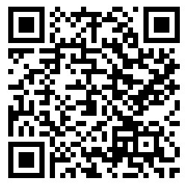

A letter always seemed to me like immortality because it is the mind alone without corporeal friend.
― Emily Dickinson

I do
Flipside-postlude by Kid Quill
Dear Reader, April 2017
What do you want to be when you grow up?
I’ve answered variations of this question over the years: What are you majoring in? What’s next after college?
Do you want to go to medical school?
I’m a first-generation Haitian-Filipino American, and no one in my family is a scientist. But going into medicine and becoming a doctor was preached as the ideal life by the adults in the immigrant community I grew up in.
And I’ve always loved science. An elementary school field trip to the botanical gardens sticks with me: they gave each of us magnifying glasses and I was the kid getting left behind, needing to be reminded to keep up with the group. Getting lost in the observation of flower petals, mesmerized by this new perspective on nature.
When I got to college, I majored in biology to assuage my curiosity, to learn more about how life works.
I studied how nature puzzle pieces molecules together; I’ve seen the beauty in how cellular systems work. Even got the chance to do some independent research, learning a bunch about mice hormones and neurons.
But I ended up taking most of the classes necessary for med school. I knew that my path could result in me becoming a doctor. Internally, it felt like I was scared to run from the expectations that adults had for me.
So when my biology professor told me that a PhD might be a good fit for me, I got emotional. Befuddled. Elated.
I never thought that I could complete an advanced degree. I was rejected from several labs during college, and I didn’t even know that PhD programs existed until my junior year. But I think he saw my passion for learning: this deep-seeded interest in diving into subjects and a willingness to bang my head against a wall full of knowledge.
I applied, and I’ve recently been accepted to a biochemistry program at the University of Wisconsin-Madison!
I’m not particularly gifted, I end up being average at everything I do, and although I wanted to help people from a young age, I couldn’t see myself going to med school at this stage in my life. But I’m fascinated by science. This route to becoming a PhD “doctor” feels semi-validating and soothes those immigrant expectations within me.
College didn’t exactly prepare me for adulthood, but I’m excited to use the skills I’ve learned on this PhD journey! To become a professor who instills confidence in students just as mine have for me!
Gilbert Jamilla Loiseau
P.S. Did you grow up with expectations that you felt defined by?
P.P.S. Frisson: The aesthetic chills from the layering of instruments, the tingling up your spine from hypnotic harmony, engulfing you in tantalizing bliss. When I close my eyes and listen to music, I feel sound pouring into my being, my body literally resonating. Some of these letters might be convoluted, but I hope you’ll understand my feelings by listening to the music: a leitmotif for each of these letters!
P.P.P.S. This song is about wanting to be heard. About having bold ideas and passions, about wanting to share. I’m hoping that a PhD will allow me to cultivate ideas, determine my strengths in learning, and allow me to confidently share something that I’m passionate about with the world!

It’s so hard to swim against the tide
Swim Against the Tide by The Japanese House
Dear Reader, October 2017
Graduate school classes have a conversation-like feel. Instead of lectures where professors talk about a subject for an hour, classes focus on maximizing time to discuss what we students are most curious about.
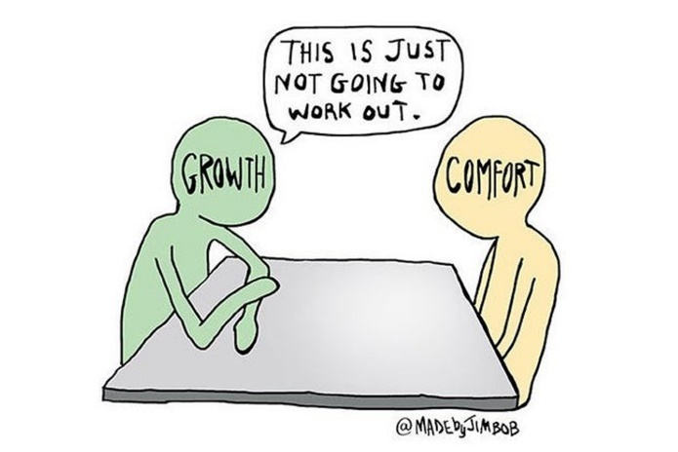
Recently, one professor posed a personal question: What are your goals with your graduate education?
“Gilbert, what about you?”
“I’m not sure.” I’ve never been good with public speaking, I never raise my hand in class, and being called on is extremely uncomfortable.
“That’s okay, just say anything that feels right.”
With that little bit of encouragement, I used my avoidant gaze, stared at the ceiling, and thought. What could I do?
“I want to find a way to replace PowerPoint.”
“Okay! Why is that?”
“I feel like there are weaknesses in how it communicates concepts and that something better could be made.”
In biochemistry, there’s a technique called polymerase chain reaction, or PCR. Using our knowledge of how DNA replicates in cells, we’re able to effectively replicate DNA with PCR!
But how did we come up with PCR, this fundamental tool used for forensic screening and diagnosing diseases?
Kary Mullis, the inventor of PCR said it best: “I was looking for something else…PCR was the possible outcome of a solution to a hypothetical problem that didn’t really exist.”
The best science comes from harnessing creativity, trying to see things that haven’t been imagined, and discovering questions that haven’t yet been answered.
How does van der Waals packing impact membrane protein association?
Research doesn’t look for a specific answer. It focuses on understanding why things are as they are. My mind is racing, questioning what I know about my project, striving to delve deeper into membrane protein research.
What sticks with me is that this professor gave me the opportunity to share an idea of an idea.
Asking “why” helped me feel comfortable and helped me grow. And although it currently feels impossible, this journey into the unknown reaches of science is beginning to feel a little more comfortable.
GJL
P.S. How often do you go outside of your comfort zone?
P.P.S. Grad school is showing me that personal growth is enhanced when outside of your comfort zone. Whether it’s getting called out in a class and answering with something that sounds outlandish, or moving to a state where the temperatures reach an unimaginable -40 degrees (the same in both Fahrenheit and Celsius!), there are a variety of ways to get outside of your comfort zone to grow! Why does Gjetost exist, why does it taste like caramel, and how the heck does it taste so delicious? By harnessing creativity and learning when to ask why, I’m hoping to find my stride on this journey for discovering knowledge.

The world sayin’ what you are because you’re young and black
Outside by Childish Gambino
Dear Reader, September 2018
I was chatting with someone recently about TV shows. They were surprised that I had never watched How I Met Your Mother and Arrested Development.
“Why not?”
“Honestly, there are too many white people in them.”
A couple of days later, they recounted the conversation: “I looked up the demographics in those shows, and they don’t skew too far from the US population.” They didn’t understand that those shows aren’t likely to portray experiences I can relate to. Why didn’t they just ask me to clarify?
As a person of mixed descent, I’ve found it difficult to figure out how I belong. How do I fit in while being myself? What’s the correct answer for surveys asking for my ethnicity? I love sharing culture, ideas, and listening to a wide variety of perspectives. But why don’t I know who I am? Why do I feel like an outsider?
In science I’ve often felt the same. And now after majoring in biology, my transition into a biochemistry PhD has been more arduous than expected. I’m finding it difficult to communicate how I understand science with the appropriate wording and depth. As if the words I’m saying don’t mean what I think they mean.
What knowledge am I missing? Do I have the ability to navigate the field of biochemistry? Do I even belong here?
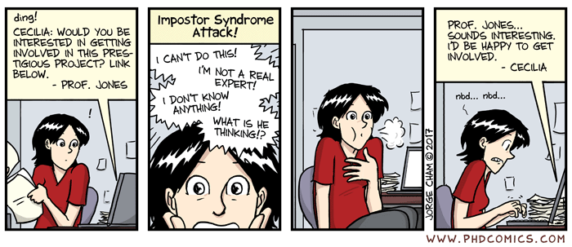
Imposter syndrome: a persistent, unjustified feeling that one’s success is fraudulent.
I know how the world perceives me by the color of my skin, so I can quickly spiral into a mix of negative thoughts. I’m a token minority for my program to look good, people don’t understand me because I’m not smart enough to be understood, I wouldn’t have been accepted if I wasn’t a minority, I don’t deserve to be here.
In both my personal and professional life, I feel like an outsider. Isolated from people who are like me.
Does that feeling ever go away?
GJL
P.S. When was the last time you felt like you didn’t belong?
P.P.S. I thought coming here would allow me to feel more comfortable because I’d find people like me: People who want to understand more about science, to better understand different cultures and perspectives, to learn by challenging the norm and gaining insights into the unique experiences of others. So why does it often feel like I have to conform to what other people expect of me rather than being given the chance to share my own identity?

There will be mountains you won’t move
Godspeed by Frank Ocean
Salutations,
In the previous letter, I reflected on how a conversation about TV shows made me feel like an outsider and amplified my feelings of imposter syndrome.
I can’t change how people see or treat me, but I’m still trying to treat others the way that I want to be treated. We all deserve to have opportunities to share our thoughts and feelings, likes and dislikes. So before getting deep into the mental anguishes of grad school, I wanted to share some things that helped break up my grad school journey.
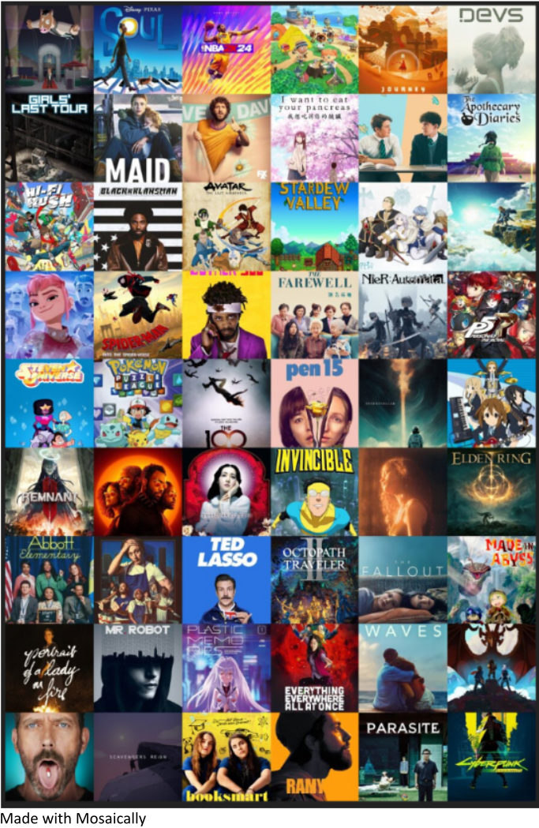
Below is a mosaic highlighting some of the TV shows, video games, and movies that kept me going while helping me reflect on my grad school journey.
Bojack Horseman | Soul | NBA 2K24 | Animal Crossing | Journey | Devs
Girls’ Last Tour | Maid | Dave | I want to eat your pancreas | Heartstopper | The Apothecary Diaries
Hi-Fi Rush | BlacKkKlansman | Avatar | Stardew Valley | Sousou no Frieren | Zelda: Tears of the Kingdom
Nimona | Spiderman: Into the Spiderverse | Sorry to Bother You | The Farewell | Nier:Automata | Persona 5: Royale
Steven Universe | Pokemon Puzzle League | The 100 | Pen15 | Interstellar | K-On
Remnant II | Atlanta | Sympathy for Lady Vengeance | Invincible | Euphoria | Elden Ring
Abbott Elementary | The Bear | Ted Lasso | Octopath Traveler II | The Fallout | Made in Abyss
Portrait of a Lady on Fire | Mr. Robot | Plastic Memories | Everything Everywhere All At Once | Waves | The Dragon Prince
House | Scavengers Reign | Booksmart | Ramy | Parasite | Cyberpunk Edgerunners
Tsundoku: the art of buying books and never reading them. I didn’t get to read much other than scientific journal articles…but I’ll get to books eventually!
Hope you’re well and taking time to take care of yourself!
GJL
P.S. If a friend asked you to give them something so they could know you better, what would you give and why?
I don’t belong here
atlas by Keshi
Reader, May 2019
Today I had my preliminary exam, or prelim for short. It’s the most unique exam I’ve taken: After a year of conducting independent research and reading copious academic papers, I prepared a presentation detailing how I’m going to successfully complete my research.
I was put into a room with my advisors – 5 professors who I’ve asked to supervise my progress during my PhD. I stood tall and explained a carefully thought-out research proposal to experts who each have published many scientific publications.
“What’s the definition of van der Waals? What will you do if your experiments don’t work as you expect? If a tree falls in a forest and no one is around to hear it, does it make a sound?”
After an hour of answering questions on my project, I left the room to allow my advisors to discuss how I did.
Deflated, exasperated, mind afloat, I remembered to breathe.
“Did you just finish your prelim?” I nodded to the student passing by in the hall. “Congrats, the worst part is over.”
After sitting on the floor for 27 minutes, I’m called back into the room.
“Gilbert, we’d like to thank you for the presentation, but we can’t give you a pass. There are some weaknesses…”
But I tuned the rest out. They didn’t say the word, but I knew what it meant.
i failed
“…however, you’re making progress, and we look forward to seeing you have another opportunity next year.”
I cried for an hour in that windowless, dimly lit room. I didn’t want to exist.
For many prelim failures, the journey to the PhD ends here. You’re given a master’s degree and asked to leave.
I get a second chance. But do I have what it takes to move on from this gut-wrenching result to try again next year?
I’m one of the few black people in my research program. I’m insecure about my identity and my ability to communicate. But I want to leave Wisconsin on my own terms. To do that, I have to figure out what I’m missing in my learning. What can I do to pass next year? Is something about my identity making me not good enough?
But for now, I’m in the comfort of my bed. Is it still considered crying if your eyes no longer have tears to shed?
GJL
P.S. Have you discovered any limitations about yourself recently? If so, how have you pushed through them?
P.P.S. I think this song fits how I’m feeling: strained by feeling constantly overwhelmed with a hint of wanting to be better. These lyrics have been pulsing through my head amidst my existential dread. i don’t want to fail, i don’t want to feel like i have a second chance just because i’m a minority, i don’t want to feel like a token student in this white state. i want to do science and learn, to discover knowledge and support other minorities, do i have to live with these feelings of failure forever? am i okay with that when will i be okay with that should i be okay with that? i hate myself, will i always feel like a failure no matter what i do in my life, am i worth anything other than work? why am i here?

Trigger Warning: mental health, suicidal ideation. I sincerely hope that this letter finds you in a good space and that no burden in your life is too heavy to bear.
If you can’t survive, just try
I Always Wanna Die (Sometimes) by The 1975
My Dear Reader, October 2019
A few months ago, I had a dark notion. As I was waiting for the bus, my head felt heavy and everything went black. My eyes were open, yet things looked motionless, greyscale. Intrusive thoughts flitted in and out of my head.
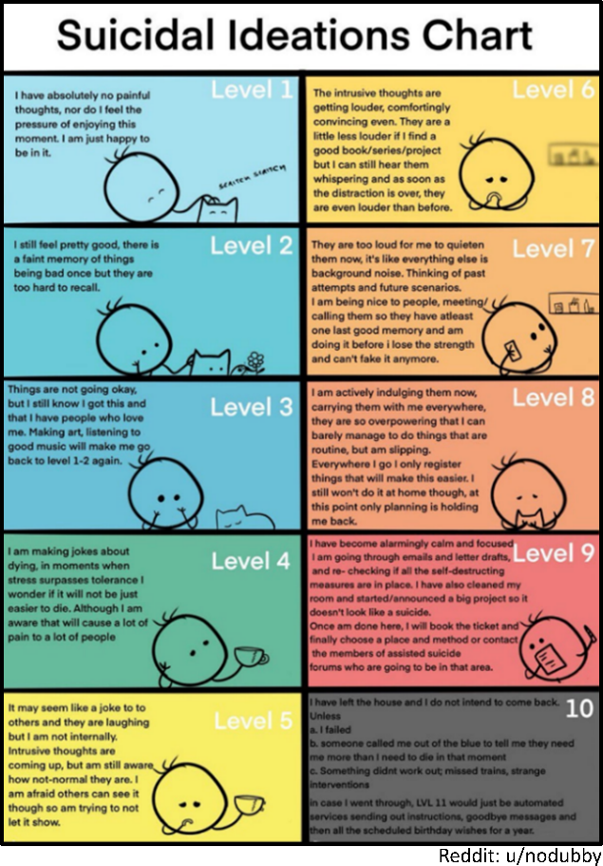
You’re tired. What if you just stopped trying?
But wouldn’t my family and friends be disappointed in me?
Nah, no one would care. Stop now, give up, what’s the point.
I want to end this on my own terms.
You still can. Just walk forward. Don’t think. Move.
Into the middle of the street?
It won’t take longer than a second.
Thankfully the bus arrived. I’ve had bouts with depression in the past, but never to the extent that my inner suicidal ideations were so evidently clear.
Then one day as I was preparing to start my day with a walk through the farmers market, I found myself unable to move. My mind was awake, eyes were open, and my inner voice saying “Move!”, “Get up!”, “Go over there”.
But my body wouldn’t listen.
Physically isolated from family and feeling like a burden to friends, my mental health continued to fade. I stopped eating and knew I needed help.
My therapist couldn’t fix my movement issues, but she helped me state my feelings, rationalize, and reflect on my thoughts. I realized that I live most days at levels 6-8 on the above suicidal ideations chart. She reminded me to eat, gave me actionable suggestions to help me. My journey back to myself began with her advice: “Take risks”.
I find it ironically comical that risking my mental health is the motivation to pass my prelim because that feels riskier than just leaving. But I’m still here. And it’s time to put in the work to learn some science.
GJL
P.S. What’s the riskiest thing you did in the past year?
P.P.S. My body stopped listening to my inner voice. Although my mind contemplated feelings of wanting to disappear, something within me felt that it wasn’t right and resulted in outright rejections of simple thoughts of movement. Literally petrifying.
P.P.P.S. My limits are being tested here, mentally, physically, emotionally. But I’m still here. I’ve never acted on my intrusive thoughts, but the risk is there. The strings fill me with hopeful melancholy, accentuated by the strain in the singer’s voice. As if things will get better with time, even though it doesn’t feel that way right now.
Don’t worry ‘bout tomorrow
WELCOME TO SOUL, PRESENT by Q
My Dear Reader, February 2020
I have a few more months before my second chance to pass my prelim. I’m anxious. I think not understanding how to effectively communicate my project was a glaring weakness during my first prelim. I need to learn how to speak confidently about my science if I’m going to be successful in this pursuit of knowledge.
How does van der Waals packing impact membrane protein association?
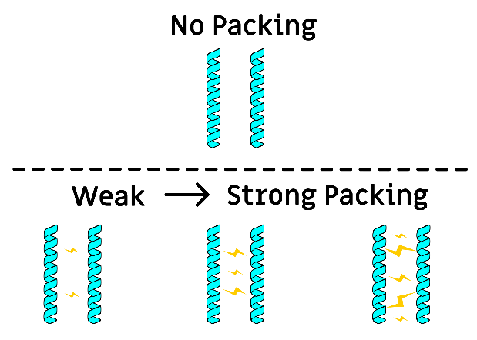
The focus of my research is to further humanity’s understanding of how proteins found within cell membranes, or membrane proteins, interact.
Membrane proteins are complex structures that help our cells adapt to stimuli. From helping us recover from cuts and bruises to signaling to our brain that something feels hot or cold, these proteins are responsible for a multitude of our body’s natural responses to the environment.
The proteins I work with are tiny, helix-like structures. These proteins naturally like to stick together, or associate. I’m trying to discover if different amounts of a force called van der Waals packing changes how well proteins associate in the membrane.
Van der Waals packing is like the “static” that comes from rubbing a balloon against hair: it’s a weak attraction between things in close contact, sticking them together. We have tools to predict the “static” strength in between proteins, but no one knows how strongly it sticks membrane proteins together. Is packing more like the lid of a jar before or after asking someone to open it: impossible to twist or so loose that it’s open in 3 seconds?
My current goal is to make a computational algorithm to build, or design, proteins with different amounts of packing. Using software produced by my lab, I can create computational models of proteins. We know that protein shape affects the amount of “static”, so I’m currently developing a way to design proteins with different shapes.
My second goal is to test these designed proteins with experiments to see if my predictions agree with the data. But that comes after my prelim. If my computation and experiments are similar, then I’ll be able to design membrane protein targeting drugs to prevent numerous viral infections and diseases.
Wouldn’t that be a story? Researcher at UW-Madison finds the cure for Alzheimer’s, cystic fibrosis, or cancer.
But that’s MUCH farther away, tens of graduate students of research after me. For now, my research will have the potential to be a “possible outcome of a solution” that impacts humanity.
I’m feeling a smidge more confident in communicating my research. But this burden to pass to prove myself as a scientist still feels heavy. if i don’t pass, then did i ever even have potential in science? why does it vaguely feel like my failure would reflect poorly on not just myself…but other minorities in science?
GJL
P.S. When was the last time that you felt proud of yourself?
P.P.S. Have you ever felt indebted to those who gave you an opportunity? I’ve been given this chance, but I feel like if I fail, I’ll reflect poorly on my advisors who trusted me to succeed. I’ll be an example of why there aren’t many minorities in upper-level degree programs. So I’m focused on learning today instead of worrying about the result.

Time has come, take it all in
5 Year Plan by Chance the Rapper
To My Humble Acquaintance, June 2020
Have you ever thought of how you could impact humanity?
With the world currently entrenched in a global pandemic, with minorities being abused and killed in a time of global strife, why is understanding how proteins interact important?
If we better understand how membrane proteins interact, could we engineer proteins to disrupt these interactions?
It’s bizarre to know that I’m living through this piece of history. For anyone studying virology, they get to see the applicability of their research in real time. But for a biochemist trying to understand the forces involved in membrane protein folding, could my research ever help anyone?
But how do you engineer proteins? We’d need to understand how van der Waals packing sticks proteins together.
I’ve learned to question whatever I don’t know about a subject. I’ve developed critical reading skills, marking any paragraph, sentence, word that I can’t fully comprehend in my brain. I take that information and go deeper, peeling away layer after layer until I reach the core bit of knowledge that I need to understand.
If we can computationally predict how viral proteins interact with human cell membrane proteins and then support that with an experiment, we could engineer drugs to combat viral infections!
Know what you don’t know. I joined my advisors on a Zoom call and pitched my research to them.
After 40 minutes of defending and answering questions, my prelim exam was over.
I passed
But did I really do that much better? Was I that much more prepared?
Yes and yes. But all of this deep learning has left me searching for more questions: What don’t I know?
With the state of police brutality and empowerment of the Black Lives Matter movement happening right now, did I pass because it would look bad if one of the few black people in the program got kicked out for failure‽
GJL
P.S. What are 5 things you’re excited to do in the next 5 years?
P.P.S. A PhD is usually 5-6 years, but who can plan for failing a prelim AND for a global pandemic. The chords in this song remind me of a sunshower: a sprinkle of refracted sunlight, dancing on your skin amidst the soothing petrichor. It’s like a prescription of hope for the future. Even if you can’t predict how things will go, you can appreciate what happened because you’re alive. It makes me feel optimistic for a future in which I’ll feel nostalgic about the present.
P.P.P.S. My feelings of my identity driving my success still weigh heavily on me. There are still a lot of things that I don’t understand about my project, but I’m trusted to take it to completion. My research may not be used for anything impactful. But the fact that it’ll be a small bubble on the expansion of human knowledge is enough for me.

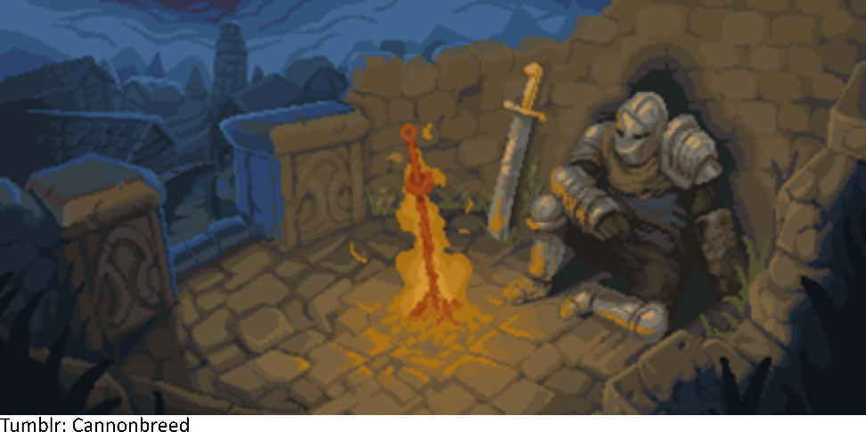

Into the woods
Into the Woods by Mree
Rest Here Weary Traveler,
When I need a break from thinking, from emotions, from stress, I close my eyes and find respite in music.
This song channels both the fear of traversing the unknown, and the excitement of the discovery waiting ahead.
You’ve made it to the middle stages of my journey. The pandemic slowed everything down for me while I was in grad school. Those few years blurred together. Then as if no time passed, stores began to open, mask mandates ended, and people started to gather again.
Have you ever felt so much pressure that you felt like you couldn’t carry on? Like there’s a huge weight on your shoulders and you need to finish something for it to go away?
I’ve learned how to learn, but science isn’t kind. It’s purely honest. And if your hypothesis or experiment isn’t good enough, it’s difficult to find data to make conclusions worthy to be shared with the scientific community.
And it’s equally difficult to know your timeline. To have to convey that you’re a year away from being a year away from graduation to family and friends, and then repeating the same thing each year after that.
But I’m nearing what it means to find knowledge, to ascertain truth, to discover.
Thanks for reading, sending much love and support your way! I hope you enjoy the rest of these letters.
GJL
P.S. If you’re still not convinced that research like mine could be helpful to humanity, another group doing similar stuff was able to use protein design to combat Coronavirus.

Why don’t you leave if you wanna leave
Leave If You Wanna by Overcoats
Dear Friend, July 2023
I’ve fine-tuned my algorithm over the last few years, tested my designed proteins in small experiments, and it’s time to do a larger test. My algorithm can do three things: 1) build 1000s of proteins with unique shapes, 2) predict how well the proteins stick together (associate), and 3) estimate the amount of packing (“static”).
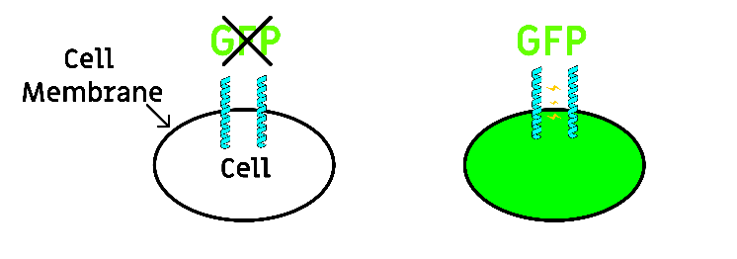
A few years ago, my lab developed an experiment that I can use to test my proteins. We created a way for bacterial cells to produce our proteins alongside green fluorescent protein, or GFP. When the proteins associate stronger in the cell, more GFP is produced. We can’t count exactly how much GFP is made, BUT the GFP makes cells light up green!
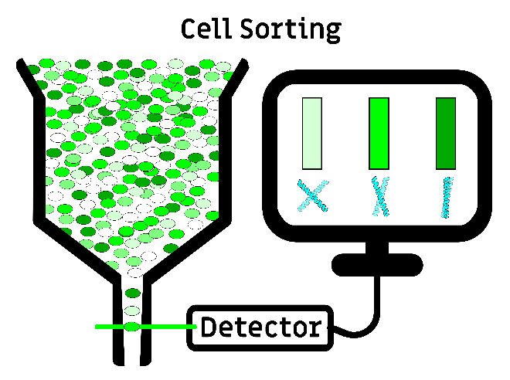
We can measure the cells’ green light using a machine called a cell sorter. The machine passes bacterial cells through a detector that records the green light for each cell. This allows us to estimate how much GFP is produced per cell, effectively telling me how well our proteins stick together! I sorted billions of cells producing different proteins, and calculated how well each protein sticks together from the data. And for once, it looks promising! My designed proteins associate!
In my first 3 years of graduate school, no experiments worked, and I grew accustomed to failure. But I’ve finally reached the point in my graduate career where instead of taking an hour to work up the mental bandwidth to conduct an experiment, I can plan 2 or 3 experiments around one another. My experiments work on the first or second try. I’m a well-trained, diligent grad student.
But the laboriousness of research is draining me. I know this is the best data I’ve discovered, so why do I feel so detached from my science? Why is my excitement so fleeting? Why do I miss my family and friends so much?
Why is the only thing on my mind this desire to leave?
GJL
P.S. What was the last family/friend gathering that you regret missing?
P.P.S. After years of failure, I’ve finally found my stride in grad school. My project is taking shape, and the data I’ve discovered will ever so slightly push the boundary of membrane protein knowledge forward. I’ve learned to think on my feet and to dissect experimental data. I’ve become a good scientist. But after experiencing some success, I now feel this sudden urge to leave. I’m realizing how much I’ve neglected my life outside of science. Missing events with family, not seeing close friends for years. Am I losing my passion for research? Is science moving on from me?
P.P.P.S. Why am I still here?

'Cause is it really love if it don't tear you apart?
When You’re Breaking My Heart by Gatlin
Confidante, September 2023
When was the last time you had your heart broken?
My time in graduate school is finally coming to an end.
I was given the acknowledgement of my advisors that I’m close to finishing up: “We can see the story forming, and we think you’ll be able to graduate next summer.”
Have you ever experienced a mental spiral? Where your thoughts begin in one place and start looping into another. And then another. Another. An infinite abyss of issues, problems, and conundrums to work out in your head.
I need to rest but I should organize the data for my thesis, I guess I’ll just do that this weekend, but then when do I get to watch a new anime? I also need to go grocery shopping, but is eating even worth it this week, do I even have enough money for food? after I graduate how will I make money to live, I have no marketable skills, I still don’t know what I really want to do, is academia worth it? should I join industry, potentially do something insufferable like optimizing protocols? would I be able to listen to music every day? would I feel like more of an imposter wearing professional clothing after years of hoodies and sweatpants? am I even good enough to do anything?
Pensive, contemplative, unrelenting, my stream of consciousness spirals out:
What is my relationship with my PhD?
It’s an intense relationship, where my research can do no wrong and I’m always at fault. Experiment after experiment, failure after failure, I attribute to myself.
All this failure has resulted in a fear of rejection.
I’ve been selfish. I’m no longer reliable. I haven’t given friends support, rarely give intentional time to my family. Asking for help feels like I’ll be rejected just as I’ve rejected my relationships.
At times my PhD has felt like a black hole, sucking everything in, leaving me with nothing.
I’m not smart, I don’t pick up on things quickly, but I’m doing my best to learn how to learn at the highest level.
And now that I’m getting close to the end, and it feels like I’m finally getting something back, is it fair that I can’t even smile when I think about graduating? Why does it feel like I’m being pushed away?
GJL
P.P.S. In this song, Gatlin realizes that she loved the chase of a relationship more than the person.
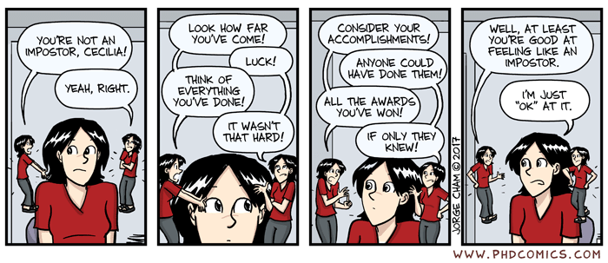
P.P.P.S. For a while now, I’ve stopped thinking about my future. I don’t know if I want to be a professor anymore, to support and mentor students, or even remain in science. I’ve been focused on chasing this PhD. What do I love? Is there anything that I would be happy doing for the rest of my life? The pursuit of finding knowledge is what kept me here, but do I even enjoy it?
P.P.P.P.S. Those questions from years ago ring in my head: Do I belong here?
You can’t stay in bed forever
GOOD MORNING SUNSHINE by The Narcissist Cookbook
Hello Supportive Friend, November 2023
I didn’t realize the end of this journey would lead to such paralyzing and everlasting burnout.
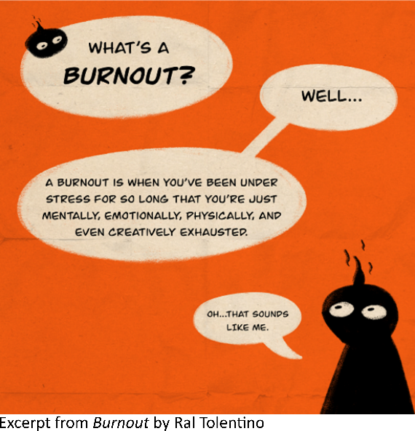
My fierce zeal for science, to understand the auspicious beauty hidden within intricate systems that naturally form life, feels like it’s nearing an end. That once unwavering fire inside me is fading as I run out of kindling: patience, time, and willpower.
It feels like I’ve already given a lifetime’s worth of energy to this endeavor called PhD. My body is perpetually tired, my mind ailing with doubt, anguish, and distress. Another sleepless night. Hours pass and I continue to feel useless, thinking of all the things that I have to accomplish to graduate, yet being unable to do any of it.
Everyday feels like I’m searching for something: What’s the one thing that will pull me out of bed?
Too many goals, temporary objectives, efforts to maintain content and find solace in the chase.
Today I’m going to re-analyze my experimental data. I’m going to write the methods portion of my thesis.
Frustration begins to set in. The goals shrink as the hours pass, as does my willingness to do anything.
I’ll prepare for my presentation next week, maybe take out the trash, go grocery shopping, do laundry for the first time this month, clean the kitchen, wash dishes from the fried rice I made 2 weeks ago, feed my cat, eat SOMETHING, shower for the first time this week, brush my teeth.
Overwhelmed and powerless, I’m forced to abandon that teeny glimmer of hope that I would make it to work today. Only one goal is left.
I just want to get up and leave the comfort of my bed.
It’s 3 pm and I’m ready to start my day. I’m alive.
But am I well‽
GJL
P.S. When was the last time you felt burnt out? Were you able to take care of yourself? Have you learned what types of support you need/want?
P.P.S. At a time when I just needed ANYTHING to feel good about, I discovered this song that immediately resonated with me. Most days, it’s hard to get out of bed. It’s difficult to motivate myself to do even the most inconsequential things. I find ways to work through it as best as I can. Even with all these anxieties bogging down my mind, I find a way to tell myself that I’ve done enough each day. Telling myself that gets me through, keeps me productive, and gets me closer to the end of grad school.

You don't cross my mind, you live in it
Off Day by Lyn Lapid
Sup Bud, February 2024
What does it mean to live?
As I write this, I should be sleeping, prepping my body and mind for the next day. I close my eyes, but thoughts continue ringing in my head, drowning out my tinnitus. I peek at my phone: 12:19 AM. Readjust, pull the sheets closer. I don’t enjoy sleeping tight. It feels restrictive and reminds me of being unable to force my body to move.
2:13 AM. I stare at my eyelids, no rest or reprieve.
During the months leading up to my 2nd prelim, I found myself dreaming of science. My subconscious was hard at work while I slept, imagining how to design proteins: conceptualizing electrons, envisioning the vibration of atoms in space, building amino acids, trying to make sense of why proteins associate.
I thought it was a superpower.
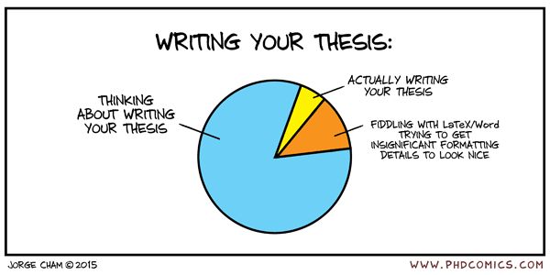
But now, with a deeper understanding of my research, the main thing left is to relay my findings. No more anxiety about redoing experiments or thinking of new ways to interpret data. I need to write, to put my thoughts into coherent words on paper. But how?
Instead of dreaming, my mind is anxious to work.
I can’t sleep because if I do, I’m not working. But if I can’t sleep, I can’t work well. A delightful feedback loop at the end of my PhD.
But during my 3AM trips to the lab, I’m one of the few beings filling the halcyon silence. I’m finding a deeper appreciation within this stillness.
Cherishing the freedom and fluidity of time in graduate school. Taking advantage of my sleeplessness. Remembering to breathe. Allowing myself to be mesmerized by blinking traffic lights. Catching myself smiling in the early glow of the sun as the brisk air fills with birdsong.
Time doesn’t feel like it’s moved much for me during my PhD.
And I’m finally starting to appreciate it.
GJL
P.S. When was the last time you closed your eyes and just took a moment to pause, breathe, and take in life?
P.P.S. I’m going to miss this environment that pushes me to discovery. Given me time to allow my brain to acclimate to the idea of working at the boundary of human knowledge. Allowing me to excise bias in pursuit of truth. It reminds me of being a kid again – staring at the sky, letting thoughts freely flow in and out of my mind. I feel like graduate school harnesses this latent ability, allowing for deeper exploration of whatever I find interesting.
P.P.P.S. This song feels like it bundles you up in a freshly washed blanket on a snowy day. A blend of tranquil and reassuring warmth amidst the frigid winter. I’ve finally made it to a place of what feels like mutual respect. Pushed to grow by finding comfort outside of my comfort zone. Pulled out of the ebbs of 36-hour water diets, to the flows of stress binge eating donuts and ice cream. Birther of my restless mind, bringer of appreciating peaceful subtleties of the day. My PhD has been that warm blanket for me, and I never expected it to be so comfortable.

Once I saw fire…Did I let it go?
Before the Line by dodie
To You Who I Hold In High Regard, May 2024
If you could do it all over again, would you still go to graduate school?
I’ve been caught within the greyscale of science for so long. Crafting my contribution to the scientific community, developing my research to ascertain a nuanced glance into membrane protein association.
But these reflections have reminded me how much I’ve learned about myself in graduate school.
From stumbling early on in my quest for discovery, to now being ever so close to reaching the mountain top. I’ve been able to reflect on my shortcomings, explore my love for science in depth, while discovering and mending cracks in my mental health.
I’ve willingly put myself through this grind because of how big this opportunity feels to me: I’ll be the first person in my family to receive a PhD, in a field as prestigious as science. I recognize how important it is to become another minority in a field still growing in diversity.
And I’ve been fortunate during graduate school. My family is healthy, my friends are understanding, and my professors and lab mates have been exactly the type of academic support I’ve needed.
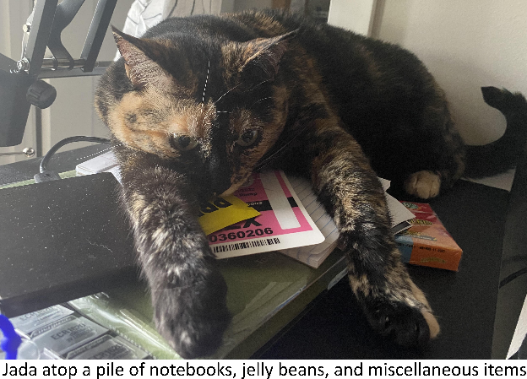
It hasn’t been easy. But I’ve learned to take care of myself through intense mental strangulation, and now I’m re-learning to cherish my life.
No longer just doing things as a distraction from stress.
Walking, breathing, smelling the morning geosmin. Running, playing basketball, investing in video games, music, and anime. Baking, composing playlists, writing letters.
Playing with my cat Jada, who’s saved me from anxious bursts and emotional downfall countless times.
And I’m realizing now how little time I’ve taken for myself.
For most of my life I’ve continuously reached for the next academic accomplishment: Diplomas, Bachelors, PhD.
But for once, I feel an odd bit of freedom: I don’t know what comes next.
Trumspringa: the longing to wander off your career track in pursuit of a simple life.
The feeling that an escape from what you’re currently doing will be enough to bring you back to the grind. To remember how to be excited about what’s next. To feel like you can take time out of your day without being stressed about all the things you have to do. To appreciate the world around you.
I can’t shake this sense of journey, of needing to go somewhere new. To remind myself to…experience.
GJL
P.S. If you could do it all again – as a bright eyed, younger version of your current self – would you make that big decision that led you to where you are today?

I’m trying to start my life again
Wallflower by mxmtoon
My Dear Friend, August 2024
After my grad school interview, students took me on a night walk around Madison. It was eerily quiet. No insects or animals, little noise of a bustling city, as if the sound was dampened by the snow mounds littering the streets.
We made our way to the terrace, tiptoeing around icy, slippery sidewalks. We went ice skating on a small lake earlier, so I understood that Madison could get quite cold. But I was astounded when I saw Lake Monona, 13km/5mi of water across, completely frozen over.
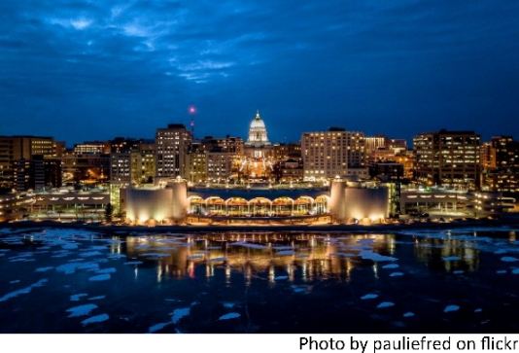
We ignored the orange tape and traffic cones and walked onto the lake. I stared into darkness, wind gusting chill against my corneas. I closed my eyes, seeing the same darkness with one difference: the phosphenes on the backs of my eyelids, clearer than ever before.
That initial memory foreshadowed my PhD: Serenity in the quiet, astonished by the unanticipated display of nature, as biting cold winds made me question why I’m here.
It’s been 7 long years.
I’ve fallen in love with the rich varieties of cheese and ice cream, got acclimated to the many farmer’s markets, became accustomed to thanking bus drivers at stops, and appreciated people biking on even the chilliest days.
Madison is a charming city, a welcoming environment despite my many ruminations of feeling like an outsider.
A lot can happen in a PhD. I failed my prelim but got a second chance. But my story isn’t the only one, and things can hinder you professionally and personally. Someone could embarrass you at a conference, or you might be forced to switch labs. You might need to prioritize a family member over science, or your partner could break up with you.
For all of us privileged enough to learn at the highest level, it’s still life. Troubles with relationships, money, work-life balance. We juggle these things, trying not to break down while thinking critically and finding comfort in the unknown.
As I’m writing this, I haven’t yet defended, the thesis isn’t finished, and I’m not even sure if my committee will award me my PhD. But my research is submitted to be published. To occupy the same library as the discoveries of DNA and protein structure, albeit in a much less frequented bookcase.
The “static” packing that I designed between proteins isn’t as strong as other forces. But hundreds of my proteins resulted in green, fluorescent light within millions of cells. I designed proteins from scratch and showed that “static” packing makes membrane proteins stick together and dance.
But my model isn’t perfect.
I designed these proteins and even though they associate, they don’t always match the prediction. There’s still more work to do to mathematically understand how strong “static” packing can be. More to learn before we can use this information to engineer effective membrane protein targeting drugs.
I hope someone can take what I’ve done to inform future models. To use what I learned about packing to dissect its impact on other forces. Does “static” packing affect the impact of other forces? Is packing always only a weak force? Or is it stronger in the presence of other forces?
If my research can nudge just one future scientist in the right direction, that’s more than enough for me.
How does it feel to discover something, to study at the boundary of knowledge?
Do you remember the first time you held a kaleidoscope? For those first few seconds you see a glistening, prismatic repeat of color and shapes so overwhelming that it seems unable to fit into the small toy in your hand. It’s infinite.
That fleeting moment in admiration of unexpected beauty is probably something I’ve been chasing my entire life.
Despite my struggles, I’ve loved my PhD. I’ve thoroughly enjoyed searching in the unknown, trekking through journal articles. Embracing that childlike, innocent curiosity while searching for deeper understanding. Becoming enthralled with that feeling of comprehending something new and building it into a lifelong passion.
In the end, my love for learning won out.
I can see myself doing the same thing forever. Searching for that same joy in discovery, that kaleidoscopic spark.
But my head is throbbing from banging against walls full of knowledge. From forgetting what it’s like to take time not thinking about my research.
From prioritizing learning over my physical, mental, and emotional well-being. Over friends and family.
For now, I’m tired of constantly putting pressure on myself to succeed. I’ve used up all my passion and determination.
Etterath: the feeling of emptiness after a long and arduous process is complete.
Every time I wanted to leave, I felt exhausted from the grind. But now it’s more like watching the last episode of a TV show or beating the final boss in a video game. Bittersweet. Not exactly ready…but knowing it’s time to let go.
I’m not yet sure what I’ll be doing next. But first I want to regain my ability to experience. Travel to new places, use my coding skills to analyze basketball stats, do a darkness retreat. Just give myself time to explore.
No one can take away your education. A break from the grind won’t lead me to forget what I’ve learned.
Thank you, PhD, for teaching me how to learn at the highest level. I’m not the smartest student, and this journey wasn’t anywhere near a perfect PhD. But it helped me grow into the person that I am: a tryhard, a thinker, and someone who knows I can make a difference somewhere if I just put my mind to it to learn.
GJL
P.S. To my mom, dad, and brother, thank you for all your support. From sending food or just making time to distract me from personal turmoil, I appreciate all the love you’ve sent my way.
P.P.S. To my advisors, friends, roommates, lab mates, therapists, communities (shoutout SciMed, CBI, and IPiB DEI!), thank you for every bit of support you gave me along the way. Whether it was thoughtfully chatting about science to discover my weaknesses, finding ways to develop a more supportive environment for students, or just discussing life and food and the mundane things – I truly appreciate every conversation, every moment of time that you’ve given me. This PhD wouldn’t be complete without it!
P.P.P.S. And to you reader, thank you for sharing this journey with me. Academia isn’t always the most vulnerable, so I wanted to create a transparent way to personally highlight one grad school experience. I hope that I succeeded! Wherever you are on your own journey, best of luck on finding solace and happiness.
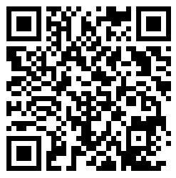
letters for my phd-the extras

