|  |  |  |  |  |  |  |  |  |
| --- | --- | --- | --- | --- | --- | --- | --- | --- |
| Sequence | Design | PercentGpA | StdDev | xShift | crossAngle | axialRot | zShift | ID |
| LLLVFLLGTLLGLLLAILILI | GAS | 2.46 | 0.08 | 6.39 | -43.89 | 52.91 | 6.05 | 1 |
| LLLTFLLGLLLGYLLSVLILI | GAS | 1.56 | 0.13 | 6.70 | -43.12 | 49.87 | 5.79 | 2 |
| LLLTLLLGVLLGLLLAFLILI | GAS | 1.53 | 0.06 | 6.61 | -45.51 | 31.65 | 3.47 | 3 |
| LLLTFLLGVLLGLLLGALILI | GAS | 1.50 | 0.13 | 6.66 | -39.32 | 42.40 | 4.77 | 4 |
| LLLAFLLGLLLGTLLTVLILI | GAS | 1.41 | 0.12 | 6.58 | -42.04 | 52.19 | 3.68 | 5 |

L

|  |  |  |  |  |  |  |  |  |
| --- | --- | --- | --- | --- | --- | --- | --- | --- |
| Sequence | Design | PercentGpA | StdDev | xShift | crossAngle | axialRot | zShift | ID |
| LLLLYWLLTILVALLLSLILI | Left | 0.67 | 0.07 | 9.34 | 22.94 | 112.55 | 2.53 | 6 |
| LLLLAILLTLLAVLFSLLILI | Left | 0.64 | 0.03 | 8.75 | 21.48 | 65.93 | 3.04 | 7 |
| LLLLVALLLTLISLLFLLILI | Left | 0.63 | 0.09 | 9.61 | 23.04 | 99.43 | 2.07 | 8 |
| LLLYALLFTLVALLLSLLILI | Left | 0.58 | 0.02 | 9.30 | 17.71 | 23.44 | 4.23 | 9 |
| LLLLLWLLTVLIALLSFLILI | Left | 0.58 | 0.08 | 9.45 | 25.30 | 109.58 | 2.30 | 10 |

R

|  |  |  |  |  |  |  |  |  |
| --- | --- | --- | --- | --- | --- | --- | --- | --- |
| Sequence | Design | PercentGpA | StdDev | xShift | crossAngle | axialRot | zShift | ID |
| LLLVALLIALLLTLLSLLILI | Right | 0.98 | 0.07 | 9.00 | -46.04 | 102.85 | 5.25 | 11 |
| LLLVALLLALLFTLLSILILI | Right | 0.65 | 0.05 | 8.15 | -32.83 | 94.00 | 5.62 | 12 |
| LLLYALLLALLVSLLTILILI | Right | 0.63 | 0.03 | 8.04 | -47.60 | 97.94 | 5.07 | 13 |
| LLLSYLLTLLLAFLLSILILI | Right | 0.58 | 0.08 | 7.88 | -41.29 | 58.40 | 2.99 | 14 |
| LLLSYLLVALLTLLLSFLILI | Right | 0.58 | 0.02 | 8.88 | -46.89 | 44.27 | 2.20 | 15 |

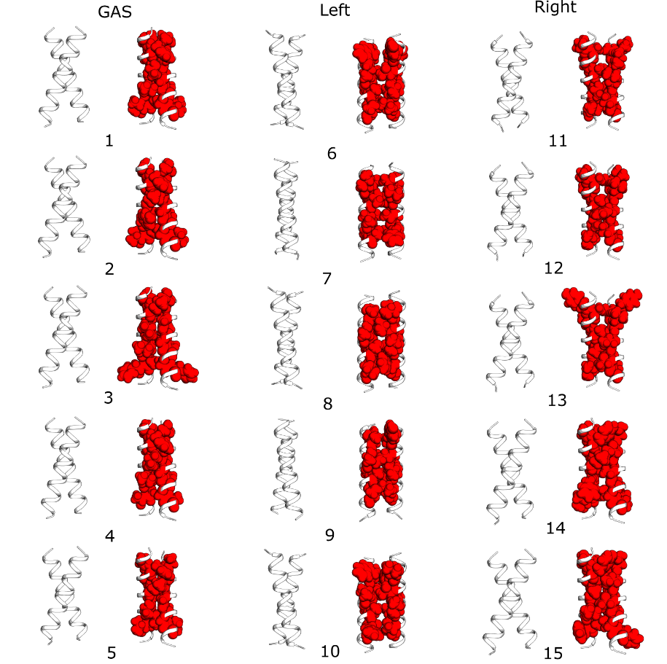

|  |  |  |  |  |  |  |  |  |
| --- | --- | --- | --- | --- | --- | --- | --- | --- |
| Sequence | Design | PercentGpA | StdDev | xShift | crossAngle | axialRot | zShift | ID |
| LLLVFLLGTLLGLLLAILILI | GAS | 2.46 | 0.08 | 6.39 | -43.89 | 52.91 | 6.05 | 1 |
| LLLTFLLGLLLGYLLSVLILI | GAS | 1.56 | 0.13 | 6.70 | -43.12 | 49.87 | 5.79 | 2 |
| LLLTLLLGVLLGLLLAFLILI | GAS | 1.53 | 0.06 | 6.61 | -45.51 | 31.65 | 3.47 | 3 |
| LLLTFLLGVLLGLLLGALILI | GAS | 1.50 | 0.13 | 6.66 | -39.32 | 42.40 | 4.77 | 4 |
| LLLAFLLGLLLGTLLTVLILI | GAS | 1.41 | 0.12 | 6.58 | -42.04 | 52.19 | 3.68 | 5 |
| LLLLYWLLTILVALLLSLILI | Left | 0.67 | 0.07 | 9.34 | 22.94 | 112.55 | 2.53 | 6 |
| LLLLAILLTLLAVLFSLLILI | Left | 0.64 | 0.03 | 8.75 | 21.48 | 65.93 | 3.04 | 7 |
| LLLLVALLLTLISLLFLLILI | Left | 0.63 | 0.09 | 9.61 | 23.04 | 99.43 | 2.07 | 8 |
| LLLYALLFTLVALLLSLLILI | Left | 0.58 | 0.02 | 9.30 | 17.71 | 23.44 | 4.23 | 9 |
| LLLLLWLLTVLIALLSFLILI | Left | 0.58 | 0.08 | 9.45 | 25.30 | 109.58 | 2.30 | 10 |
| LLLVALLIALLLTLLSLLILI | Right | 0.98 | 0.07 | 9.00 | -46.04 | 102.85 | 5.25 | 11 |
| LLLVALLLALLFTLLSILILI | Right | 0.65 | 0.05 | 8.15 | -32.83 | 94.00 | 5.62 | 12 |
| LLLYALLLALLVSLLTILILI | Right | 0.63 | 0.03 | 8.04 | -47.60 | 97.94 | 5.07 | 13 |
| LLLSYLLTLLLAFLLSILILI | Right | 0.58 | 0.08 | 7.88 | -41.29 | 58.40 | 2.99 | 14 |
| LLLSYLLVALLTLLLSFLILI | Right | 0.58 | 0.02 | 8.88 | -46.89 | 44.27 | 2.20 | 15 |

