Westerns

AA Frequency used for Sequence Entropy

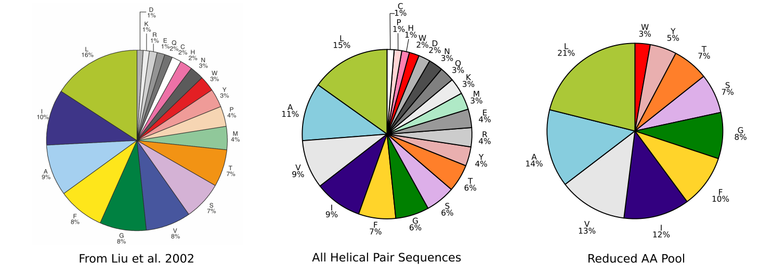

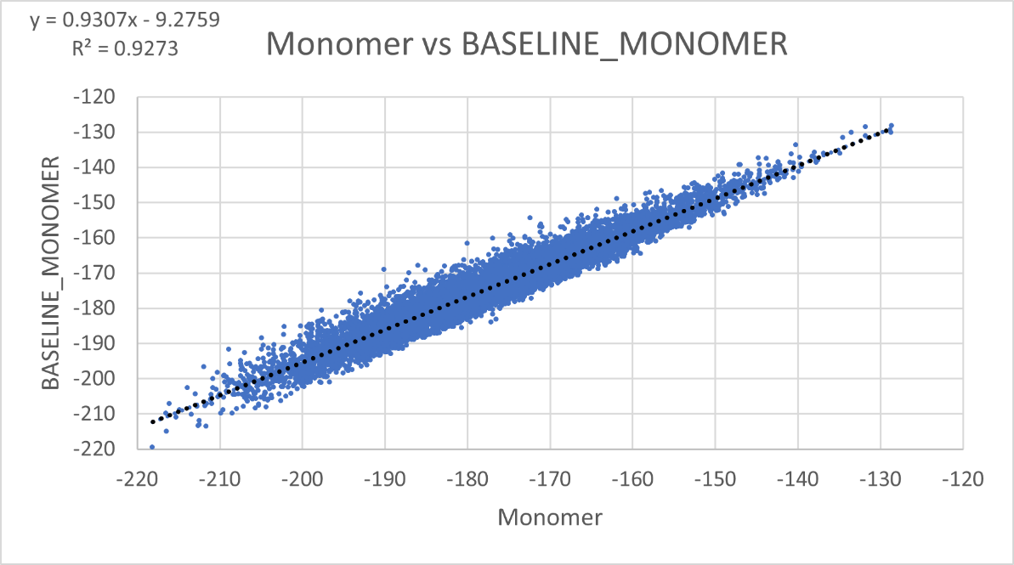Baseline Monomer

Geometry vs %GpA

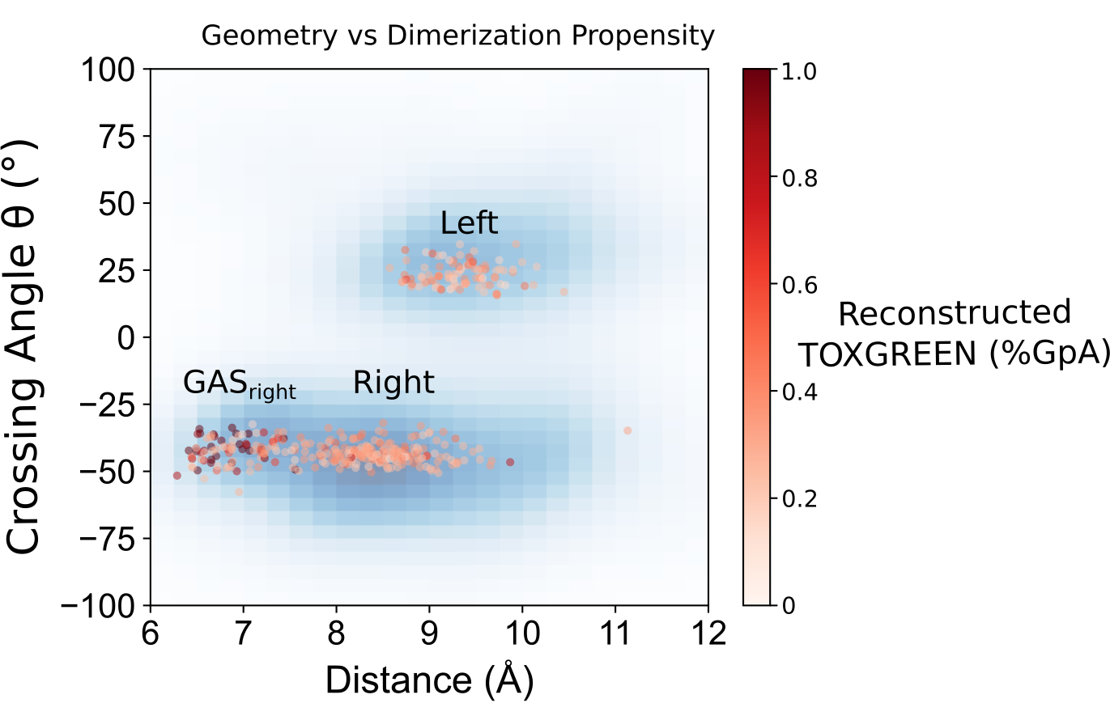

Energy Score breakdown for finalized set of sequences

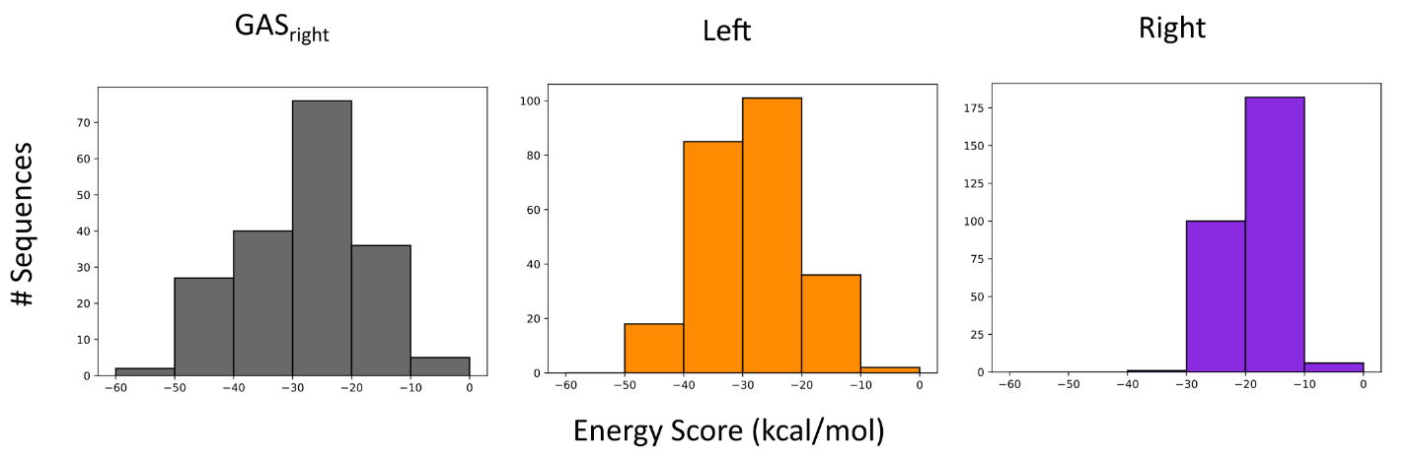

Interface SASA

GASright axial rotations and z-shifts

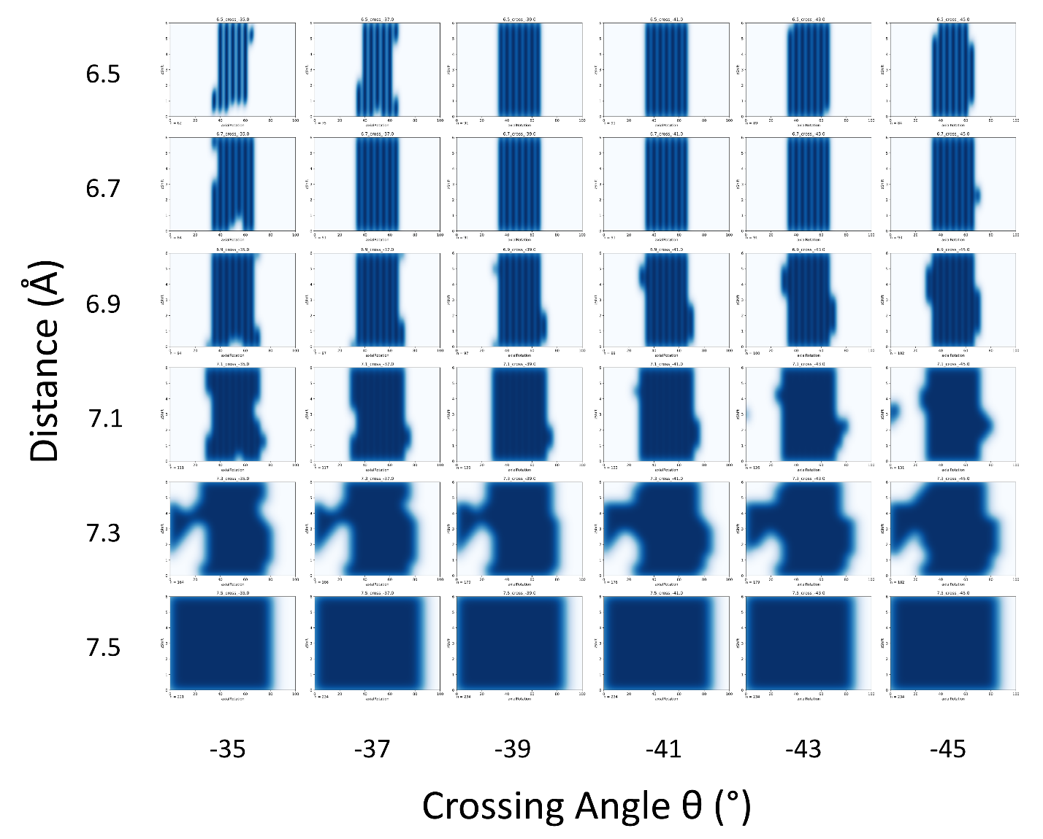

Left axial rotations and z-shifts

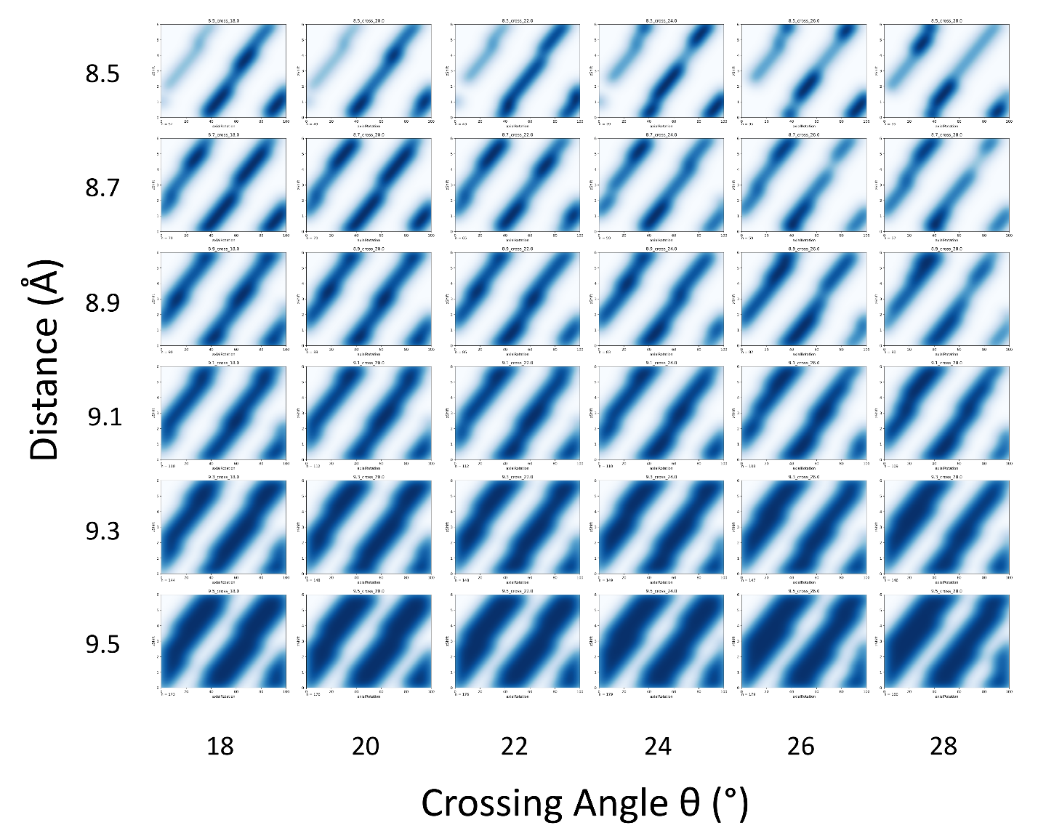

Right axial rotations and z-shifts

