**Assessing van der Waals packing as a driving force in membrane protein folding**

Membrane proteins comprise 25-30% of the proteins found within protein-coding genes of various organisms (Fagerberg et al., 2010). Proper membrane protein folding is critical for essential biological functions, including cell signaling, ion balance, and gene regulation. Misfolding of membrane proteins has been found to be involved in several human diseases such as Parkinson’s, cystic fibrosis, and cancer (Sanders and Myers, 2004; Gregersen et al., 2006). To understand how protein misfolding plays a role in disease states and progression, it is necessary to investigate how these proteins fold. However, studying membrane protein folding is inherently a difficult challenge because of their hydrophobic nature. Membrane proteins are difficult to express in yields high enough for biophysical experiments, and purification and solubilization of these proteins often lead to aggregation or unfolding (Carpenter et al., 2008). To combat these challenges, much of the research studying membrane protein folding is focused on understanding the biophysical forces that govern the folding process. Investigation of the biophysical forces that govern protein folding will allow us to determine why specific mutations result in diseases caused by misfolding. In addition, this knowledge can be applied to design new therapeutics that specifically target proteins in these misfolded states. Understanding the forces that enable membrane proteins to fold will contribute to our knowledge of how these fundamental forces are involved in human health and disease.

Proper membrane protein folding is regulated by a distribution of stabilizing hydrogen bonds, weak polar interactions, and van der Waals forces between the unfolded and folded states. Previous research has measured the contributions of both hydrogen bonding and weak polar interactions in the membrane and determined that these forces can drive membrane protein folding (Zhou et al., 2001; Yano et al., 2002; Johnson et al., 2007), but research is lacking on the contribution of van der Waals packing. This force is particularly important due to the nature of van der Waals interactions: Even if hydrogen bonding or polar interactions play a significant stabilizing role, because van der Waals occurs between any nonbonded atoms in close contact, it is a necessary force that is always present within the folded state. This means that van der Waals packing is essential for folding, but the extent at which packing can be a driving force for membrane protein folding is unclear. Without understanding the extent at which van der Waals packing contributes to folding, we cannot complete our understanding of how these other forces contribute to membrane protein association and folding.

The contribution of van der Waals packing to membrane protein folding can be broken down into three distinct interactions: lipid-lipid packing, lipid-protein packing, and protein-protein packing. Protein-protein (or sidechain) packing, is a technically feasible starting point because of the ability to manipulate sequences and determine changes in stability due to mutation. Previous research has demonstrated that disruption of packing within the core of bacteriorhodopsin destabilizes protein structure (Faham et al., 2004; Joh et al., 2009). In addition, a recent study using membrane protein design has shown that optimized sidechain packing can stabilize the folded state of phospholamban (Mravic et al., 2019). Although it is known that sidechain packing plays a role in stabilizing membrane protein structure in these individual systems, the energetic contribution of sidechain packing to the folded state of membrane proteins more generally has not yet been determined. My research aims to characterize and quantify the extent at which sidechain packing is a driving force for membrane protein association. To do so, I am investigating the role that sidechain packing plays in the association of homodimers, a simple and tractable model for studying membrane protein folding (Popot and Engelman, 1990). Using large scale computational design on common dimeric backbone geometries found within the PDB, I have begun to study the extent at which sidechain packing can be considered a driving force for the general population of membrane protein structures (Figure 1). After computational design, I will validate the overall strengths of the designs using a complementary high throughput method, aiming to see if there is a correlation between *in vivo* dimerization and computational energy (Figure 2). Overall, my research will give insight into the extent at which fundamental sidechain packing impacts membrane protein association and folding, something that has not yet been done despite the importance of van der Waals packing to membrane protein folding.

**Figure 1:** **Flowchart of the computational design algorithm.** I have searched the PDB for common membrane protein geometries that can be input as templates for designing sequences. Positions found at the interface of this geometry are identified and common computational methods are used to search sequence space for well-packed homodimers. One of those sequences undergoes uses local geometric repacks to search for a geometry with the most stable energy. The algorithm then repeats this process until there are no more sequences with good packing at the interface. This process can be repeated with all common geometries from the PDB, allowing me to design hundreds of sequences with an array of expected dimerization based on sidechain packing energies.

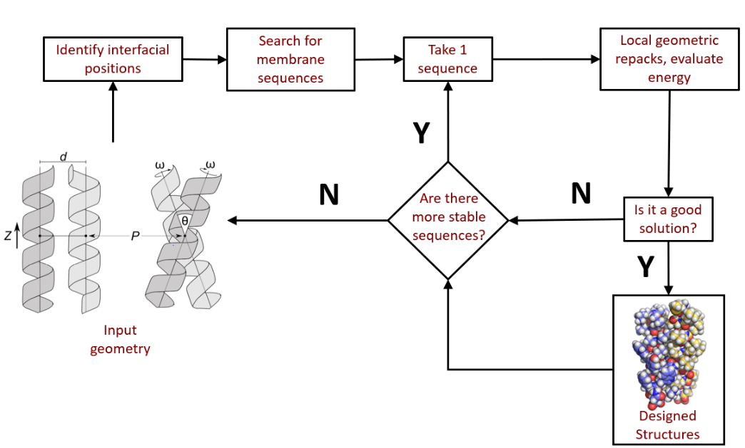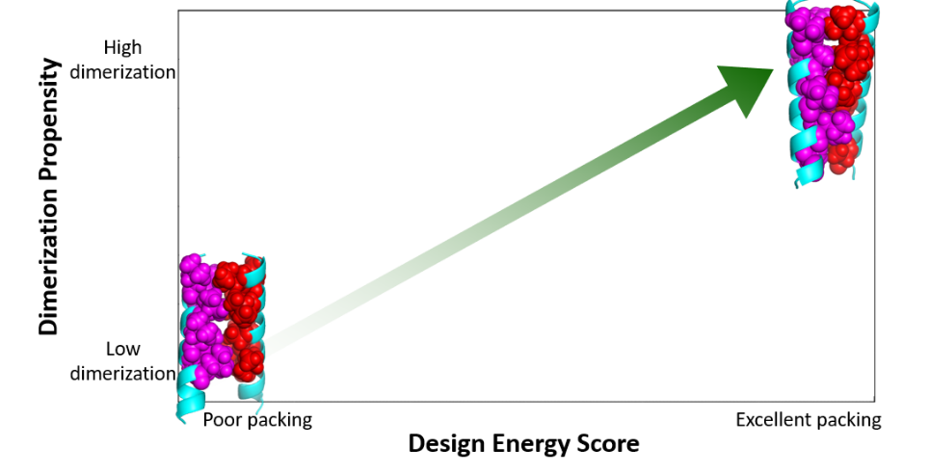

**Figure 2:** **Graphing correlation of design scores versus dimerization propensity.** Using a high throughput method that my lab developed known as sort-seq, I will test and evaluate the dimerization propensity of hundreds to thousands of constructs designs from common geometries found within the PDB, aiming to see if there is a correlation between my designed energy scores and the dimerization propensity.

The contribution of van der Waals packing to stabilizing membrane protein structure remains a significant gap in our understanding of membrane protein folding (Hong et al., 2014). Determining how sidechain packing impacts the association of membrane protein subunits will give us a better understanding of how membrane proteins assemble to fold stabilized structures. By understanding how these forces contribute to stability, we will be closer to obtaining a holistic view of how all forces involved combine to stabilize membrane protein structure. My research will increase our knowledge of the fundamental rules of membrane protein folding, and add to our understanding of complex membrane protein mechanisms, such as oligomerization and conformational change necessary for essential biological processes including signal transduction and ion transport (Sanders and Myers, 2004; Gregersen et al., 2006). Eventually, this knowledge can be used to design new functional membrane protein structures, advancing the field of synthetic biology.

**References**

1. Fagerberg, L., Jonasson, K., von Heijne, G., Uhlén, M. & Berglund, L. (2010). Prediction of the human membrane proteome. Proteomics 10, 1141–1149.
2. Sanders, C.R., and Myers, J.K. (2004). Disease-Related Misassembly of Membrane Proteins. Annu. Rev. Biophys. Biomol. Struct. 33, 25–51.
3. Gregersen, N., Bross, P., Vang, S., and Christensen, J.H. (2006). Protein Misfolding and Human Disease. Annu. Rev. Genom. Hum. Genet. 7, 103–124.
4. Carpenter, E.P., Beis, K., Cameron, A.D., and Iwata, S. (2008). Overcoming the challenges of membrane protein crystallography. Current Opinion in Structural Biology 18, 581–586.
5. Zhou, F.X., Merianos, H.J., Brunger, A.T., and Engelman, D.M. (2001). Polar residues drive association of polyleucine transmembrane helices. Proc Natl Acad Sci U S A 98, 2250–2255.
6. Yano, Y., Takemoto, T., Kobayashi, S., Yasui, H., Sakurai, H., Ohashi, W., Niwa, M., Futaki, S., Sugiura, Y., and Matsuzaki, K. (2002). Topological Stability and Self-Association of a Completely Hydrophobic Model Transmembrane Helix in Lipid Bilayers. Biochemistry 41, 3073–3080.
7. Johnson, R.M., Hecht, K., and Deber, C.M. (2007). Aromatic and Cation−π Interactions Enhance Helix−Helix Association in a Membrane Environment †. Biochemistry 46, 9208–9214.
8. Faham, S., Yang, D., Bare, E., Yohannan, S., Whitelegge, J.P., and Bowie, J.U. (2004). Side-chain Contributions to Membrane Protein Structure and Stability. Journal of Molecular Biology *335*, 297–305.
9. Joh, N.H., Oberai, A., Yang, D., Whitelegge, J.P., and Bowie, J.U. (2009). Similar Energetic Contributions of Packing in the Core of Membrane and Water-Soluble Proteins. J. Am. Chem. Soc. *131*, 10846–10847.
10. Mravic, M., Thomaston, J.L., Tucker, M., Solomon, P.E., Liu, L., and DeGrado, W.F. (2019). Packing of apolar side chains enables accurate design of highly stable membrane proteins. Science 363, 1418–1423.
11. Popot, J.L., and Engelman, D.M. (1990). Membrane protein folding and oligomerization: the two-stage model. Biochemistry 29, 4031–4037.
12. Hong, H. (2014). Toward understanding driving forces in membrane protein folding. Archives of Biochemistry and Biophysics 564, 297–313.