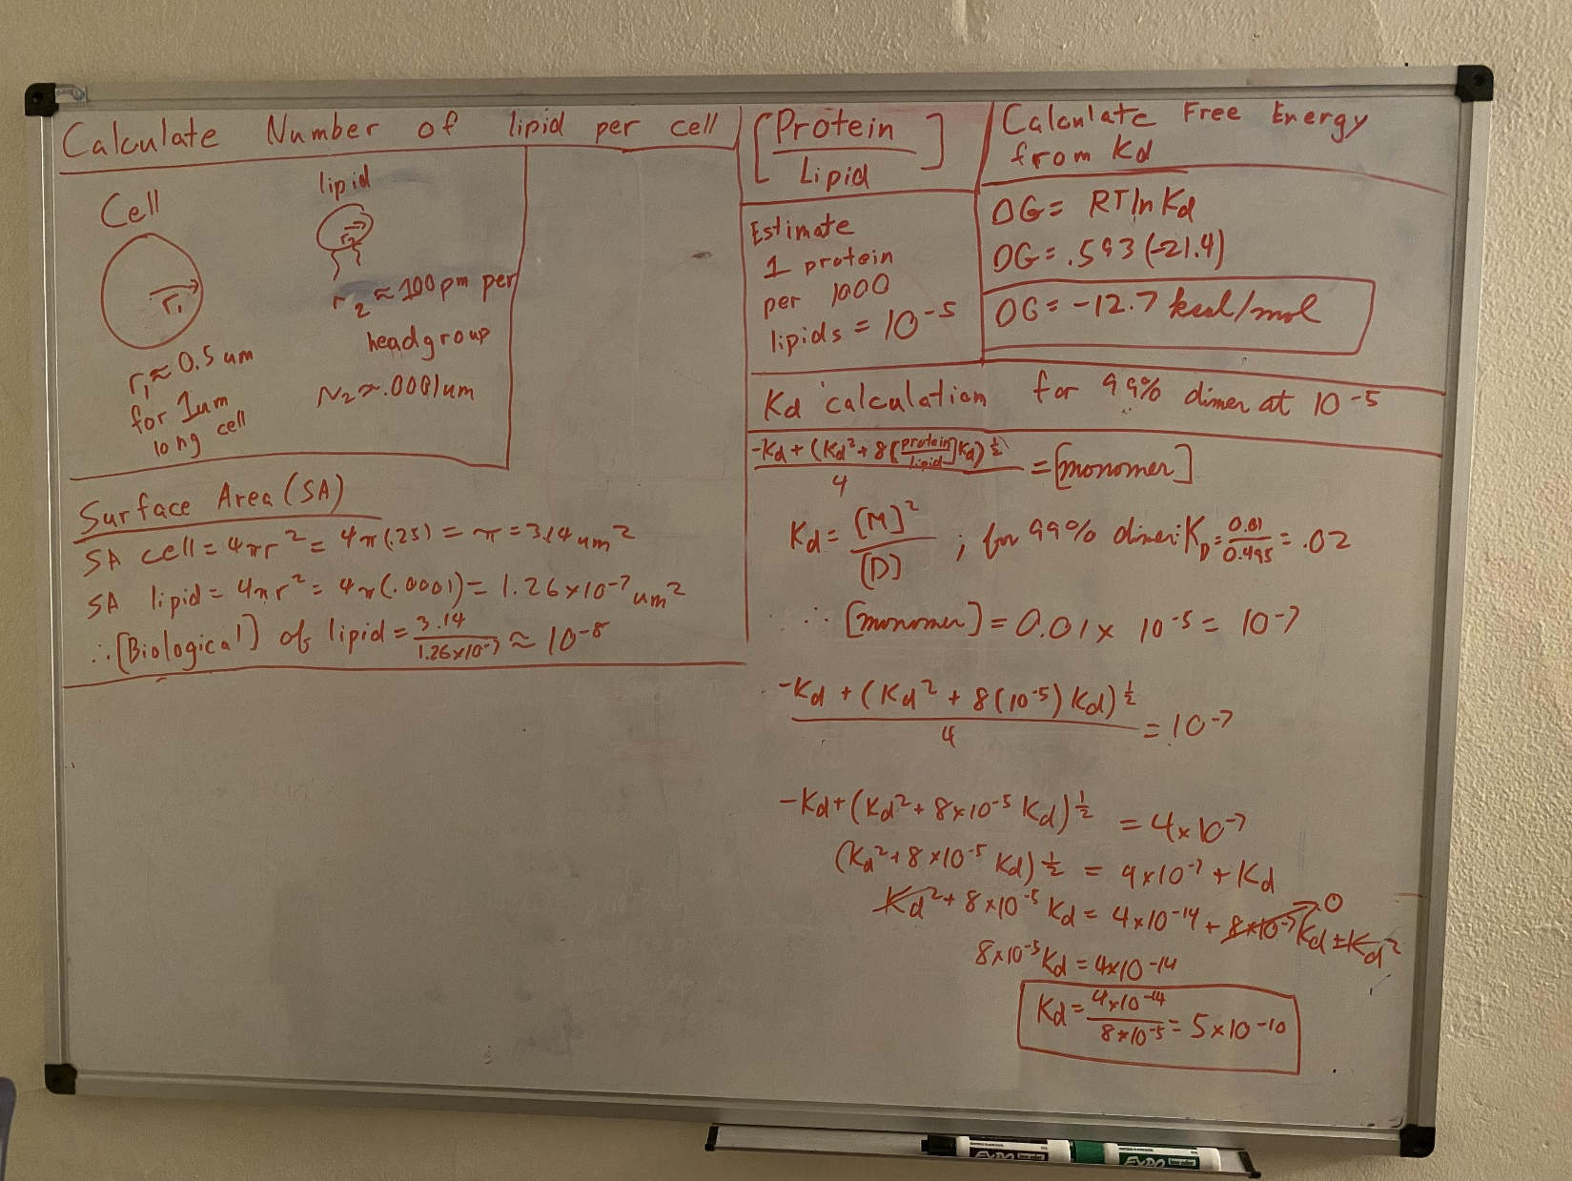

Now on to Kd: Since I now have an estimate for a biological concentration, I can use the Kd equation to get the Kd at which dimer is found to be 99% at the protein/lipid concentration at 10-5:

* Because Kd = monomer2/dimer, I can calculate the amount the monomer concentration at the biological concentration of interest. Since we are interested in 99% dimer, the ratio is 0.01/0.99 (or 0.01/0.495 as you pointed out because the dimer is two monomers). I multiplied the 0.01 monomer concentration we want by the total protein to lipid concentration 10-5 to get the monomer concentration when 99% of the protein is dimerizing, which is 10-7.
* Then I set the quadratic equation equal to the monomer concentration and solved for the Kd
* I then used the above values to solve for the Kd (rather than subtract the 8x10-7Kd from 8x10-5Kd, I treated 8x10-7Kd as 0 since it was two orders of magnitude smaller.
* The resulting Kd is 5x10-10

I then used this Kd to calculate the free energy using deltaG = RTlnKd, and got -12.7kcal/mol as the free energy necessary for our dimer to be found as 99% dimer in my estimated cellular protein/lipid biological concentration of 10-5.

