1. dict排序

方法：sorted(iterable, cmp=None, key=None, reverse=False)

>>> a_dic = {'a':{'val':3}, 'b':{'val':4}, 'c':{'val':1}}

>>> dict= sorted(a_dic.iteritems(), key=lambda d:d[1]['val'], reverse = True)

>>> dict

[('b', {'val': 4}), ('a', {'val': 3}), ('c', 'val': })]

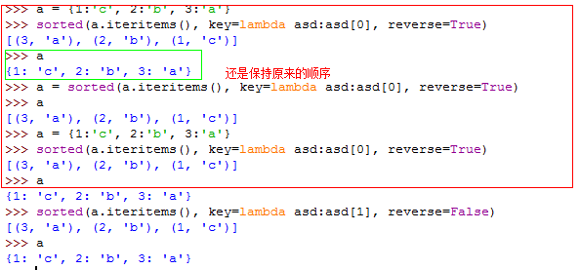

2.初始化