17/03/2016

CS12320

Mini-Assignment. Map: Roads, Settlements and Routes

Glyn Josef Roux –gjr4@aber.ac.uk

|  |  |
| --- | --- |
| **Program screenshots- map assignment** | |
| Creating a new settlement | |
| Normal entry | Erroneous entry |
|  |  |
| Deleting a settlement | |
| Normal entry | Erroneous entry |
|  |  |
| Create a road | |
| Normal entry | Erroneous entry |
|  |  |
| Delete a road | |
| Normal entry | Erroneous entry |
|  |  |
| Displaying a map (couldn’t fit the whole thing on but fitted settlements) | |
|  | |
| Saving and loading ( program loads on startup) | |
|  | |

**UML Class diagram for the Map assignment**

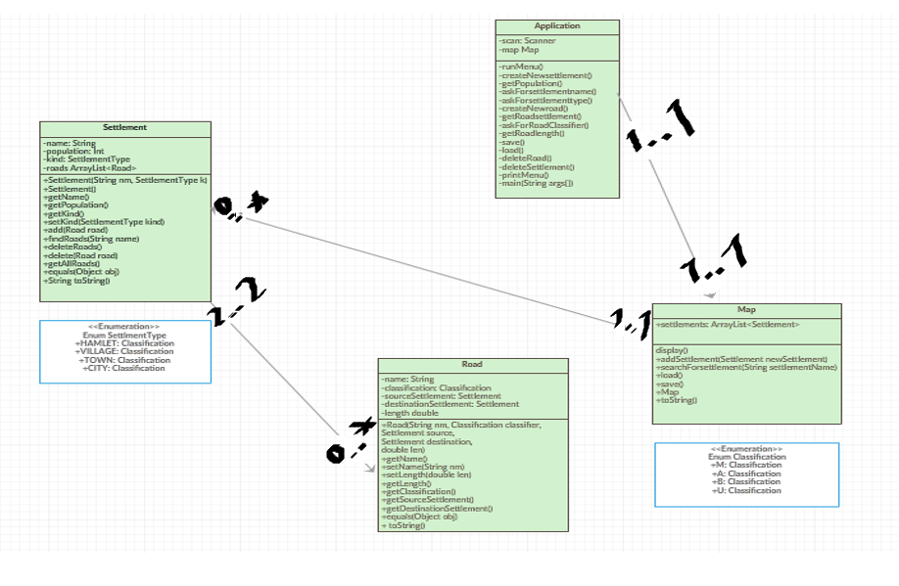

()

2..2

0..*

1..1

1..1

1..1

0..* 

**Project evaluation**

The first task was to produce a menu for the program. This was fairly straight forward. I started by writing a menu using print lines in ‘printMenu()’. I then had to call this in ‘runMenu(), I also used a case statement for when each different option on the menu was chosen by the user. I also used a do whole loop in order for the menu to stop printing when quit was chosen.

The second task in the project was to create a settlement. This part of the project was more challenging than creating the menu but this is to be expected I had to create a new method that asks the user to enter data for the new settlement and produces an error for invalid input. I had to include some way of reading in a settlementType variable, I did this by making my own version of ‘askForRoadClassifier()’. I then wrote a function in map to add the settlement and called these functions in the case in the ‘runMenu()’ function. I did a similar thing to allow for a road to be created with ‘createNewroad()’ although I checked that the settlements to that road exist first.

To load and save the map in the program was a step that I had already covered in very basic detail in worksheet 11 so was familiar to me. I used the basic structure of the load and save from the worksheet along with a pre-defined function ‘split ()’. In using the ‘split ()’ function I was able to keep the formatting the same so I was able to load and save easily.

In order to delete settlement I implemented a function ‘deleteSettlement()’ that asked the user for the name of the settlements. This meant it would check for the existence of the settlement. I also wrote the method so that of roads existed to that settlement then they would also be deleted. To delete a road I use a method called ‘deleteRoad()’ this is similar to the method to delete a settlement however the settlements either side of this road are notified when it is deleted.

Display map was an easy enough step and it just required me to specify the format with print line statements which I did and stored in the result variable and calling ‘toString()’

I found the project challenging but interesting. I had to explore java more than I had previous. The end result I achieved was pleasing but far from perfect. I would award myself a mark that is upwards of 60% for this project because my solution works and is sound but is far from perfect, I feel if I did this again I would write code that adheres more with the java coding conventions however these were a little unfamiliar to me at the time of completing the assignment.