# Power

Type I Error: Rejection of the Null Hypothesis (H0) when H0 is true.

Type II Error: Acceptance of the Null Hypothesis (H0) when H0 is not true.

No accepting H1 when H1 is true.

Power: The probability of not making a Type II error.

The probability of rejection H0 when it is false.

$Prob\left(Type II\right)= β= P\left(Accept H_{0}\right|H_{1}is true$

$Power=1- β= P\left(reject H_{0}\right|H_{1}is true)$

$$Power α \frac{Sample Size \left(n\right)*(Effect Size)}{(Alpha\left(α\right)) } (α==Proportional too)$$

## **Statistical Power and Beta**

[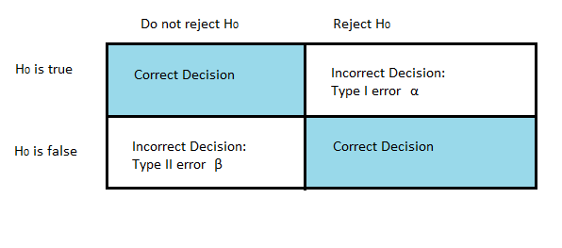](https://www.statisticshowto.datasciencecentral.com/wp-content/uploads/2015/04/statistical-power.png)

*A Type I error is the incorrect rejection of a true null hypothesis. Alpha is the*size of the test*. A Type II error is where you don’t reject a false null hypothesis. This is the*β.

.

Beta( β) is the probability that you won’t reject the null hypothesis when it is false. The statistical power is the complement of this probability: 1- β

See Wiki Example: <https://en.wikipedia.org/wiki/Power_(statistics)>