Find the minimum value of the following 2 functions:

1. Goldstein-price Function.

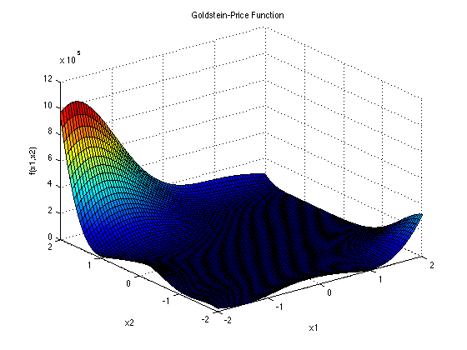

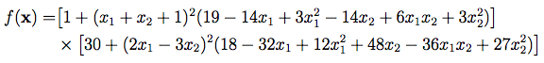

*The function is usually evaluated on the square xi ∈ [-2, 2], for all i = 1, 2.*

1. Rastrigin Function

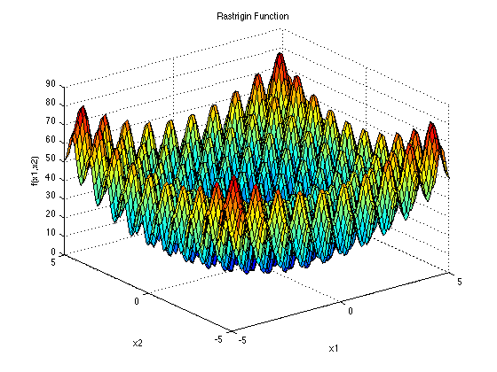

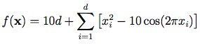

*here d=2.*

Please consider at least two of the DSE Methodology using C/C++/Python to find the minimum value and compare the different DSE algorithms (their performance, speed etc). Please feel free to use the open-source library (citations/reference are required) to implement the algorithms and source code should be submitted with your results.

A few example DSE algorithms are given. Other algorithms are also welcome.

1. Simulated Annealing.
2. Genetic Algorithm.
3. Bayesian optimization
4. Greedy
5. Random Search
6. Grid Search