[Share Post](http://www.addthis.com/bookmark.php?url=https%3A%2F%2Fcommunity.appdynamics.com%2Ft5%2FKnowledge-Base%2FTroubleshooting-EUM-custom-user-data%2Fta-p%2F26267&title=Troubleshooting+EUM+custom+user+data&username=PoweredByLithium)

Symptoms

The user wants to [add custom user data to a page browser snapshot](https://docs.appdynamics.com/display/PRO43/Add+Custom+User+Data+to+a+Page+Browser+Snapshot) and has followed the documentation for version 4.3. They are still unable to see the EUM custom user data attached to requests.

Diagnosis

1. In the latest version of Chrome browser, open the developer tools.
2. Click on the Network tab and reload the page.
3. Look for the Adrum post request   
   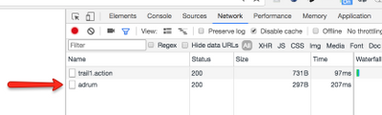  
   Click the Adrum request and view the payload.
4. There will be an element in the payload under 'es'[index] => 'ud'   
     
   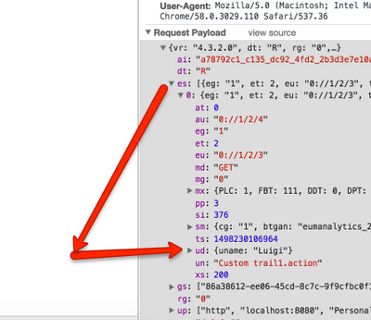  
   If you do not see this, there is a problem.

Solution

 A common mistake can be made when setting the Adrum config.

window['adrum-config'] = {

userEventInfo: {

"Ajax": function(context) {

...

}

}

};

**Set the window['adrum-config'] before the Adrum.js called.**

Example:

<!DOCTYPE html PUBLIC "-//W3C//DTD HTML 4.01 Transitional//EN" "http://www.w3.org/TR/html4/loose.dtd">

<html>

<head>

<meta http-equiv="Content-Type" content="text/html; charset=ISO-8859-1">

<script>

window['adrum-start-time'] = new Date().getTime();

**window['adrum-config']** = {

userEventInfo: {

"Ajax": function(context) {

return {

userData: {

email : "sample@example.com"

}

}

}

}

};

(function(config){

config.appKey = 'AD-AAB-XXX-XXX';

config.adrumExtUrlHttp = 'http://cdn.appdynamics.com';

config.adrumExtUrlHttps = 'https://cdn.appdynamics.com';

config.beaconUrlHttp = 'http://col.eum-appdynamics.com';

config.beaconUrlHttps = 'https://col.eum-appdynamics.com';

config.xd = {enable : false};

})(window['adrum-config'] || (window['adrum-config'] = {}));

if ('https:' === document.location.protocol) {

document.write(unescape('%3Cscript')

+ " src='https://cdn.appdynamics.com/adrum/adrum-4.3.2.0.js' "

+ " type='text/javascript' charset='UTF-8'"

+ unescape('%3E%3C/script%3E'));

} else {

document.write(unescape('%3Cscript')

+ " src='http://cdn.appdynamics.com/adrum/adrum-4.3.2.0.js' "

+ " type='text/javascript' charset='UTF-8'"

+ unescape('%3E%3C/script%3E'));

}

</script>

<script src="js/jquery.js"></script>

</head>

<body>

...

...

...

</body>

</html>

To dynamically set the user data at a later point in time, create a JSON structure before setting window['adrum-config'] and assign it to userData.

Later, update the user data when before the AJAX event is fired.

Example:

<!DOCTYPE html PUBLIC "-//W3C//DTD HTML 4.01 Transitional//EN" "http://www.w3.org/TR/html4/loose.dtd">

<html>

<head>

<meta http-equiv="Content-Type" content="text/html; charset=ISO-8859-1">

<script charset='UTF-8'>

window['adrum-start-time'] = new Date().getTime();

var jsonData = {};

function addToMap(key, value) {

jsonData[key] = value;

}

function getJsonData() {

return jsonData;

}

window['adrum-config'] = {

userEventInfo: {

"Ajax": function(context) {

return {

userData: getJsonData()

}

}

}

};

(function(config){

config.appKey = 'AD-AAB-XXX-XXX';

config.adrumExtUrlHttp = 'http://cdn.appdynamics.com';

config.adrumExtUrlHttps = 'https://cdn.appdynamics.com';

config.beaconUrlHttp = 'http://col.eum-appdynamics.com';

config.beaconUrlHttps = 'https://col.eum-appdynamics.com';

config.xd = {enable : false};

})(window['adrum-config'] || (window['adrum-config'] = {}));

if ('https:' === document.location.protocol) {

document.write(unescape('%3Cscript')

+ " src='https://cdn.appdynamics.com/adrum/adrum-4.3.2.0.js' "

+ " type='text/javascript' charset='UTF-8'"

+ unescape('%3E%3C/script%3E'));

} else {

document.write(unescape('%3Cscript')

+ " src='http://cdn.appdynamics.com/adrum/adrum-4.3.2.0.js' "

+ " type='text/javascript' charset='UTF-8'"

+ unescape('%3E%3C/script%3E'));

}

</script>

<script src="js/jquery.js"></script>

</head>

<body>

<button onclick="make_calls()">Make Calls</button>

<script type="text/javascript">

function make_calls(){

var random_number = Math.floor(Math.random() * 6) + 1;

if (random_number%2==0){

addToMap("uname", "Mario");

}else{

addToMap("uname", "Luigi");

}

$.ajax({

url: "http://localhost:8080/PersonalMusicManagerApp/trail1.action",

success: function(result){

}

});

}

</script>

</body>

</html>

Manage this structure carefully, and make sure that the user data is populating.