Python IDLE Shell (default opening screen) runs commands one at a time. Always displays >>>

Python IDLE -> File New File Editor is more for complete programs.

2+2 is an expression

Expressions always evaluate down to a single value. Expression = Values + Operators

Data Type – all values belong to exactly one data type

3.14 floating points

3 integers

3.0 float

‘text’ string

>>> ‘Alice’ + ‘Bob’

‘AliceBob’

>>> ‘Alice’ * 3

Variable is a box that can store a value or expression

Variables are assigned using an Assignment Statement, spam = 42

>>> spam = 42

>>> spam

42

>>>

Statements don’t evalueate to a single value

The Execution is the current instruction being done

Print() function that displays text

Arguments are values that are passed into a Function

Input() waits for user to type in keystrokes, always returns a string

Flowcharts

Flow control statements control how python executres

**Boolean Values –** True or False. Needs to be capital T F then lowercase

**Comparison Operators –** returns Boolean value from an expression using Comparison Operator

myAge = 26

myAge < 30

TRUE

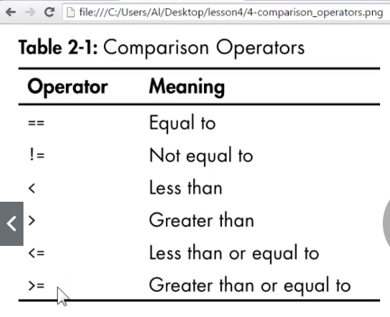

ONE = IS FOR VARIABLES

TWO == IS FOR OPERATOR EQUAL TO

**Boolean Operators –** AND, OR, NOT. Evaluates to True or False Boolean value. NOT operator only works on one Boolean operator.

Any False component of the statement returns False

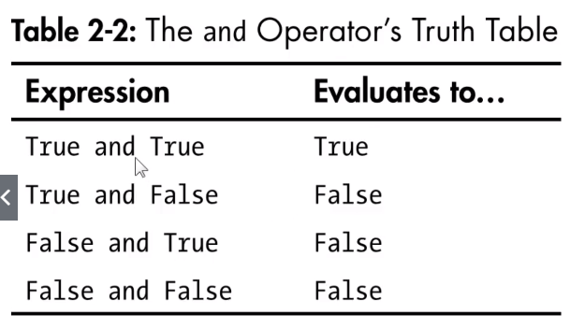

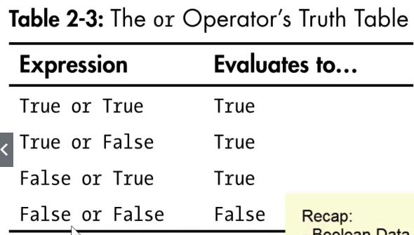

myAge = 26

myPet = ‘cat’

myAge > 20 and myPet == ‘cat’

True

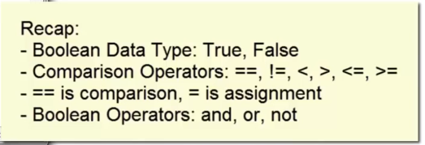

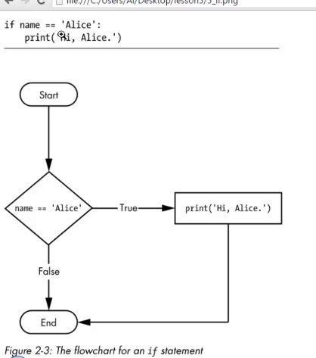

PYTHONTUTOR.COM

Can paste in code and it shows how it evaluates

**While statements are basically an IF but it loops back at the start**

**break** statement leaves the loop execution immediately without re-checking the condition

**continue** statement causes the execution to immediately jump back to the start of the look and re-check the condition

**cntrl-c** breaks out of an infinite loop

**For loops run a specific # of times**

**Functions**

Functions live in modules, which must be imported first before the function can be used.

Modulename.function to use functions after the modulename has been imported

Sys.exit() will terminate program

Def() defines a new function.

def hello():

print('HOwdy')

print('Howdy!!!!')

print('Hello there!!')

hello()

Argument = the value passed in the function call. The inputs to a function.

Parameter = the variable inside the function

**None** is kind of like True and False. It is a special data type. Its not a string, it displaying null if you run None. Every function call has a return value.

**Print()** can use optional extra arguments to print multiple separate words, or ignore the second line skip. END and SEP.

**GLOBAL VS LOCAL VARIABLES SCOPES:**

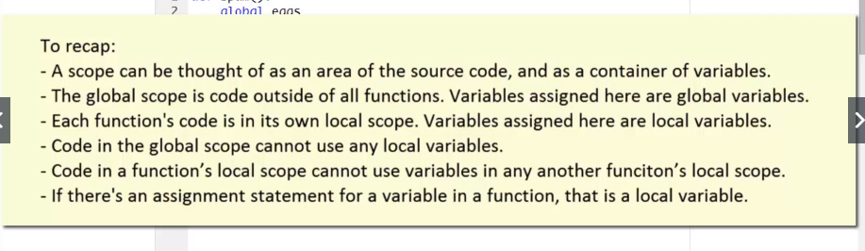

**ERRORS, CRASHES AND ERROR HANDLING WITH TRY/EXCEPT**

