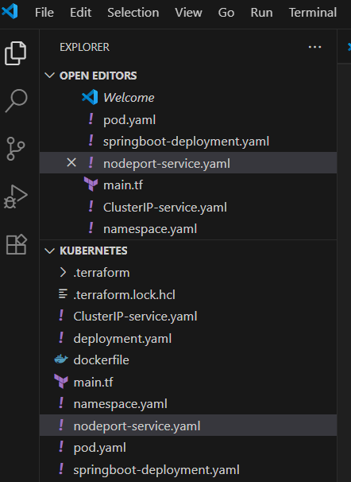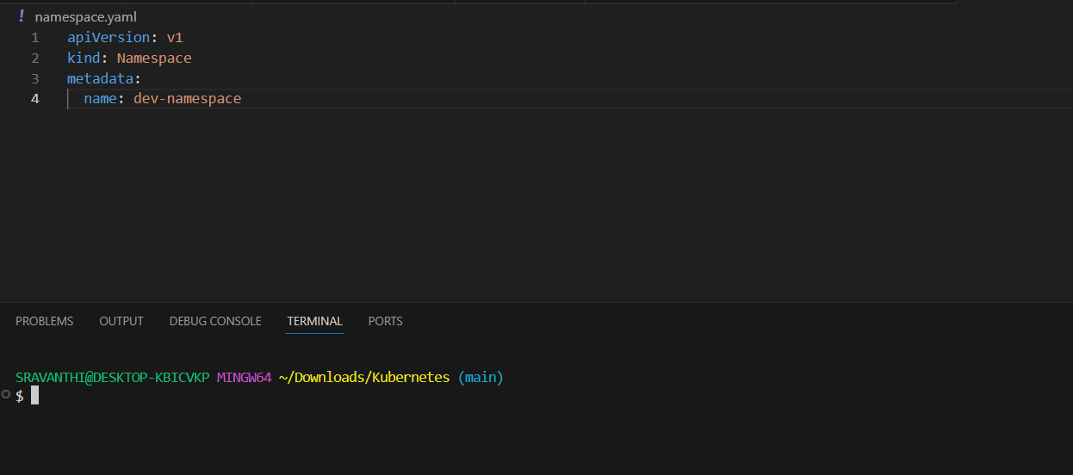

I created an namespace.yaml

Then firstly we need to create a local cluster and set kubeconfig.

Since, we have created an eks clusterfor our team, I just run the command as follows by changing the region and cluster name

**aws eks update-kubeconfig --region eu-west-3 --name batch4-team2-eks-cluster**

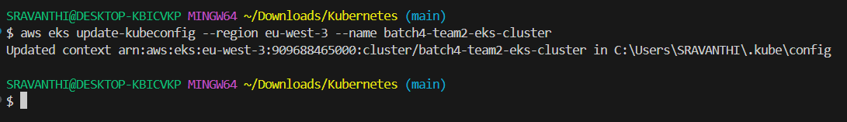

This will gives the kubeconfiguration

Then once kubeconfig is set, run the commands as follows,

1: For test connection to our cluster run the command “ **kubectl get nodes**”, which shows the status of our worker nodes as below,

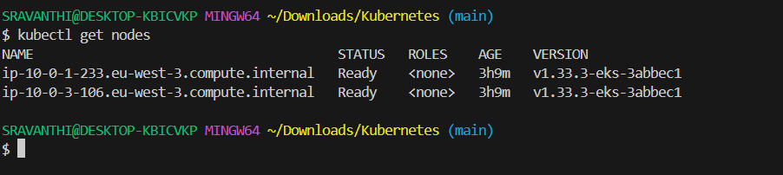

Then for applying our namespace run the command as “**kubectl apply -f namespace.yaml**”

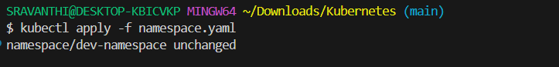

Then for verifying the namespace is created or not run “**kubectl get namespaces**”

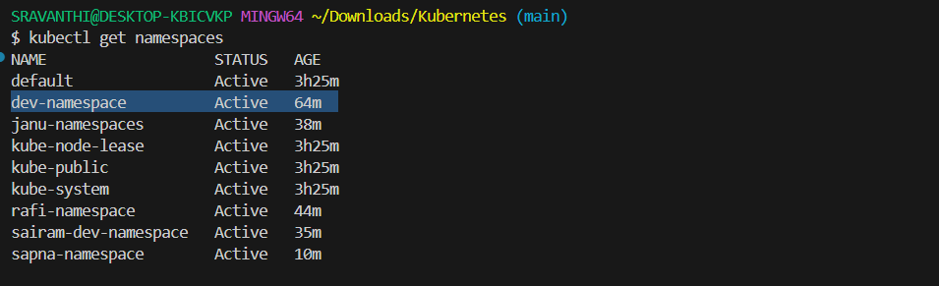

Here is my namespace which is created.

Now we can start deploying workloads inside **dev-namespace**

So for that I created an pod.yaml file

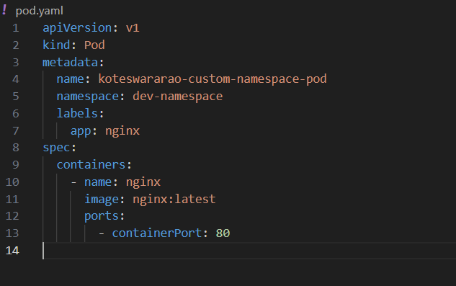

Then run the commands as follows,

**kubectl apply -f pod.yaml**

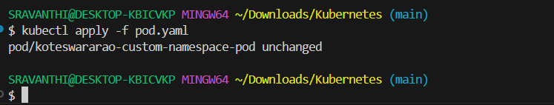

**kubectl get pods -n dev-namespace**

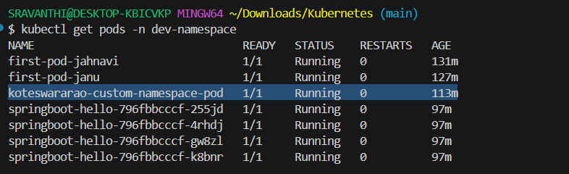

Now create an **springboot-deployment.yaml** that runs **2 replicas** of our nginx pod in the **dev-namespace**.

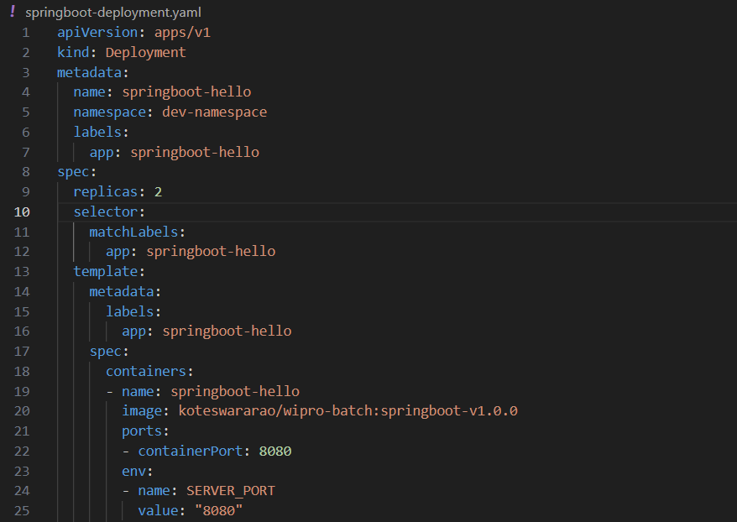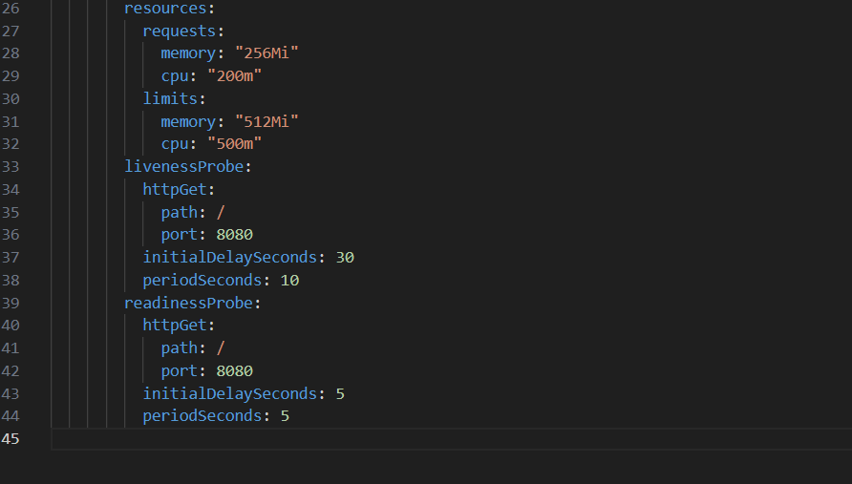

Then run the commands,

**kubectl apply -f springboot-deployment.yaml**

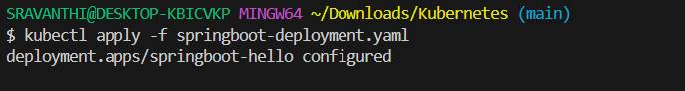

**kubectl get deployments -n dev-namespace**

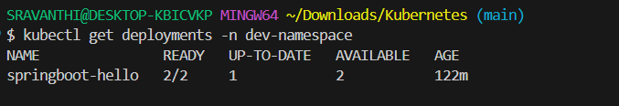

**kubectl get pods -n dev-namespace -o wide**

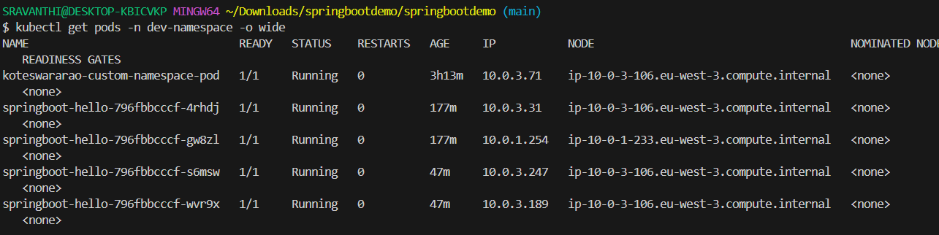

Then created an nodeport-service.yaml

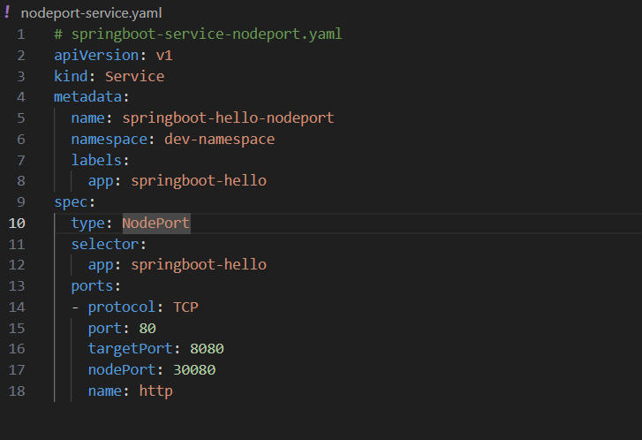

Then run the commands,

**Kubectl get svc -n dev-namespace**

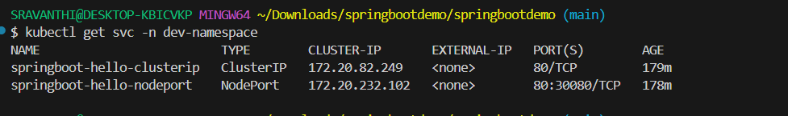

**kubectl get nodes -o wide**

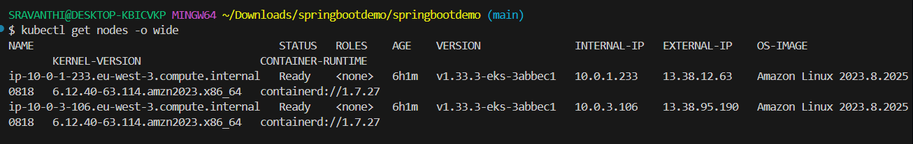

Then check in browser with [**https://13.38.95.190/**](https://13.38.95.190/)

