**1. ReactJS-HOL**

1. Define SPA and its benefits

Answer:**-**A Single Page Application (SPA) is a web app that loads one main HTML page and updates content dynamically using JavaScript, without reloading the whole page. This results in faster navigation, a smoother user experience, and reduced server load after the initial page load.

2. Define React and identify its working

Answer:**-**React is a JavaScript library used for building user interfaces, especially for dynamic web apps. It works by dividing the UI into components and using a virtual DOM to track changes, updating only what’s necessary to keep the app fast and efficient.

3. Identify the differences between SPA and MPA

Answer:-SPA loads content dynamically within a single page using JavaScript, offering speed and smooth transitions. MPA, on the other hand, loads a new HTML page from the server for each request, which is better for SEO and suited for larger, complex apps.

4. Explain Pros & Cons of Single-Page Application

Answer:**-**SPAs provide fast, app-like performance with fewer server requests. However, they have downsides like limited SEO support, reliance on JavaScript, and potentially longer initial loading time compared to MPAs.

5. Explain about React

Answer:**-** React is an open-source library from Facebook for building interactive and reusable UI components. It’s commonly used in SPAs to efficiently manage content updates without full page reloads.6. Define virtual DOM

Answer:**-** The virtual DOM is an in-memory version of the real DOM. React uses it to detect changes efficiently and updates only the changed elements in the actual DOM, improving speed and performance.

7. Explain Features of React

Answer:- React uses a virtual DOM for quick updates, has a component-based structure, supports one-way data flow, and allows writing UI with JSX. These features help in building fast, scalable, and maintainable web apps.

***Created and Installed React App***

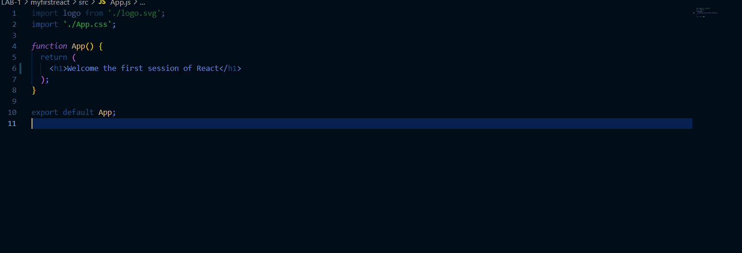

Starting the React Application on local Server by npm start

Output:-



**2. ReactJS-HOL**

Solution:-

1. Explain React components

Answer:- React components are reusable, independent blocks of UI built using functions or classes that return JSX.

2. Identify the differences between components and JavaScript functions

Answer:-Components return JSX and can manage state; regular JS functions return values and don’t handle UI or lifecycle.

3. Identify the types of components

Answer:-React has two main types: class components and function components.

4. Explain class component

Answer:-A class component is an ES6 class that extends React.Component and uses a render() method to return JSX.

5. Explain function component

Answer:-A function component is a JS function that returns JSX. With Hooks, it can also handle state and side effects.

6. Define component constructor

Answer:-The constructor initializes state and binds methods in class components. It runs before the component mounts.

7. Define render() function

Answer:-render() is a method in class components that returns the UI as JSX.

***Created and Installed React App***

***Created a Home.js in Inside src/Home.js and add this code***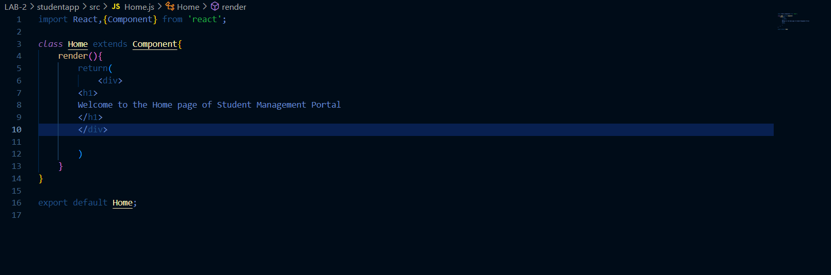

Create a About.js in Inside src/About.js and add this code

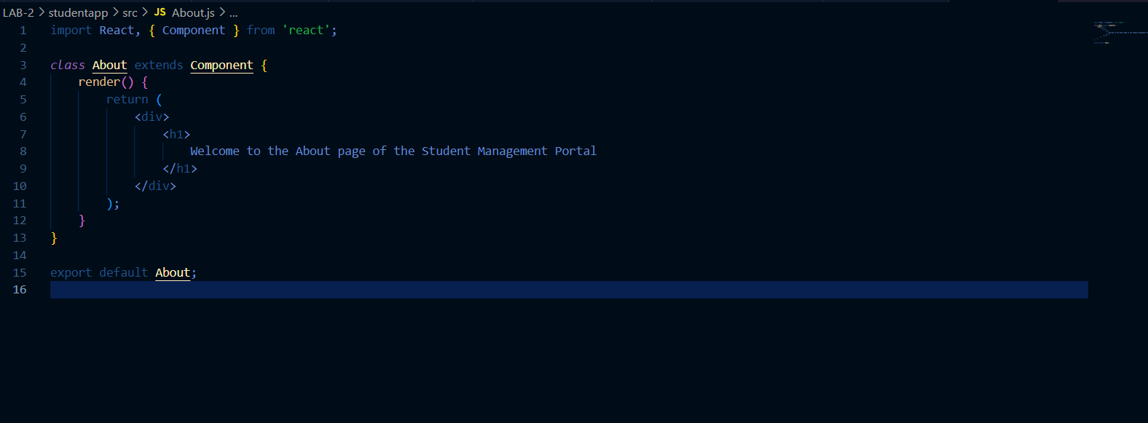

}

export default About;

Create a Contact.js in Inside src/Contact.js and add this code

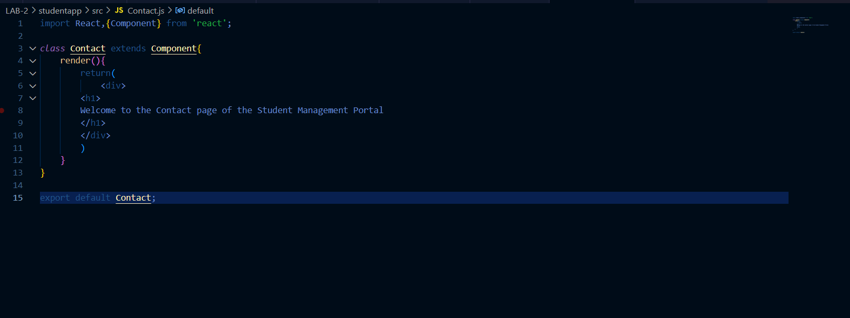Update the code of App.js in src/App.js

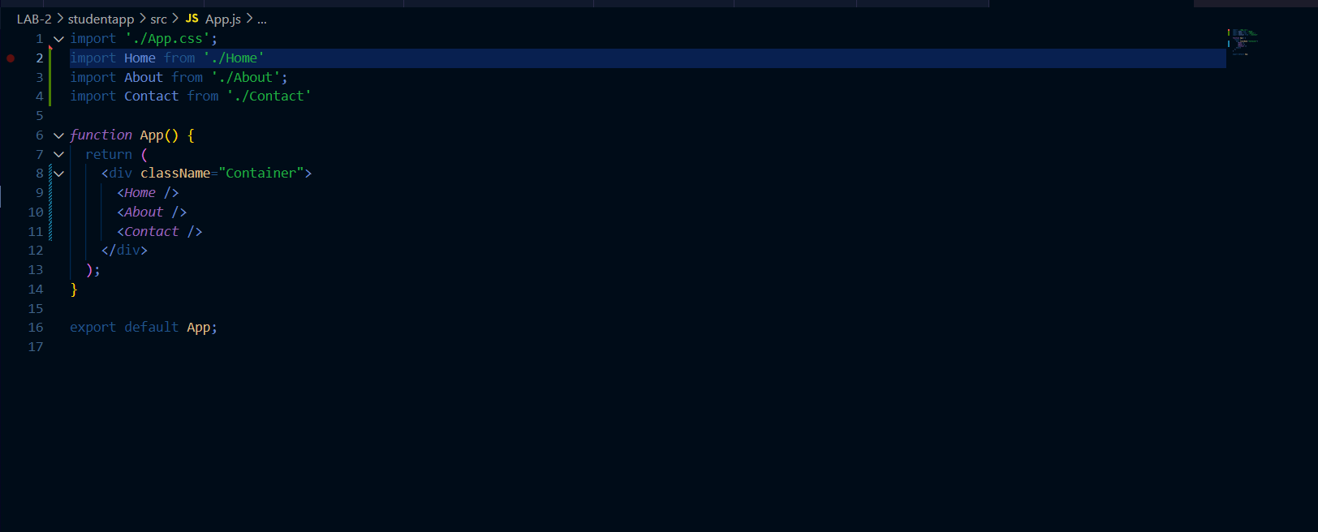

Output:-

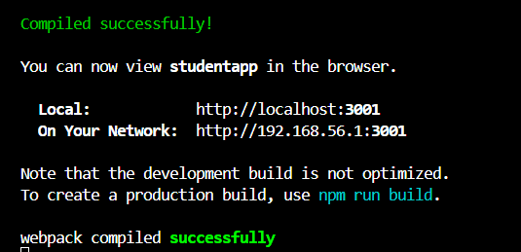

Output on Local Server localhost:3001

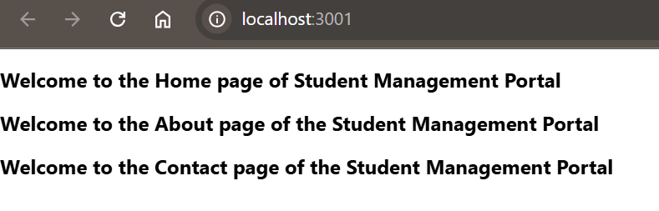

**3. ReactJS-HOL**

Solution:-

1. Explain React components

Answer:- React components are reusable UI blocks that return JSX, like functions returning HTML.

2. Identify the differences between components and JavaScript functions

Answer:-Components return JSX and manage state/lifecycle; JS functions return values and don’t handle UI.

3. Identify the types of components

Answer:-React has two types: **Class components** and **Function components**.

4. Explain class component

Answer:-A class component extends React.Component, uses render() to return JSX, and can handle state and lifecycle.

1. Explain function component

Answer:- A function component is a simple JS function that returns JSX and can use Hooks for state and effects.

6. Define component constructor

Answer:-The constructor in class components initializes state and binds methods; it runs before mounting.

7. Define render() function

Answer:-render() is a method in class components that returns JSX to display UI.

***Created and Installed React App***

***Created a CalculateScore.js in src/Components Folder with the below code***

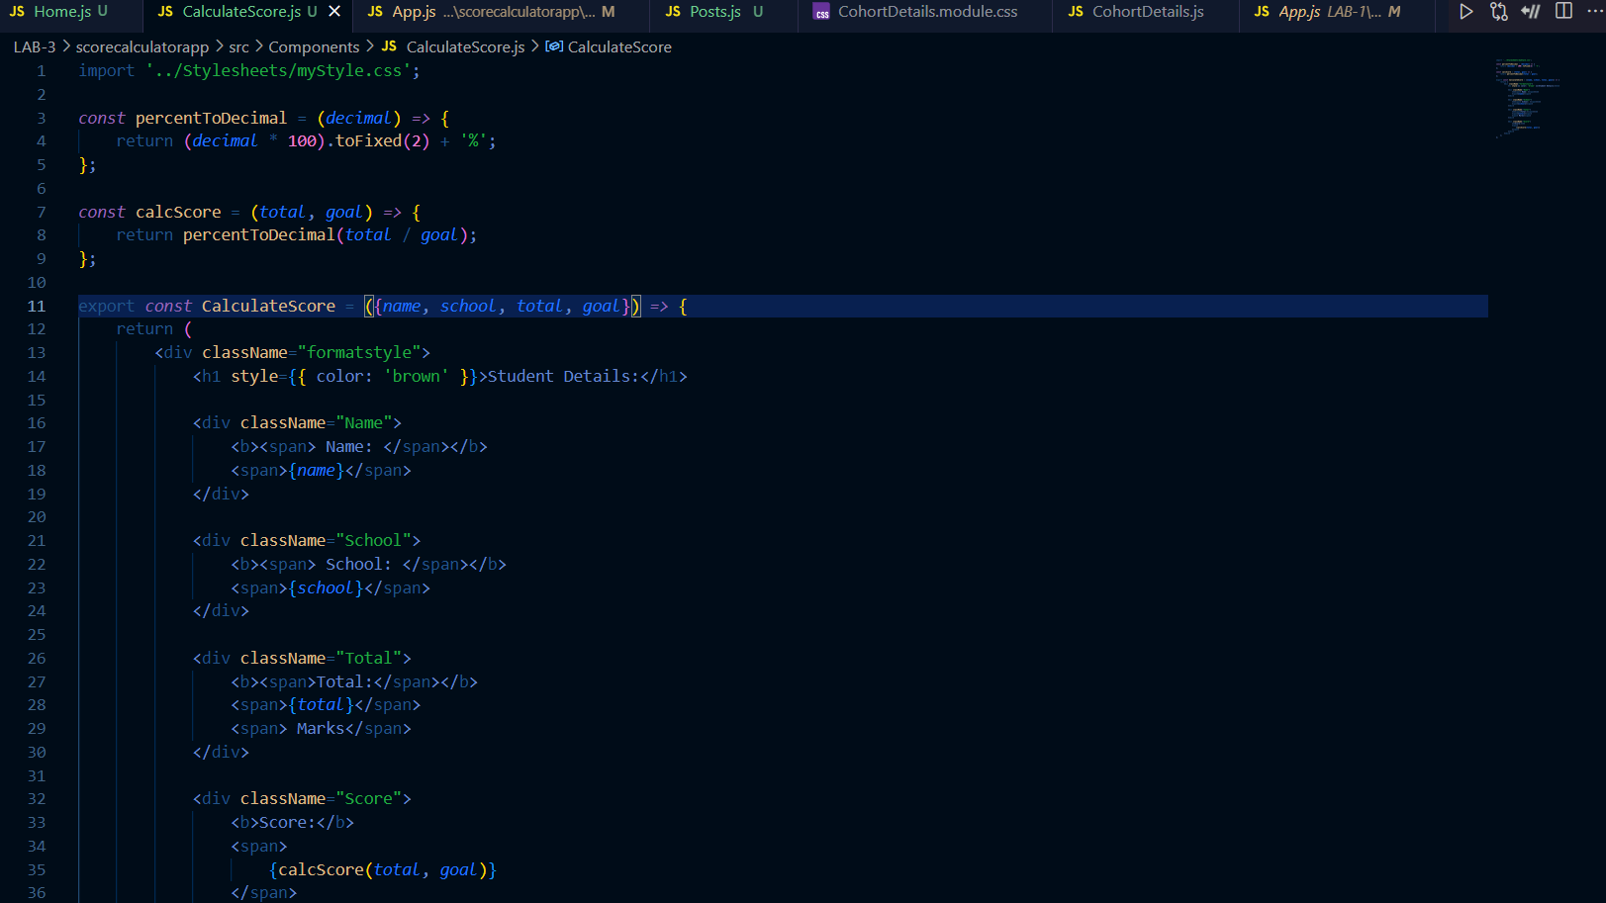

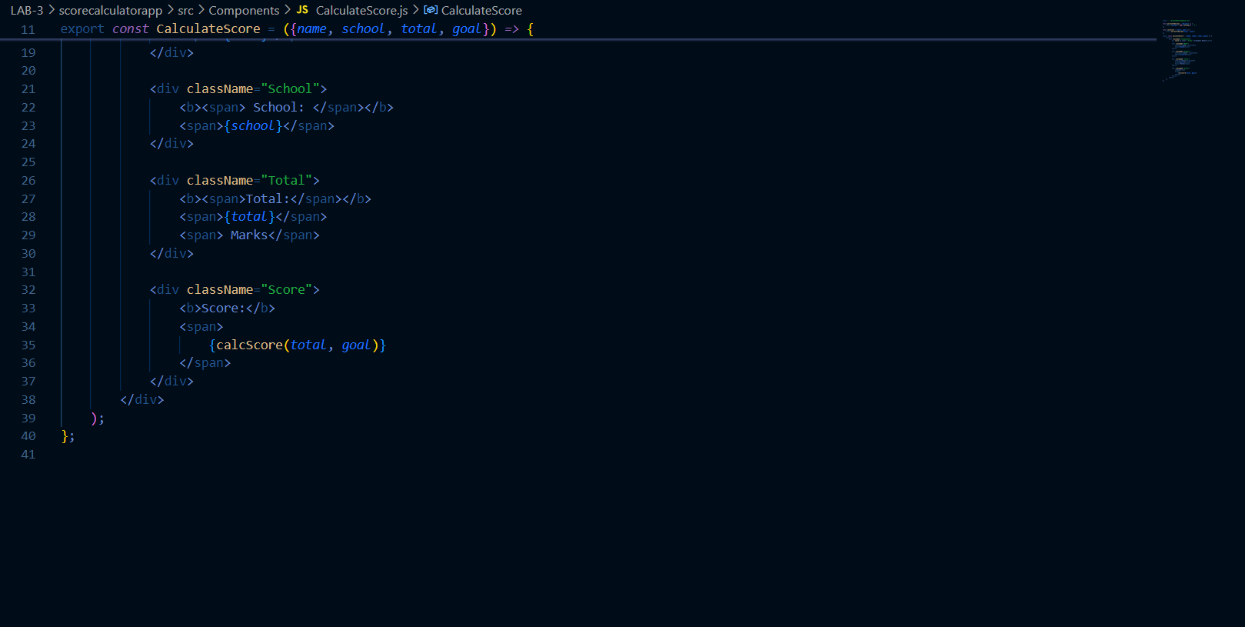

***Created a New_Folder with name stylesheets in that create a mystyle.css***

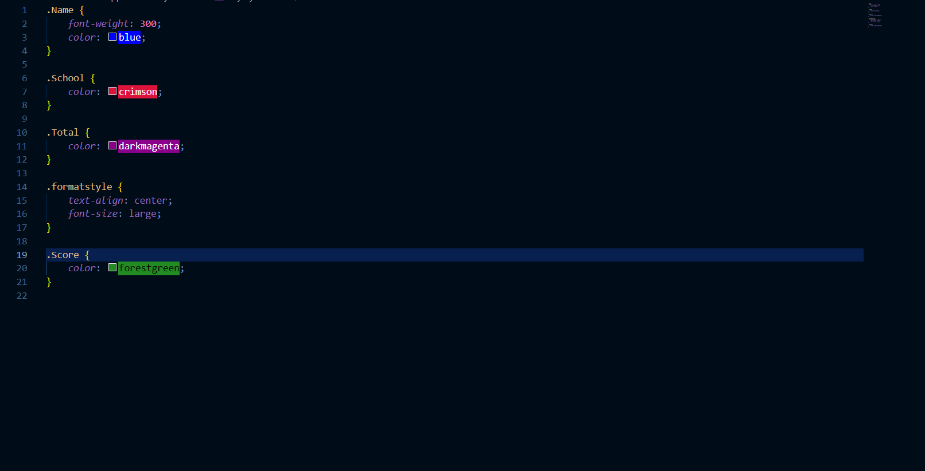}

***Update the code of App.js in src/App.js***

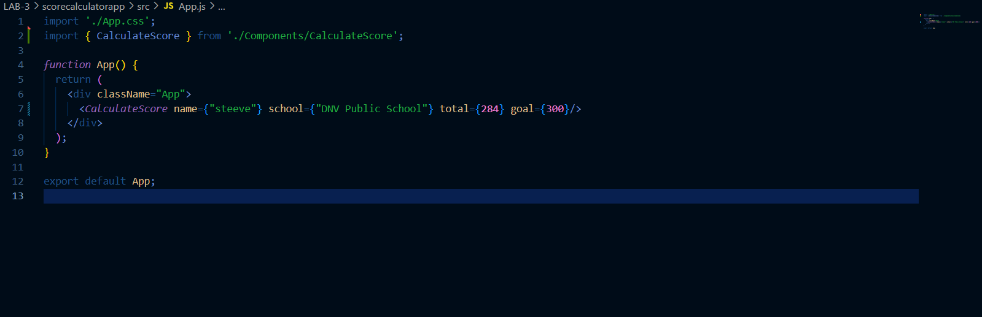

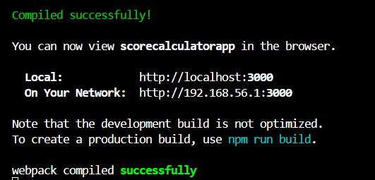

**Filename:- 4. ReactJS-HOL**

**Solution:-**

1. Explain the need and Benefits of component life cycle

Answer:-The component lifecycle in React allows control over what happens during a component’s creation, update, and removal.  
**Benefits:** Improves performance, manages resources, and allows running specific code at different stages like mounting, updating, and unmounting.

2. Identify various life cycle hook methods

Answer:-  
- constructor()  
- render()  
- componentDidMount()  
- componentDidUpdate()  
- componentWillUnmount()

3. List the sequence of steps in rendering a component

Answer:- 1. constructor()  
2. render()  
3. componentDidMount()  
4. componentDidUpdate() (on update)  
5. componentWillUnmount() (on removal)

***Created and Installed React App***

***Created a Post.js inside the folder of src/***

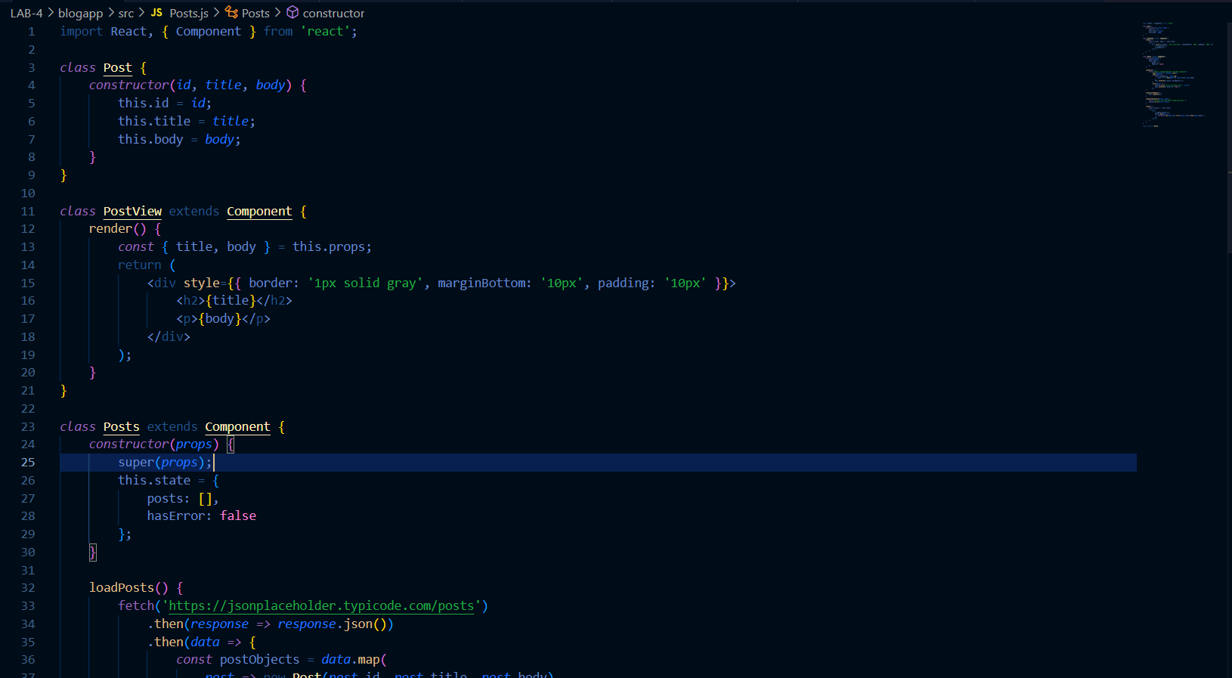

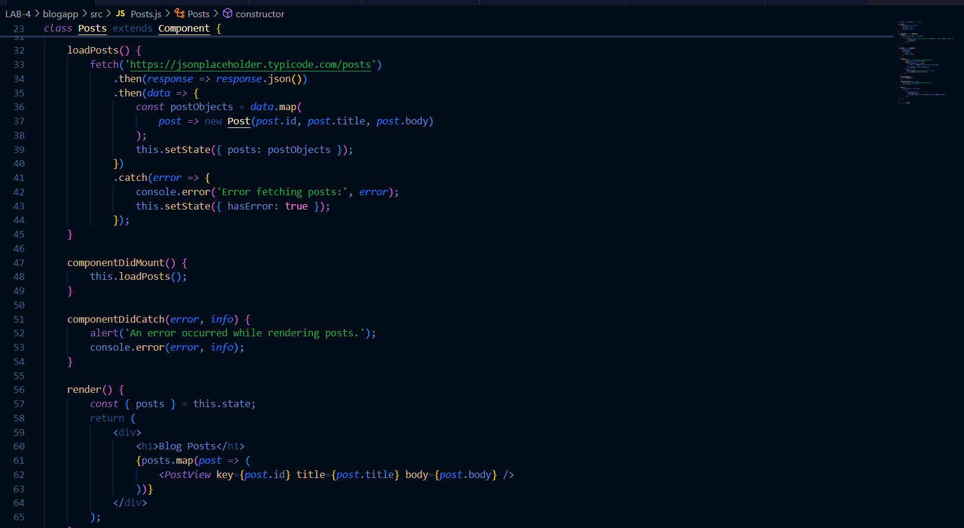

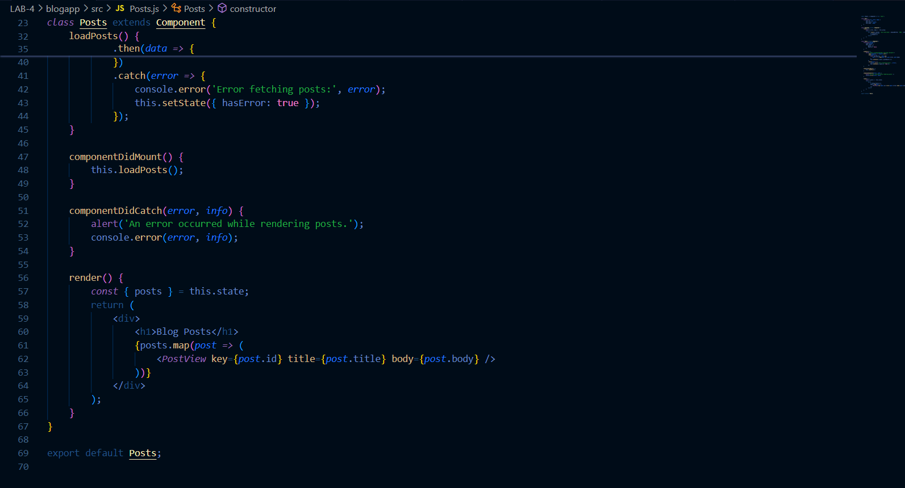

***Update the code of App.js in src/App.js***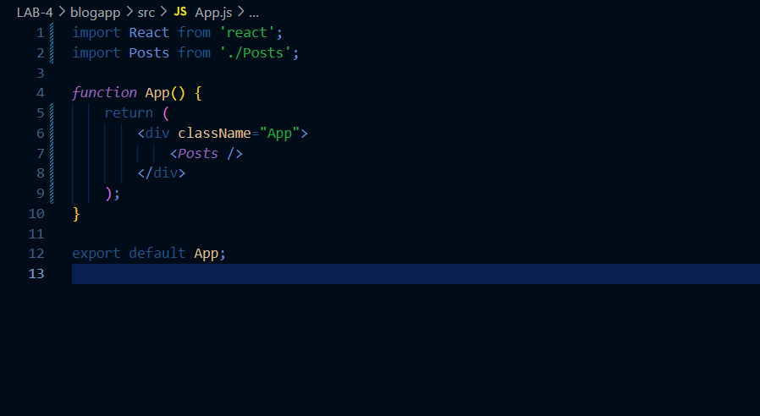

Output:-

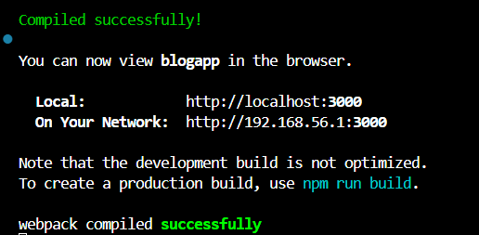

Output on Local Server localhost:3000

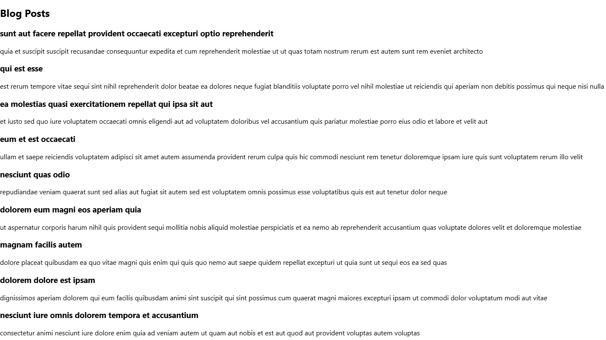

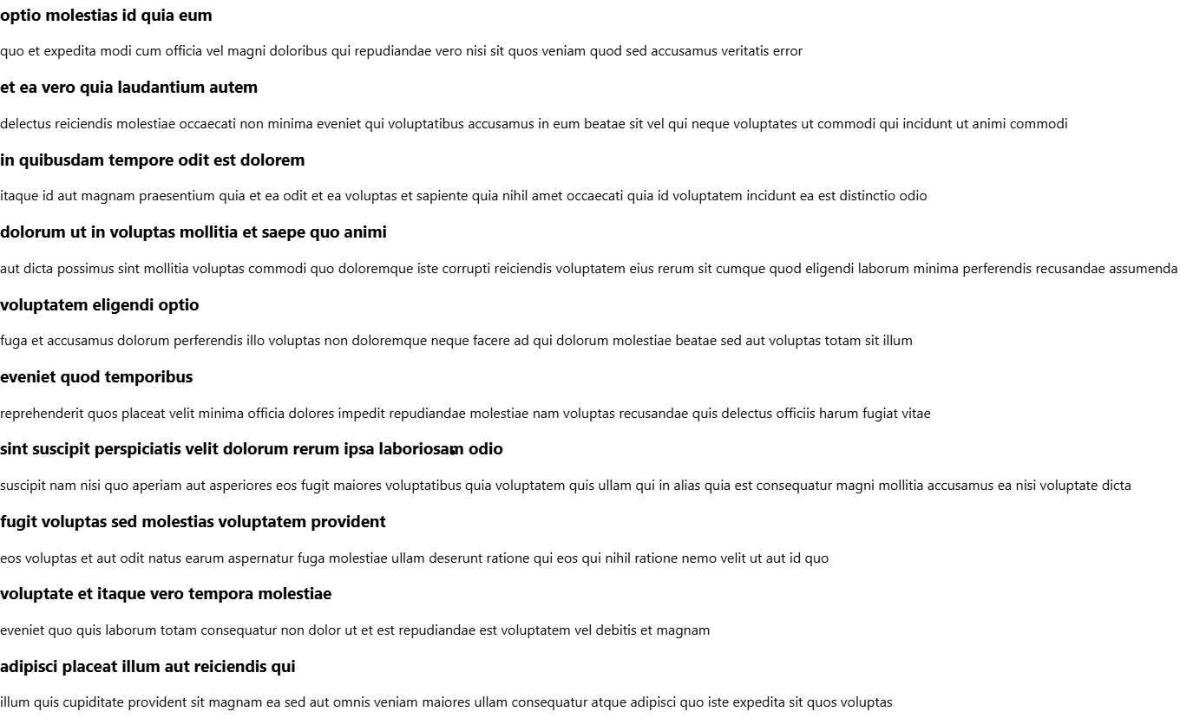

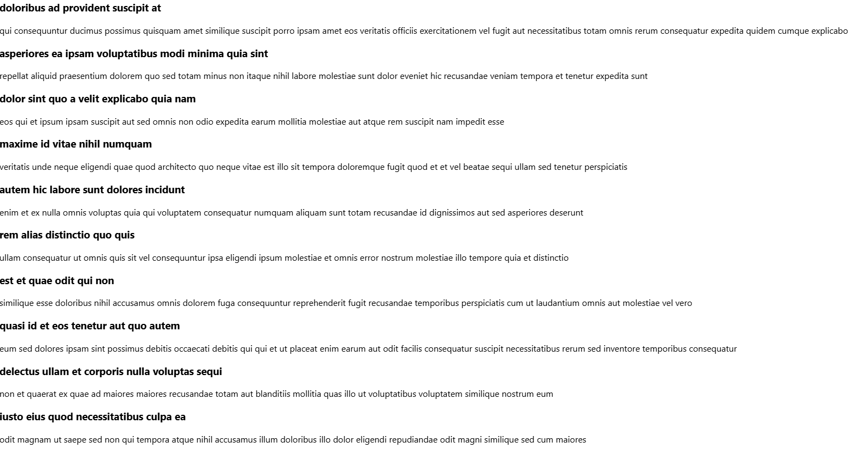

**5. ReactJS-HOL**

Solution:-

1. Understanding the need for styling react component

Answer:-Styling is essential in React to create visually appealing interfaces, ensure consistent design, and improve user experience.

2. Working with CSS Module and inline styles

Answer:-· **CSS Modules** allow scoped styling with unique class names to avoid conflicts.· **Inline Styles** are defined as JavaScript objects and applied directly, ideal for dynamic or quick styles.

***Created the CSS Module File as CohortDetails.module.css***

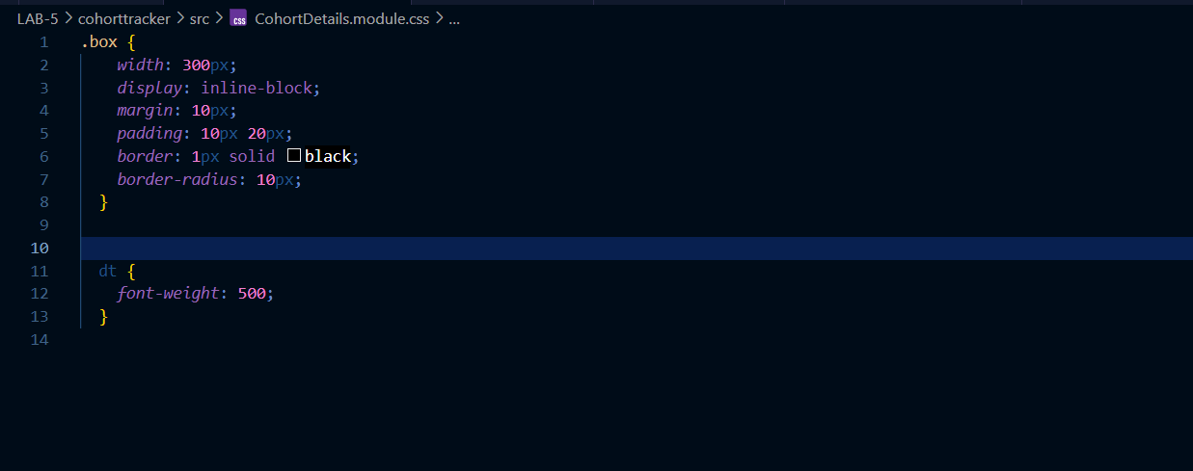

***Update the code of CohortDetails.js in src/CohortDetails.js***

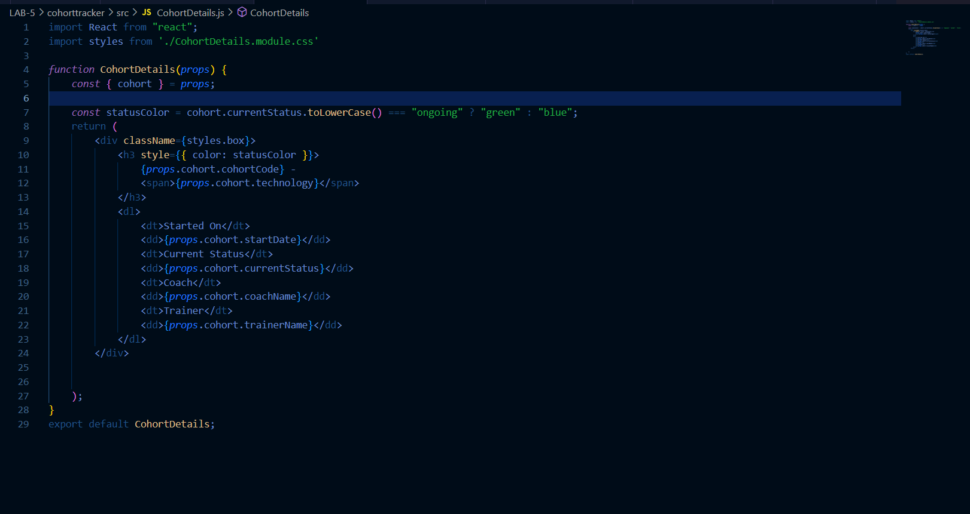

Output:-

