CarController Documentation

Idea from:  
<https://www.youtube.com/watch?v=LG1CtlFRmpU>

Spring&damper based on:  
<https://www.youtube.com/watch?v=ko6lDSSNhV8>

# Functionality

The car basically functions like a hovercraft, it has n points (wheels) that apply a force upwards to keep the car above the ground.

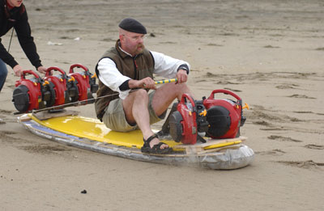

The closer one of the wheels is to the ground the greater is the upwards force force applied.

# Accelerating and Turning

To accelerate a force is applied at the ThrustApplyTransform position. This is located a bit lower and more forward than the center of mass. This make the car lean backward when accelerating (and forward when braking/reversing).   
The rigidbody speed is limited its drag and the maxSpeed of the carcontroller (maxspeed is only really there in case the physics engine fucks, so the car doesn’t shoot across the level).

To turn a torque (drehmoment/kraft) is applied to the car.

All forces that are applied ignore the mass of the car (I don’t really know if that’s smart, but it makes the values smaller and more manageable)

# Traction

To apply traction a force is applied in the opposite direction of the sideways velocity of the car.

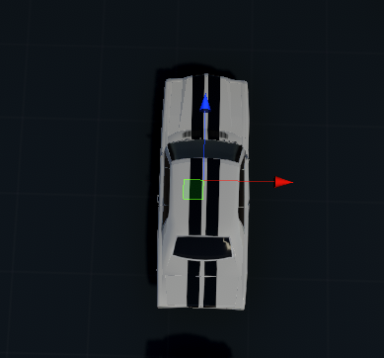

The formula goes:   
**force = counterVelocity** * tractionForce * **velocityRatio**

## CounterVelocity

This is the inverse of the sideways velocity, clamped to the maxLocalCounterVelocity.

## TractionForce

The force you define in the inspector.

## VelocityRatio

1 - rigidBody.velocity.magnitude / currentMaxSpeed

This means the faster you go the less traction is applied   
speed zero == velocityRatio 1, max speed == velocityRatio 0

Other influences:  
Drag of the rigidbody (I wouldn’t change this too much)  
Physics material of the car and friction (currently none == friction of 0.4f)

# Hovering, Spring, Damper

Each wheel shoots a ray down with the length of the hoverHeight.

The SpringCoefficient determines the stiffness of the spring. (Lower value – more bouncy, higher value – more stiffness)   
The DampingCoefficient determines how fast the velocity of the spring moving up and down is reduced. (low value – the spring doesn’t really stop moving up and down, high value – pretty stiff)

I don’t really know all that much about springs and dampers to this might not be 100% correct.

# Other Stuff

A low center of mass makes the car harder to flip.   
Airdrag is 0 because otherwise it slows down too much and looks weird.   
If you limit the angular velocity and set the turning speed high you can make the car extremely responsive to turning input.   
Rigidbody interpolation eliminates jitter.   
Always make sure scale is uniform (1,1,1)