

|  |  |  |
| --- | --- | --- |
| |  | | --- | |  | | **PES University, Bengaluru** |
|  | (Established under Karnataka Act 16 of 2013) |
| **Department of Computer Science & Engineering** | |
| **Session: Jan - May 2022** | |

**Object Oriented Analysis and Design with Java - Laboratory UE19CS353**

**Mini Project**

Report on

**Video Streaming Service**

**By: Team C19**

**PES1UG19CS139 - DEVI REDDY N**

**PES1UG19CS172 - GURU KIRAN H M**

**PES1UG19CS184 - HARSHIT SINGH**

**6th Semester – ‘G’ Section**

1. **Project Description**

This is JAVA project developed for Video Streaming System. Video streamingservers allow users to stream videos of different categories**.** It is a Streaming system where a subscriber can watch videos on the Platform and whereas non-Subscriber can only search the content on the platform. Whole project is developed in Java programming language. Here in this project, as a Subscriber, you can watch and search videos on the platform and you can manage your account as well. As a technician you can manage account and maintain the database consisting of details of the users and videos. This project comes along with MongoDB and AWS cloud database as backend.

**GitHub link -** [**https://github.com/gk1743/OOAD-Project**](https://github.com/gk1743/OOAD-Project)

1. **Analysis and Design Models**

**Use Case:**

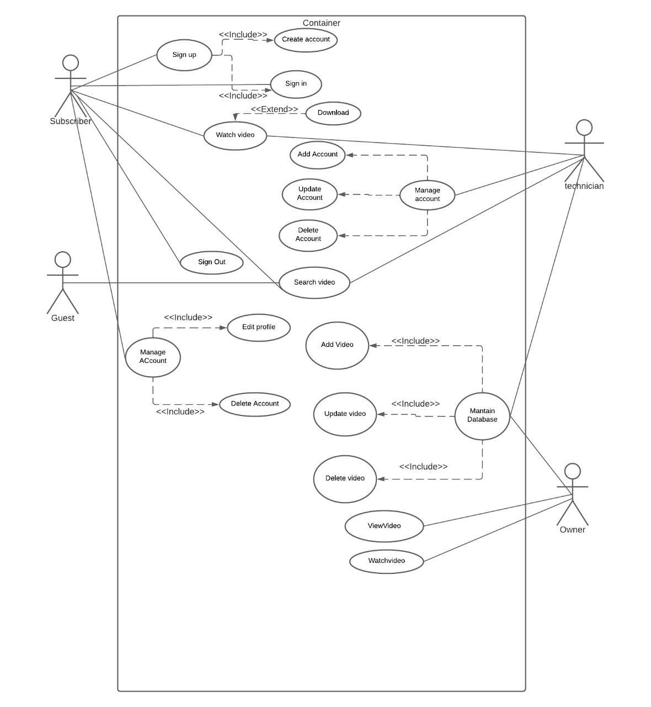

**Class Diagram:** 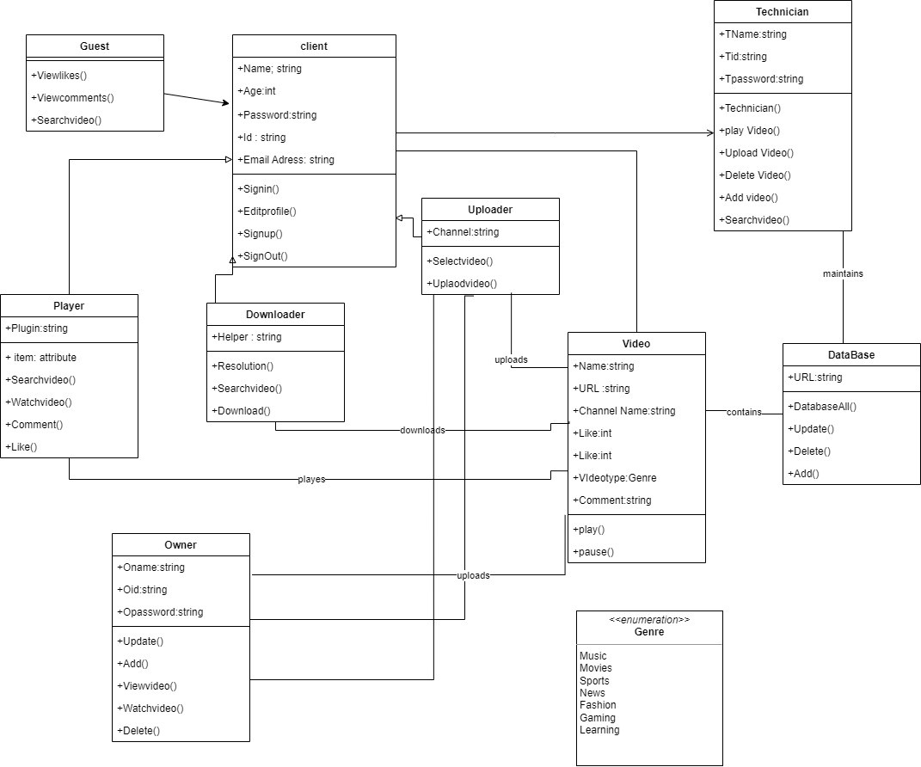

**State Diagram for login:**

**State diagram for user:**

**State diagram for watching video:**

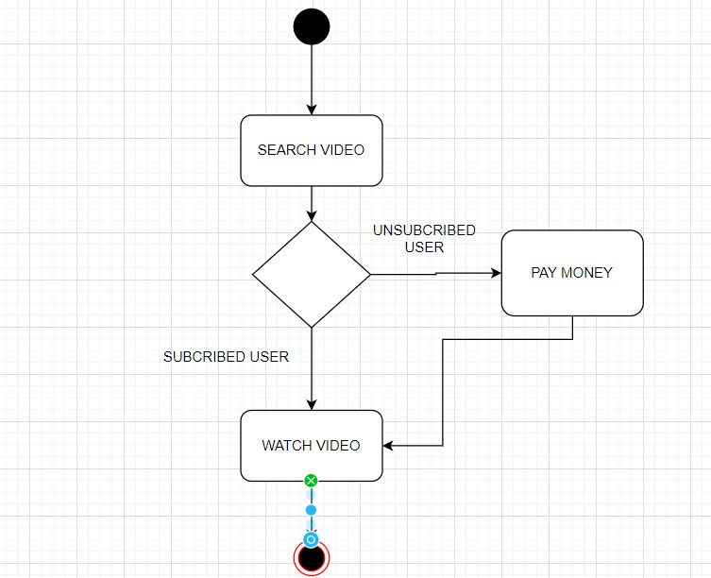

**Activity Diagram for Login:**

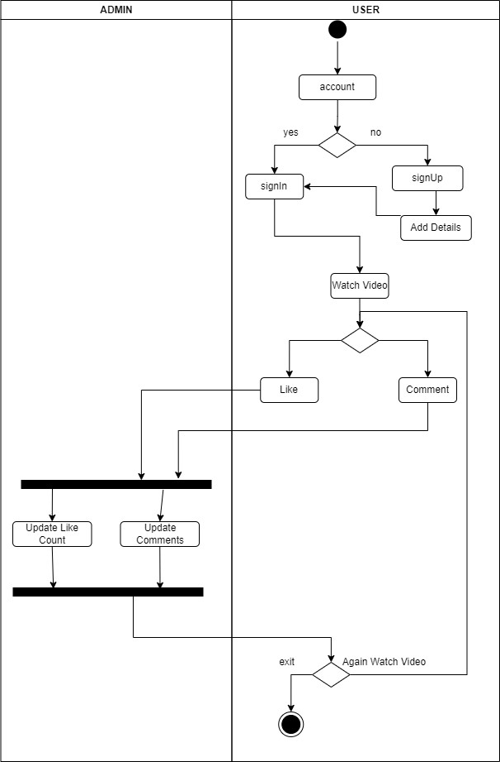

**Activity diagram for watching video:**

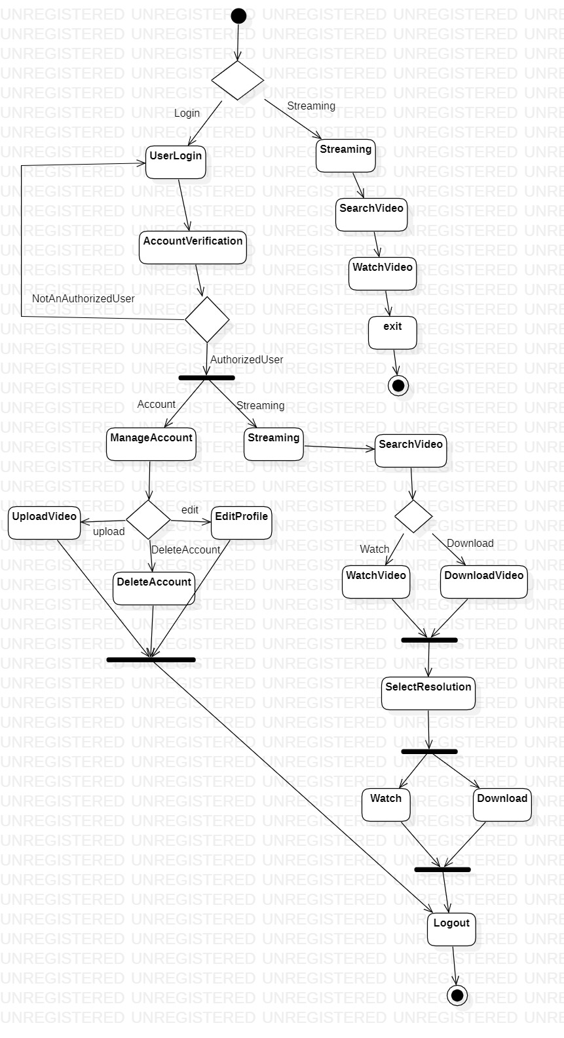

**Activity diagram for managing account:**

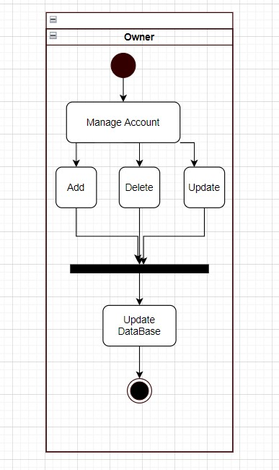

1. **Tools and Frameworks Used:**

* Java OOP concepts are used to develop this application.
* IntelliJ IDEA is used, it is an integrated development environment written in Java for developing computer software.
* Spring boot framework is used.
* Mongo DB database is used to store video Metadata, such as Video ID, title, description, artist information etc.
* Amazon Web Services(AWS) is used to store videos in a bucket.

1. **Design Principles and Design Patterns Applied**

Design Principle followed: Single Responsibility Principle, Open/Closed Principle.

Design Pattern used: Singleton

Classes which form the structure of Singleton and follow the above-mentioned principles are EncryptLSB and DecryptLSB.

1. **Application Screenshots (3-4 important pages)**

Option to browse and choose a video file. 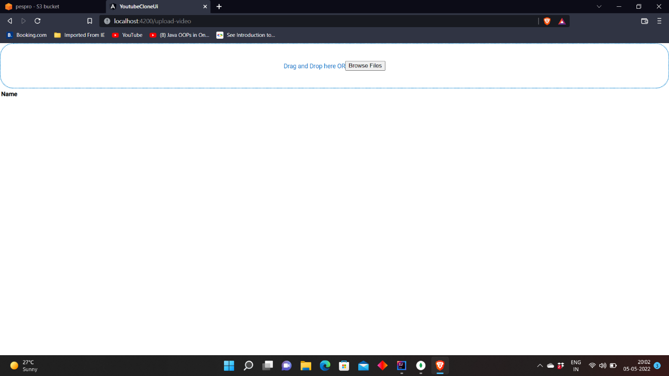

Option to upload choosen video file. 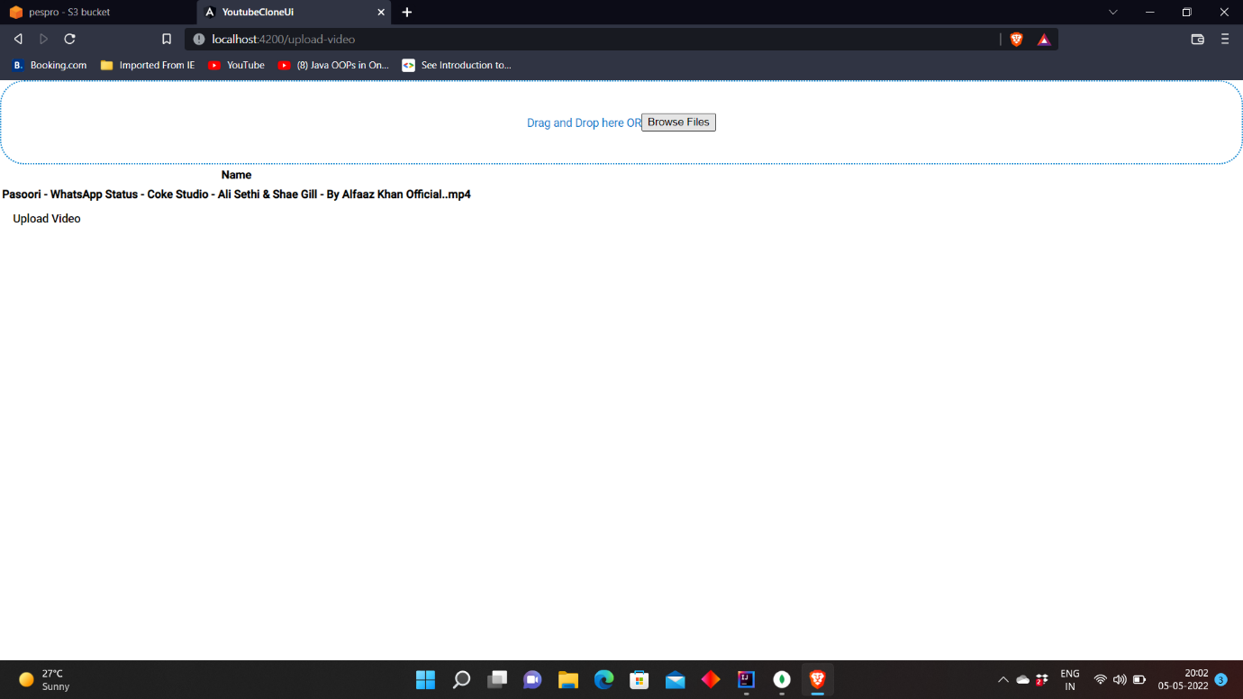

Uploading Video(status 201 represents successful request i.e., video being uploaded successfully)

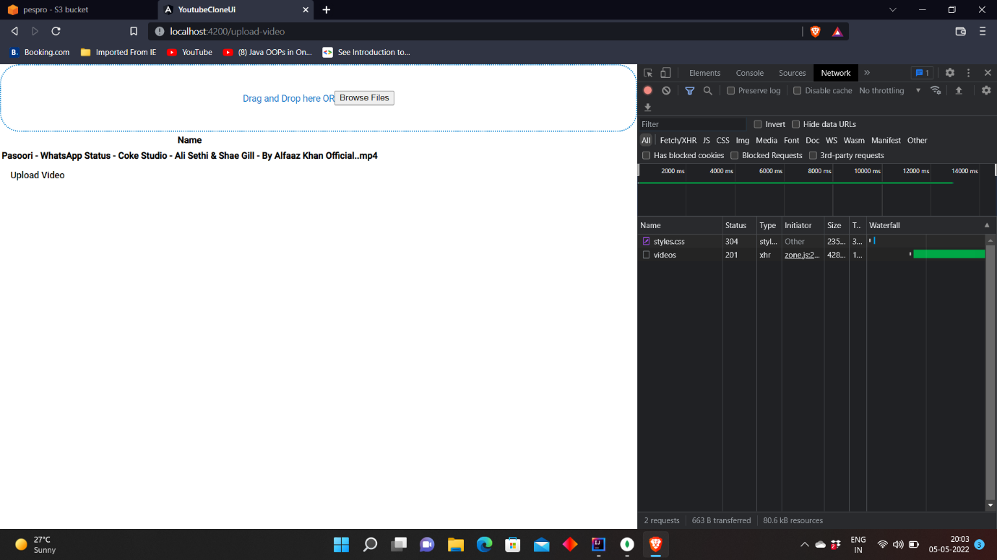

Video stored in AWS bucket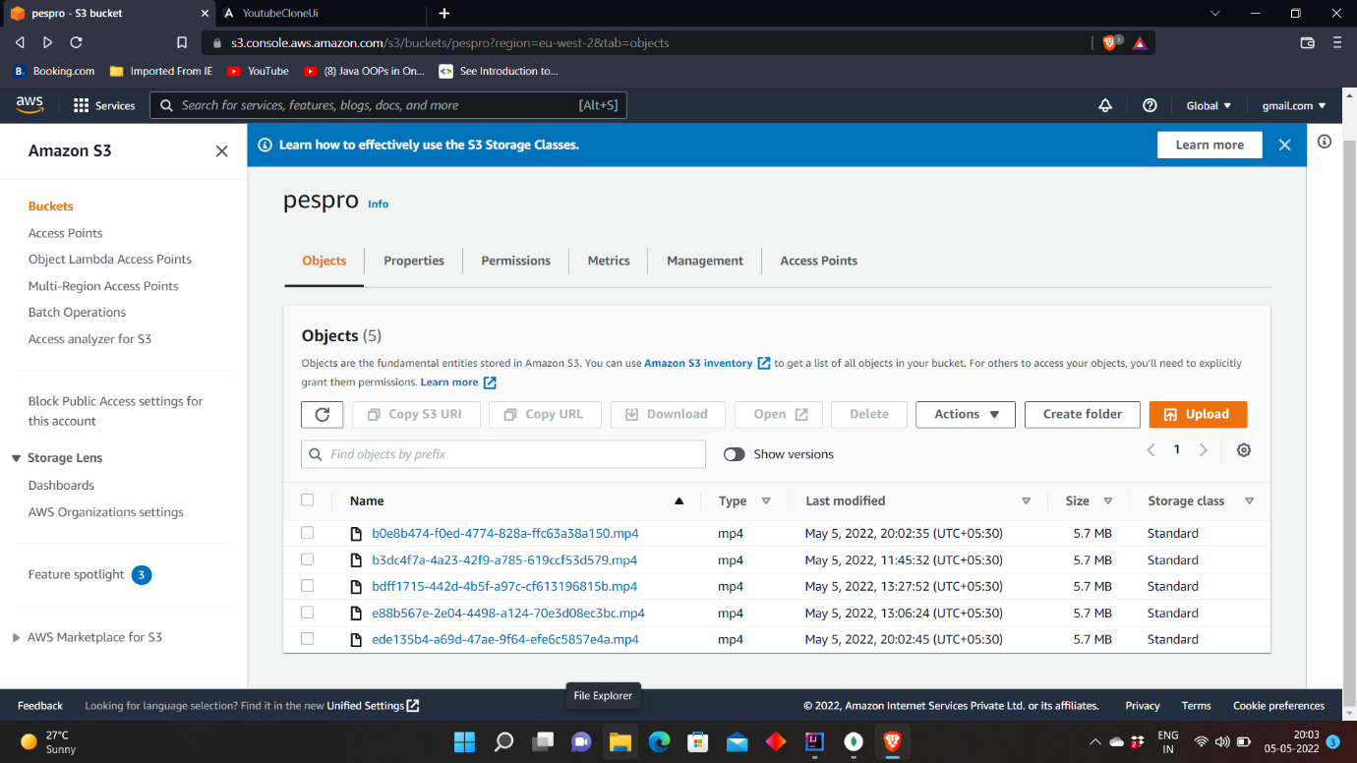

Video metadata stored in Mongo DB

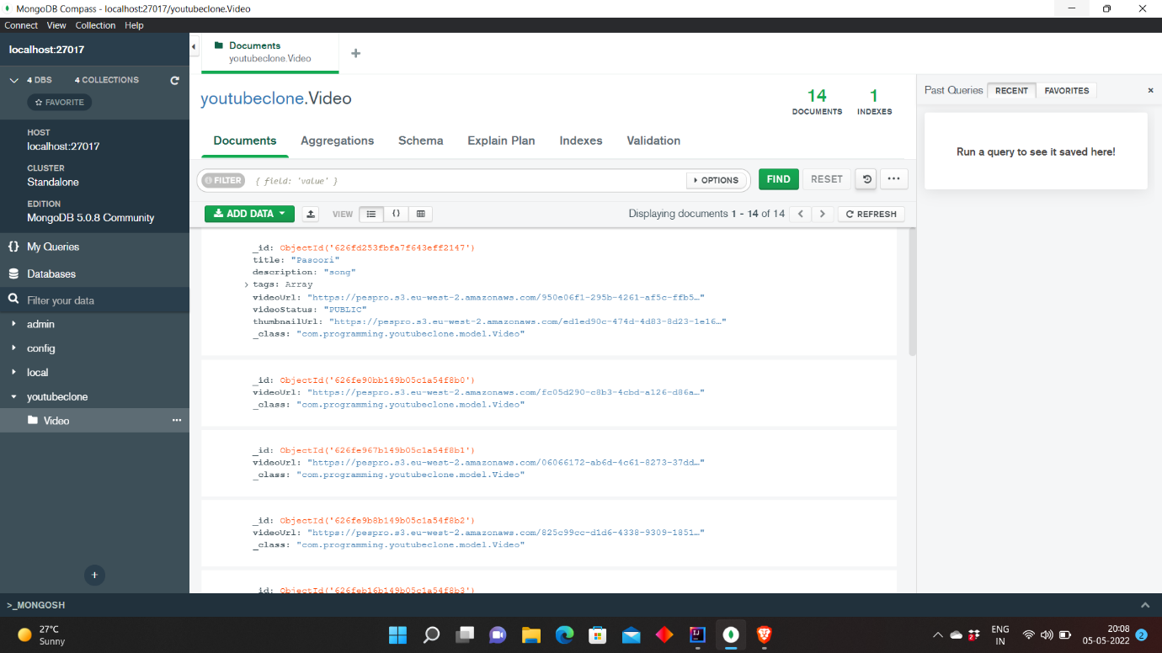

Video can be accessed in AWS bucket

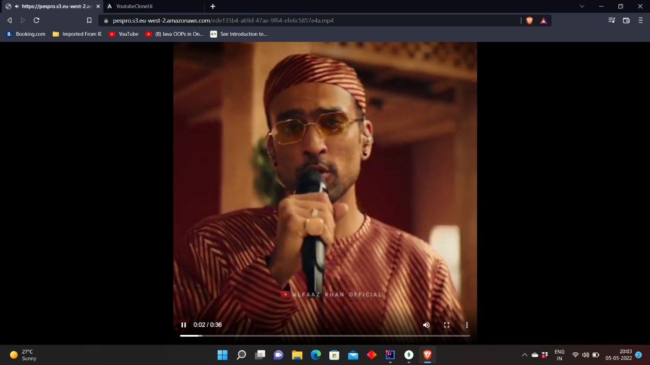

**6.Team member contributions**

|  |  |
| --- | --- |
| **Team Member** | **Contributions** |
| Devi Reddy N | Model (AWS+MongoDB) + Error handling |
| Guru Kiran H M | Controller + Error handling |
| Harshit Singh | Frontend (View) + Error handling |