INDIVIDUAL ASSIGNMENT - 4

Name: Kshitij Roll number: C012

Result of manual regression:

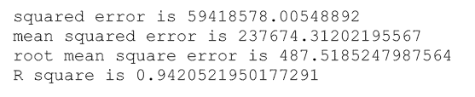

Result of skikit library:

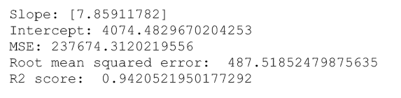

Result of excel:

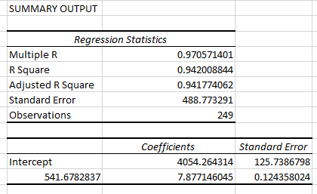

\*\*for more details refer files python and excel files attached along with this\*\*