We recently provided an addendum to our initial pre-registration, in which we outlined the need to re-evaluate our recruitment goal in light of a slower-than-anticipated pace of recruitment. We have followed that addendum, and used simulations to estimate the effect size we can detect with 80% statistical power with an alpha of 0.05 using label permutation testing. Throughout these analyses we have remained masked to the group assignment of any subject. Thus, to represent variation across subjects, we drew from subjects studied to date, pooled across diagnostic category. The masking and pooling method means that our estimates of between-subjects measurement variability are a lower bound, in the sense that the procedure treats any actual group effect as between-subjects variability rather than as a systematic effect of group.

We calculated the minimum detectable change in modeled parameters between a simulated patient and control group, each with 20 subjects. The model we implemented is a variation on the three-component model cited in our initial pre-registration document. We looked at two parameters of our model that reflect response duration: percent persistent and exponential tau.

The results of the power analysis suggest that with 20 subjects per group, we can detect a difference between patient and control groups in percent persistent of 10% and a difference in exponential tau of 6 s. Below are modeled responses of these simulated patient and control groups with the minimum detectable differences. The control and patient responses were computed as a decrease and increase, respectively, in the parameter of interest from the median model response across subjects. Other model parameters were kept the same between patients and controls, with the additional constraint of same peak constriction.

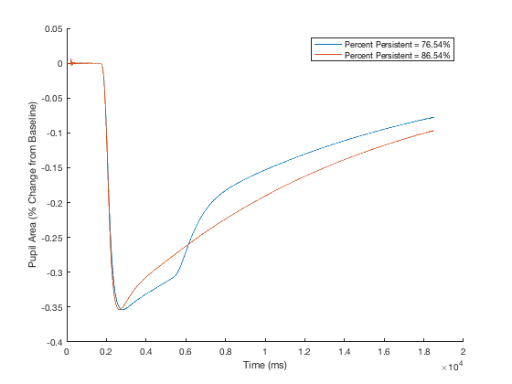
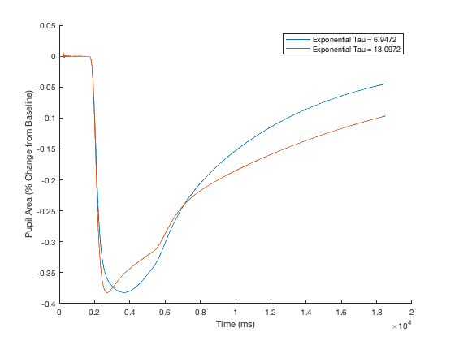
Percent Persistent Exponential Tau

We believe that the magnitudes of these group differences are a reasonable approximation for what we would hope to be able to detect as a consequence of pathology. Therefore we have revised our initial recruitment goals from 40 subjects within each group to 20.

We will continue to be masked as to the group identity of our subjects until we post a plan to unmask in a subsequent addendum.

