

Supplier Specs

V 0.1

12/11/2014 Prepared for: SNS Admin

Table of Content

1. Scope 3

2. Suppliers Main Screen 3

3. What should happen when we click “PRINT CHECK” 5

4. What should happen when we click “PRINT LETTER” 5

1. Scope:

The existing Suppliers Screen should allow adding a new supplier, his primary contact, Type, his phone number and his bank details.

The scope is to print the supplier payment either through a bank instruction letter or a bank check.

1. Suppliers Main Screen:

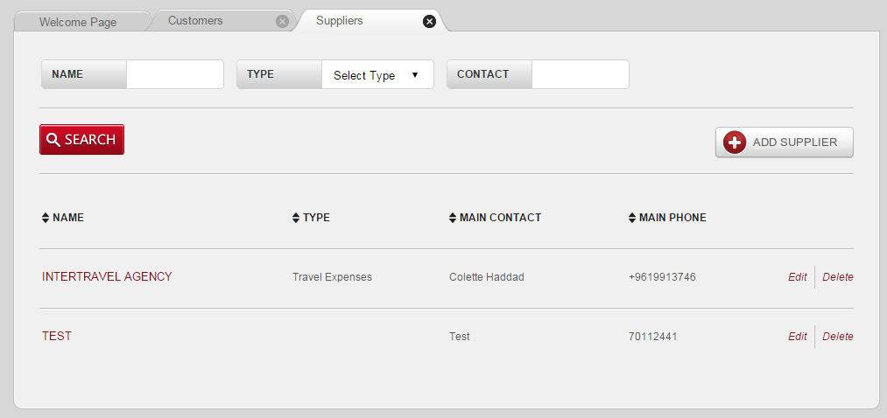

**Figure 1**

We need to perform the below changes in the Supplier Screen Header (Figure 1):

1. Replace the “Add Supplier “ button by the “Action” button 
2. Under “Action” button a drop list should appear with follow action options:

* ADD SUPPLIER
* PRINT CHECK
* PRINT LETTER

1. By clicking on “ADD SUPPLIER” action, the below “ New Supplier” screen shall remain (Figure 2) but we need to add the following new input fields:
   1. CURRENCY 🡪 should open a drop list with all currencies options.
   2. COUNTRY

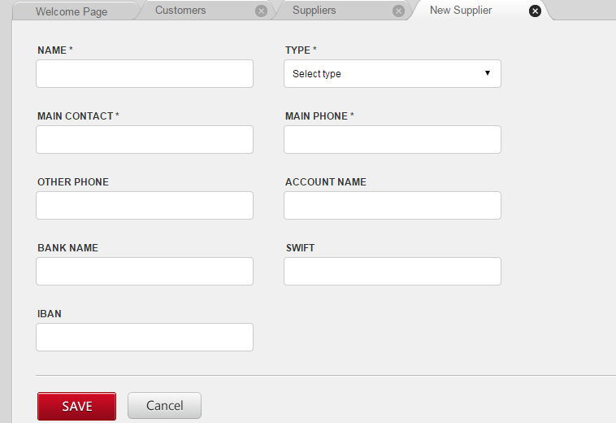

**Figure 2**

1. By clicking on “PRINT CHECK” a new popup screen should appear with the following:
   1. Input fields:
   2. Supplier Name: auto complete field
   3. Number field
   4. Description
   5. Check #
   6. Calendar field

4.2 buttons:

1. Print

2. Cancel

1. By clicking on “PRINT LETTER” a new screen should appear with the following:

5.1 Input fields:

1. Supplier Name: auto complete field

2. Number filed

3. Description

4. Calendar field

* 1. buttons:

1. Print

2. Cancel

1. What should happen when the user click “PRINT CHECK”

When we click the “PRINT CHECK” button the below actions should be performed:

1. Print on a valid check (dimensions mentioned in the attached excel file following this section 3) the customer name, amount in letters and figures and date.
2. Keep history of the printed checks by adding rows in a grid form under each supplier screen (Figure 3). This means that the existing form screen should have a grid section like the maintenance screen.
3. Each row in the grid should display:

* check #,
* description,
* amount,
* date
* User name (author).

1. Figure 4 is a snapshot of the original check form.
2. The records in the grid section should be sorted in a way that the latest transaction is displayed in the first row.

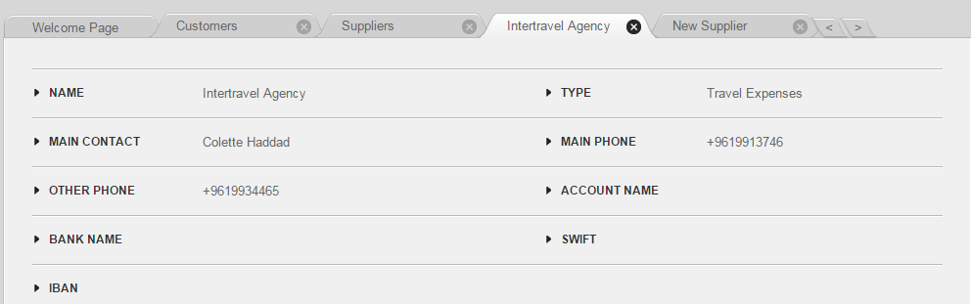

**Figure 3**

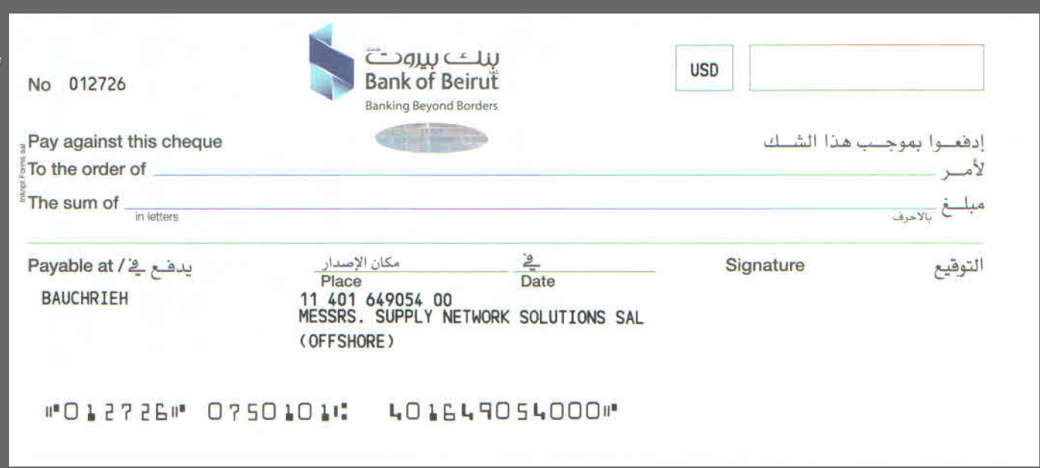

**Figure 4**



1. What should happen when the user click “PRINT LETTER”

When we click the “PRINT LETTER” button the below actions should be performed:

1. Print a valid bank letter (as per attached form) the customer name, amount in letters and figures.
2. Keep history of the printed letters by adding rows in a grid form under each supplier screen (Figure 3). The latest transaction is to be displayed in the first row.
3. Each row in the grid should display:
   * Description
   * Amount
   * Date
   * User name (author)
4. All yellow fields below in Figure 5 should be automatically filled out by the system
5. Figure 5 is a snapshot of the bank letter.

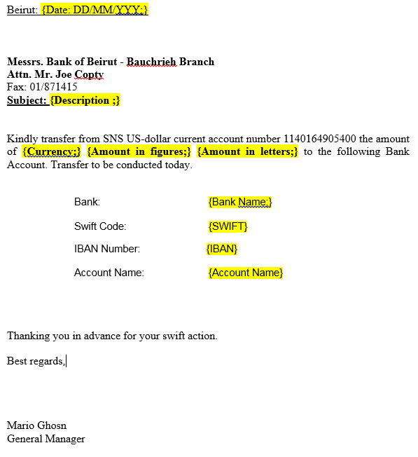**Figure 5**

