Arrays
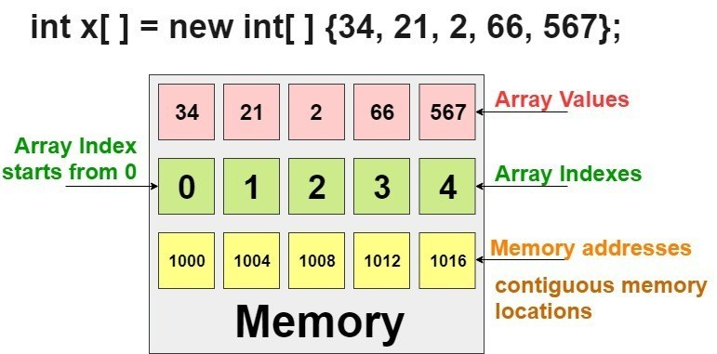
1. Normally, array is a collection of similar type of elements that have contiguous memory location.
2. Java array is an object the contains elements of similar data type. It is a data structure where we store similar elements. We can store only fixed set of elements in a java array.
3. Array in java is index based, first element of the array is stored at 0 index.
Advantage of Java Array:
1. Code Optimization:
It makes the code optimized, we can retrieve or sort the data easily.
2. Random access:
We can get any data located at any index position.
Disadvantage of Java Array:
Size Limit:
We can store only fixed size of elements in the array. It doesn't grow its size at runtime. To solve this problem, collection framework is used in java.
There are two types of array:
1. Single Dimensional Array
2. Multidimensional Array
Single Dimensional Array
Syntax to Declare an Array in java:
dataType[] arr; (or)
dataType []arr; (or)
dataType arr[];
Instantiation of an Array in java:
arrayRefVar=new datatype[size];
class Testarray{
public static void main(String args[ ]){
int a[ ]=new int[5];//declaration and instantiation
a[0]=10;//initialization
a[1]=20;
a[2]=70;
a[3]=40;
a[4]=50;
//printing array
for(int i=0;i<a.length;i++)//length is the property of array
System.out.println(a[i]);
}
}
Output:
10
20
70
40
50
We can declare, instantiate and initialize the java array together by:
int a[]={33,3,4,5};//declaration, instantiation and initialization
Let's see the simple example to print this array.
class Testarray1{
public static void main(String args[]){
int a[]={33,3,4,5};//declaration, instantiation and initialization
//printing array
for(int i=0;i<a.length;i++)//length is the property of array
System.out.println(a[i]);
}

}

Output:
33
3
4
5

Multidimensional Array in Java
In such case, data is stored in row and column based index (also known as matrix form).
Syntax to Declare Multidimensional Array in Java
dataType[][] arrayRefVar; (or)
dataType [][]arrayRefVar; (or)
dataType arrayRefVar[][]; (or)
dataType []arrayRefVar[];
Example to instantiate Multidimensional Array in Java
int[][] arr=new int[3][3];//3 row and 3 column
Example to initialize Multidimensional Array in Java
arr[0][0]=1;
arr[0][1]=2;
arr[0][2]=3;
arr[1][0]=4;
arr[1][1]=5;
arr[1][2]=6;
arr[2][0]=7;
arr[2][1]=8;
arr[2][2]=9;

Example of Multidimensional Java Array
Let's see the simple example to declare, instantiate, initialize and print the 2Dimensional array.
//Java Program to illustrate the use of multidimensional array
class Testarray3{
public static void main(String args[]){
//declaring and initializing 2D array
int arr[][]={{1,2,3},{2,4,5},{4,4,5}};
//printing 2D array
for(int i=0;i<3;i++){
for(int j=0;j<3;j++){
System.out.print(arr[i][j]+" ");
}
System.out.println();
}
}}
Output:
1 2 3
2 4 5
4 4 5
Three Dimentional Array
class GFG {
public static void main(String[] args)
{

int[][][] arr = { { { 1, 2 }, { 3, 4 } }, { { 5, 6 }, { 7, 8 } } };

for (int i = 0; i < 2; i++)
for (int j = 0; j < 2; j++)
for (int z = 0; z < 2; z++)
System.out.println("arr[" + i
+ "]["
+ j + "]["
+ z + "] = "
+ arr[i][j][z]);
}
}
Output:
arr[0][0][0] = 1
arr[0][0][1] = 2
arr[0][1][0] = 3
arr[0][1][1] = 4
arr[1][0][0] = 5
arr[1][0][1] = 6
arr[1][1][0] = 7
arr[1][1][1] = 8

Simple example of 3d Array
package Evening;
import Morg.First;
public class Third extends First{
public static void main(String[] args) {
String[ ] department = {"Electronics", "CS", "IT"};
int dept, st, sc, total = 0;
double perc = 0;

// Take the scores of students in a 3D array.
int[ ][ ][ ] scores = {
{{75, 87, 69}, {90, 87, 85},{56, 67, 76}},
{{78, 67, 75}, {87, 98, 76}, {67, 56, 66}},
{{72, 63, 72}, {82, 91, 71}, {64, 56, 66}}
};
// Display the scores of students from 3D array.
for(dept = 0; dept < 3; dept++)
{
for(int i = 0; i < 3; i++)
{
System.out.println("Department " +department[i]+ ": ");
for(st = 0; st < 3; st++) {
System.out.println("Student" +(st + 1)+ " scores: ");
for(sc = 0; sc < 3; sc++) {
System.out.print(scores[dept][st][sc]+ " ");
total += scores[dept][st][sc];
perc = (double)total/3;
}
System.out.println("\nTotal scores: " +total); // Displaying total marks of student.
System.out.println("Percentage: " +perc); // Displaying percentage.
System.out.println();
System.out.println("--------------------");
System.out.println();
total = 0; // reset total to zero.
}
System.out.println();
}
break;
}
} }
- Declare an array
int a[];
a=new int[40];
String[] aArray = new String[5];
String[] bArray = {"a","b","c", "d", "e"};
String[] cArray = new String[]{"a","b","c","d","e"};

1. Print an array in Java
int[] intArray = { 1, 2, 3, 4, 5 };
String intArrayString = Arrays.toString(intArray);

// print directly will print reference value
System.out.println(intArray);
// [I@7150bd4d

System.out.println(intArrayString);
// [1, 2, 3, 4, 5]

2. Create an ArrayList from an array

String[] stringArray = { "a", "b", "c", "d", "e" };

ArrayList<String> arrayList = new ArrayList<String>(Arrays.asList(stringArray));

System.out.println(arrayList);
// [a, b, c, d, e]

3. Check if an array contains a certain value

String[] stringArray = { "abc", "bcd", "cba", "dcb", "efg" };

boolean b = Arrays.asList(stringArray).contains("abc");
System.out.println(b);
// true

4. Concatenate two arrays

int[] intArray = { 1, 2, 3, 4, 5 };
int[] intArray2 = { 6, 7, 8, 9, 10 };
// Apache Commons Lang library
int a[] = ArrayUtils.addAll(intArray, intArray2);

String s = Arrays.toString(a);

System.out.println(s);

//1,2,3,4,5,6,7,8,9,10

6. Joins the elements of the provided array into a single String
// containing the provided list of elements
// Apache common lang
String j = StringUtils.join(new String[] { "a", "b", "c" }, ", ");
System.out.println(j);
// a, b, c

9. Reverse an array
int[] intArray = { 1, 2, 3, 4, 5 };
ArrayUtils.reverse(intArray);
System.out.println(Arrays.toString(intArray));
//[5, 4, 3, 2, 1]

10. Remove element of an array
int[] intArray = { 1, 2, 3, 4, 5 };
int[] removed = ArrayUtils.removeElement(intArray, 3);//create a new array
System.out.println(Arrays.toString(removed));

COPYING AN ARRAY:

1. USING ARRAYCOPY() METHOD:
The arraycopy() method belongs to the System class. It is used to copy the contents of one array to the other.

Example:

public class ArrayCopying {
public static void main(String[] args) {
int Source[] = {5,6,7,8,9,10};

int Destination[] = new int[5];

System.arraycopy(Source, 1, Destination, 0, 5);
System.out.print(Arrays.toString(Destination));

}
}

OUTPUT:
[6, 7, 8, 9, 10]

2. USING COPYOF() AND COPYOFRANGE() METHOD:
The Arrays class has two commonly used methods for copying the content of array i.e. copyOf() and copyOfRange() method.

EXAMPLE:

public class ArrayCopying {
public static void main(String[] args) {
int Source[] = {5,6,7,8,9,10};

int Destination[] = java.util.Arrays.copyOf(Source, 8);//0 is padded for index beyond source

System.out.println(Arrays.toString(Destination));

int Destination2[] = java.util.Arrays.copyOfRange(Source, 0, 5);

System.out.println(Arrays.toString(Destination2));

}
}

OUTPUT:
[5, 6, 7, 8, 9, 10, 0, 0] [5, 6, 7, 8, 9]

Write a Java program to sort a numeric array and a string array.
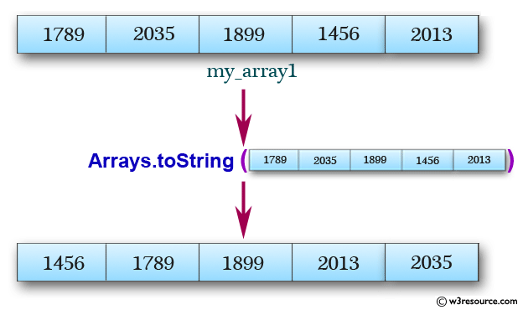
import java.util.Arrays;
public class Exercise1 {
public static void main(String[] args){

int[] my_array1 = {
1789, 2035, 1899, 1456, 2013,
1458, 2458, 1254, 1472, 2365,
1456, 2165, 1457, 2456};

String[] my_array2 = {
"Java",

"Python",
"PHP",
"C#",
"C Programming",
"C++"
};
System.out.println("Original numeric array : "+Arrays.toString(my_array1));
Arrays.sort(my_array1);
System.out.println("Sorted numeric array : "+Arrays.toString(my_array1));

System.out.println("Original string array : "+Arrays.toString(my_array2));
Arrays.sort(my_array2);

}
}

