Alter Query

alter table emp add dept varchar(10);

alter table emp rename column dept to depts;

alter table emp drop column dept;

alter table emp modify age int unique;

alter table emp rename to emps;

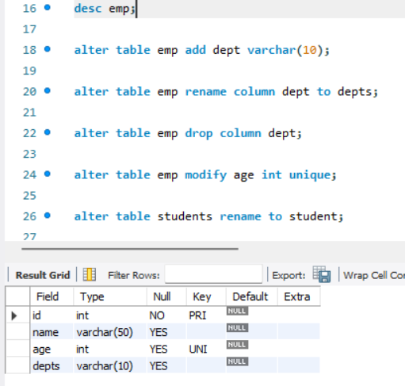

Drop Query
create database dummpy;
show databases;
DROP DATABASE dummpy;

create table demo(id int,name varchar(10));
DROP TABLE IF EXISTS demo;
DROP TABLE demo;

alter table emp drop column dept;

Update Query
update emp set depts="MSC" where id=1;
update emp set depts="Msc"; \\ warning error

Delete Query
delete from emp where id=1;
delete from emp; \\ warning error

Aggregation Function


