Instructions for Exercise 1:

1. Examine the new syntax for requiring a module. You can find the new syntax in the file: dojoNewModuleDefinitions.js

*require(["module1", "module2", ...], function (module1, module2...) {*

*});*

1. add new javascript file called bootstrapper.js
2. Add the required modules related to the user interface using the new syntax, and make the code run when the dom is ready. Check the required modules by the user interface from file oldMap_step1.js.
3. Examine the output

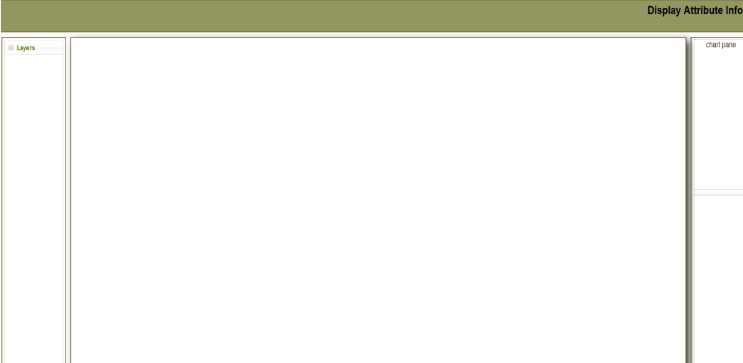

1. add esri module to add the map.
2. add the code to create the map, and add the base layer to it. You can find the required code from the file oldmap_step1.js.
3. run the application, and check the result.

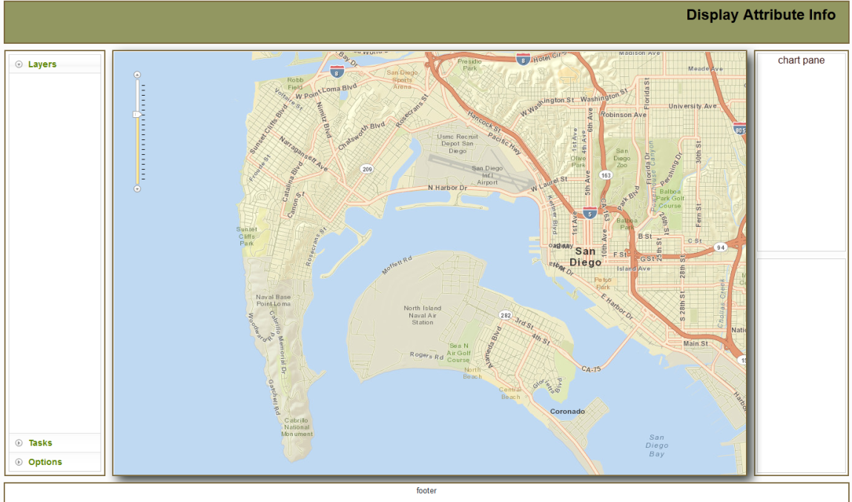

1. next step is to transfer this code to be a module that comply with AMD standard.
2. create a directory under js called modules
3. create a new file under modules called map.js
4. define a new module, using the new syntax. You can find a sample of the new syntax in the file: dojoNewModuleDefinitions.js

to define new module, use the syntax

*define([dependencies....], function (...) {...});*

1. have the module return a new declaration of a class using the syntax mentioned in the file dojoNewModuleDefinitions.js
2. change the dojoConfig to instruct the loader to load module from our directory. Look at the syntax in the file: dojoNewModuleDefinitions.js.
3. Make sure that the config is added before the script tag that is calling esri library.
4. change the bootstrapper to load the map module.
5. test the code again, by loading the app in firefox.
6. Add the code that add the feature layer to the map.
7. Test the app.

