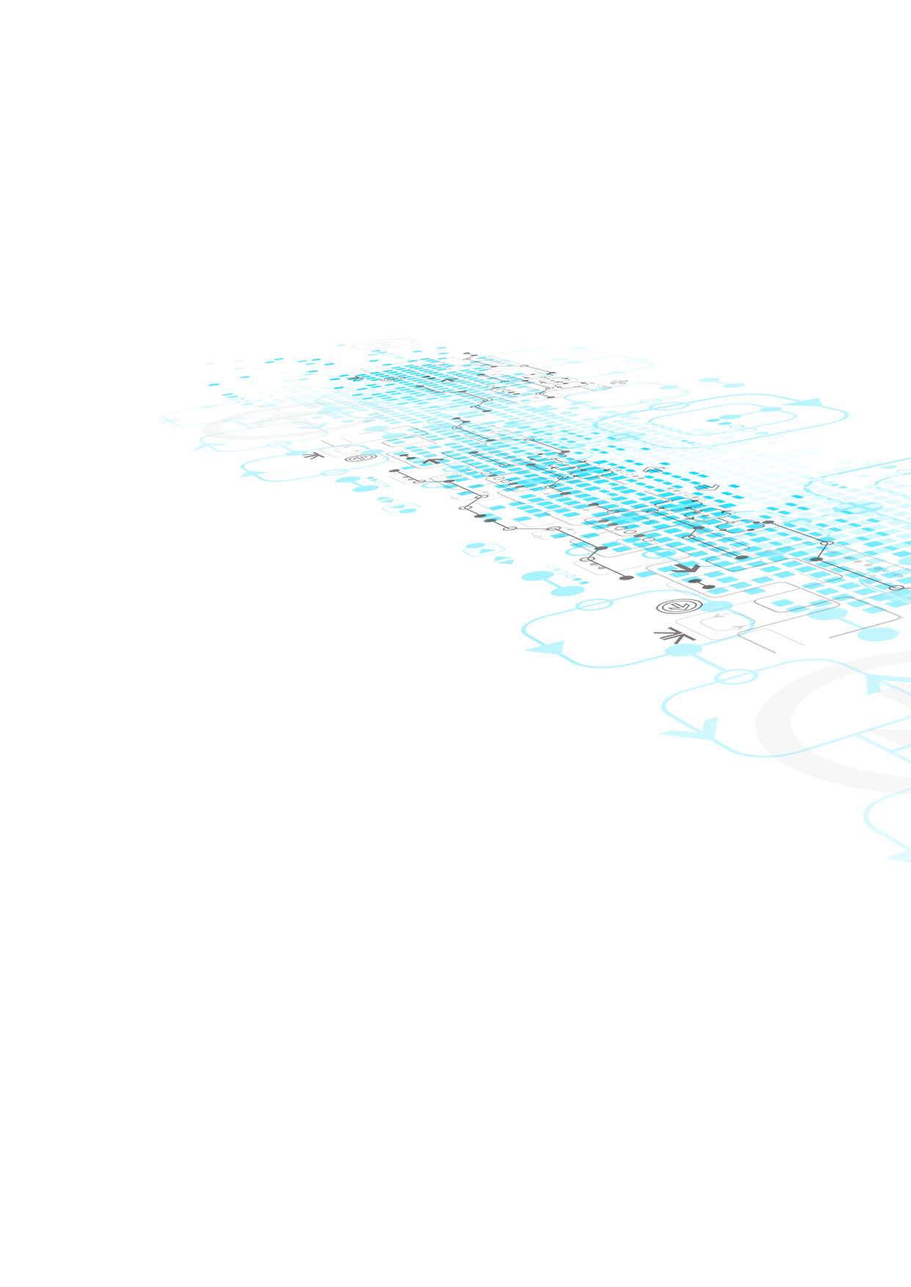

MyShare

Digital Advertising System

Composed By: MAVEN TEK (Y1S2)

**Group Members**

|  |  |
| --- | --- |
| **Member Name** | **Registration Number** |
| V. Siyam | SA22445704 |
| C. Shamini | SA22447920 |
| P. Manav Pranavin | SA22493606 |
| V. Thujithra | SA22447098 |
| P. Nitishe | SA22446008 |
| G. Kavinesh | SA22446626 |
| K. Diluksha | SA22448088 |
| S. Vickash | SA22497420 |

**Use Case Diagram for Proposed System**

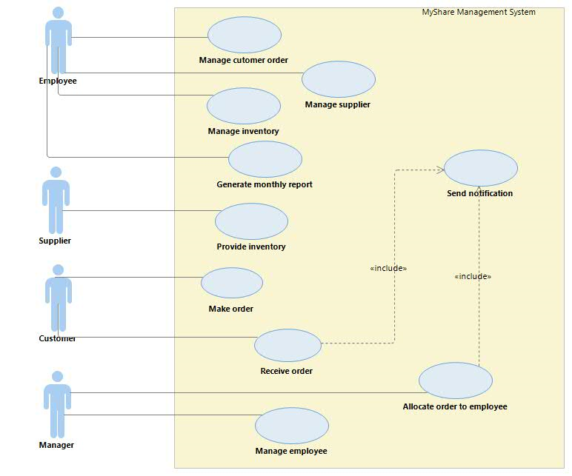

**ER Diagram for Proposed System**

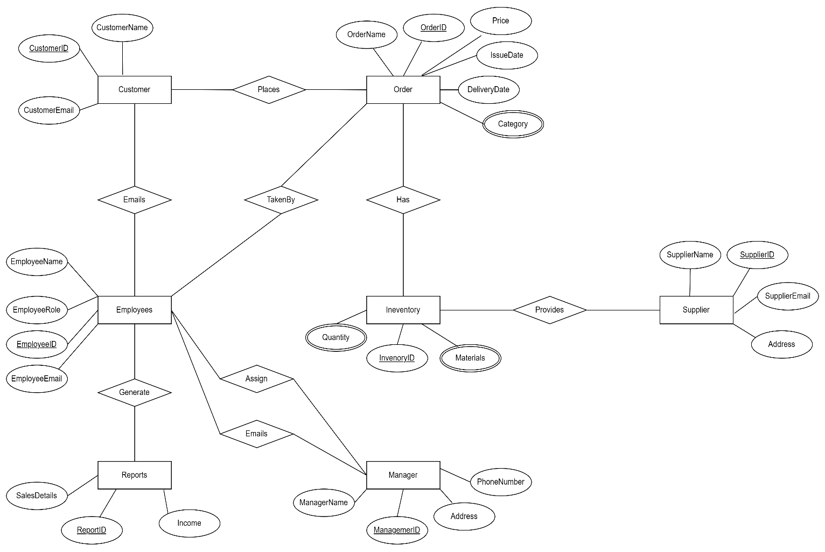

**Class Diagram for Proposed System**

