Table of Contents

* [Ansible Tower Lab](https://cloud.scorm.com/content/courses/A9KI96X2QE/Ansible_Foundations/11/05_Ansible_Tower/05_Tower_Lab.html" \l "_ansible_tower_lab)
* [1. Install Ansible Tower](https://cloud.scorm.com/content/courses/A9KI96X2QE/Ansible_Foundations/11/05_Ansible_Tower/05_Tower_Lab.html" \l "_install_ansible_tower)
  + [1.1. Access Environment](https://cloud.scorm.com/content/courses/A9KI96X2QE/Ansible_Foundations/11/05_Ansible_Tower/05_Tower_Lab.html" \l "_access_environment)
  + [1.2. Install Ansible Packages and Enable EPEL Repository](https://cloud.scorm.com/content/courses/A9KI96X2QE/Ansible_Foundations/11/05_Ansible_Tower/05_Tower_Lab.html" \l "_install_ansible_packages_and_enable_epel_repository)
  + [1.3. Install Ansible Tower Package](https://cloud.scorm.com/content/courses/A9KI96X2QE/Ansible_Foundations/11/05_Ansible_Tower/05_Tower_Lab.html" \l "_install_ansible_tower_package)
  + [1.4. Verify Installation](https://cloud.scorm.com/content/courses/A9KI96X2QE/Ansible_Foundations/11/05_Ansible_Tower/05_Tower_Lab.html" \l "_verify_installation)
  + [1.5. Install License Key](https://cloud.scorm.com/content/courses/A9KI96X2QE/Ansible_Foundations/11/05_Ansible_Tower/05_Tower_Lab.html" \l "_install_license_key)
* [2. Launch a Job](https://cloud.scorm.com/content/courses/A9KI96X2QE/Ansible_Foundations/11/05_Ansible_Tower/05_Tower_Lab.html" \l "_launch_a_job)

## Ansible Tower Lab

In this Lab you set up Ansible Tower, become familiar with its web interface, and launch a job.

## 1. Install Ansible Tower

### 1.1. Access Environment

1. Connect to the control node:

# ssh your-sso-login@workstation-GUID.rhpds.opentlc.com

1. Become the root user:

# sudo -i

1. Connect to the tower node using the password redhat:

# ssh tower.example.com

### 1.2. Install Ansible Packages and Enable EPEL Repository

* Attach the Extra Packages pool to make Ansible packages available:

# subscription-manager attach --pool=`subscription-manager list --all --available --matches "\*Extra Packages\*" --pool-only`

### 1.3. Install Ansible Tower Package

1. Get the latest Ansible Tower installation package:

# yum install -y wget

# wget http://releases.ansible.com/ansible-tower/setup/ansible-tower-setup-3.0.3.tar.gz -O ansible-tower-setup-latest.tar.gz

1. Decompress the archive and change to the folder:

# tar -xvzf ansible-tower-setup-latest.tar.gz

# cd ansible-tower-setup-\*

1. Edit the inventory file to contain the following:

[primary]

localhost ansible\_connection=local

[secondary]

[database]

[all:vars]

admin\_password='redhat'

pg\_password='redhat'

rabbitmq\_password='redhat'

redis\_password='redhat'

pg\_host=''

pg\_port=''

pg\_database='awx'

pg\_username='awx'

* + Because the setup script uses Ansible to install Ansible Tower, you can change the installation parameters by modifying the inventory file.

1. Launch the Ansible Tower setup script:

# ./setup.sh

* + This installs Tower on the tower node and sets redhat as the password for the Tower admin user, the database, and rabbitmq.

|  |  |
| --- | --- |
|  | If those values are not changed, Tower is still installed, but it is installed on the current machine and sets blank passwords. |

1. Watch the installation process go through an ansible-playbook run that takes about 15 minutes:

[...omitted output...]

PLAY RECAP \*\*\*\*\*\*\*\*\*\*\*\*\*\*\*\*\*\*\*\*\*\*\*\*\*\*\*\*\*\*\*\*\*\*\*\*\*\*\*\*\*\*\*\*\*\*\*\*\*\*\*\*\*\*\*\*\*\*\*\*\*\*\*\*\*\*\*\*\*

localhost : ok=113 changed=40 unreachable=0 failed=1

The setup process completed successfully.

Setup log saved to /var/log/tower/setup-2017-03-06-15:50:15.log

|  |  |
| --- | --- |
|  | Ansible playbooks sometimes use checks that "fail" to test the condition of the environment, these red lines are not always a sign of something gone wrong. |

### 1.4. Verify Installation

1. Go to https://tower-GUID.rhpds.opentlc.com.
2. Accept the SSL certificate warnings from your web browser, if needed.
3. Confirm that you see this login screen:

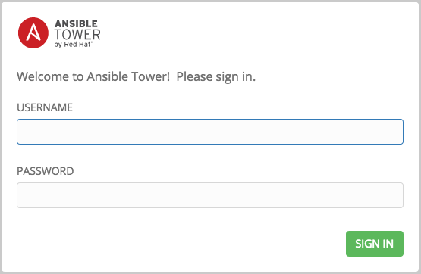

### 1.5. Install License Key

1. First you need to [download a valid License file](https://www.opentlc.com/download/ansible_foundations/licence.json).
2. Sign in to Ansible Tower with the following credentials :
   * USERNAME: admin
   * PASSWORD: redhat

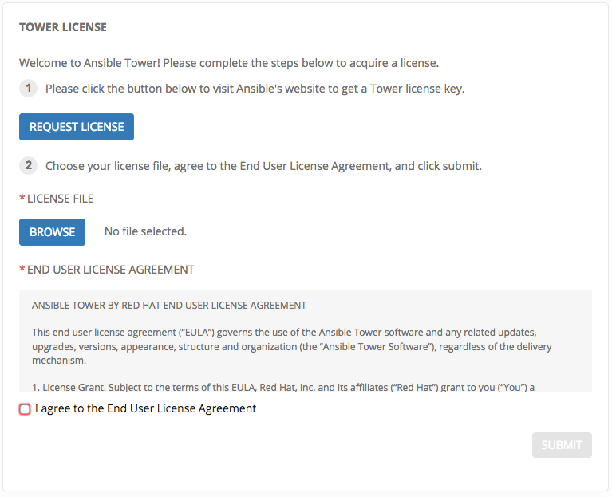

1. You already have a Licence file so you can skip step 1. In step 2, click BROWSE and browse your computer to select the Licence file you just downloaded.
2. Check the agreement box at the bottom and click Submit:
   * The Ansible Tower dashboard opens.

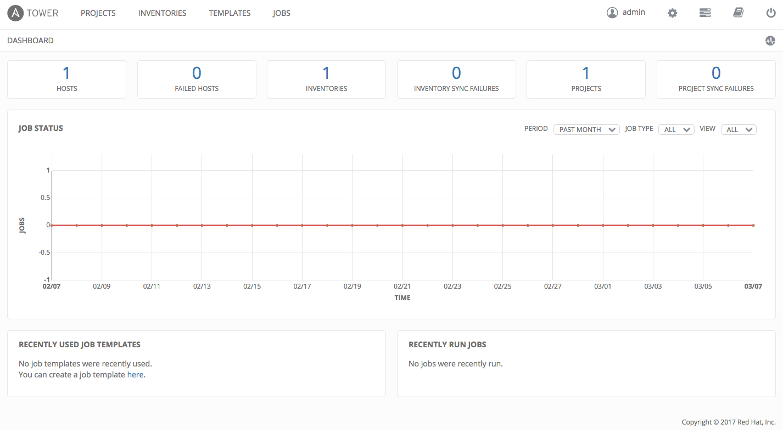

## 2. Launch a Job

In this exercise, you launch a job using Ansible Tower.

1. From the menu at the top of the Ansible Tower dashboard, select TEMPLATES.
2. Click  to launch the Demo Job Template:
   * You see information about the job and the live output of the run.

