Table of Contents

* [Ansible Galaxy Lab](https://cloud.scorm.com/content/courses/A9KI96X2QE/Ansible_Foundations/11/06_Ansible_Galaxy/06_Galaxy_Lab.html" \l "_ansible_galaxy_lab)
* [1. Download a Role From Ansible Galaxy Website](https://cloud.scorm.com/content/courses/A9KI96X2QE/Ansible_Foundations/11/06_Ansible_Galaxy/06_Galaxy_Lab.html" \l "_download_a_role_from_ansible_galaxy_website)
* [2. Install an Ansible Galaxy Role](https://cloud.scorm.com/content/courses/A9KI96X2QE/Ansible_Foundations/11/06_Ansible_Galaxy/06_Galaxy_Lab.html" \l "_install_an_ansible_galaxy_role)
* [3. Use Ansible Galaxy Role](https://cloud.scorm.com/content/courses/A9KI96X2QE/Ansible_Foundations/11/06_Ansible_Galaxy/06_Galaxy_Lab.html" \l "_use_ansible_galaxy_role)

## Ansible Galaxy Lab

In this lab, you familiarize yourself with Ansible Galaxy and use a role to set up a database.

## 1. Download a Role From Ansible Galaxy Website

In this exercise, you use the Explore tab on the Ansible Galaxy website to find a role created by someone in the community.

1. Go to [https://galaxy.ansible.com/explore#/](https://galaxy.ansible.com/explore" \l "/):
   * This page list some of the top roles created by the community.

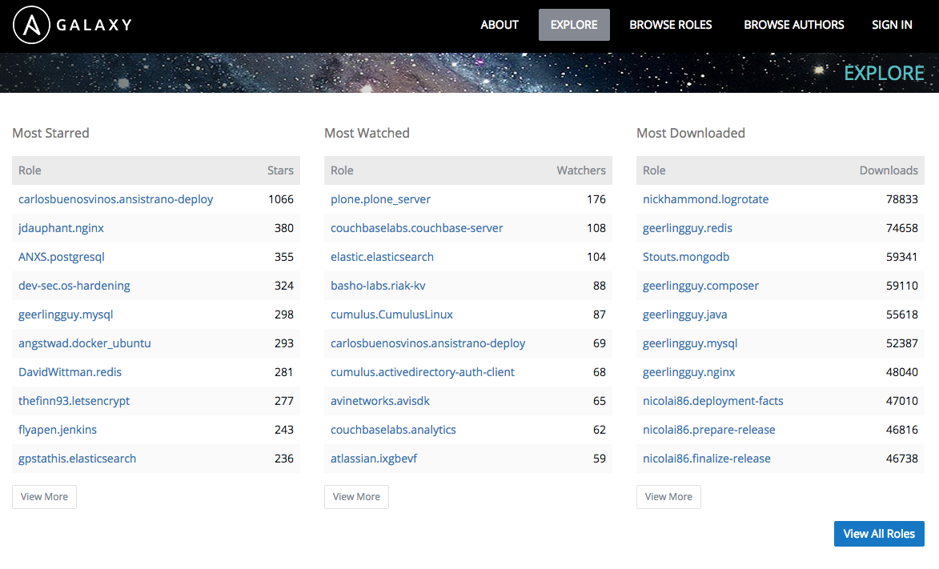

1. Select the following MySQL role: <https://galaxy.ansible.com/geerlingguy/mysql/>.
   * This page displays the ansible-galaxy command to use in order to install the role to your environment.
   * This role was the "Most Starred" MySQL role when Red Hat created this lab.

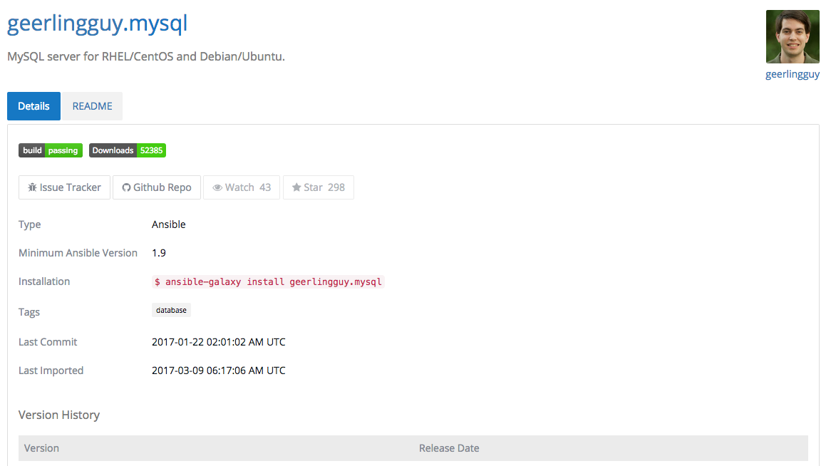

## 2. Install an Ansible Galaxy Role

1. Connect to your workstation:

# ssh your-sso-login@workstation-GUID.rhpds.opentlc.com

1. As root, install the MySQL role you just viewed:

# ansible-galaxy install geerlingguy.mysql

- downloading role 'mysql', owned by geerlingguy

- downloading role from https://github.com/geerlingguy/ansible-role-mysql/archive/2.5.1.tar.gz

- extracting geerlingguy.mysql to /etc/ansible/roles/geerlingguy.mysql

- geerlingguy.mysql was installed successfully

* + The role is downloaded and extracted by default into the /etc/ansible/roles/ folder.

## 3. Use Ansible Galaxy Role

In this exercise, you use a role you installed from Ansible Galaxy.

1. Create a new playbook called install-database.yml and add the following content:

- hosts: sql

name: Install the database server from an Ansible Galaxy role

roles:

- geerlingguy.mysql

* + This playbook uses the geerlingguy.mysql role on the sql group you defined previously in your inventory.

1. Run the playbook:

# ansible-playbook install-database.yml

[...omitted output...]

changed: [serverb.example.com]

PLAY RECAP \*\*\*\*\*\*\*\*\*\*\*\*\*\*\*\*\*\*\*\*\*\*\*\*\*\*\*\*\*\*\*\*\*\*\*\*\*\*\*\*\*\*\*\*\*\*\*\*\*\*\*\*\*\*\*\*\*\*\*\*\*\*\*\*\*\*\*\*\*

serverb.example.com : ok=30 changed=8 unreachable=0 failed=0

1. Watch the playbook run and observe all of the tasks as they are performed.
   * The creator of this role uses many best practices to install and secure a MySQL server, and it is easy to read and understand no matter what technical level you have with MySQL servers.