Experiment No.: 9
Date:
Experiment Title: Data Flow Diagram for Library Management System
Aim:
To design a Data Flow Diagram (DFD) for a Library Management System to represent the flow of data between external entities and the system.

Problem Description:
The Library Management System is designed to manage the operations of a library efficiently. It allows library members to search for books, borrow and return them, and manage membership details. The system maintains records of books, student memberships, teacher memberships, and generates fine bills for overdue books.The system interacts with external entities such as Library Members and Books database. The objective is to represent these interactions using a Data Flow Diagram, showing how data flows between different components of the system.

Given Conditions / Constraints:
• The system must include Library Member and Books as external entities
• Data stores such as Book Detail List, Student Membership List, Teacher Membership List, and Fine Bill Report must be included
• Only essential processes should be represented (Level 0 DFD)
• Data flow should be clearly labelled
• The diagram should be simple and easy to understand

Approach / Methodology:
The DFD was designed using a structured approach. First, external entities such as Library Member and Books were identified. Then, the main process “Library Management System” was defined at the center.Data flows such as book requests, membership details, book availability, and fine details were identified. These flows were connected between the external entities and the system.The system outputs include Book Detail List, Student Membership List, Teacher Membership List, and Fine Bill Report. The diagram was organized to ensure clarity and simplicity.

Planning and Estimation:
The system was designed as a single main process (Level 0 DFD) to maintain simplicity. Only essential data interactions were included:
• Library Member interactions: search books, borrow/return books, membership details
• Books interactions: book availability and updates
• System outputs: book details, membership lists, and fine reports
This approach ensures that the diagram remains easy to understand while covering all necessary operations.

Scheduling / Design Considerations:
The diagram was designed by placing the main process “Library Management System” at the center. External entities like Library Member and Books were positioned on the left side.Data stores such as Book Detail List, Student Membership List, Teacher Membership List, and Fine Bill Report were placed on the right side.Arrows were used to represent the direction of data flow. Proper labels were added to indicate the type of data being transferred, such as book request, membership data, and fine details.The design focuses on clarity, readability, and avoiding unnecessary complexity.

Diagram:
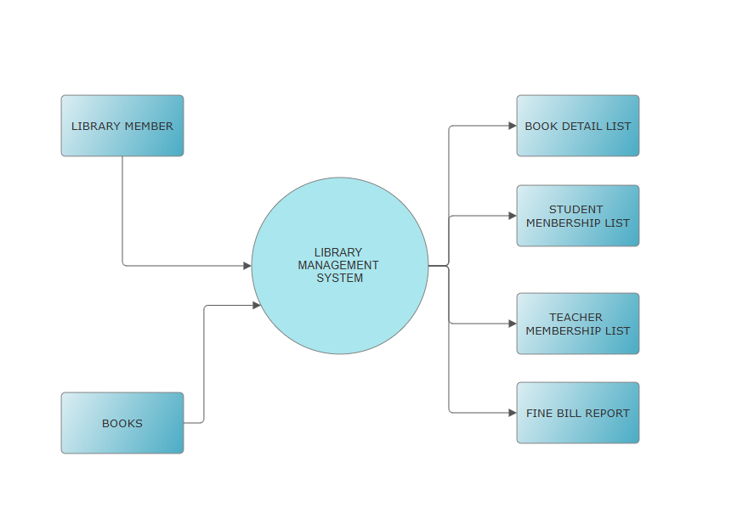

Feasibility Analysis:
• Technical Feasibility:
The system uses standard DFD concepts and can be easily implemented using basic software tools.
• Economic Feasibility:
No cost is involved as this is a conceptual design of the system.
• Operational Feasibility:
The system is practical and reflects real-world library operations such as book issuing, returning, and fine calculation.
• Schedule Feasibility:
The diagram can be designed within the allotted time without complexity.

Observation:
During this experiment, it was observed that the Data Flow Diagram helps in understanding how data moves between different components of the Library Management System.It clearly shows how the library member interacts with the system, how book data is processed, and how outputs such as reports and membership lists are generated.A simple Level 0 DFD effectively represents the system without making it complex.

Result:
A Data Flow Diagram for the Library Management System was successfully designed. It clearly shows the interaction between external entities, the main system process, and the output data stores.

Conclusion:
This experiment demonstrates that DFD is a powerful tool for representing system processes and data flow. It simplifies complex operations of a library system and helps in better understanding, analysis, and communication of system design

