Use Case Diagram for ATM System

Aim

To design and model the functional requirements of an ATM system using a UML Use Case Diagram, showing the interaction between users and the system.

System Overview
The ATM (Automated Teller Machine) system allows bank customers to perform banking transactions without visiting a bank branch. The system authenticates the user and provides services such as cash withdrawal and balance inquiry.
The main components involved are:
- User – Bank customer who operates the ATM.
- ATM Machine – Interface that allows interaction.
- Server – Bank backend system that validates and processes transactions.
The system ensures secure authentication and communicates with the bank server to verify account details and process transactions.

Diagram
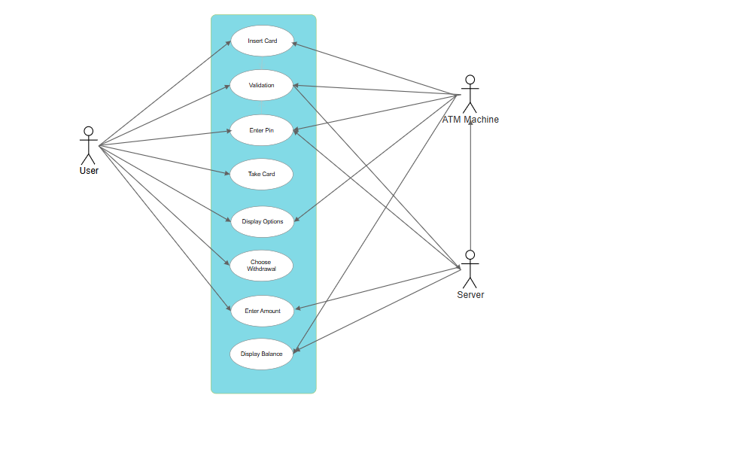

Diagram Explanation
The Use Case Diagram represents the interaction between actors and the ATM system.
Actors:
- User
  - Inserts card
  - Enters PIN
  - Chooses withdrawal
  - Enters amount
  - Views balance
  - Takes card
- ATM Machine
  - Acts as an interface between user and server.
  - Displays options and messages.
- Server
  - Validates card details
  - Verifies PIN
  - Checks account balance
  - Updates account after withdrawal

Use Cases Included in the Diagram:
- Insert Card – User inserts ATM card.
- Validation – System validates card details through server.
- Enter PIN – User enters PIN for authentication.
- Display Options – System displays available transactions.
- Choose Withdrawal – User selects withdrawal option.
- Enter Amount – User enters withdrawal amount.
- Display Balance – System shows account balance.
- Take Card – User removes card after transaction.

Flow of Interaction:
- User inserts card.
- System validates the card.
- User enters PIN.
- Server verifies PIN.
- ATM displays transaction options.
- User selects withdrawal and enters amount.
- Server checks balance and processes transaction.
- Balance is displayed.
- User takes the card.

Conclusion
The Use Case Diagram clearly illustrates the functional behavior of the ATM system and the interaction between the User, ATM Machine, and Server. It helps in understanding system requirements, improving system design, and ensuring secure and efficient banking transactions.

